Trend Summary

Table of Contents

This report narrates the development of the the “trend summary” graphic that states the observed suicide rates in Florida county by sex, race, and ethnicity. Annotates ./analysis/trend-summary/trend-summary.R script.

# Set the scene

Describe the working environment.

16.1 MB

[1] "list"

[1] "granularity_gls" "granularity_population"

variable type na na_pct unique min mean max  
1 county chr 0 0.0 67 NA NA NA  
2 year chr 0 0.0 17 NA NA NA  
3 sex chr 0 0.0 2 NA NA NA  
4 race chr 0 0.0 2 NA NA NA  
5 ethnicity chr 0 0.0 3 NA NA NA  
6 age_group chr 0 0.0 13 NA NA NA  
7 population_count dou 0 0.0 14511 0 2926.53 144791  
8 peer_group dou 1612 1.5 25 1 32.85 81  
9 resident_deaths dou 97718 90.5 40 1 3.30 41  
10 region chr 101972 94.4 4 NA NA NA  
11 community dou 104156 96.4 35 8 491.19 3764  
12 professionals dou 102388 94.8 45 4 95.89 1161  
13 county_gls log 101972 94.4 2 1 1.00 1

# A tibble: 15 x 3  
 county community professionals  
 <chr> <dbl> <dbl>  
 1 Orange 8182 1605  
 2 Saint Lucie 1068 830  
 3 Volusia 2170 432  
 4 Seminole 2400 419  
 5 Lake 206 290  
 6 Palm Beach 935 241  
 7 Saint Johns 250 210  
 8 Brevard 1126 166  
 9 Hernando 115 131  
10 Marion 325 119  
11 Indian River 245 118  
12 Osceola 35 84  
13 Sumter 85 81  
14 Martin 535 46  
15 Flagler 397 29

variable type na na_pct unique min mean max  
1 county chr 0 0.0 67 NA NA NA  
2 year chr 0 0.0 17 NA NA NA  
3 sex chr 0 0.0 2 NA NA NA  
4 age_group chr 0 0.0 13 NA NA NA  
5 race chr 0 0.0 2 NA NA NA  
6 ethnicity chr 0 0.0 3 NA NA NA  
7 racethnicity chr 0 0.0 6 NA NA NA  
8 region chr 101972 94.4 4 NA NA NA  
9 rgn chr 101972 94.4 4 NA NA NA  
10 population_count dou 0 0.0 14511 0 2926.53 144791  
11 deaths_by_suicide dou 97718 90.5 40 1 3.30 41  
12 community dou 104156 96.4 35 8 491.19 3764  
13 professionals dou 102388 94.8 45 4 95.89 1161

[1] "Brevard" "Orange" "Osceola" "Seminole" "Flagler" "Hernando" "Lake"   
 [8] "Marion" "Saint Johns" "Sumter" "Volusia" "Indian River" "Martin" "Palm Beach"   
[15] "Saint Lucie"

# I Exposition

# II. Summary View

[1] “County FIPS code” “County Name, State” “Peer County Group”

## Peer Group 1

county

county_gls

peer_group

Duval

TRUE

1

Hillsborough

NA

1

Miami-Dade

NA

1

Orange

TRUE

1

## Peer Group 6

county

county_gls

peer_group

Clay

TRUE

6

Saint Johns

TRUE

6

Seminole

TRUE

6

## Peer Group 7

county

county_gls

peer_group

Broward

NA

7

Palm Beach

TRUE

7

## Peer Group 9

county

county_gls

peer_group

Osceola

TRUE

9

## Peer Group 11

county

county_gls

peer_group

Hernando

TRUE

11

Lake

TRUE

11

Nassau

NA

11

Pasco

TRUE

11

## Peer Group 24

county

county_gls

peer_group

Brevard

TRUE

24

Collier

NA

24

Escambia

NA

24

Flagler

TRUE

24

Lee

NA

24

Manatee

NA

24

Marion

TRUE

24

Martin

TRUE

24

Polk

TRUE

24

Saint Lucie

TRUE

24

Sarasota

NA

24

Volusia

TRUE

24

## Peer Group 25

county

county_gls

peer_group

Charlotte

NA

25

Citrus

TRUE

25

Highlands

NA

25

Indian River

TRUE

25

Sumter

TRUE

25

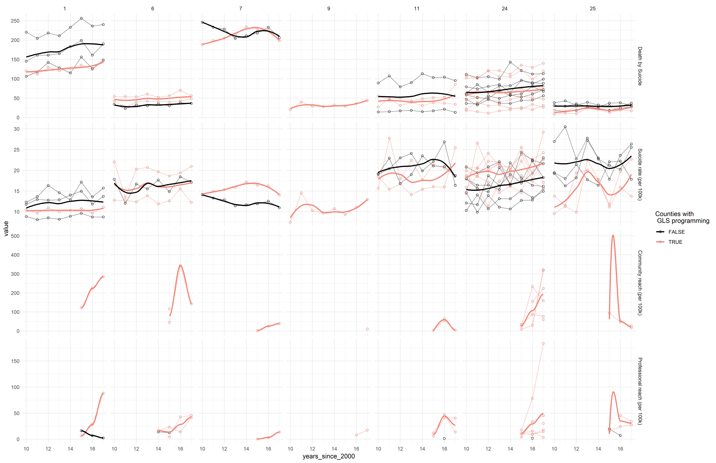

# III County View

## Brevard

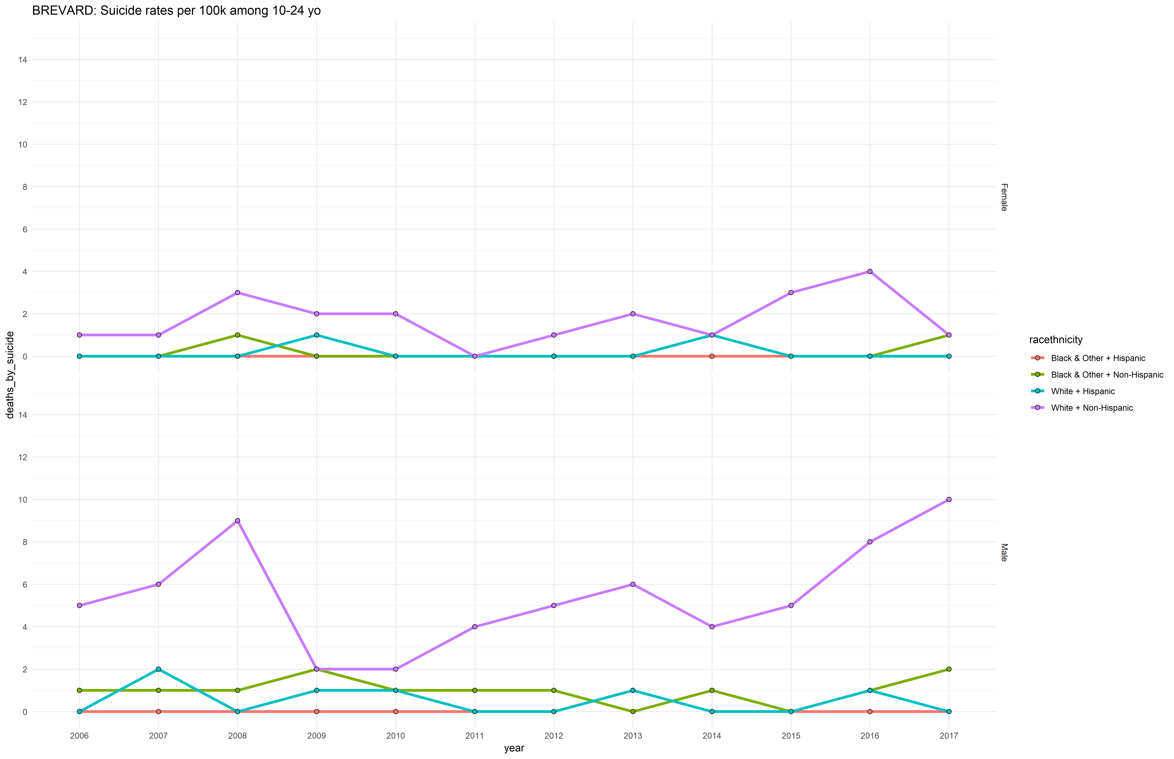

## Orange

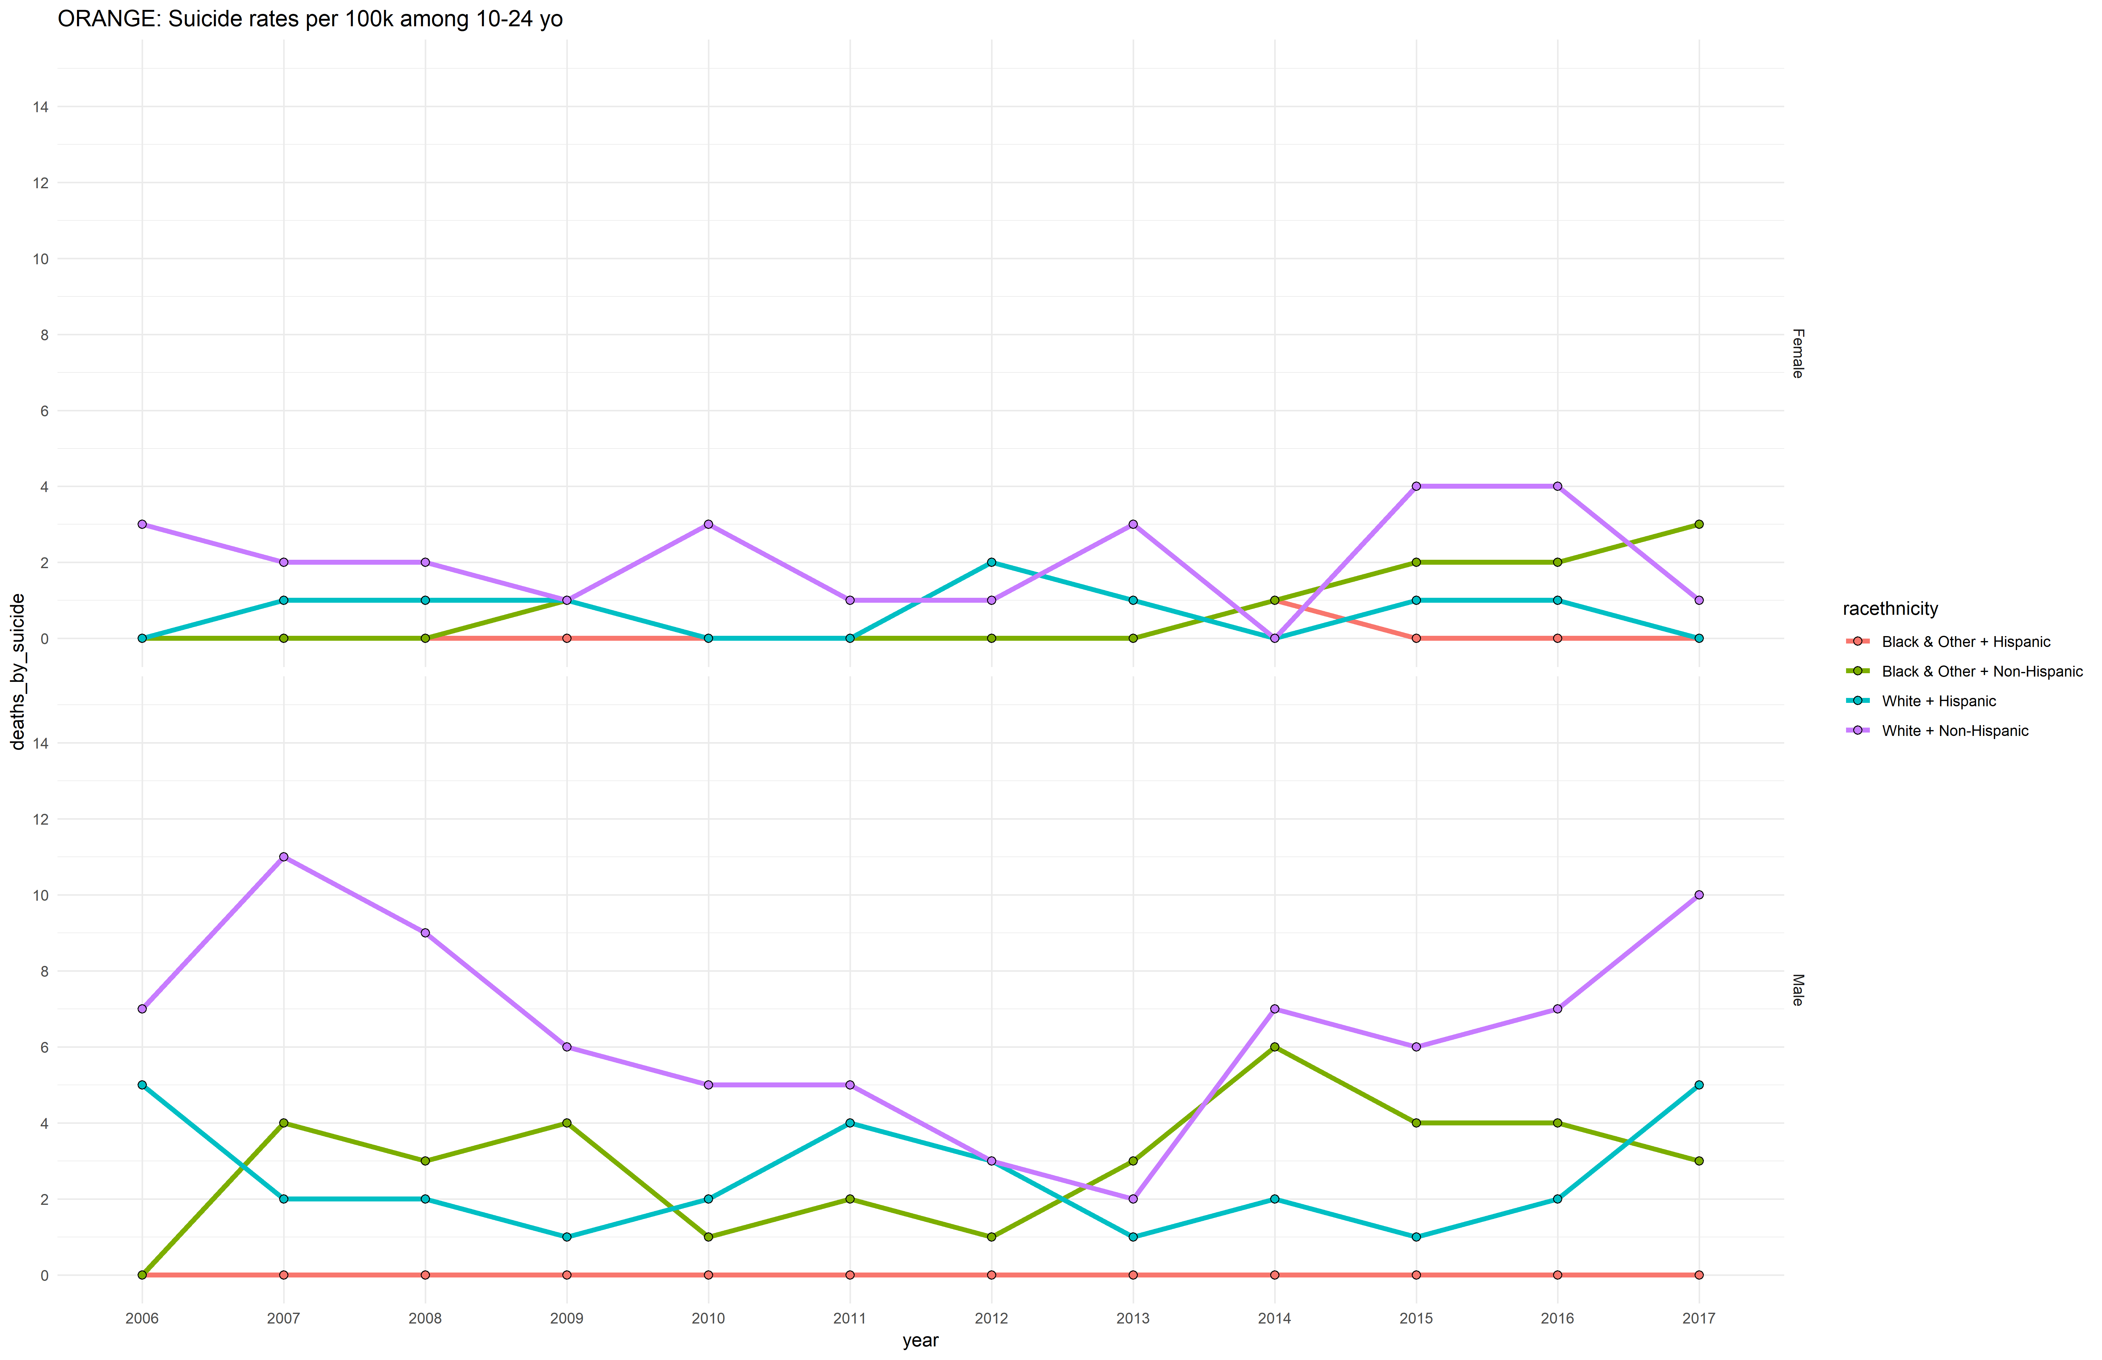

## Osceola

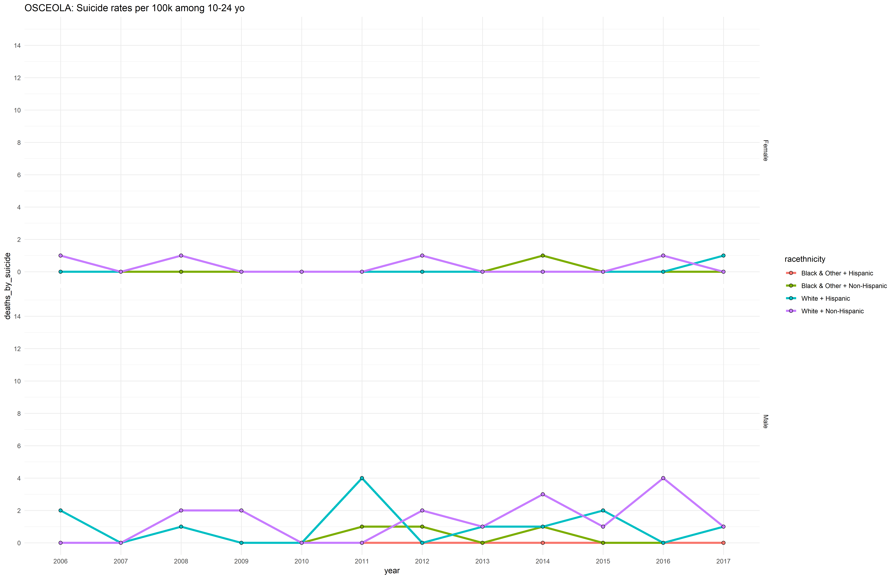

## Seminole

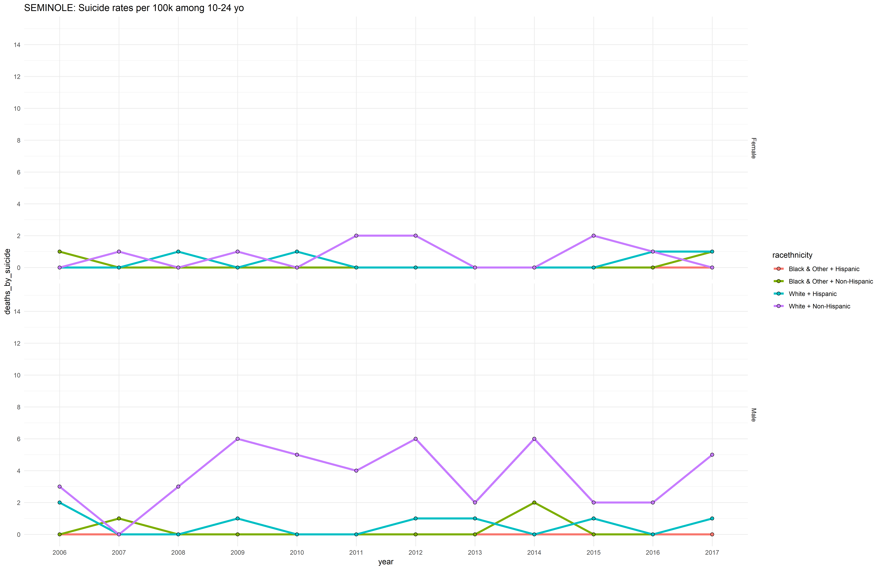

## Flagler

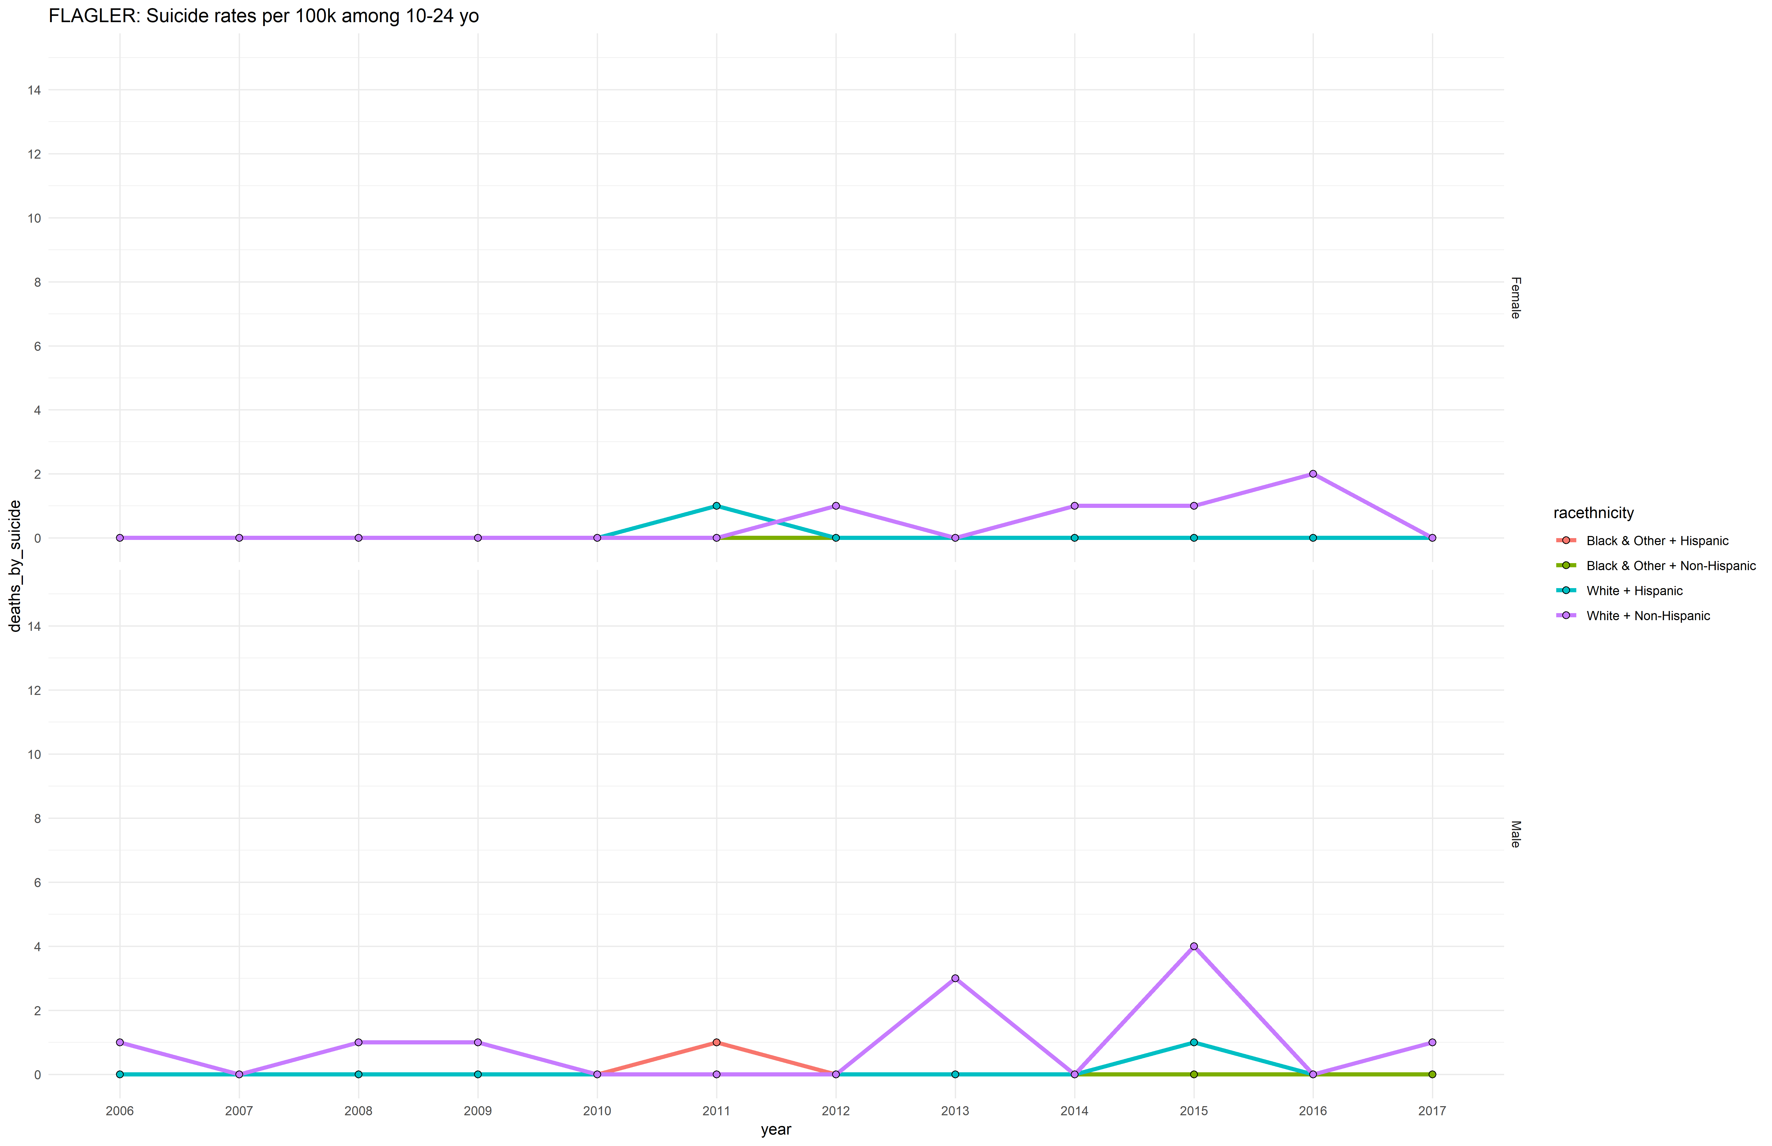

## Hernando

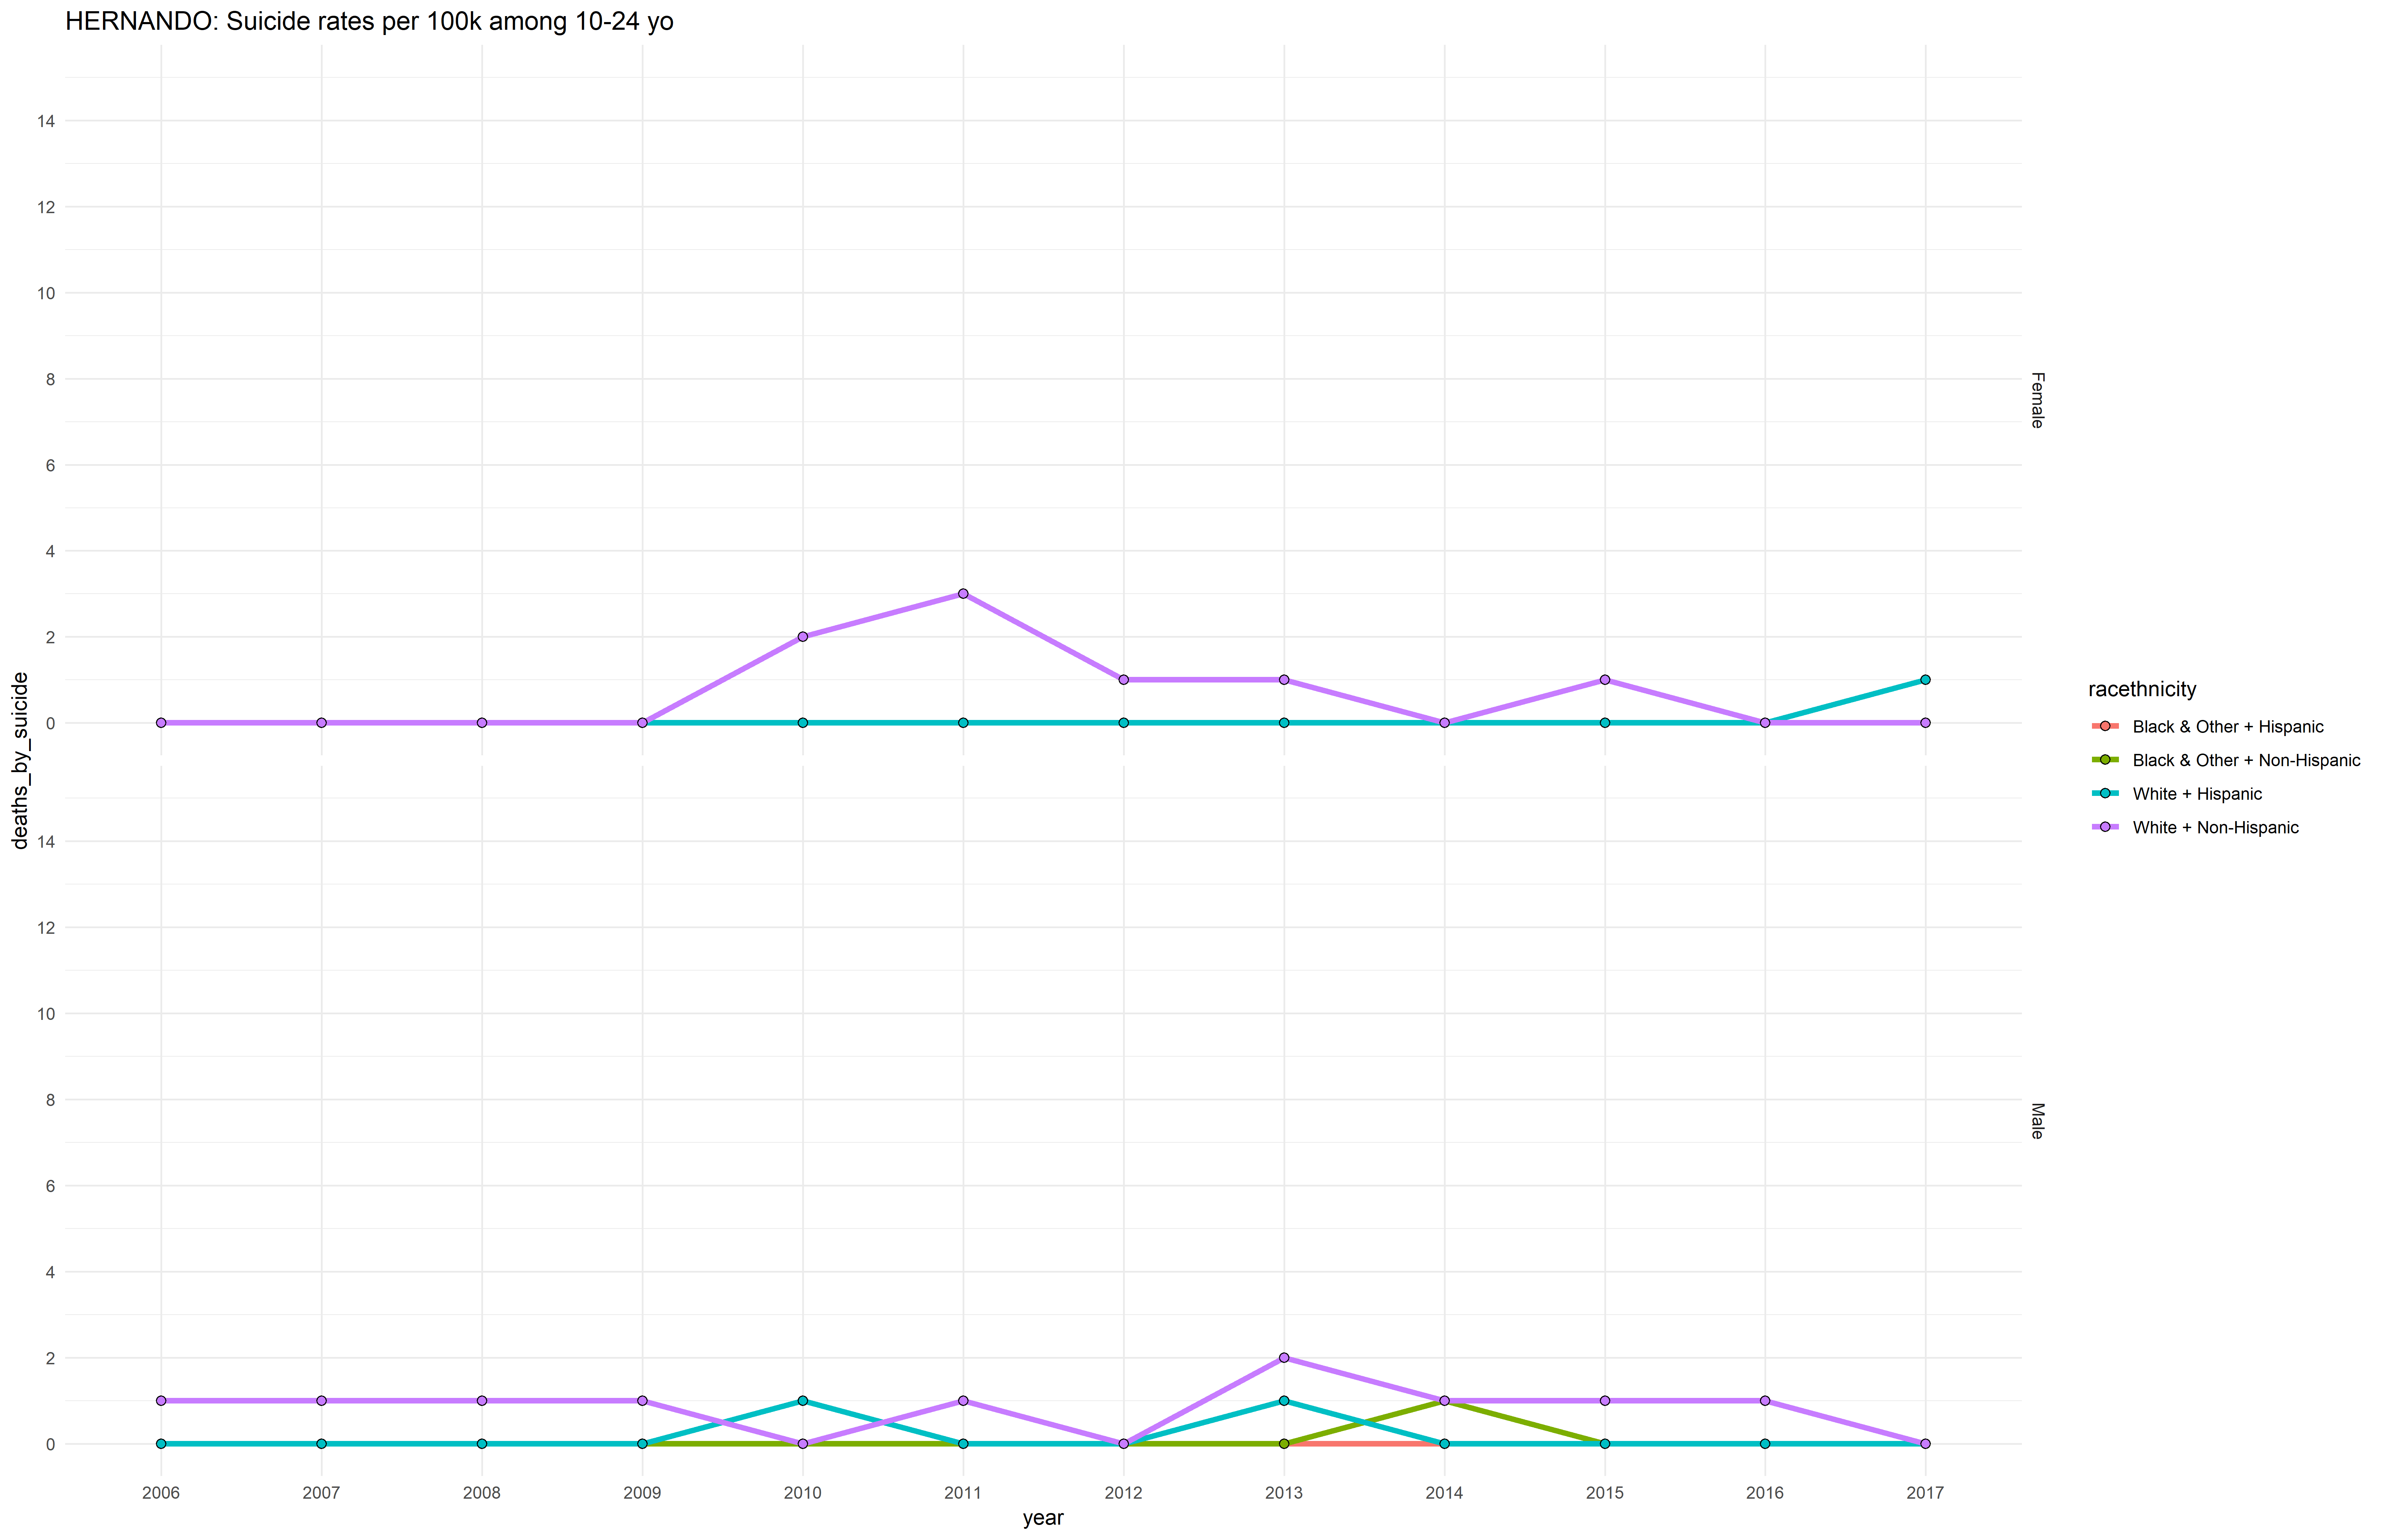

## Lake

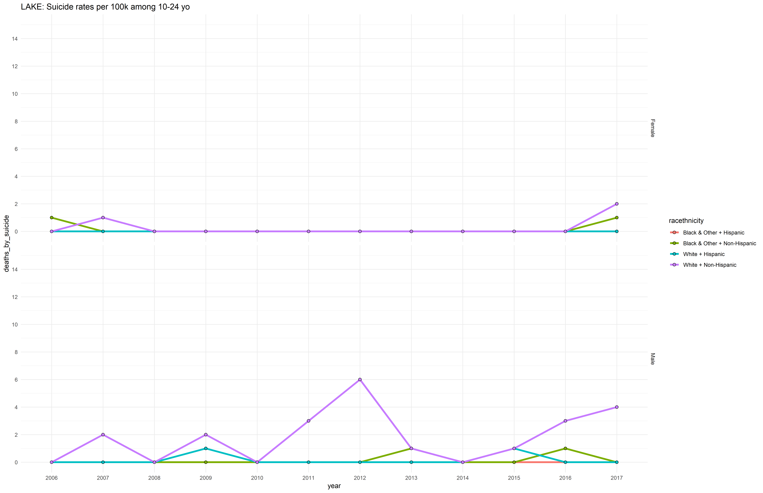

## Marion

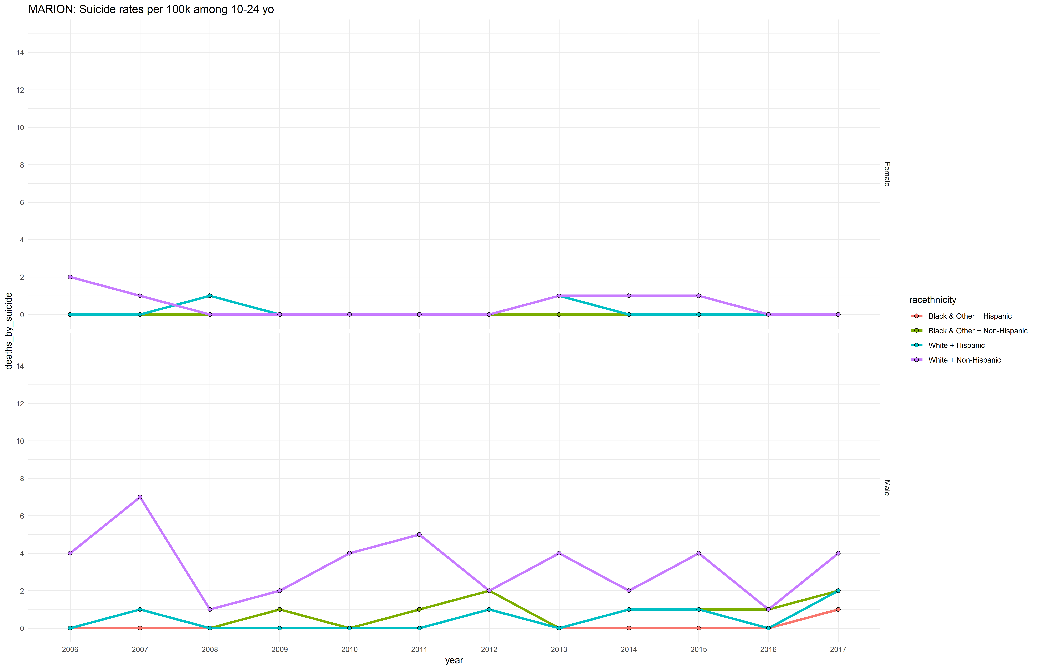

## Saint Johns

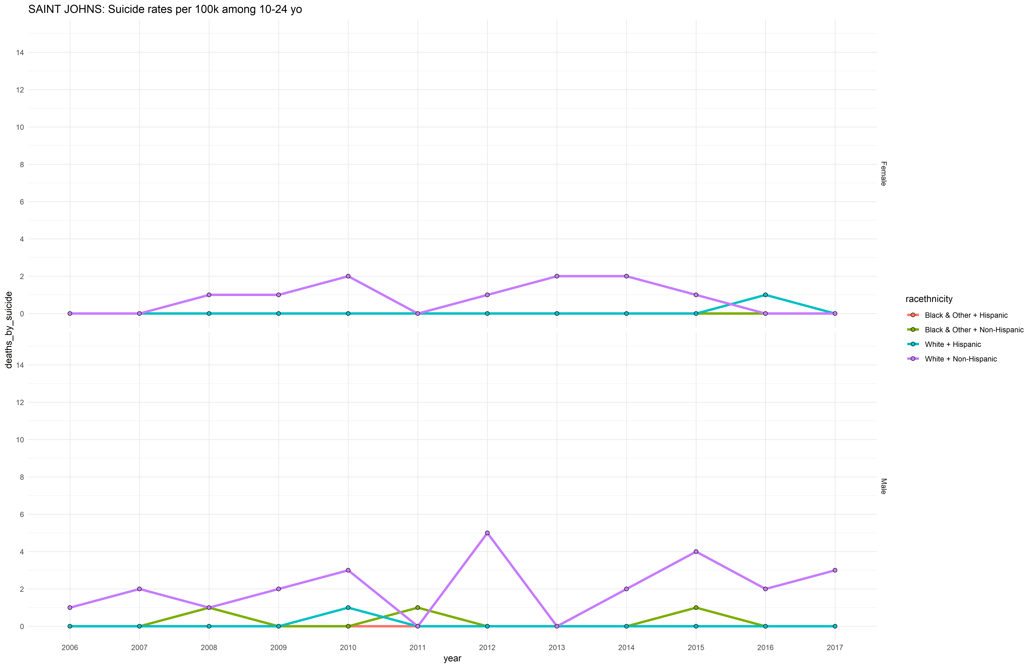

## Sumter

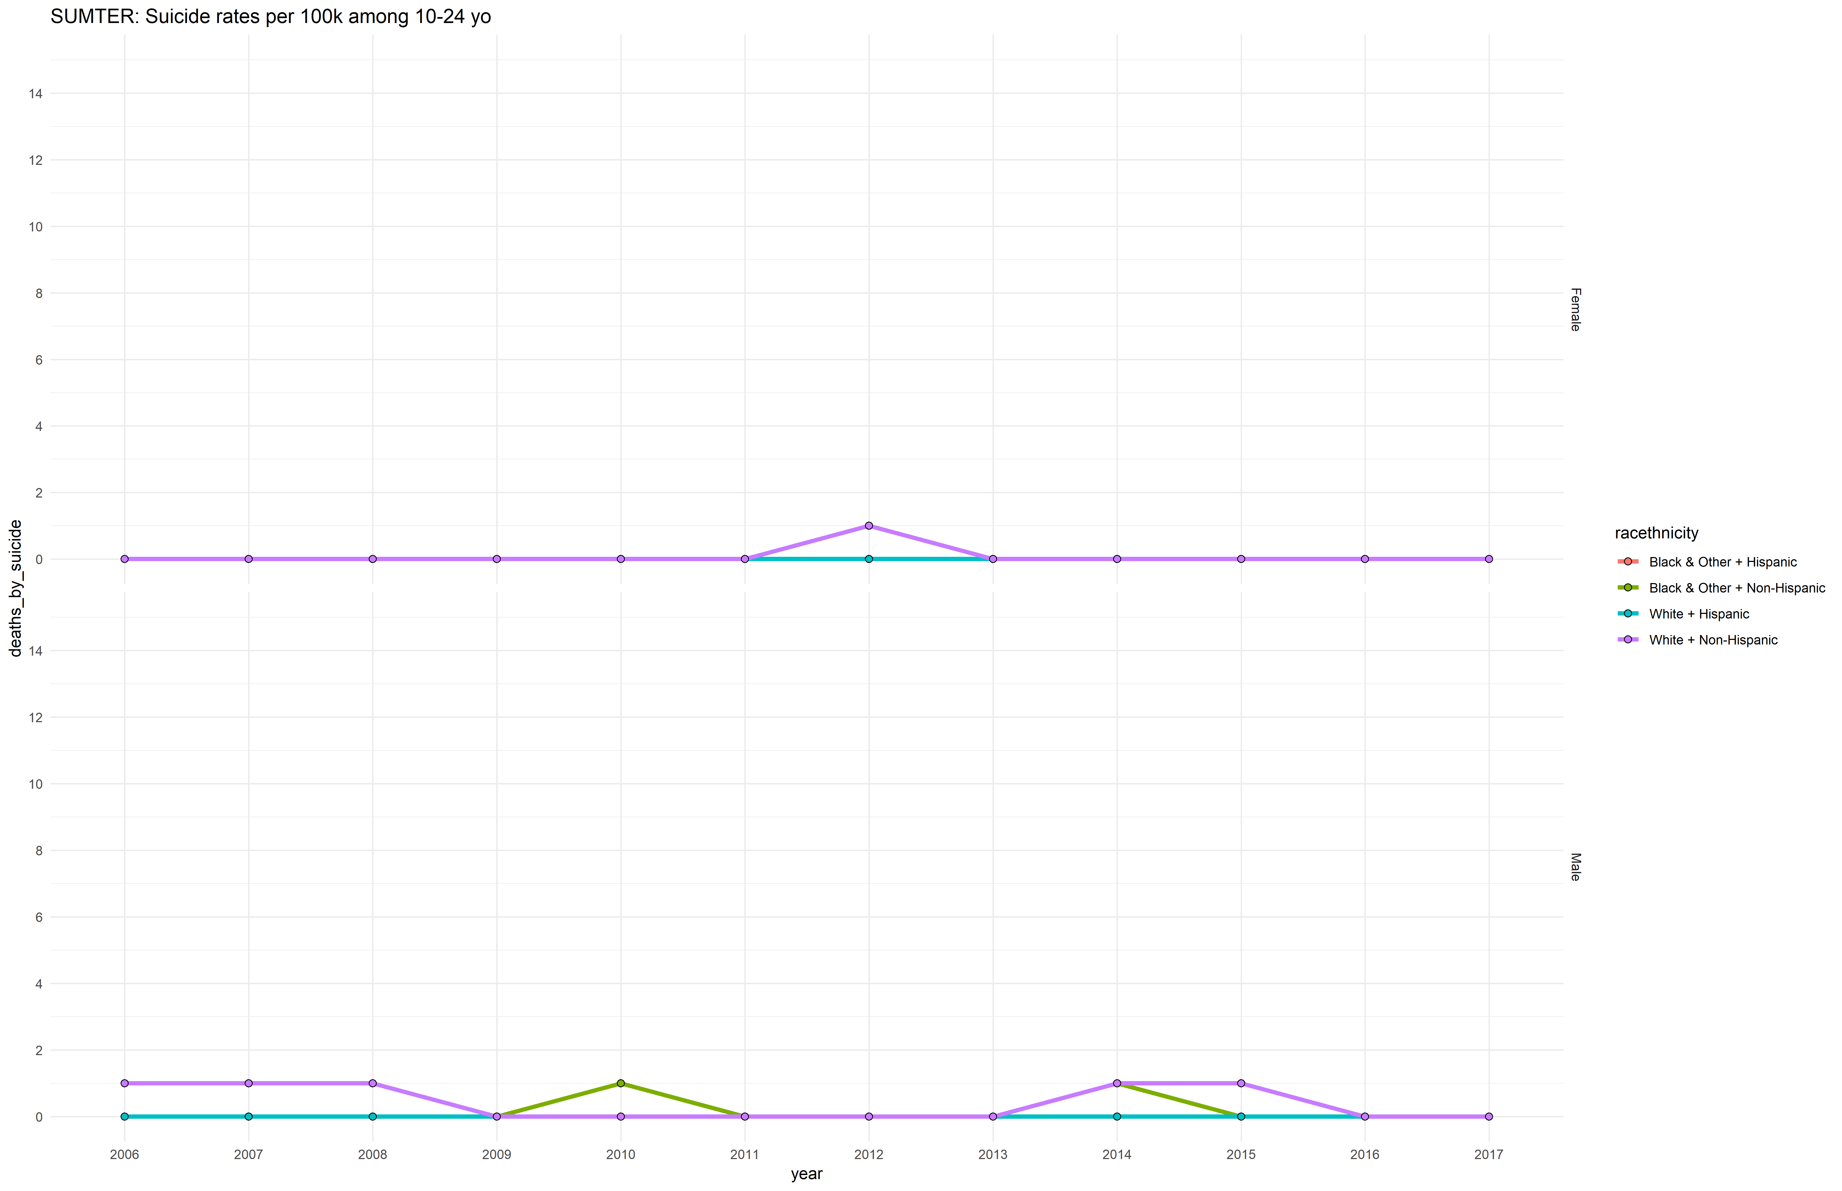

## Volusia

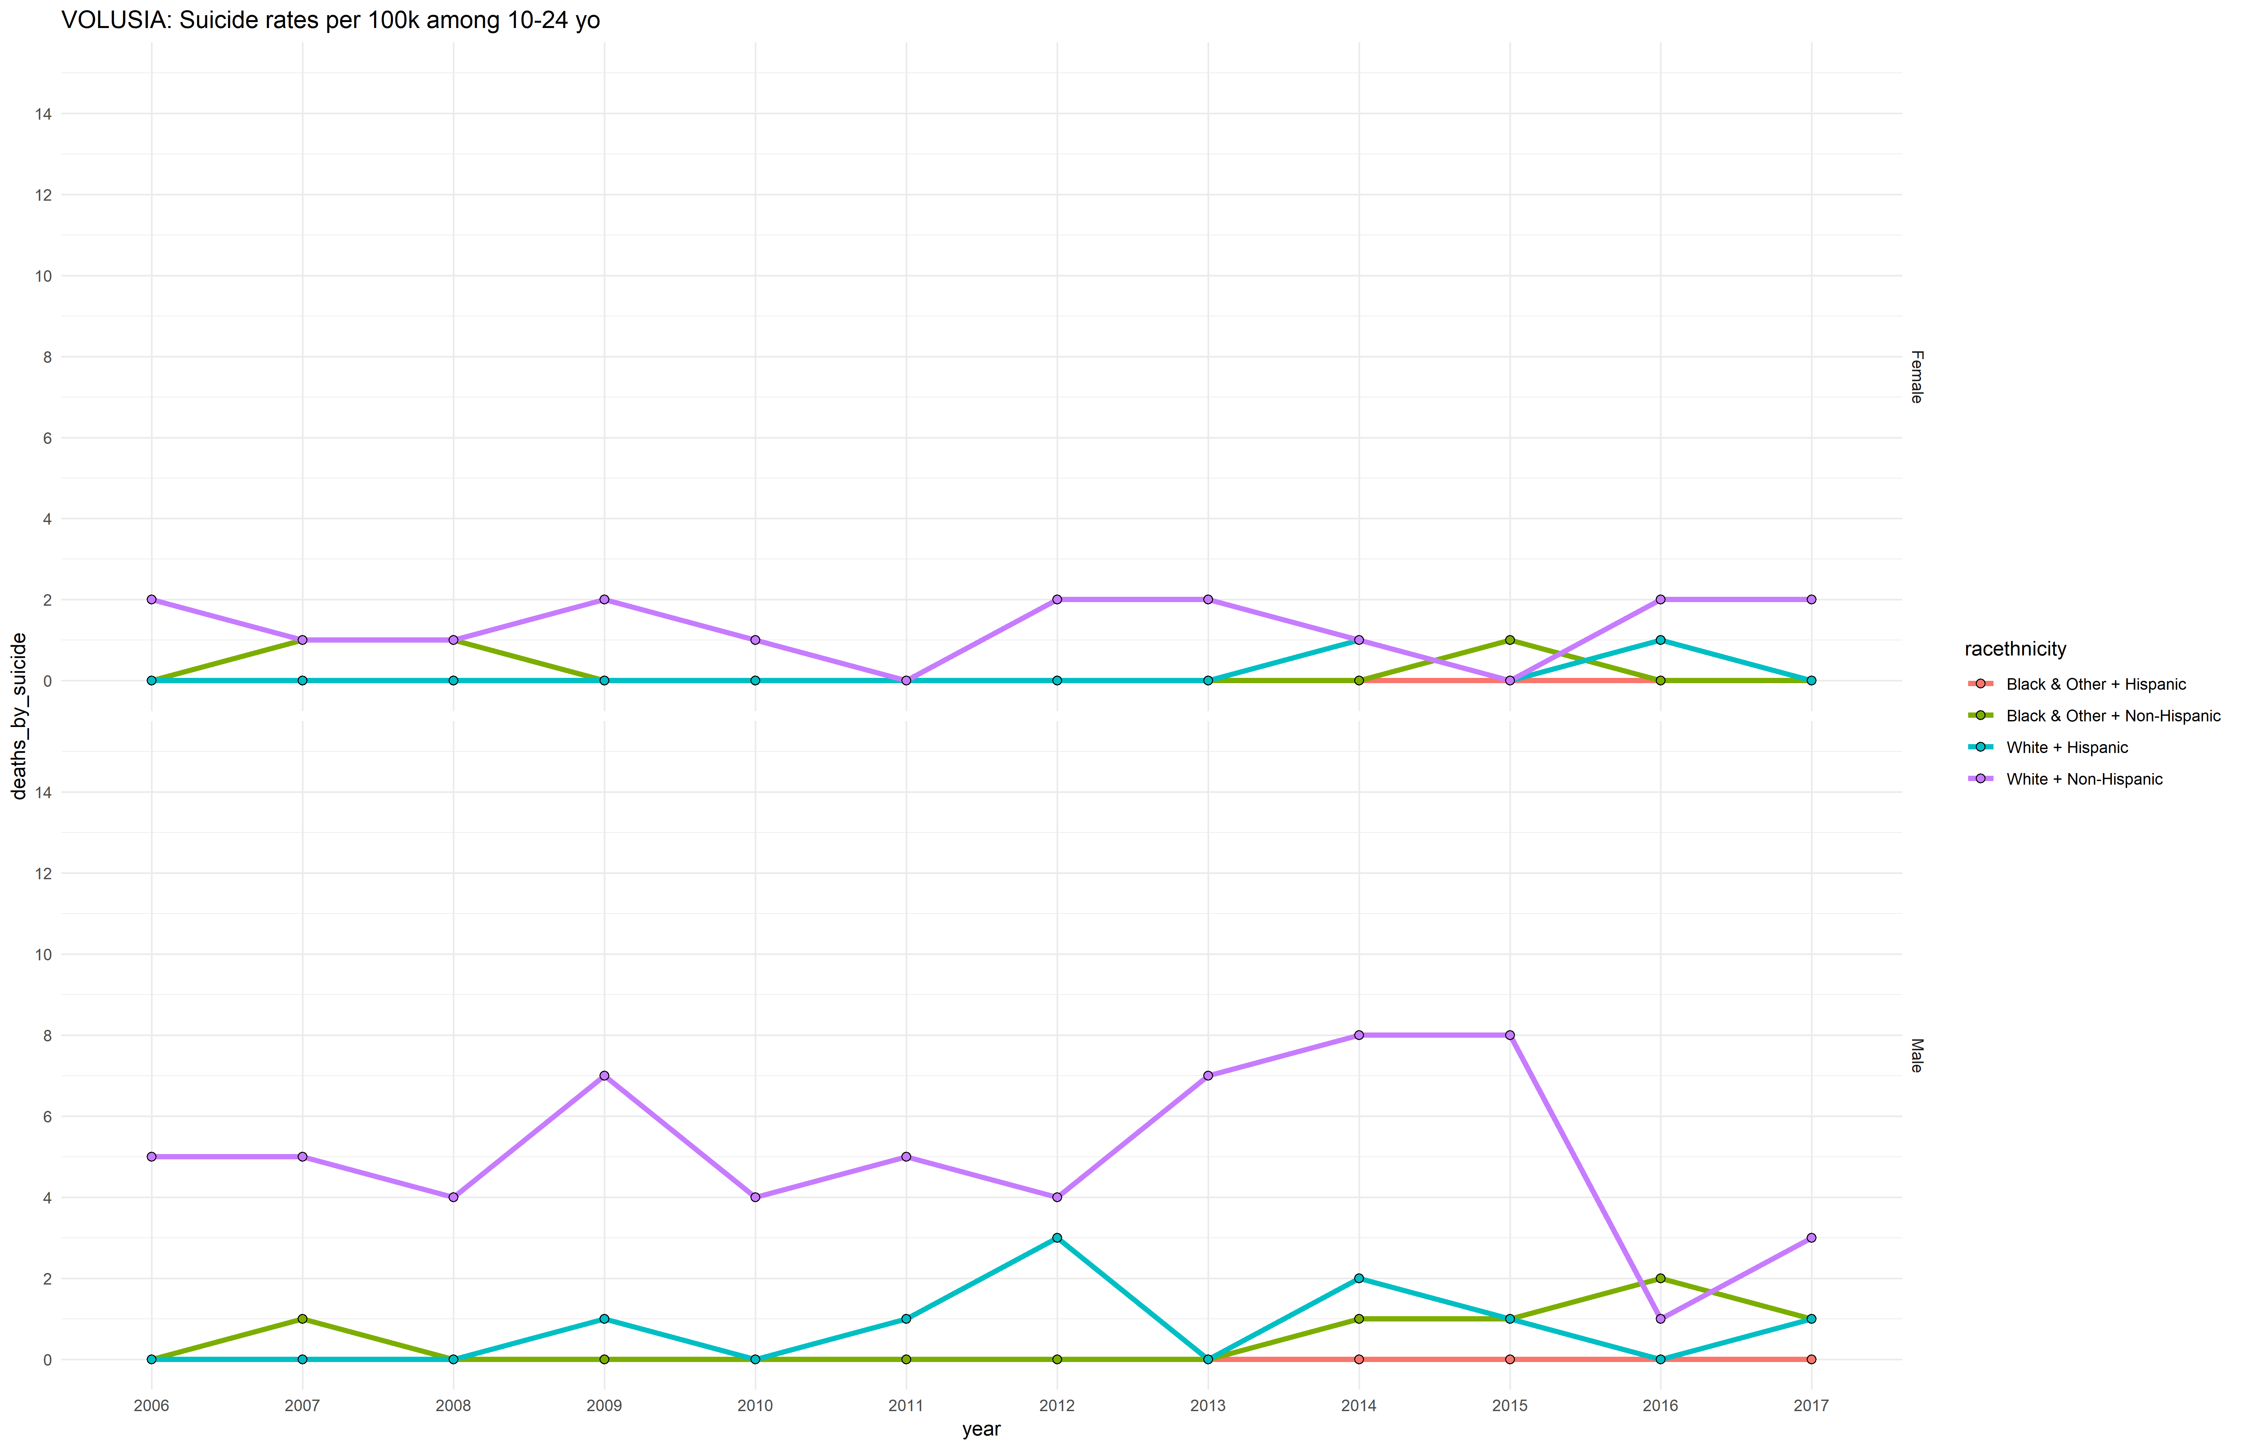

## Indian River

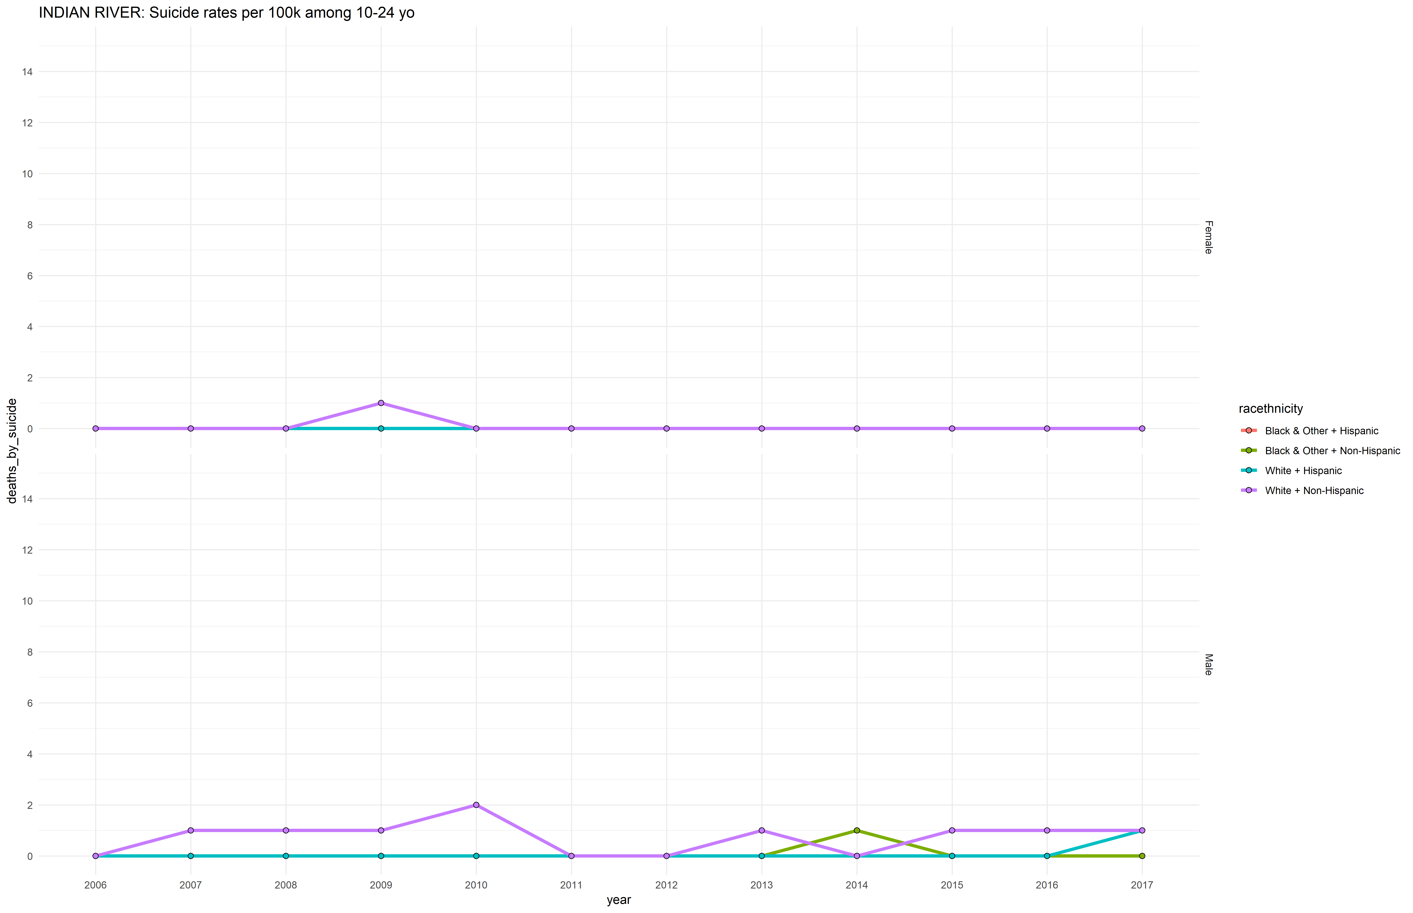

## Martin

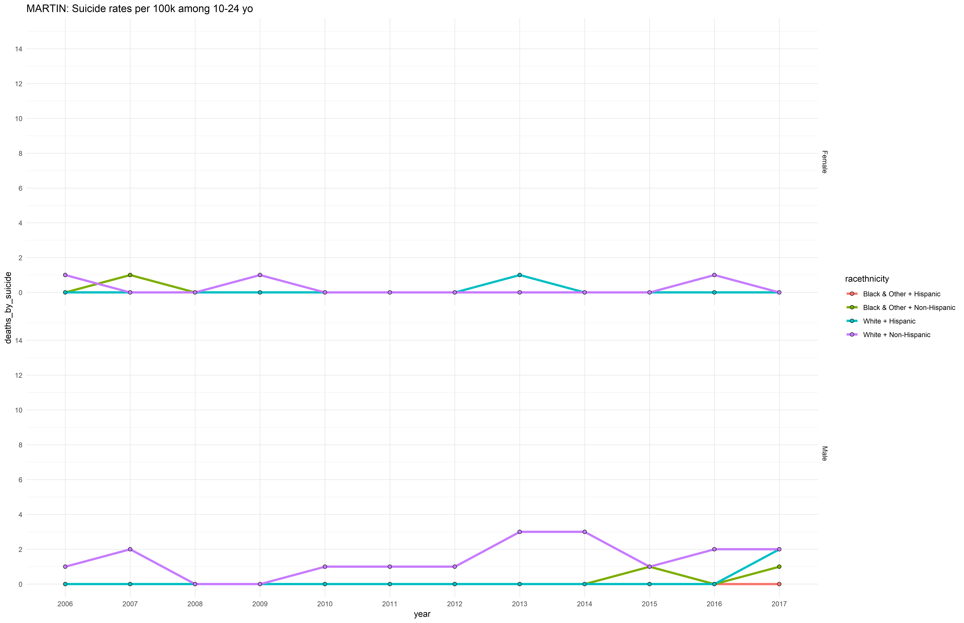

## Palm Beach

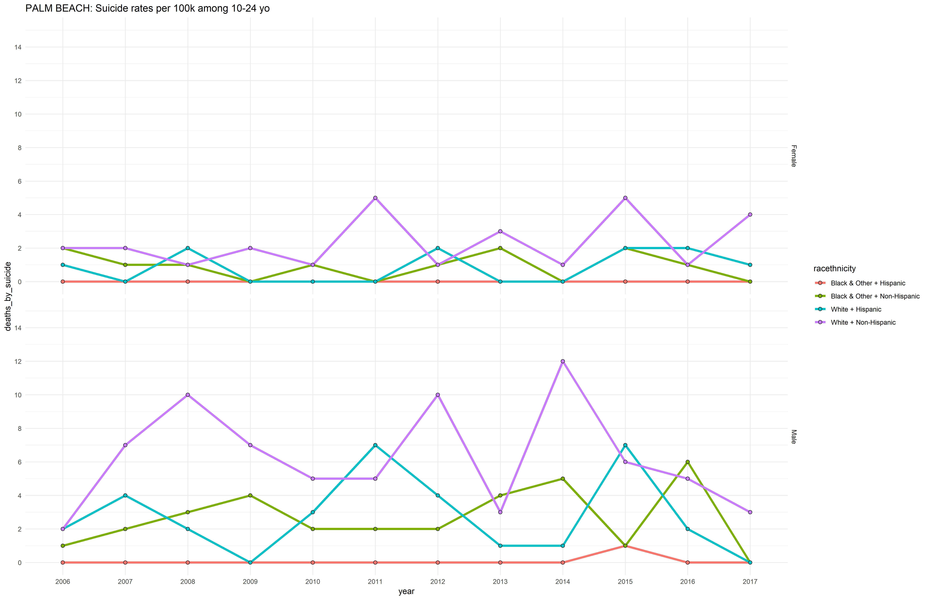

## Saint Lucie

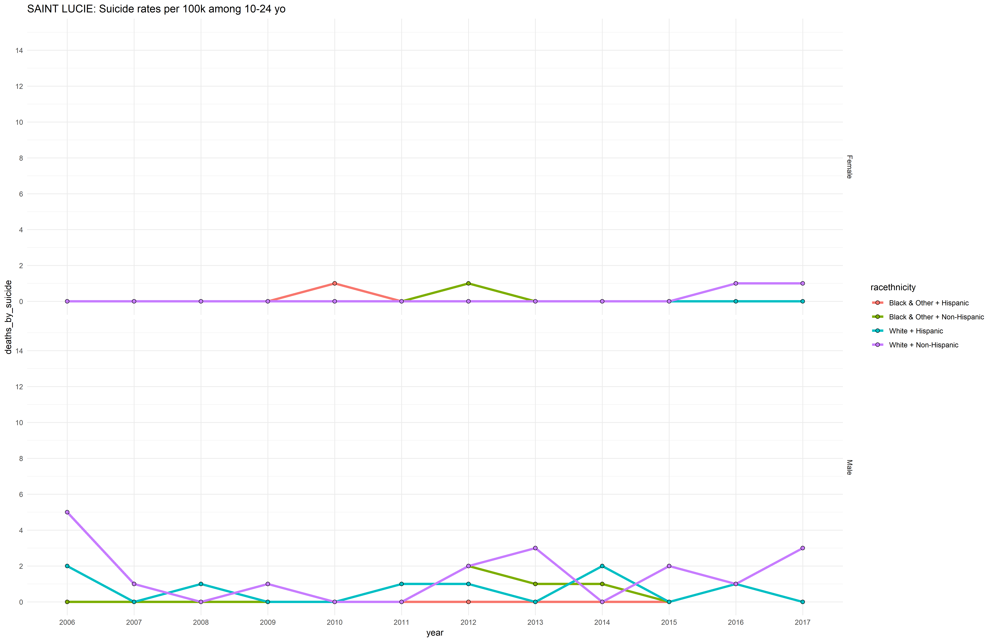

# Session Information

For the sake of documentation and reproducibility, the current report was rendered in the following environment. Click the line below to expand.

Environment

- Session info -------------------------------------------------------------------------------------------------------  
 setting value   
 version R version 3.5.2 (2018-12-20)  
 os Windows 10 x64   
 system x86_64, mingw32   
 ui RTerm   
 language (EN)   
 collate English_United States.1252   
 ctype English_United States.1252   
 tz America/Los_Angeles   
 date 2019-07-05   
  
- Packages -----------------------------------------------------------------------------------------------------------  
 package * version date lib source   
 abind 1.4-5 2016-07-21 [1] CRAN (R 3.5.2)  
 assertthat 0.2.1 2019-03-21 [1] CRAN (R 3.5.3)  
 backports 1.1.4 2019-04-10 [1] CRAN (R 3.5.3)  
 callr 3.2.0 2019-03-15 [1] CRAN (R 3.5.3)  
 car 3.0-3 2019-05-27 [1] CRAN (R 3.5.3)  
 carData 3.0-2 2018-09-30 [1] CRAN (R 3.5.2)  
 cellranger 1.1.0 2016-07-27 [1] CRAN (R 3.5.3)  
 cli 1.1.0 2019-03-19 [1] CRAN (R 3.5.3)  
 codetools 0.2-16 2018-12-24 [1] CRAN (R 3.5.2)  
 colorspace 1.4-1 2019-03-18 [1] CRAN (R 3.5.3)  
 crayon 1.3.4 2017-09-16 [1] CRAN (R 3.5.3)  
 curl 3.3 2019-01-10 [1] CRAN (R 3.5.3)  
 data.table 1.12.2 2019-04-07 [1] CRAN (R 3.5.3)  
 desc 1.2.0 2018-05-01 [1] CRAN (R 3.5.3)  
 devtools 2.0.2 2019-04-08 [1] CRAN (R 3.5.3)  
 digest 0.6.19 2019-05-20 [1] CRAN (R 3.5.3)  
 dplyr * 0.8.1 2019-05-14 [1] CRAN (R 3.5.3)  
 DT 0.6 2019-05-09 [1] CRAN (R 3.5.3)  
 evaluate 0.14 2019-05-28 [1] CRAN (R 3.5.2)  
 explore 0.4.2 2019-05-22 [1] CRAN (R 3.5.3)  
 fansi 0.4.0 2018-10-05 [1] CRAN (R 3.5.3)  
 forcats 0.4.0 2019-02-17 [1] CRAN (R 3.5.3)  
 foreign 0.8-71 2018-07-20 [2] CRAN (R 3.5.2)  
 fs 1.3.1 2019-05-06 [1] CRAN (R 3.5.3)  
 ggplot2 * 3.1.1 2019-04-07 [1] CRAN (R 3.5.3)  
 ggpubr * 0.2 2018-11-15 [1] CRAN (R 3.5.3)  
 glue 1.3.1 2019-03-12 [1] CRAN (R 3.5.3)  
 gridExtra 2.3 2017-09-09 [1] CRAN (R 3.5.3)  
 gtable 0.3.0 2019-03-25 [1] CRAN (R 3.5.3)  
 haven 2.1.0 2019-02-19 [1] CRAN (R 3.5.3)  
 highr 0.8 2019-03-20 [1] CRAN (R 3.5.3)  
 hms 0.4.2 2018-03-10 [1] CRAN (R 3.5.3)  
 htmltools 0.3.6 2017-04-28 [1] CRAN (R 3.5.3)  
 htmlwidgets 1.3 2018-09-30 [1] CRAN (R 3.5.3)  
 httpuv 1.5.1 2019-04-05 [1] CRAN (R 3.5.3)  
 httr 1.4.0 2018-12-11 [1] CRAN (R 3.5.3)  
 kableExtra 1.1.0 2019-03-16 [1] CRAN (R 3.5.3)  
 knitr * 1.23 2019-05-18 [1] CRAN (R 3.5.2)  
 labeling 0.3 2014-08-23 [1] CRAN (R 3.5.2)  
 later 0.8.0 2019-02-11 [1] CRAN (R 3.5.3)  
 lazyeval 0.2.2 2019-03-15 [1] CRAN (R 3.5.3)  
 magrittr * 1.5 2014-11-22 [1] CRAN (R 3.5.3)  
 memoise 1.1.0 2017-04-21 [1] CRAN (R 3.5.3)  
 mime 0.6 2018-10-05 [1] CRAN (R 3.5.2)  
 munsell 0.5.0 2018-06-12 [1] CRAN (R 3.5.3)  
 openxlsx 4.1.0.1 2019-05-28 [1] CRAN (R 3.5.3)  
 pillar 1.4.1 2019-05-28 [1] CRAN (R 3.5.2)  
 pkgbuild 1.0.3 2019-03-20 [1] CRAN (R 3.5.3)  
 pkgconfig 2.0.2 2018-08-16 [1] CRAN (R 3.5.3)  
 pkgload 1.0.2 2018-10-29 [1] CRAN (R 3.5.3)  
 plyr 1.8.4 2016-06-08 [1] CRAN (R 3.5.3)  
 prettyunits 1.0.2 2015-07-13 [1] CRAN (R 3.5.3)  
 processx 3.3.1 2019-05-08 [1] CRAN (R 3.5.2)  
 promises 1.0.1 2018-04-13 [1] CRAN (R 3.5.3)  
 pryr 0.1.4 2018-02-18 [1] CRAN (R 3.5.3)  
 ps 1.3.0 2018-12-21 [1] CRAN (R 3.5.3)  
 purrr 0.3.2 2019-03-15 [1] CRAN (R 3.5.3)  
 R6 2.4.0 2019-02-14 [1] CRAN (R 3.5.3)  
 Rcpp 1.0.1 2019-03-17 [1] CRAN (R 3.5.3)  
 readr 1.3.1 2018-12-21 [1] CRAN (R 3.5.3)  
 readxl 1.3.1 2019-03-13 [1] CRAN (R 3.5.3)  
 remotes 2.0.4 2019-04-10 [1] CRAN (R 3.5.3)  
 reshape2 1.4.3 2017-12-11 [1] CRAN (R 3.5.3)  
 rio 0.5.16 2018-11-26 [1] CRAN (R 3.5.3)  
 rlang 0.3.4 2019-04-07 [1] CRAN (R 3.5.3)  
 rmarkdown 1.13 2019-05-22 [1] CRAN (R 3.5.3)  
 rprojroot 1.3-2 2018-01-03 [1] CRAN (R 3.5.3)  
 rstudioapi 0.10 2019-03-19 [1] CRAN (R 3.5.3)  
 rvest 0.3.4 2019-05-15 [1] CRAN (R 3.5.3)  
 scales 1.0.0 2018-08-09 [1] CRAN (R 3.5.3)  
 sessioninfo 1.1.1 2018-11-05 [1] CRAN (R 3.5.3)  
 shiny 1.3.2 2019-04-22 [1] CRAN (R 3.5.2)  
 stringi 1.4.3 2019-03-12 [1] CRAN (R 3.5.3)  
 stringr 1.4.0 2019-02-10 [1] CRAN (R 3.5.3)  
 tibble 2.1.3 2019-06-06 [1] CRAN (R 3.5.3)  
 tidyr 0.8.3 2019-03-01 [1] CRAN (R 3.5.3)  
 tidyselect 0.2.5 2018-10-11 [1] CRAN (R 3.5.3)  
 usethis 1.5.0 2019-04-07 [1] CRAN (R 3.5.3)  
 utf8 1.1.4 2018-05-24 [1] CRAN (R 3.5.3)  
 vctrs 0.1.0 2018-11-29 [1] CRAN (R 3.5.3)  
 viridisLite 0.3.0 2018-02-01 [1] CRAN (R 3.5.3)  
 webshot 0.5.1 2018-09-28 [1] CRAN (R 3.5.3)  
 withr 2.1.2 2018-03-15 [1] CRAN (R 3.5.3)  
 xfun 0.7 2019-05-14 [1] CRAN (R 3.5.3)  
 xml2 1.2.0 2018-01-24 [1] CRAN (R 3.5.3)  
 xtable 1.8-4 2019-04-21 [1] CRAN (R 3.5.3)  
 yaml 2.2.0 2018-07-25 [1] CRAN (R 3.5.2)  
 zeallot 0.1.0 2018-01-28 [1] CRAN (R 3.5.3)  
 zip 2.0.2 2019-05-13 [1] CRAN (R 3.5.3)  
  
[1] C:/Users/an499583/Documents/R/win-library/3.5  
[2] C:/Program Files/R/R-3.5.2/library

Report rendered by an499583 at 2019-07-05, 11:22 -0700 in 48 seconds.