HBSA-DSSB SQL Workshop Computer Setup Instructions

For Windows:

1. Navigate to this site to download SQLite Studio: <http://sqlitestudio.pl/?act=download>
   1. Click “Download Windows binary (ix86_64) Version 3.1.1” at the very top of the screen.

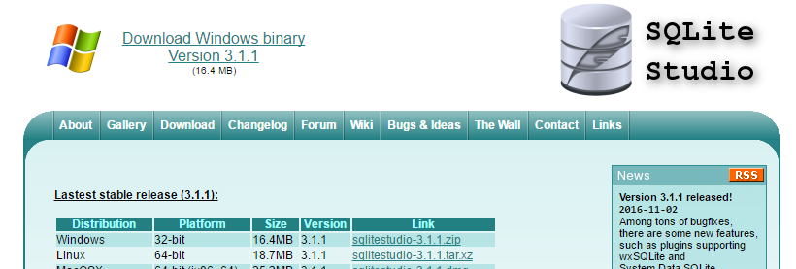

1. Choose a convenient folder to download into. Navigate to where “sqlitestudio-3.1.1.zip” and unzip it into its own folder names “sqlitestudio-3.1.1”.
   1. I use 7zip to unzip my zip files. Go ahead and use whatever method you normally do to unzip files, but if you have never done this before you may want to install 7zip here: http://www.7-zip.org/download.html (64 bit), then double click on your .zip file and you should see the 7zip option to “Extract to sqlitestudio-3.1.1/”.
2. Double click into your “sqlitestudio-3.1.1” folder, then double click again into the “SQLiteStudio” folder, and then double click on the SQLiteStudio application to launch the program.
   1. The path on my machine is: C:\Users\Jerry\Downloads\sqlitestudio-3.1.1\SQLiteStudio
   2. SQLite Studio should now open and look similar to this:

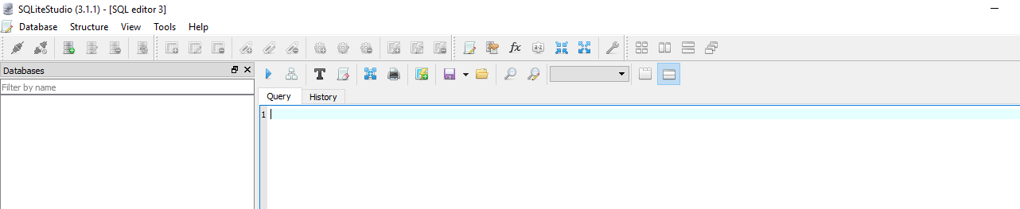

1. Now, navigate to this url to get the sqlite database we’ll be working with today: <https://chinookdatabase.codeplex.com>

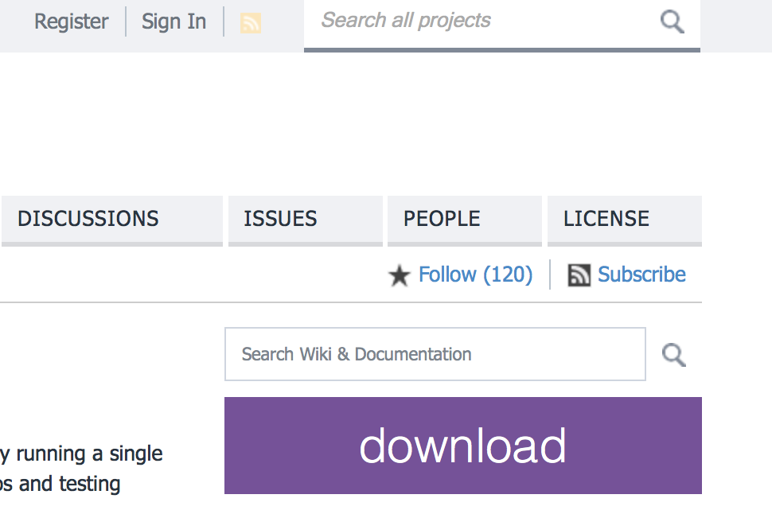

* 1. The Chinook database represents a digital media store that contains information such as Albums, Artists, Customers, and Employees. It is a simplified format of what you will likely see in industry, but we will talk more about formats later in the workshop.

1. Like before, download into a convenient location and unzip the “ChinookDatabase1.4_CompleteVersion.zip” file into a new folder called “ChinookDatabase1.4_CompleteVersion”.
2. Double click into the “ChinookDatabase1.4_CompleteVersion” folder. Find “Chinook_Sqlite.sqlite”, click and drag the file into your SQLiteStudio application. Drop it in the left hand panel called “Databases”.

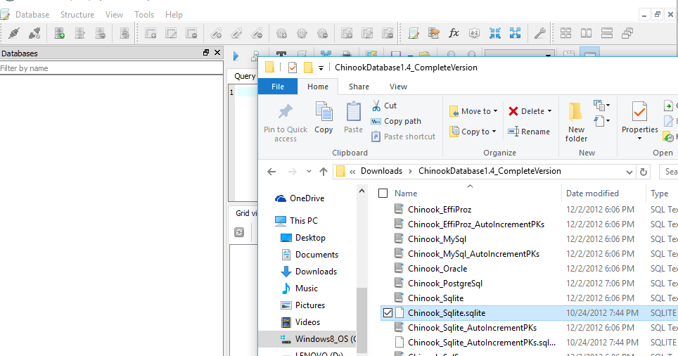

1. Uncheck “Permanent (keep it in configuration)” in the Optional panel at the very bottom of the Database popup. Then click Ok.

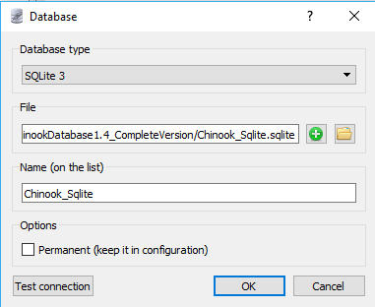

1. Done! The left hand Databases panel should now have “Chinook_Sqlite (SQLite 3)” in there. Double click on that to see the list of Tables. We’ll cover more about these in the workshop but you can always look around in the meantime. Double click on “Album” for example and then click on the “Data” tab to view its contents.

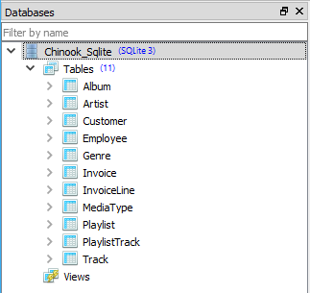

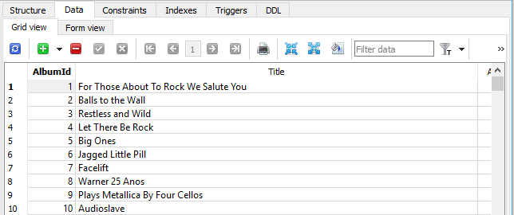

For Mac:

1. Navigate to this site to download SQLite Studio: <http://sqlitestudio.pl/?act=download>
   1. 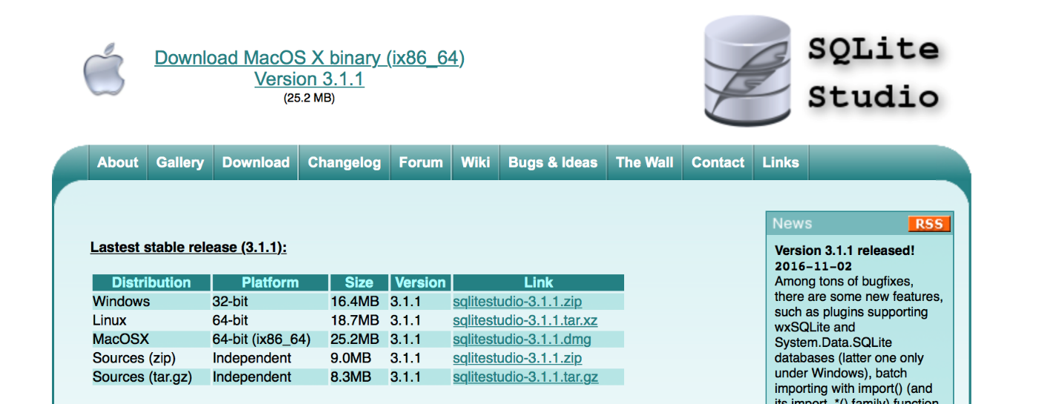Click “Download MacOS X binary (ix86_64) Version 3.1.1” at the very top of the screen.
2. Go to your Downloads folder in your Finder, locate the “sqlitestudio-3.1.1.dmg” file you downloaded from before and double click to install. Your screen should look something like this when done:

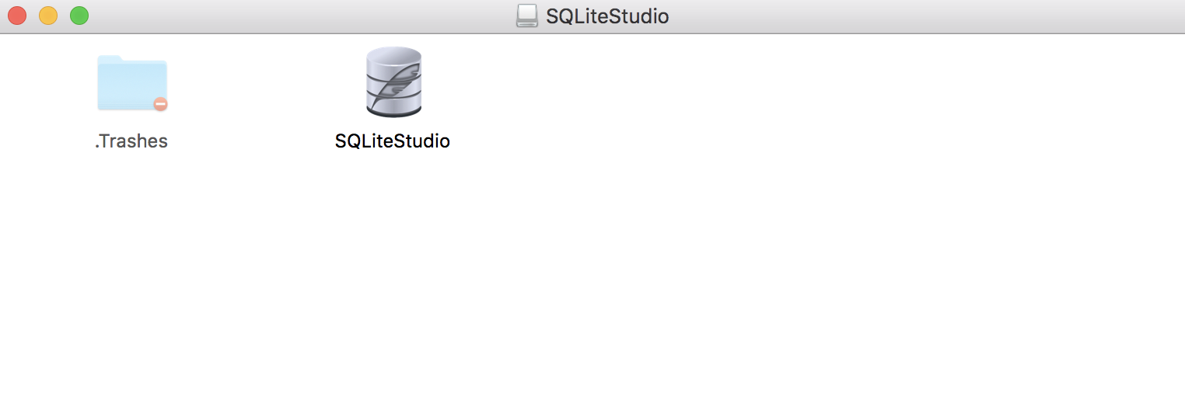

1. **While holding the Ctrl key (not the Command key!), double click on SQLiteStudio.**
2. Click open. Then choose Ok at the language popup.

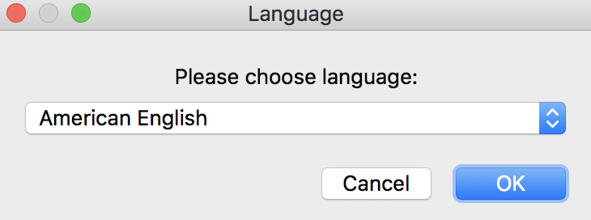

1. And SQLiteStudio is now running! You should see the following:

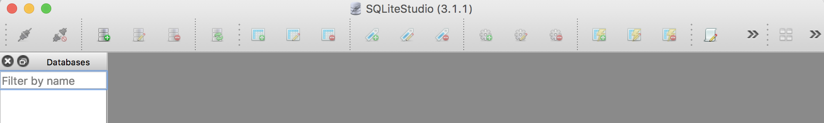

1. Now, navigate to this url to get the sqlite database we’ll be working with today: <https://chinookdatabase.codeplex.com>



* 1. The Chinook database represents a digital media store that contains information such as Albums, Artists, Customers, and Employees. It is a simplified format of what you will likely see in industry, but we will talk more about formats later in the workshop.

1. Open up the “ChinookDatabase1” folder. Find “Chinook_Sqlite.sqlite”, click and drag the file into your SQLiteStudio application. Drop it in the left hand panel called “Databases”.

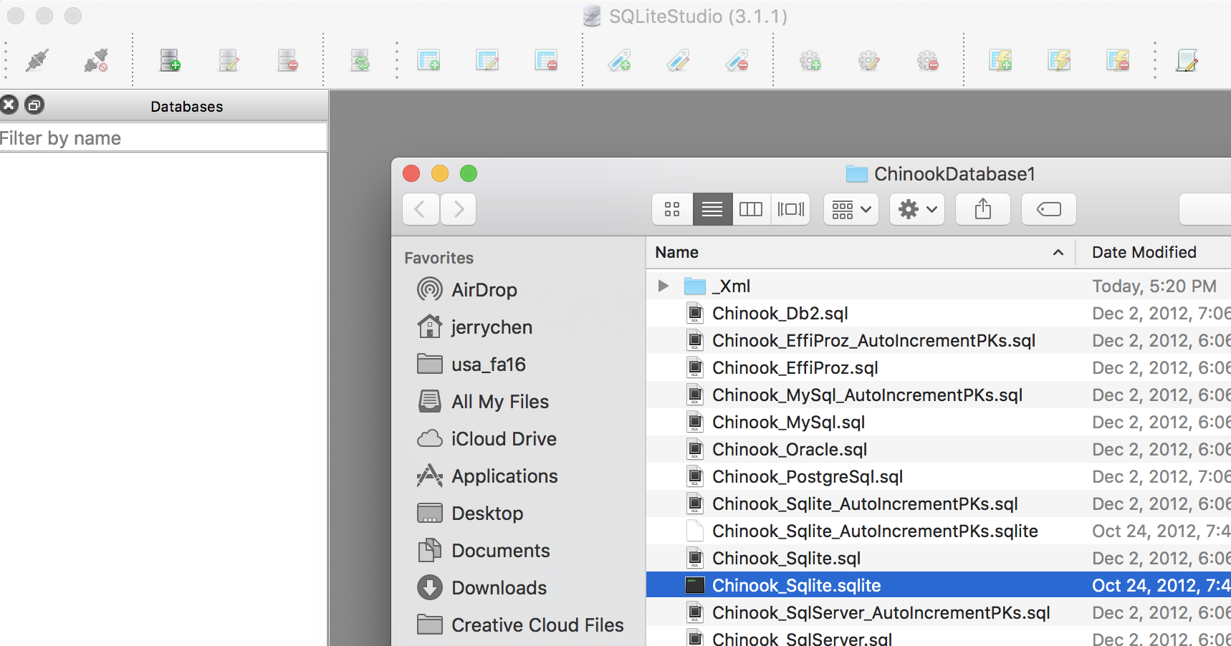

1. **Uncheck** “Permanent (keep it in configuration)” in the Optional panel at the very bottom of the Database popup. Then click Ok.

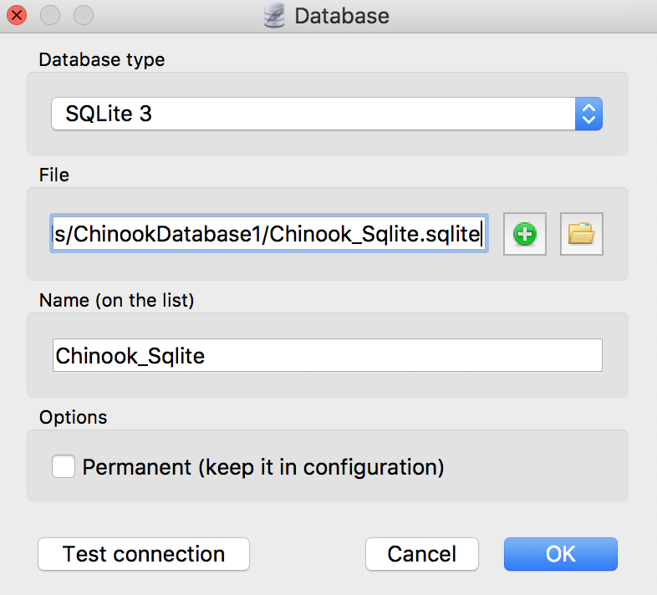

1. Done! The left hand Databases panel should now have “Chinook_Sqlite (SQLite 3)” in there. Double click on that to see the list of Tables. We’ll cover more about these in the workshop but you can always look around in the meantime. Double click on “Album” for example and then click on the “Data” tab to view its contents.

