What is Metadata?

Often defined as “data about data,” metadata is information about an electronic file that is not readily visible when looking at the file, such as the software used to create it, the date and time of its creation, or the author’s name. Metadata is often used for internal purposes, such as tracking changes during document collaboration.

The following paragraph represents text as it appears on screen or in print:

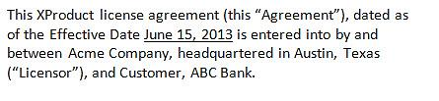

When exposing the metadata, the above paragraph displays as follows:

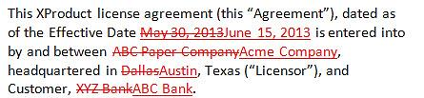

Metadata Concerns

While metadata is often harmless, if it includes sensitive, confidential, or protected information, it presents concerns about confidentiality, attorney/client privilege, liability, and possible regulatory breaches. The smallest of exposures can create confidentiality breaches or court protocol violations and illustrate the need to clean documents of metadata before transmitting to courts, clients, or opposing counsel.

The increased use of mobile devices for document collaboration has raised new challenges and concerns with regard to metadata. In addition, the devices’ built-in camera software controlling the photography/video function may embed geographical location metadata.

Metadata Best Practices

* Know firm policies on metadata removal and follow procedures. Learn the process for removing metadata from electronic files that are leaving the firm, including those on mobile devices.
* Become familiar with the laws in your region related to the ethical standards associated with metadata. Most refer to the duty of confidentiality and to act competently to avoid inadvertent or unauthorized disclosures.
* Since the use of certain word processing features, such as comparing documents or tracking changes, can create highly sensitive metadata, follow firm policies on the use of these features.
* Follow firm procedures to reduce risk when transmitting documents using mobile devices. Knowing that certain device software can embed geographical location metadata, learn firm policy on the use of device cameras.