w:compatSetting

# 2010 adds:

**settings.xml**



ie <w:compatSetting w:name="compatibilityMode" w:uri="http://schemas.microsoft.com/office/word" w:val="12"/>

changed to val 14.

<w:savePreviewPicture/>

thumbnail.emf

styleWithEffects part: what effect on compat?

<AppVersion>

14.0000

# 2013

<AppVersion>

15.0000

doesn’t add thumbnail.emf

or styleWithEffects part

**settings.xml**

adds 



theme part: panose...



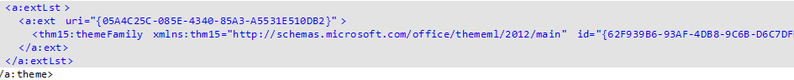

# 2016

<AppVersion>

16.0000

doesn’t add thumbnail.emf

or styleWithEffects part

**settings.xml**

<w:compatSetting w:name="compatibilityMode" w:uri="http://schemas.microsoft.com/office/word" w:val="12"/>

changed to val 15 (not 16!!)

theme is same as 2013, more or less