**Super Secret Awesome Project: Features, Draft Two**

**Login Feature**

Login is required for users to sign up for and participate in projects. Once the system recognizes person as a registered user, they will gain access to the site’s resources. Anyone coming to the site can choose to register, but the feature will be aimed toward users who want to sign up for and make projects. Users not logged in will be able to view projects that have been completed by others that are displayed on the site, as well as any information about the website and its purpose, as well as any information that would benefit from being public to all users.

The login is also required to manage user roles and give them authentication to their own projects, but restricting others from viewing their codes and projects; user roles will ensure that their project and all work is secure from people who are not part of the project development.

|  |  |
| --- | --- |
| userID | INT UNIQUE Primary Key AI |
| Username | VARCHAR(15) Unique |
| Password | VARCHAR(15) |
| Fname | VARCHAR(45) |
| Lname | Varchar(45) |
| Email | VARCHAR(45) |
| Role | INT |

* Added user role

**Dataflow**

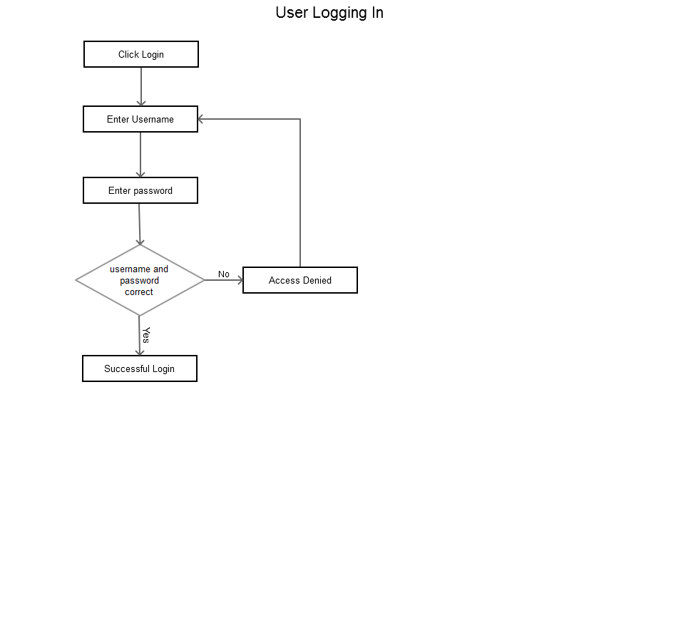

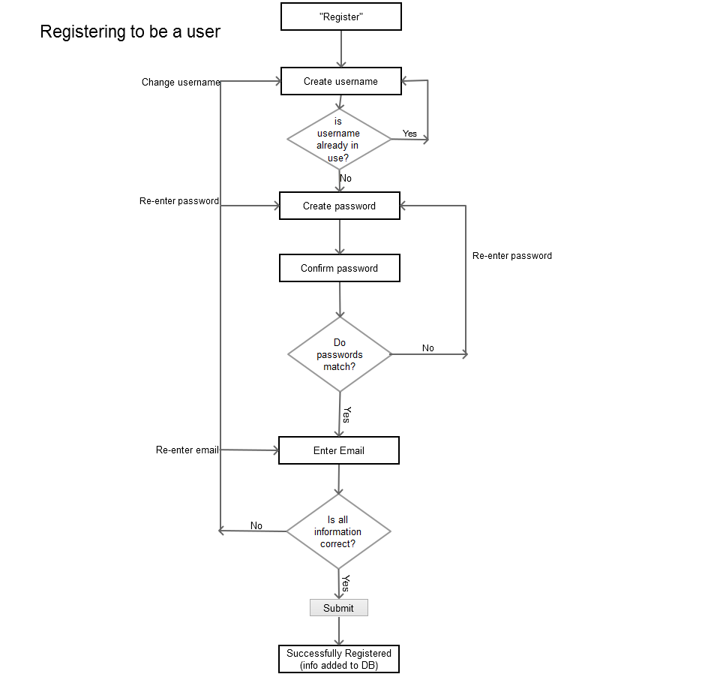

**2. Sorting Hat Feature**

This feature is responsible for sorting people into development groups. Registered users, who are logged in, can fill out as much information on the form that is applicable to them, in order to get sorted into a project group. It takes all filled out information and sorts it based on closest matches among submitted forms.

The form is detailed and will cover as many aspects pertaining to each individuals experience, interests, and skills. The user will fill out each language they know and the amount of time they have worked with each one. There will be a field to include languages that a user can specify languages they do not want to work in to avoid discrepancies between finalized group members over codes to use. The form will also cover areas that interest the user, such as something they may want to build, or something they want to further develop their skills in (ie. Want to develop in php for more experience).

A user may sign up for one project at a time, but once the project is completed a user can update and resubmit their form to become part a new project. A user may participate in as many projects (at different times) as they wish, there is no limit constraints so a user can participate in many different projects to develop different skills.

* Is adding set number of languages the best way to go about this
* Changed languages so user can enter up to 5 they want to work in, that they have experience in

**Database Table**

|  |  |
| --- | --- |
| profileID | INT unique PK AI |
| userID | INT FK |
| username | VARCHAR(15) Unique |
| email | VARCHAR(45) |
| lang1 | VARCHAR(15) |
| lang1Exp | NUMERIC |
| lang2 | VARCHAR(15) |
| lang2Exp | NUMERIC |
| lang3 | VARCHAR(15) |
| lang3Exp | NUMERIC |
| lang4 | VARCHAR(15) |
| lang4Exp | NUMERIC |
| lang5 | VARCHAR(15) |
| lang5Exp | NUMERIC |
| langDislike1 | VARCHAR(15) |
| langDislike2 | VARCHAR(15) |
| langDislike3 | VARCHAR(15) |
| Manage_Exp | VARCHAR(3) |
| Years for Man | VARCHAR(10) |
| Interests* | VARCHAR(30) |
| role Preference | VARCHAR(30) |
| roleExp | NUMERIC |
| noPeers | INT (1) |
| city | VARCHAR(45) |

**Dataflows**

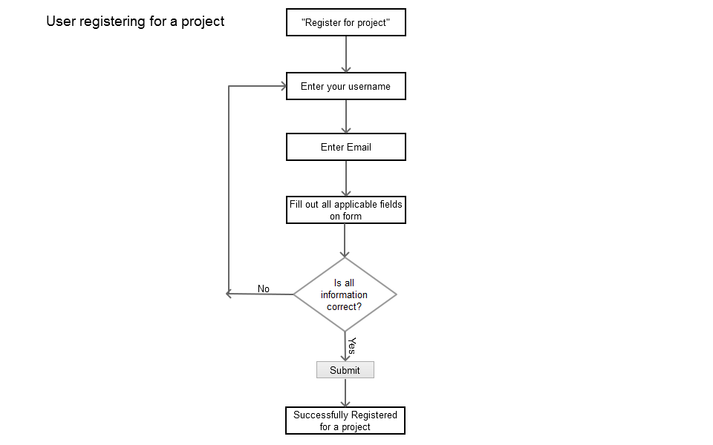

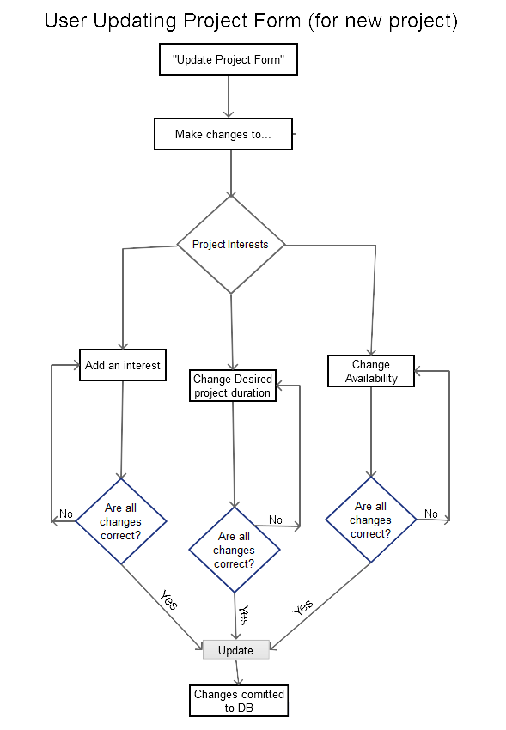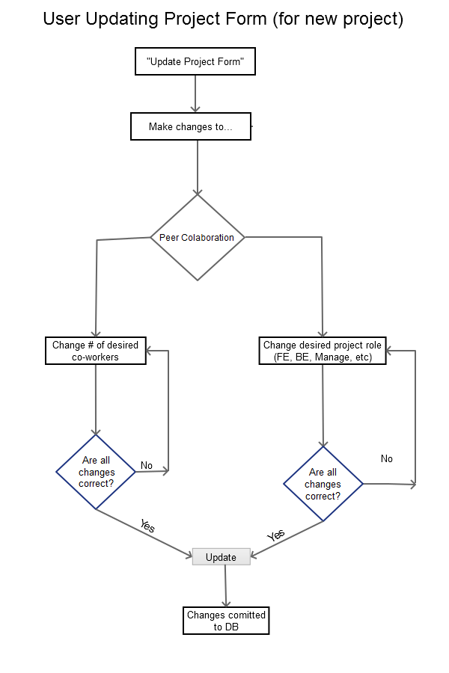

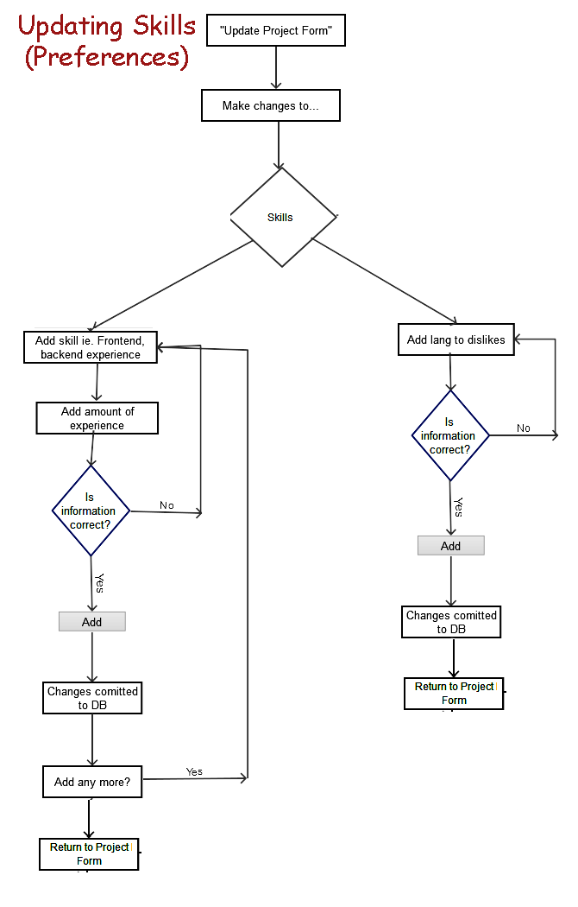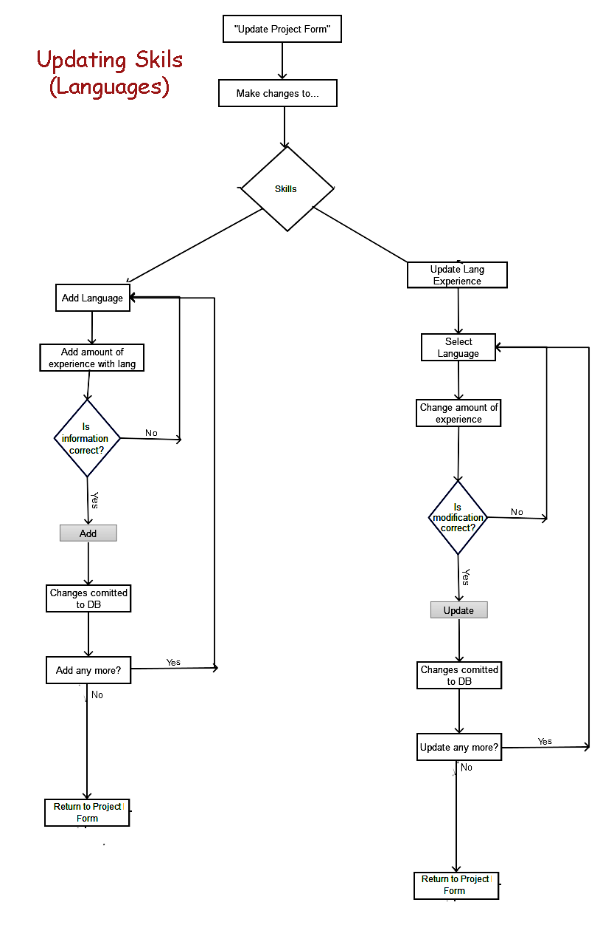

**3. File Sharing Feature**

An integral part to the site is a file uploading feature in order for members of projects to upload their files as they progress through their projects. The user will click the option to upload a file and then be prompted to search through their computer files and select a file. Once the user has selected the file they need to upload they will be able to upload it, or select more files to upload. After all files are selected they would click the upload button and their files will be added to the database and be available for viewing by user, and other members in their project team.

This feature will also provide an option for a user to decide who can view their file if they wanted to put a restriction on it of some sort, or, even make it public to other registered users on the site. This option includes an option for restricting access to the file to everyone (including team members) except the user who uploaded the file. Users will be able to view all of their files and manage them (update, modify, remove and change who can view).

* How to manage who can update files (if they are working on the same file)

**Database Tables: User Uploads**

|  |  |
| --- | --- |
| uploadID | INT PK AI |
| userID | INT FK |
| username | VARCHAR(30) |
| ProjectID | INT(15) FK |
| Title | VARCHAR(30) |
| Description | VARCHAR(255) |
| Created | Date |
| Modified | Date |
| FilePath | VARCHAR(60) |
| modifiedBy | VARCHAR(15) |

**Dataflow**

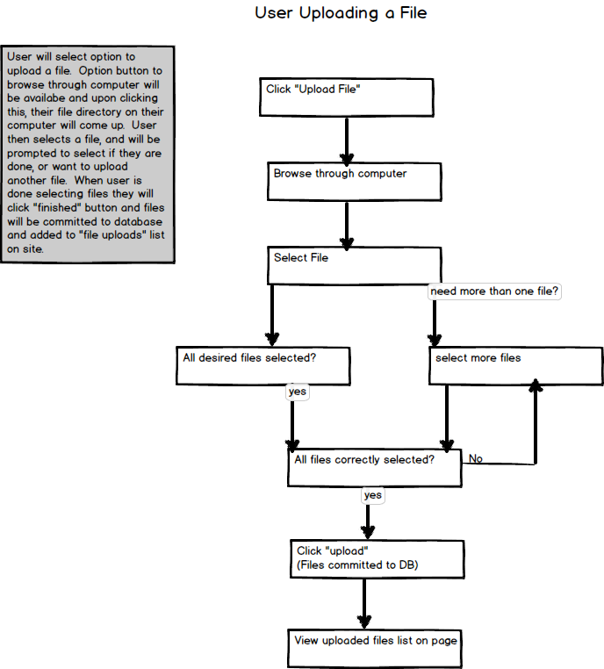

Users may choose to upload files to share on the site. The user will select “Upload File” and will be prompted to browse through their computer and select the file they wish to upload. The user can then decide if they want to add more files, and ensure all files they want have been selected. After all desired files have been selected the user will click “Upload” and the files will be added to the database and will be viewable on the View uploaded files page.

**User Deleting A File**

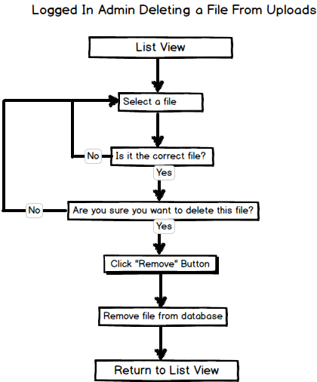

A logged in user can function as an admin within this feature, in order to maintain their file uploads. They have the option to remove files they have uploaded and would begin by reviewing the list view of uploaded files. The admin will select a file to delete, ensure it is the right file, and be promted to confirm whether they wish to delete the file or not. If the admin were to decide to cancel instead of delete a file they will return to list view to select a different file. When admins do confirm they want to delete a file they will hit the “Remove” button and upon confirmation the file will be removed from the database and the admin will return to list view.

**WireFrames:**

**These are from my other php project, but are a general idea of how this feature will be structured so I included them.**

File Upload

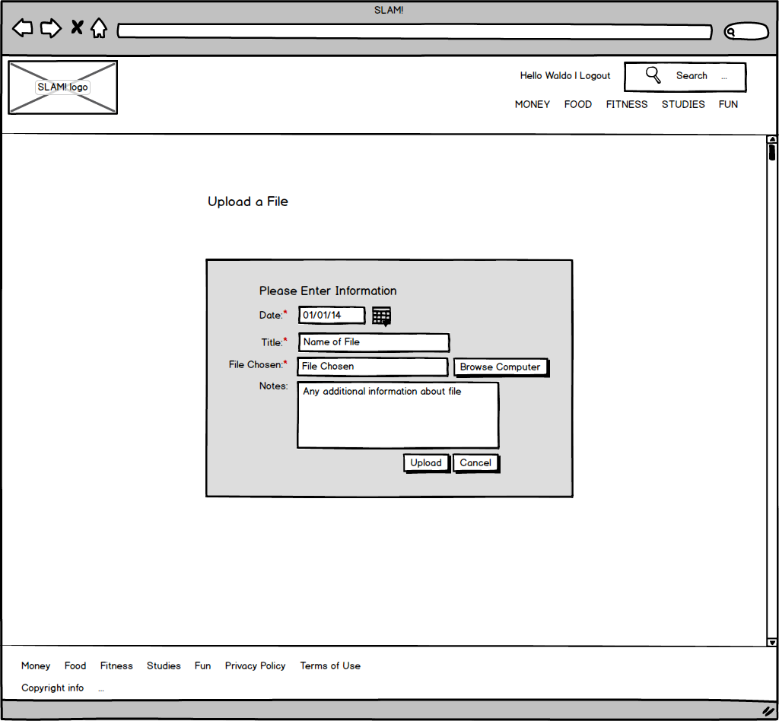

Logged In User View of File Uploads

This wireframe will have the addition of a “download” option.

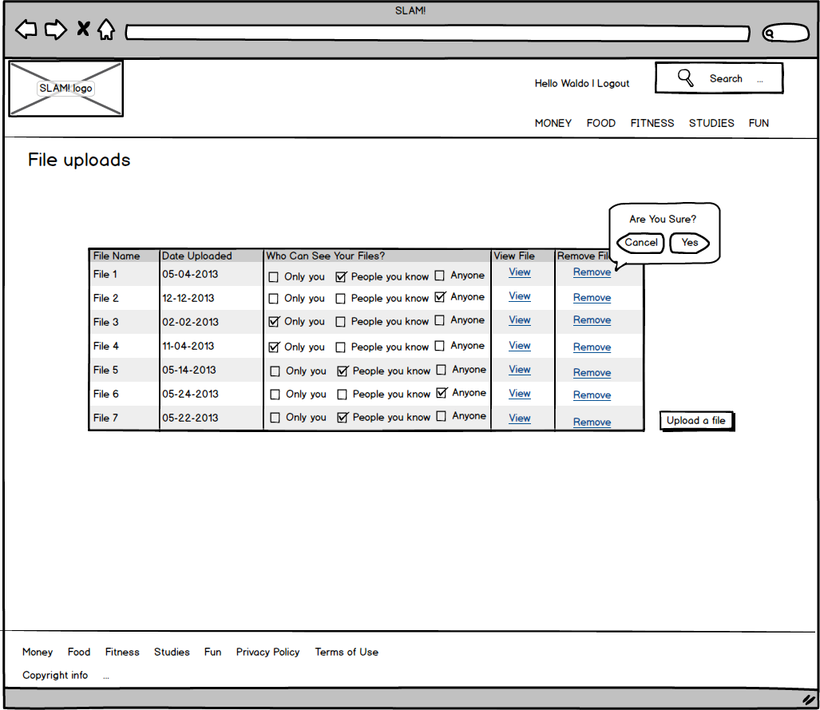

**4. Participants Feature**

After the completion of a project the final product will be uploaded / linked to the site and have information on who developed each aspect of the project, a peer review and a personal overview each individual had of the project. Each person working on the project will fill out a review of each one of their peers and each review for an individual will be compiled into a profile based on the project for all participants. Each member will also fill out the review section based upon themselves, as an added personal perspective on what they thought about the project, such as what they enjoyed, what they want to improve on, and things they may have become interested in from working on the project.

This will provide insight to viewers as to what each person did, what skills they have and how advanced they are in said skills, what their strengths are, what they need improvement on, future aspirations of each individual, and how they function within a team.

The project manager will be responsible for reviewing the submitted reviews to ensure they are professional, do not have errors, and contain all information requested. The project manager will also be able to remove inappropriate or unprofessional reviews and notify the person who submitted that they must change or re-do their review.

**Database Table**

|  |  |
| --- | --- |
| peerID | INT Unique Primary Key |
| projectID | INT(15) |
| username | VARCHAR(15) |
| peer | VARCHAR(15) |
| role | VARCHAR(15) |
| featureDev | VARCHAR(255) |
| strengths | VARCHAR(255) |
| improvements | VARCHAR(255) |
| review | TEXT |
| date | DATE |
| Future | TEXT, optional |

**Projects Table**

|  |  |
| --- | --- |
| projectID | INT PK AI |
| projectName | VARCHAR(45) |

**Project Members**

|  |  |
| --- | --- |
| membersID | INT PK AI |
| projectID | INT FK |
| member1 | Varchar(15) |
| member2 | VARCHAR(15) |
| member3 | VARCHAR(15) |
| member4 | VARCHAR(15) |

**Dataflow**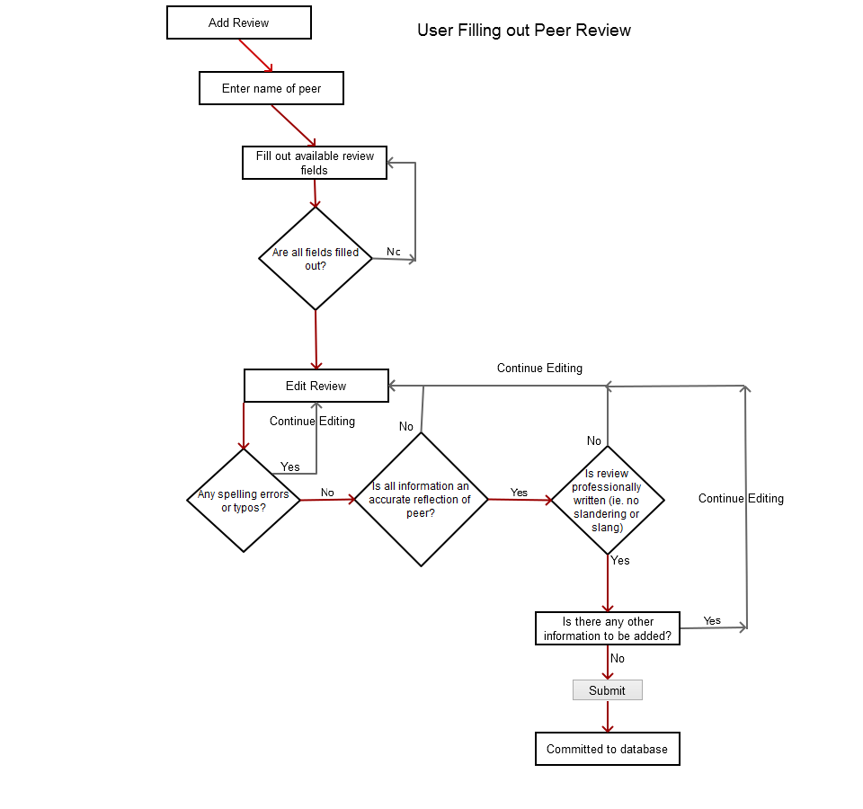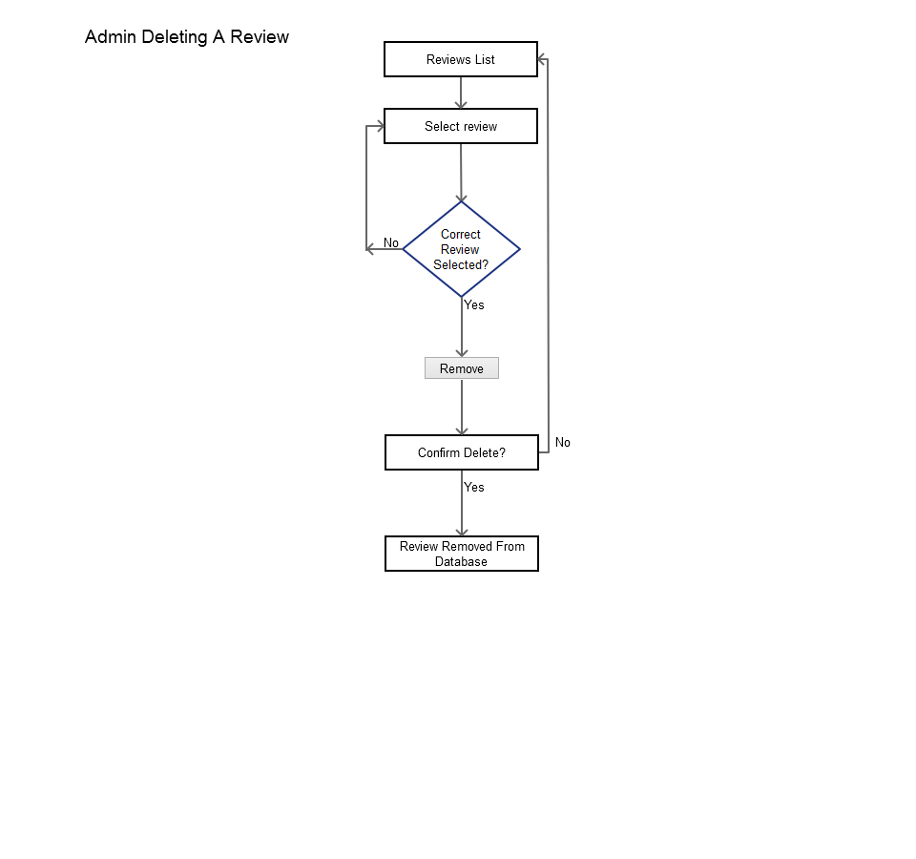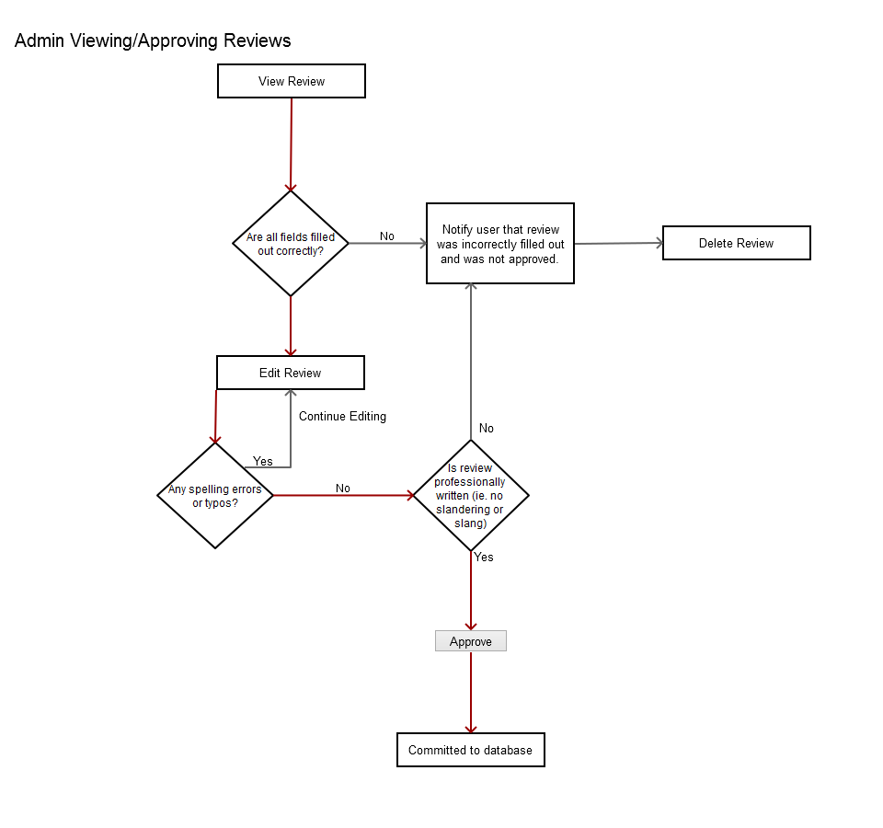

Some Concerns:

How to anticipate or create a database for wide variety of input (ie languages & interests)

Creating tables for projects? Will I need to create tables to keep track of different projects in progress (projectID, name, users involved etc)… &should this be worried about now or later

User Roles and how to define them.. or at least how to think about them so I can look up the best way to define them.

Admin sides… Do any of these features need them? I can’t imagine them… have never even seen a real admin side to anything so it is difficult to determine/ imagine

In regards to project teams:

Probably need an admin side to this, unless the algorithm does everything; but would need an admin to notify team members, and send them some sort of project key to have access to some sort of area where

How to think about developing a space for each team to develop. Like a group section (kind of like facebook group but only team members have access)?

Need another login for project access?

Should I be (not developing yet) but looking into how to algorithms work, or how to use them, because, with small amount of users in beginning, theoretically an admin could review project forms and match manually.