# Introduction

The Compass software tool was created by Rob Stobbe at the University of Alberta. Please feel free to use. Report any errors or problems to rstobbe@ualberta.ca**.**

This document focusses on analyzing images within Compass.

To run Compass (for the purpose of image analysis):

* Navigate within Matlab to the downloaded or cloned Compass directory
* Type ‘CompassImageAnlz’ in the Command Window.
* The following window will open

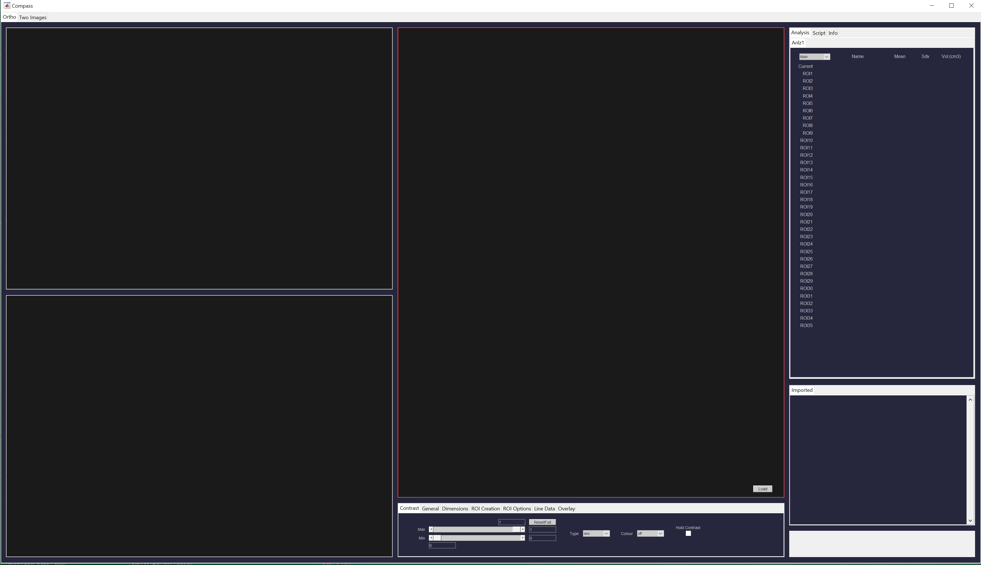

* The remainder of this manual coming soon!