# Introduction

The Compass software tool was created by Rob Stobbe at the University of Alberta. Please feel free to use. Report any errors or problems to rstobbe@ualberta.ca**.**

This document focusses on running Matlab scripts with Compass. Note that these scripts include ‘Yarnball’, a rapid 3D-spiralling MRI acquisition technique. Scripts for Yarnball are also available on GitHub. The purpose of Compass within this context of this manual is to provide a simple visual user interface for script parameter and sub-function selection.

To run Compass (for the purpose of running Matlab scripts):

* Navigate within Matlab to the downloaded or cloned Compass directory
* Type ‘CompassScripts’ in the Command Window.
* The following window will open

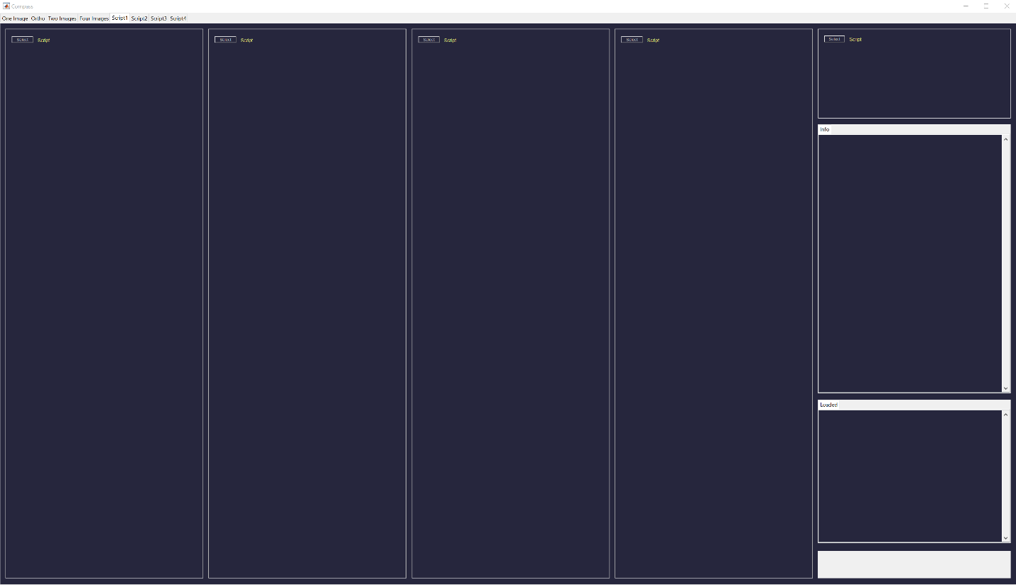

Within each **Script** tab there are four long columns to run Matlab scripts (and one short column to the top right – however, this short column is of no concern for this document and should not be used). Each column on each **Script** tab operates independently. Thus, up to 16 scripts may be created or loaded into Compass as the same time.

* Note that we will be using a ‘Yarnball’ script to demonstrate Compass. Download or clone Yarnball from Github and add the Yarnball folder and its subfolders to the Matlab path.

# Selecting a Script

To select the DesignYarnball script:

* Click one of the **Select** (Script) buttons at the top of a column
* Navigate to the ../Yarnball/Scripts folder and select ‘DesignYarnball.mat’
* The following information should appear in the column

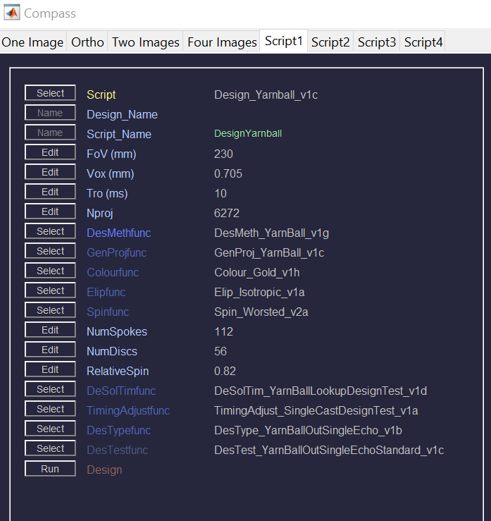

‘Design_Yarnball_v1c’ is the primary function and it’s input parameters are: FoV (field of view), Vox (voxel width at 1/2kmax), Tro (readout duration) and Nproj (number of projections or trajectories). Any input parameter is indicated in the lightest blue.

Brightest blue labels (in this case DesMethfunc) indicate functions directly called by the primary funtion. Although there is only one function in this case, there may be several functions directly called by the primary function. These will all be indicated with a brightest blue label.

The darker blue functions (GenProjfunc, Colourfunc, Elipfunc, Spinfunc, DeSolTimfunc, TimingAdjustfunc, DesTypefunc) are all called by ‘DesMeth_YarnBall_v1g’ (in this case). Note that the function ‘Spin_Worsted_v2a’ has three input parameters.

The darkest blue function (DesTestfunc) is called by the function directly above it, the function ‘DesType_YarnBallOutSingleEcho_v1b’.

# Running a Script

To run the DesignYarnball script:

* Click the **Run** button at the bottom of the column.
* Indicators will describe progress at the bottom right of Compass (these should all be green)

In this case the following things are produced:

* A figure name ‘Test Waveform’
* Information inside the **Info** tab to the right of Compass
* And a small window requesting the user to name the design (a default name is suggested)

* Note that the ‘DES_’ prefix of the default name identifies the output as a non-Cartesian trajectory design. The remaining characters help identify the design.

# Saving the Script Output

To save the output from running the DesignYarnball script:

* Accept the default name, or enter a new name
* Click **OK**
* Save Script and Data – Click **Yes**
* Navigate to the folder in which you would like to save the output and click **Save**

The output from running the script will be saved inside that folder. An additional folder with the same name as the saved output will also be created. Inside this folder are copies of the figure(s) generated.

In this case the ‘Test Waveform’ figure shown below is saved.

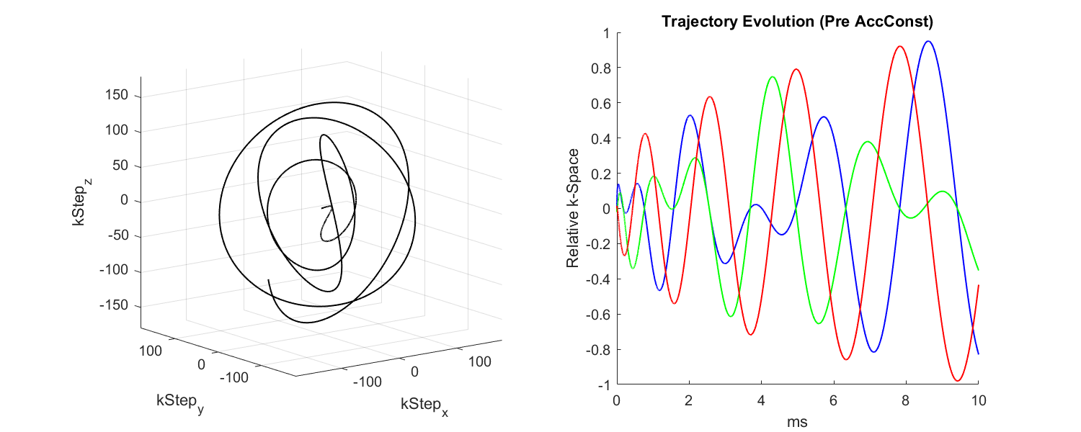

The name of the output from running this DesignYarnball script will be placed in yellow at the top of the column. It will also be placed into the **Loaded** tab to the bottom right of Compass.

# Editing Scripts

To edit any of the parameters (lightest blue):

* Click the **Edit** button associated with the parameter
* The parameter field will be altered as shown below
* In this case the value of 230 can now be edited.
* Note that if any value is selected to be edited the ‘Design_Name’ will disappear (i.e. if a yellow ‘Design_Name’ label is present, the parameters listed are associated with that particular output).

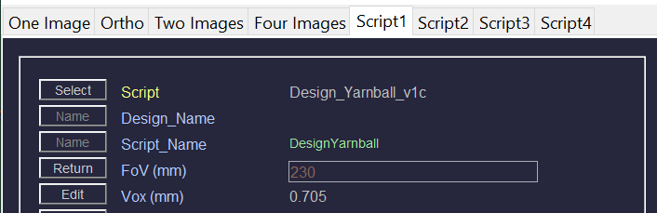

To return to the original value:

* Click the **Return** button

If we change FoV to 220 and click **Run** (while it is still brown), the script will run with that 220 value and when it is finished, the FoV value will turn white. The script can then be saved as before.

To select different sub-functions:

* Click the **Select** button associated with the sub-function
* Windows explorer will open to possible options (as *folders*) for that sub-function.
* Note that it is the function *folder* that is selected.

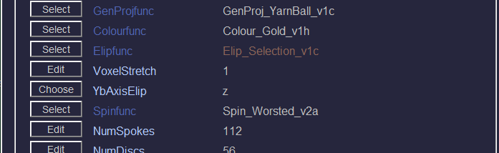If we select ‘Elip_Selection_v1c’ for Elipfunc, we can see that this new function has two parameters of its own as shown below (i.e. VoxelStretch and YbAxisElip). These can be edited before running as with any other parameter.

# The ‘Loaded’ Tab

If there are multiple entries in the **Loaded** tab, clicking between the entries will provide information in the **Info** tab associated with that entry.

Right clicking on an entry within the **Loaded** tab gives the option to delete the entry or all entries.

# Loading Script Output Into a Script Column

To load a saved script output file from the computer:

* *Right* click one of the **Select** (Script) buttons at the top of a column.
* Choose – ‘Load from File’.
* Find the saved output and click **Open**.
* The script and the all the parameters associated with the selected output will be displayed in the associated column.
* The selected output will also be placed in the **Loaded** tab and the associated information shown in the **Info** tab.
* This script can be rerun as is (the output should be identical), or it can be modified and the output saved with a different name.

To load saved script output from the **Loaded** tab in Compass:

* Click on the desired entry in the **Loaded** tab (this entry will be highlighted)
* *Right* click one of the **Select** (Script) buttons at the top of a column.
* Choose – ‘Load from Panel’.
* The script and the all the parameters associated with the selected output will be displayed in the associated column.
* This script can be rerun as is (the output should be identical), or it can be modified and the output saved with a different name.

# Drag and Drop

Dragging a saved script output (.mat) file from Windows Explorer into the **Loaded** tab will load that output file into Compass. A entry will be placed in the **Loaded** tab and the associated information shown in the **Info** tab. This entry can then be loaded into a script column as described above.

# Removing a Script From a Script Column

To remove a script from a script column:

* *Right* click one of the **Select** (Script) buttons at the top of a column.
* Choose – ‘Remove’.

# Saving a Script

‘Saving a Script’ does *not* save the output associated with running a script (this process happens at the end of clicking **Run**). The purpose of ‘Saving a Script’ is to create a default starting point from which one might to edit and run future scripts.

To save a script:

* *Right* click the **Select** (Script) button at the top of the column of interest.
* Choose – ‘Save Script’.
* Enter a file name and save to the desired location
* The name of the new script will be displayed in green.
* This script can now be selected for future use (as in 2. Selecting a Script).