Packet Anatomy

This is the anatomy of one packet. It is inspired by the [CAN](http://en.wikipedia.org/wiki/Controller_Area_Network) and SAE AS-4 standards.

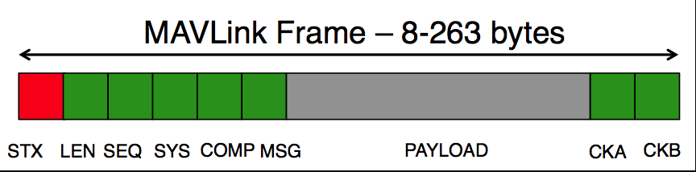

|  |  |  |  |
| --- | --- | --- | --- |
| **Byte Index** | **Content** | **Value** | **Explanation** |
| 0 | Packet start sign | v1.0: 0xFE (v0.9: 0x55) | Indicates the start of a new packet. |
| 1 | Payload length | 0 - 255 | Indicates length of the following payload. |
| 2 | Packet sequence | 0 - 255 | Each component counts up his send sequence. Allows to detect packet loss |
| 3 | System ID | 1 - 255 | ID of the SENDING system. Allows to differentiate different MAVs on the same network. |
| 4 | Component ID | 0 - 255 | ID of the SENDING component. Allows to differentiate different components of the same system, e.g. the IMU and the autopilot. |
| 5 | Message ID | 0 - 255 | ID of the message - the id defines what the payload “means” and how it should be correctly decoded. |
| 6 to (n+6) | Data | (0 - 255) bytes | Data of the message, depends on the message id. |
| (n+7) to (n+8) | Checksum (low byte, high byte) | ITU X.25/SAE AS-4 hash, **excluding packet start sign, so bytes 1..(n+6)** Note: The checksum also includes MAVLINK_CRC_EXTRA (Number computed from message fields. Protects the packet from decoding a different version of the same packet but with different variables). | |

* The checksum is the same as used in ITU X.25 and SAE AS-4 standards ([CRC-16-CCITT](http://en.wikipedia.org/wiki/Cyclic_redundancy_check#Commonly_used_and_standardized_CRCs)), documented in [SAE AS5669A](http://www.sae.org/servlets/productDetail?PROD_TYP=STD&PROD_CD=AS5669A). **Please see the MAVLink source code for a documented C-implementation of it.**[**LINK TO CHECKSUM**](https://github.com/pixhawk/mavlink/blob/master/include/checksum.h)
* The minimum packet length is 8 bytes for acknowledgement packets without payload
* The maximum packet length is 263 bytes for full payload