# What makes Americans of different political parties different?

With an upcoming presidential election in the US, many Americans will be engaging in an ancient cultural taboo; discussing politics and religion at the dinner table. For those unfamiliar with the taboo, we have a knack for getting quite passionate about these topics. The discomfort about this taboo raises a question; how are Americans across the political spectrum different?

|  |  |  |  |
| --- | --- | --- | --- |
|  | **Republican** | **Democrat** | **Independent** |
| *n* | 1158 | 1372 | 1198 |
| *Men* | 50.60% | 45.20% | 54.50% |
| *Women* | 49.40% | 54.80% | 45.50% |
|  |  |  |  |
| *Ages 18-29* | 10.79% | 16.25% | 24.80% |
| *30-44* | 21.07% | 21.65% | 22.62% |
| *45-59* | 33.07% | 29.30% | 30.13% |
| *60+* | 35.06% | 32.80% | 30.47% |
|  |  |  |  |
| *White* | 88.20% | 53.70% | 74.50% |
| *Black* | 0.80% | 20.30% | 7.30% |
| *Hispanic* | 5.40% | 17.00% | 9.20% |
| *Other, non-Hispanic* | 5.60% | 9.00% | 9.10% |
|  |  |  |  |
| *College graduate* | 35.80% | 38.60% | 35.70% |
| *Some college* | 29.00% | 26.60% | 29.80% |
| *High school graduate* | 30.80% | 26.00% | 26.40% |
| *Less than high school* | 4.40% | 8.70% | 8.10% |
|  |  |  |  |
| *Household Income $100,000+* | 24.40% | 21.40% | 23.40% |
| *$50,000-$99,999* | 30.70% | 26.40% | 25.10% |
| *$30,000-$49,999* | 30.20% | 27.50% | 26.20% |
| *<$30,000* | 14.70% | 24.80% | 25.30% |

To unpack this question, I have gathered data from the Pew Research Center's 2017 Science and News Survey. This survey asked 4,024 American adults from across the nation, 18 years or older, 50.5% female, with education ranging from high school or less to postgraduate education what their thoughts were on a variety of topics related to science and news today.

Because my research question was quite vague, I decided to divide it into three main questions:

1. *What are the demographic differences between Americans of various political parties?*

2. *Do Americans across the political spectrum consume news information differently?*

3. *Do Americans across the political spectrum have differing views on society or religion?*

## What are the demographic differences between Americans of different political parties?

The first step was to categorize the data by political affiliation. Surveyors were asked to self-identify as Republican, Democrat, Independent, or Other. Because we are looking at differences across the political spectrum, it is impossible to categorize the ‘Other’ and ‘No Answer’ responses along a continuum in relation to the other parties. For example, a surveyor identified as ‘Other’ could have political views ranging from the far-left to the far-right and we would be unable to categorize them appropriately. For this reason, I removed those who did not identify as either Republican, Democrat, or Independent (n = 296, or 7.3% of surveyors).

## C:\Users\Derek Tolbert\AppData\Local\Microsoft\Windows\INetCache\Content.MSO\7BE99739.tmpDo Americans across the political spectrum consume news information differently?

If Americans do have wide-ranging views on politics and science, perhaps it stems from the sources they choose to get their information from. Surveyors were asked to pick which news sources they regularly get news from about government and politics from a list of sources. From the first list of sources, a higher number of Democrats selected the Big Three television networks (ABC, CBS, and NBC) when compared to Republicans and Independents. On average, 45.0% of Democrats choose one of these networks while only 32.0% of Republicans and 35.7% of Independents chose these networks. Business Insider, Vox, and the Independent Journal Review all had less than 10% of selection from each party. In contrast, Republicans (47.7%) and Independents (43.9%) chose the ‘None of the Above’ option much more frequently than Democrats (30.0%).

In the second list of sources, there were again many differences between parties. While these sources were not as popular as those in question one, Democrats selected PBS, Politico, Slate, and LA Times more frequently than Republicans and Democrats. Like the first list, Republicans were the most frequent selectors of 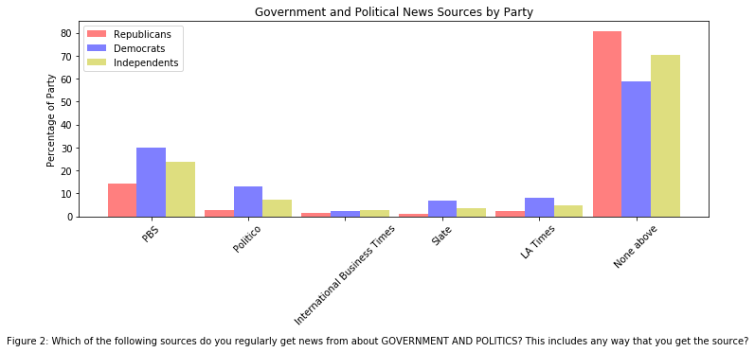 “None of the above” at 80.8% with Independents at 70.2%% and Democrats at 59.0%. Based on these lists 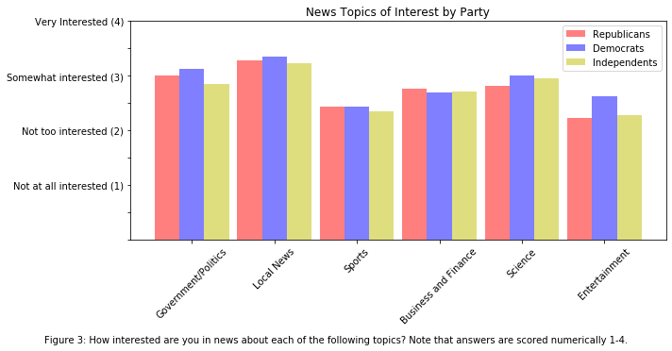alone, Democrats may rely on a more diverse set of sources for their government and political sources.

Alternatively, Democrats may simply rely on more mainstream news sources when compared to Republicans and Independents. However, without assessing the individual political bias of each source, it is impossible to determine if there is bias in the survey itself. Hypothetically, if the sources that were included in the survey were biased to the political left, it would explain why the majority of “None of the above” answers were given by Republicans.

When polled on which news topics were most interesting, differences between political parties become much less apparent. Surveyors were asked to identify their level of interest in various news topics. Mean scores were taken from each group for comparison. The largest difference was in the “Entertainment” category where Democrats had the most interest at 2.62, followed by Independents and Republicans at 2.28 and 2.23, respectively. Overall, surveyors identified government and political news, local news, and science news as the three most interesting news topics.

While Americans of different political parties may get their information from different sources, do they have different views on society as a whole?

## C:\Users\Derek Tolbert\AppData\Local\Microsoft\Windows\INetCache\Content.MSO\B18F2F6B.tmpDo Americans across the political spectrum have differing views on society and religion?

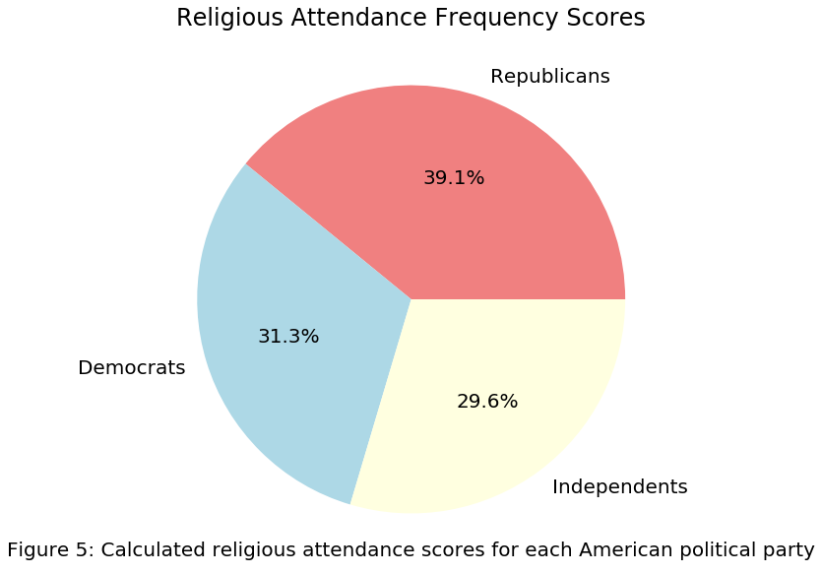When asked, “In general, would you say life in America today is better, worse or about the same as it was 50 years ago for people like you?” Democrats were the most frequent to answer, ‘Better Today’ while Republicans were the most frequent to answer, ‘Worse Today’ and Independents were the most frequent to answer, ‘About the same’. These results are not surprising as in America, Democrats tend to be more progressive while Republicans tend to be more conservative. Surprisingly, the differences between groups are quite small (<5% for all questions); indicating that Americans across the political spectrum have similar views about the current state of society.

Finally, I evaluated the differences in attendance of religious events between political parties. Surveyors were asked to select a score between 1-6 which corresponded to a ranking of religious attendance ranging from ‘Never’, to ‘More than once a week’. To compare scores between groups, the data was recoded so that larger scores would indicate more frequent attendance. Following this, group means were calculated and converted to a percentage of total attendance scores for the entire survey. This analysis revealed that Republicans were the most frequent attenders of religious ceremonies followed by Democrats and Independents. This conclusion is supported by the fact that scores for both Democrats (2.89) and Independent (2.73) were below the mean score for the dataset (3.06) while Republican religious scores (3.61) were notably higher.

## Conclusions

1. What are the major demographic differences between Americans of various political parties?
   1. Gender, Age, Education, and Household Income were very similar between groups
   2. Democrats had the largest number of Black and Hispanic Americans
   3. Republicans had the largest number of White Americans
2. Do Americans across the political spectrum consume news and scientific information differently?
   1. Democrats may prefer major news sources more than Republicans and Independents
3. Do Americans across the political spectrum have differing views on society or religion?
   1. Republicans and Independents may have a more pessimistic view of life in America today whereas Democrats may have a more optimistic view. However, group differences were minor and suggest Americans across political parties see things similarly.
   2. Republicans were the most religious of the political parties, followed by Democrats and then Independents

## Future Research

**Question**- How are religious, economic, and political views in the United States correlated? Can a model predict changes in economic policies based on social and religious trends?

**Techniques-**

* Gather historical data of religious/social views, and major changes in economic policies (i.e. changes in taxes, implementation of social programs, etc.)
* Test for historical correlations using linear regressions
* Train a model to predict future changes in economic policies