**Climate-projected distributional shifts and refugia for North American ecoregions**

Diana Stralberg, AdaptWest (adaptwest.databasin.org)

Climate model projections suggest major shifts in North American biomes in response to anthropogenic climate change (Rehfeldt et al. 2012).

Random forest models (Breiman 2001) were developed for level III ecoregions (Commission for Environmental Cooperation 1997) based on derived bioclimatic variables for the 1981-2010 period (tinyurl.com/climatena). Future (2071-2100) random forest model projections represent the most frequently selected ecoregion based on 19 global climate model simulations for the

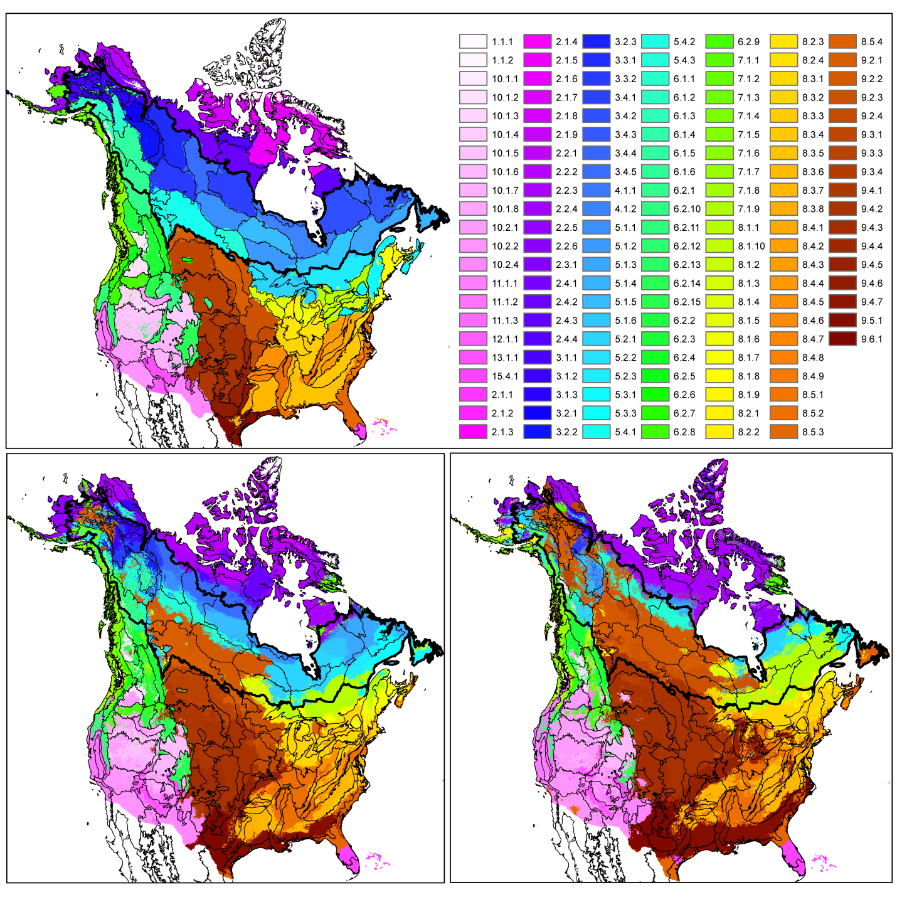

Figure 1. Model-predicted (a) baseline, (b) mid-century, and (c) end-of-century changes in North American ecoregions. Boreal and western forested regions are shown in green and blue-green shades; arctic ecoregions are in purple shades; prairie/parkland ecoregions are in red-brown shades; and temperate forest ecoregions are in light green, yellow, and orange shades (see Table 1 for full list of ecoregions). Boreal ecoregions are also outlined in black.

References

Breiman, L. 2001. Random Forests. *Machine Learning* 45:5-32.

Commission for Environmental Cooperation. 1997. Ecological Regions of North America: Toward a Common Perspective, Montreal, Canada.

Rehfeldt, G. E., N. L. Crookston, C. Sáenz-Romero, and E. M. Campbell. 2012. North American vegetation model for land-use planning in a changing climate: a solution to large classification problems. *Ecological Applications* 22:119-141.