OpenLapSim
The Open Source Lap Time Simulator Software

Documentation

Autor: Davide Strassera
First release: 21th December 2019

Abstract

The aim of this project is to build a structure for an open source Lap Time Simulator software, which can give an understanding of the main functionality of such a tool.
The software as it is can be used for preliminary study related to race car and help to compare some of the main trade off of setup configurations or design (aero, power, mass, grip), but as a community project can be further developed to a more advanced tool.

Intro

The OpenLapSim is a quasi-static Lap Time Simulator for a point mass vehicle, with aerodynamics forces, engine map, gear ratio and tire friction ellipse, written in Python.
The program simulates the maximum performance (accelerations) of the given vehicle-setup on all the sections of the circuit, giving the fastest lap time and highest speed trace over the lap the car could theoretically give.

Methodology

For the development of this Software it has been used Python 3.7 and Spyder as IDE, which allows to easily visualize the variable space (explorer). Python is a free programming language very powerful for mathematical modelling. The libraries used are NumPy, SciPy and Matplotlib.

Theory

The structure of the Lap time simulator is divided mainly in two components: the Acceleration Envelope calculator and the Lap Time Simulation calculator for the speed trace calculator.

The Acceleration Envelope is also called GGV diagram [1] and describes the maximum accelerations of the vehicle on the axis of velocity, from 0 to max speed, for positive (ax acc), negative (ax dec), which is braking phase and lateral direction (ay).

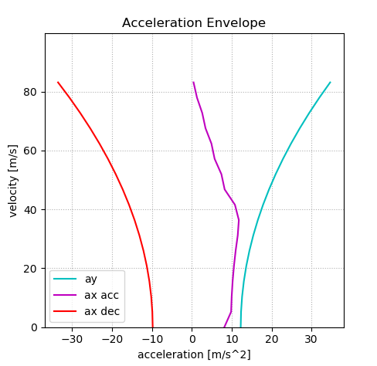

To calculate it the program uses the setup parameters (defined by the user) and calculates the forces equilibrium for both longitudinal and lateral directions for each point of the speed vector.

The Lap Time Simulator uses both the results from the previous routine and the track file.
The TrackFile.txt is a two columns matrix which contains the distance [m] and curvature (1/corner radius) of the circuit.
This routine calculates for each segment of the circuit (row of the track file) the maximum lateral acceleration the car could performed based on the GGV diagram, and then integrates it over the distance to compute the fastest speed trace on the circuit [2].
The same calculation is computed for the longitudinal, in both acceleration (positive) and deceleration (negative) phases. On the Long calculation we have to consider the amount of lateral acceleration te vehicle have, which means it is a “combination” of acceleration and we are moving out from the pure longitudinal point of the GGV.
In this tool the combined performance between long and lateral acceleration is calculated with the equation of the ellipse (simple ellipse of adherence).

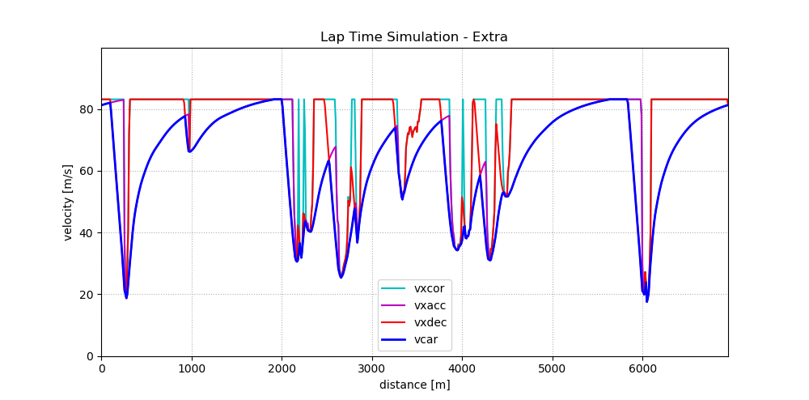

At the end for each segment of the circuit it is taken the minimum value between the three speed traces calculated.
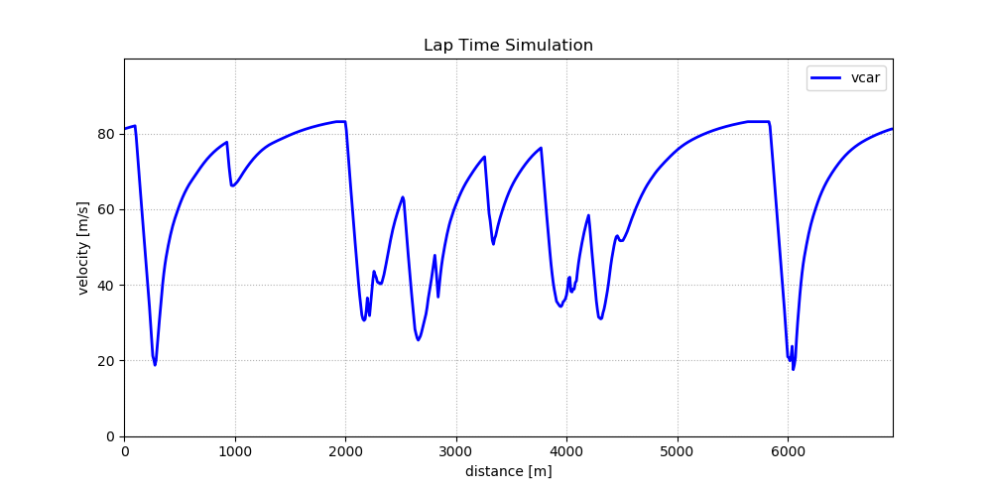

Software Guide

The structure of the code inside OpenLapSim/src is as following:

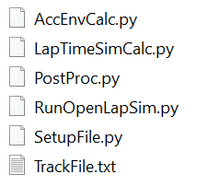

The file needed to run the simulation is RunOpenLapSim.py, where the user needs to specify two files: SetupFile.py and TrackFile.txt

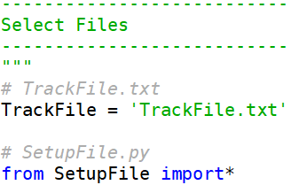

On the SetupFile.py the user can modify the parameters of the vehicle as needed, while the TrackFile is a .txt file with distance in meters and curvature (1/R) of the specific circuit.

Still on the RunOpenLapSim.py, below the selection there are the objects instantiation for the AccEnv (aE) the LapTimeSim (l1 and l2 for first and second iteration), and finally the PostProc (pP) for plotting and data print.

When run the RunOpenLapSim you should see on the console these lines:

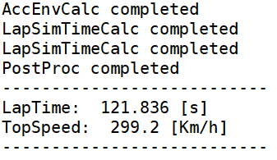

Conclusions

This Project does not want to be an advanced tool for simulation given the large amount of assumption and simplifications. It is anyway a ready to use tool which can be furthermore developed and an education software.
It is important to remember that the simulation results are both a combination of model approximation and correctness of the input data, especially in a Formula type car, where aerodynamics and tire frictions coefficient heavily modify the results.

Links

The source code is available on GitHub and is licensed under GNU General Public License: https://github.com/dstrassera/OpenLapSim

References

[1] W. F. Milliken, D. L. Milliken, Race Car Vehicle Dynamics. Warrendale, Pa: SAE, 1995

[2] J. Hakewill, Lap Time Simulation. 2000 [Online], available: http://www.jameshakewill.com/Lap_Time_Simulation.pdf

