OpenLapSim
The Open Source Lap Time Simulation Software

Documentation

Author: Davide Strassera

First release: 21th December 2019
Last update: 1st November 2020

Abstract

The aim of this project is to build an open source Lap Time Simulation software, which can be used as frame for further improvements and give an understanding of the main functionality of this type of tools.
The software as it is can be used for preliminary study of the performance of a race car and can help to compare some of the main trade off of setup configurations or design (aero, power, mass, grip), but as a community project can be further developed to a more advanced tool.

Intro

The OpenLapSim is a quasi-static Lap Time Simulator software written in Python.
The program simulates the maximum performance (accelerations and velocity) of the given vehicle-setup on all the sections of the circuit, computing the fastest lap time and highest speed trace over the lap the car could theoretically achieve.
The default vehicle model available is a simple point mass, with aerodynamics forces, engine map, gear ratios and tire friction ellipse, but if needed a user can develop and plugin its own more specific and advance vehicle model.

Methodology

For the development of this Software it has been used Python 3.7 along with Spyder IDE (by Anaconda). Python is a free programming language very powerful for mathematical modelling; in addition, many external libraries are available to be used (following the main used here are: NumPy, SciPy and Matplotlib).
The programming paradigm used for this software is mainly Object Oriented, to facilitate the modular maintenance and the development of the program. Moreover, where possible, the functionalities have been divided in different classes and methods to help with an easier understand of the computational phases and help with testing and debugging as well.

Theory

The structure of the Lap time simulator is divided mainly in two components: the Acceleration Envelope calculator and the Lap Time Simulation calculator for the speed trace and lap time computations.

The Acceleration Envelope, also called GGV diagram [1], describes the maximum accelerations of the vehicle on the axis of velocity, from 0 to max speed, for positive (ax acc), negative (ax dec), which is braking phase and lateral direction (ay).

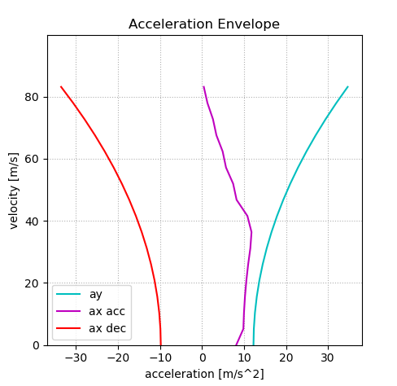

To calculate it the program uses the setup parameters (defined by the user) and calculates the forces equilibrium for both longitudinal and lateral directions for each point of the speed vector.

The Lap Time Simulator uses both the results from the previous routine and the track file.
The TrackFile.txt is a two columns matrix which contains the distance [m] and curvature (1/corner radius) of the circuit.
This routine calculates for each segment of the circuit (row of the track file) the maximum lateral acceleration the car could performed based on the GGV diagram, and then integrates it over the distance to compute the fastest speed trace (in this phase for the corner) over the circuit [2].
The same calculation is computed for the longitudinal, in both acceleration (positive) and deceleration (negative) phases. On the Long calculation we have to consider the amount of lateral acceleration the vehicle has, which means the car has a “combination” of accelerations and it is moving out from the pure longitudinal point of the GGV, if not in straight line.
In this tool the combined performance between long and lateral accelerations is calculated with the equation of the ellipse (simple ellipse of adherence).
Below in the chart we can see all the velocity traces calculated during the Lap Time Sim process: max corner speed (vxcor), max acceleration speed (vx acc) and max braking speed (vxdec).

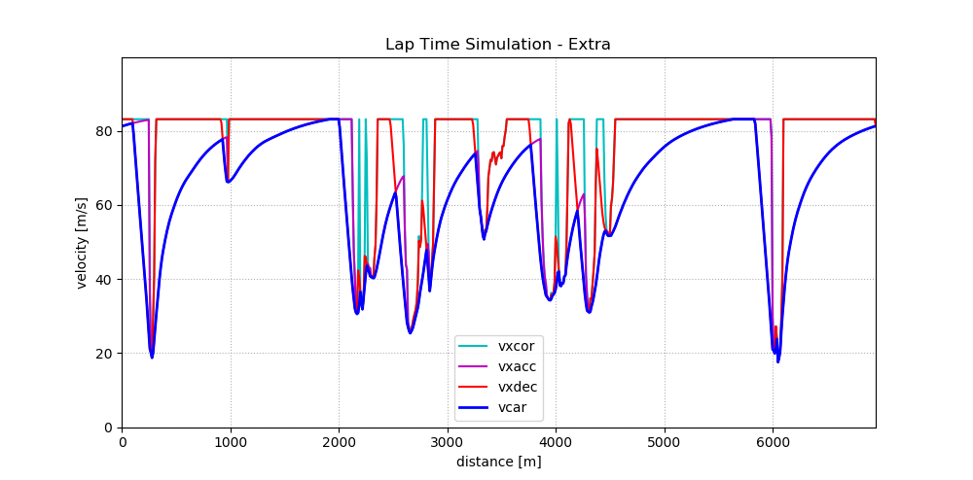

Finally, for each segment of the circuit, it is taken the minimum value between the three speed traces calculated.
Below it is plotted the fastest car velocity (vcar) over the circuit distance.
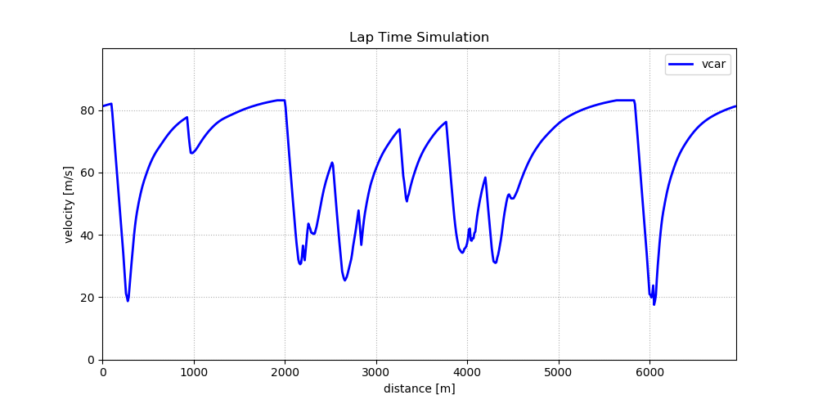

Software Guide

The structure of the code inside OpenLapSim/src is as following:

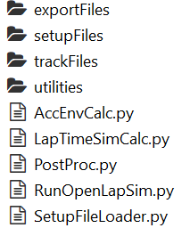

The file needed to run the simulation is RunOpenLapSim.py, where the user needs to specify two files: SetupFile.json and TrackFile.txt

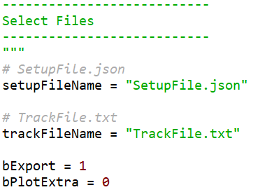

After successful run of the simulation you should see on the console these lines:
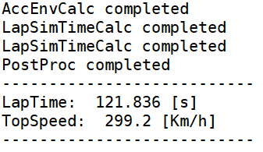

Moreover, you can specify two other parameters: bExport and bPlotExtra.
The first on if == 1 will save the result of the simulation, as .txt file automatically named with the date, containing two columns: distance [m] and vcar [m/s] inside /exportFiles directory.
The second parameter is used only to plot extra information regarding the speed trace and the acceleration envelope.

The directory /trackFiles stores the Trackfile.txt and is the location where you should save all the other track files.
TrackFile.txt contains two columns: distance in meters and curvature (1/R) of the specific circuit (see utilities for info on how generate it).

The directory /setupFiles stores the SetupFile.json. and is the location where you should save all the other setup files.
The SetupFile.json contains all the parameters of the vehicle and the respective units are specified in the SetupFileLoader.py. (comments are not part of the JSON file and must be removed).

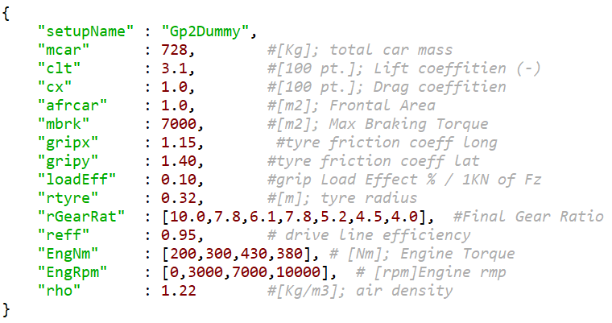

The directory /utilities contains classes and methods that help to use the software.
The first routine is “TrackFileBuilder.py” which, given a telemetryFile.csv (for example a real telemetry data export), containing at least distance, car speed and lateral acceleration, can automatically generate the TrackFile.txt in the format needed here. There is some low pass filtering to smooth noisy data, but you may need to adjust cut off frequency based on your necessity (see plot below, left). For more info on how to use it, see the comments inside the class.

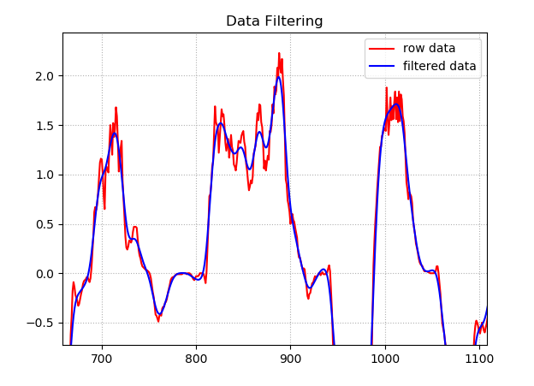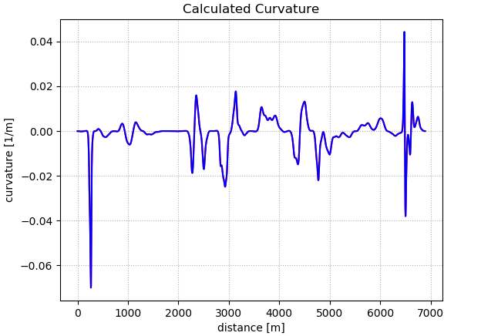

Another is “SimExportCompare.py” which given two simulation exports from the src/export folder plots the speed traces and the delta speed, and also prints the delta lap time between the simulations.

Plugin a Vehicle model

In case you want to modify or use your own vehicle model all you need to do is to write a new AccEnvCalc.py that suits your needs and accordingly modify the SetupFileLoader.py, with the vehicle parameters that your class will use.
It is important that you maintain the same structure and outputs generated by the acceleration envelop calculator that then are used by the Lap time simulator calculator (check the code to see what are the outputs and format needed).

Conclusions

This project is a ready to be used tool which can be furthermore developed or be used as an education software for passioned engineers and universities projects (such as Formula Students).
It is important to remember that the simulation results in general are both a combination of model approximation and correctness of the input data, especially in a Formula type car, where aerodynamics and tire model heavily modify the results.

Links

The source code is available on GitHub and is licensed under GNU General Public License: https://github.com/dstrassera/OpenLapSim
The website is: https://www.openlapsim.com

References

[1] W. F. Milliken, D. L. Milliken, Race Car Vehicle Dynamics. Warrendale, Pa: SAE, 1995

[2] J. Hakewill, Lap Time Simulation. 2000 [Online], available: http://www.jameshakewill.com/Lap_Time_Simulation.pdf

[3] M. Guiggiani, Dinamica del Veicolo. De Agostini, Novara, It, 2007

