Proposal for Distributed Computing at Kennesaw State University
David Russell
English 3140 – 02
Project 2

Table of contents

List of figures and tables……………………………………………………………………...3
Introduction…………………………………………………………………………………..4
Body………………………………………………………………………………………….6
Appendices…………………………………………………………………………………...9
Glossary…………………………………………………………………………….…….…11
Works cited list ………………………………………………………………………….….12

List of figures and tables

Figure 1 – Example molecule - Vascular Endothelial Growth Factor …… Appendix A
Figure 2 – Example molecule - RAS Protein………………………..…… Appendix A
Table 1 – Projected Computing power of Kennesaw State University …… Appendix B

Introduction
Statement of problem
While most of the programs and tasks your computer runs are simple and take a few seconds or minutes, some larger tasks will take the most powerful supercomputers weeks or years to compute. These tasks range in subjects from scrutinizing radio signals, to cracking incredibly complex codes, and to analyzing biological molecules. The problem my idea solves will deal with these very large computational tasks. In particular, the enormous tasks this solution will be applied to are the biomolecular puzzles. These puzzles could be keys to unlocking the secrets of potential drugs that could cure cancer and other ailments, saving countless numbers of lives. Unfortunately, most supercomputers take eons to finish analyses of relationships among complex biological chemicals.

Overview of approach
The solution to the gigantic bio-puzzle problem lies in the computational power of simple personal computers you see and use everyday. Hundreds of idle computers in labs and classrooms all around the Kennesaw State University campus have the combined potential power to rival the most advanced mainframe supercomputers. With these computers on campus, the complex tasks that would have taken years to solve could takes months or even weeks. A certain type of software has been written that breaks up large computational tasks into smaller tasks and sends these pieces across a network to be computed concurrently. The purpose of this software is known as distributed computing. The three main organizations that offer this type of software are Seti@home, distributed.net, and United Devices (UD). Whereas Seti@home specializes in the analysis of radio signals from outer space and distributed.net deals mainly with the code-cracking aspect of distributed computing, the focus of UD is in the biological potential of distributed computing. Thus UD will be the focus of this proposal. My intention will be to propose to the necessary departments and people that Kennesaw State University should volunteer its computers for this purpose. This proposal will entail that this distributed computing software be installed on most of the computers on the campus.
Scope
For my proposal, what I will do is put forward the recommendation that the UD software is installed. What I will not do is lobby for student government laws or statewide legislation that makes distributed computing software installation mandatory anywhere. The duration of this proposed project would be indefinite.
Classrooms and labs with computers will be included in the scope of this proposal. The scope of this undertaking will go only as far as the Kennesaw State University campus, including the Continuing Education classrooms. Even though the Continuing Education building is located across the I-75 interstate, it is still technically part of Kennesaw State University, and the scope of this proposal will include the Continuing Education facility because most of its classrooms contain computers with high-quality processors.

Statement of organization

Body

Biotechnology is the next big thing. In the wake of the IT industry’s downturn, general public interest has turned to life sciences. Every day the news tells us more stories about DNA mapping, cloning, genetic manipulation, stem cell research, as well as the race for cures to the deadly diseases that terrorists could use against us. Only a few corporations, start up companies, and universities have caught scent of the vanguard in technology, and only a few have started pursuit of life sciences. Those people who have started are in the news and will surely go down in the annals of history if they are successful in contributing to the next life-altering discovery. I propose that Kennesaw State University be one of them.
Kennesaw State University can do this by participating in a massive online undertaking known as distributed computing.
Statement of work
For the dispersal of this software, the needs of this proposal will include access to most of the servers on campus. Access to the servers will include granting a root directory username and password. As this requirement is a potentially huge security risk, I expect the username and password to be of a temporary nature.
The goal of this proposal is to convince the right people to have the UD software installed in classrooms and labs, and running on most of the computers of the campus of Kennesaw State University. In order for me to obtain permission to install any software on a network level, I must convince the Information Technology Services (ITS) department of the UD software’s usability. I must also convince the networking department of the software’s security. First and foremost, however, I must convince Kennesaw’s faculty of the UD software’s utility and Kennesaw’s administration of the distributed computing software’s necessity.
In order to convince Kennesaw’s administration of the distributed computing software’s necessity, I will explain the problem the software will solve as I have done here. In order to show Kennesaw’s faculty the UD software’s utility, seminars may be held, and email and paper notifications may be drawn up and distributed to the various and numerous departments. To convince the network department of the software’s security, I will show the impossibility of hacking into the campus network via the software’s interface without root access usernames and passwords. And finally, in order to demonstrate to the ITS department the UD software’s usability, I will describe in detail the specifications and case studies used to implement the UD software in other networks. All potential benefits of the installation will be explained, as will the potential drawbacks. With the approval of all the previously mentioned departments and people, the distributed computing software will be disseminated across the campus computer network, installed on most the computers, and running on any idle computer in Kennesaw State University.
Plan
Costs
Few money considerations would exist for this undertaking. One of them would be the cost for the networking staff to send out an installation. That part of the budget would be mandatory for the project. The cost would be nominal, judging by what users of the UD software has posted about large deployments and mass installations (United Devices, Inc, 2002). The cost would amount basically to the cost of one day's (or maybe a few hours) work. Optional expenditures might include the cost of KSU’s software department to write something to keep other programs from running on computers that could slow the UD software down.
Statement of qualifications
I am thoroughly qualified for this undertaking because I am aware of the problem and of the solution. My background with computers and my understanding of distributed computing adequately justifies my role in this proposal. I have experience with programming both in school and in a professional environment. In school, I have taken courses in subjects as advanced as Object Oriented Programming (CSIS3100) and Advanced Data Structures & Algorithms (CSIS3401). Furthermore, I worked as a web developer for startup software company for a year and a half, writing complex scripts dealing with media content management and a procedural database language. My background in software combined with the fact that I spend my time all day, every day with computers leaves no question as to whether I am the right person for this project.

Appendix A

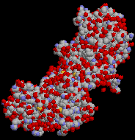
Example molecule - Vascular Endothelial Growth Factor
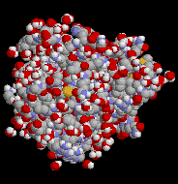
Example molecule - RAS Protein

Appendix B

Projected Computing power of Kennesaw State University
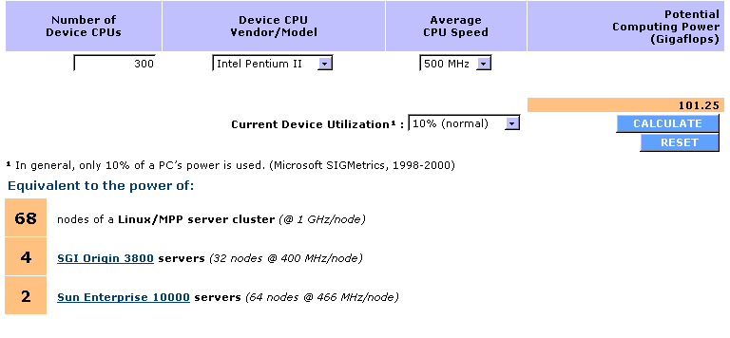

Glossary

Distributed computing: taking large tasks and dividing them into many smaller tasks, all of which are disseminated to many computers running simultaneously via a network such as a private corporate network, or the Internet. After the tasks are processed via individual computers, the data is transmitted back to a central server, which assembles the results. (United Devices, Inc, 2002)

Gigaflop: A measure of computing speed equal to one billion floating-point operations per second. (Lexico LLC, 2002)

Vascular Endothelial Growth Factor (VEGF): stimulates the growth of blood vessels. The uncontrolled growth of cancer cells is legendary. But this sort of growth requires a lot of blood flow to the cell area. If the blood vessel growth can be restrained, then, in theory, so can cancer growth. (United Devices, Inc, 2002)

RAS protein: gives a chemical "message" that activate cell growth. Without this signaling factor, the cell doesn't "know" to grow. Inhibiting RAS in cancer cells means an end to their uncontrolled growth. (United Devices, Inc., 2002)

Works cited list
United Devices, Inc. (2002). United Devices, Inc. Retrieved April 5 2002 from
http://www.ud.com/home.htm.
Lexico LLC. (2002). Dictionary.com/Gigaflop. Retrieved April 5 2002 from
http://www.dictionary.com/search?q=Gigaflop.
NPR. (2002). NPR : Home. Retrieved April 5 2002 from http://www.npr.org/.
Davidson, Charles. (2002, March/April). Life Sciences In Georgia. TechLINKS, 50-57.

