Obtaining Schwab CSV export for last year
- Go to “History” tab.
- Choose “Equity Award Center” from the dropdown.
- Chose “Custom” Data range and interval from the last year (with overlap)
  - Some events (e.g. ESPP) are reported with delay, so overlap of several days is necessary.
  - Alternatively, you can export everything.
- Click “Export”
- Select “JSON” radio button, click “Export”

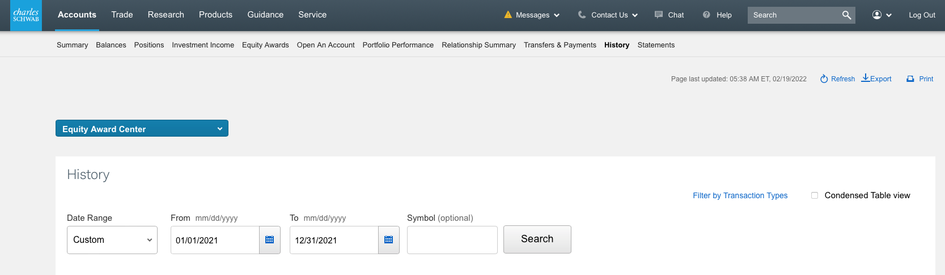

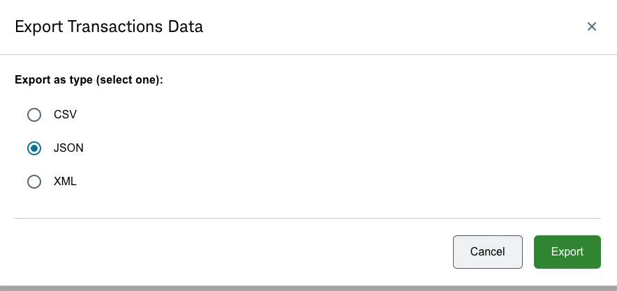

Running the application
- Compile and run cognitiveone/cognitive/core/core-tools/cockroach/src/main/java/com/cisco/td/general/cocroach/CocroachMain.java (you need to clone the whole https://wwwin-github.cisco.com/cognitive-intelligence/cognitive-one)
- it gets 3 command line arguments - path to csv export, year, and output dir.
- it uses templates located here: cognitiveone/cognitive/core/core-tools/cockroach/src/main/resources/com/cisco/td/general/cockroach
- the output are 4 simple .md files)
- In InteliJ IDEA, you can convert the md files into pdf in Markdown export options under Tools > Markdown Converter menu.
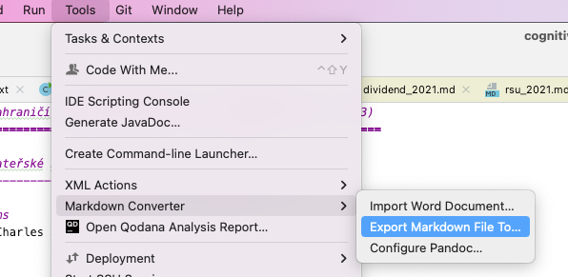

Compiling and Running (probably very redundant information)
cd cognitiveone/cognitive/core/core-tools/cockroach/
mvn clean install -am
mvn clean install shade:shade
java -jar target/cockroach-7.4-SNAPSHOT.jar /tmp/219114411.json 2023 /tmp/taxes

Converting to PDF
- pandoc sales_2021.md -V geometry:landscape --pdf-engine=/Library/TeX/texbin/pdflatex -o sales.pdf
- IDEA: Tools -> Markdown Converter

