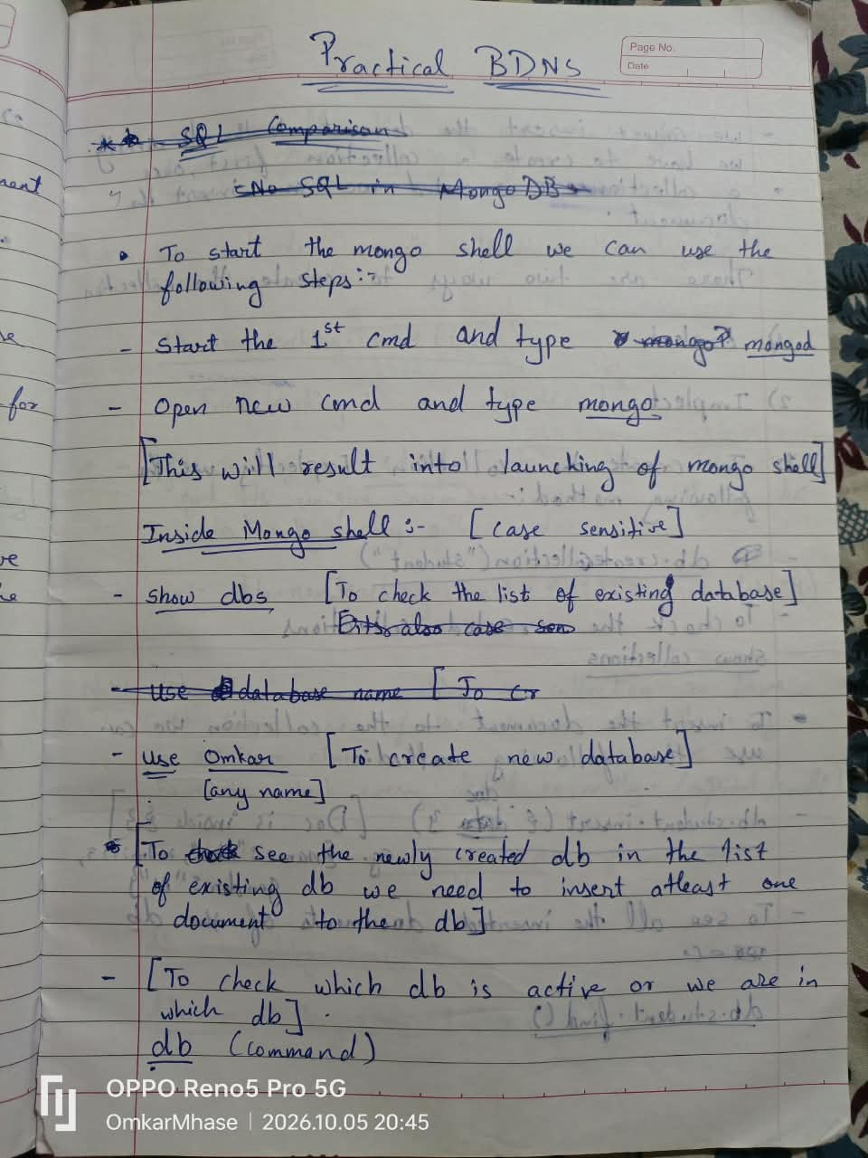

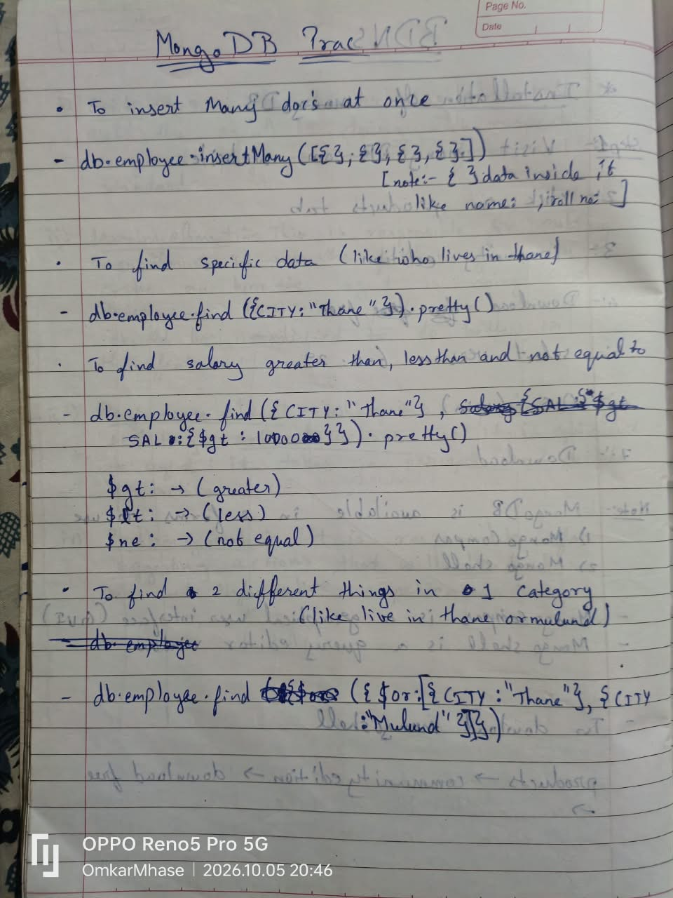

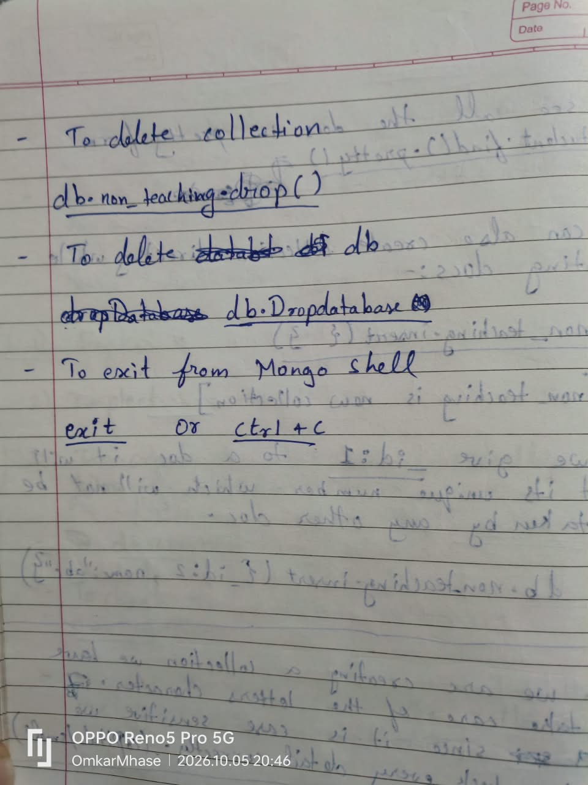
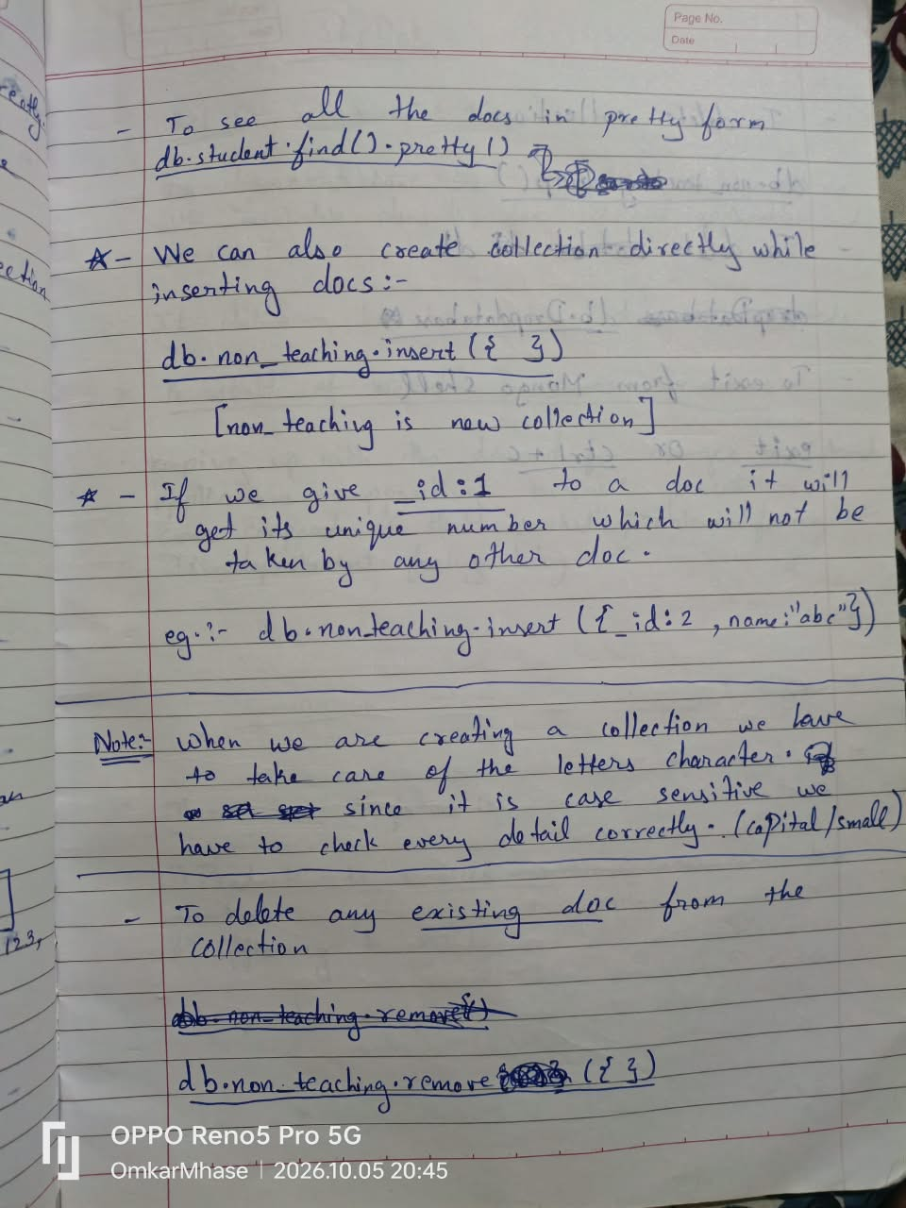

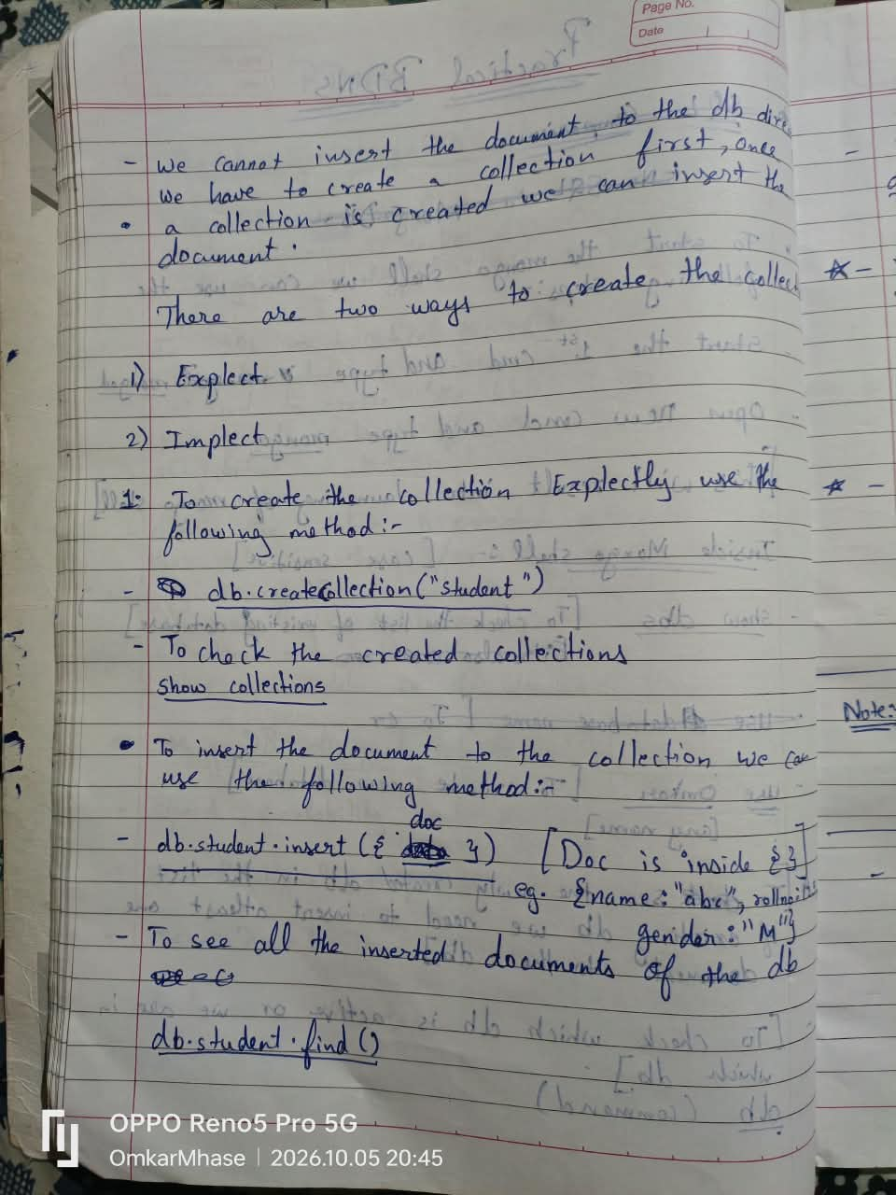
Practical 1: MongoDB Basics 1
A. Database Operations
● List all available databases using show dbs.
● Create or switch to a database named 'Romal' by running use Romal.
● Create a new collection inside the database using
db.createCollection("Practical1").
● Drop the current database completely using db.dropDatabase().
B. Collection Operations
● View all collections within the active database using show collections.
● Create a collection named 'Practicall' using
db.createCollection("Practicall").
● Drop the specific collection using db.Practicall.drop().
C. Document CRUD Operations
● Insert: Add a new document using db.Doc.insert({Name:"Romal", Age:10}).
● Query: Retrieve documents from the collection with db.Doc.find().
● Update: Modify an existing document using db.Doc.update({Name: "Romal"},
{$set: {Age:20}}).
● Delete: Remove specific documents using db.Doc.remove({"Name": "Romal"}).
D. Employee Queries
● Switch to the 'Employee' database using use Employee.
● Insert multiple employee records at once using db.col.insertMany().
● Find all employees living in Mumbai: db.col.find({City: "Mumbai"}).
● Find employees in Kurla with a salary greater than 19,000: db.col.find({City:
"Kurla", Salary: {$gt:19000}}).
● Find employees with a salary greater than or equal to 10,000 but less than 20,000:
db.col.find({Salary: {$gte:10000, $lt:20000}}).
● Find employees living in either Mumbai or Thane with a salary above 10,000:
db.col.find({$or: [{City: "Mumbai"}, {City: "Thane"}], Salary:
{$gt:10000}}).
● Find employees working as Developers or Testers whose salary is not equal to 10,000:
db.col.find({$or: [{Dept: "Developer"}, {Dept: "Tester"}],
Salary: {$ne:10000}}).

Practical 2: MongoDB Basics 2
A. Inserting and Managing Data
● Switch to the 'Data' database with use Data.
● Insert multiple user profiles (including Name, Age, Country, and Gender) using
db.col.insertMany().
● Update the country to "UK" for all female users: db.col.updateMany({Gender:
"Female"}, {$set: {Country: "UK"}}).
● Add a new field named "Company" (with the value "Wipro") to all documents:
db.col.updateMany({}, {$set: {Company: "Wipro"}}).
● Delete all documents where the user's gender is Male: db.col.remove({"Gender":
"Male"}).
B. Data Retrieval Queries
● Count the number of female users located in either India or the USA:
db.col.find({$or: [{Country: "India"}, {Country: "USA"}],
Gender:"Female"}).count().
● Display only the first name and age of female employees:
db.col.find({Gender:"Female"}, {Name:1,Age:1}).

Practical 3: Aggregate Functions
A. Collection Setup
● Switch to the 'Aggregate' database using use Aggregate.
● Insert a dataset of employees with their Name, Age, City, and Salary using
db.col.insertMany().
B. Using the Aggregation Pipeline
● Count by Group: Group by city and count the number of occurrences using
db.col.aggregate([{$group: {_id:"$City", cityCount: {$sum:1}}}]).
● Sum: Calculate the total salary per city using db.col.aggregate([{$group:
{_id:"$City", cityCount: {$sum:"$Salary"}}}]).
● Average: Find the average salary per city using db.col.aggregate([{$group:
{_id:"$City", cityCount: {$avg:"$Salary"}}}]).
● Minimum: Identify the lowest salary in each city using
db.col.aggregate([{$group:{_id:"$City", cityCount:
{$min:"$Salary"}}}]).
● Maximum: Identify the highest salary in each city using
db.col.aggregate([{$group: {_id: "$City", cityCount:
{$max:"$Salary"}}}]).
● First Record: Get the salary of the first document processed for each city using
db.col.aggregate([{$group: {_id:"$City", cityCount:
{$first:"$Salary"}}}]).
● Last Record: Get the salary of the last document processed for each city using
db.col.aggregate([{$group: {_id:"$City", cityCount:
{$last:"$Salary"}}}]).
● Add To Set: Create an array of all unique salaries per city using
db.col.aggregate([{$group: {_id:"$City", cityCount: {$addToSet:
"$Salary"}}}]).
● Push: Create an array of all salaries (including duplicate values) per city using
db.col.aggregate([{$group: {_id: "$City", cityCount:
{$push:"$Salary"}}}]).

PRACTICAL NO 3
Insert collection in the database and display all the record
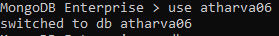
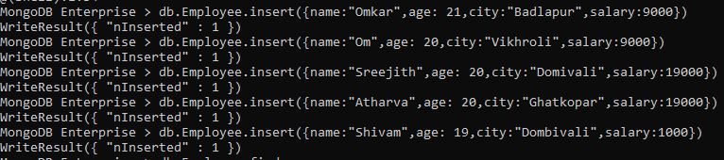
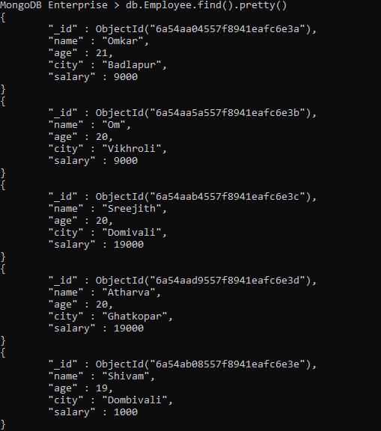
- Group by function to get count.
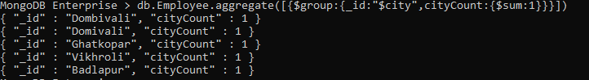
- Sum function.
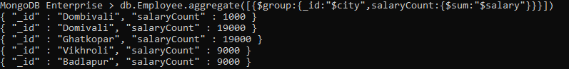
- Avg function.
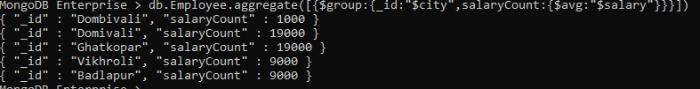
- Min, Max, First, Last function.
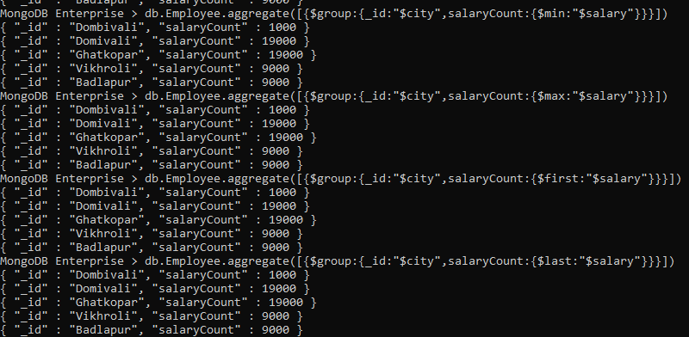
- addToSet function.
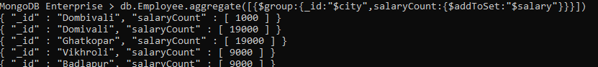
- Push function
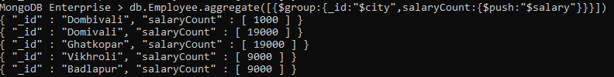
Note: Push function allows the duplicate value where as addToSet doesn’t.
Importing JSON in MongoDB Database:
Step 1 : Open cmd in admin mode and type mongod command
Step 2 : Again open new cmd in Admin mode and type mongo command.
Step 3 : Create a new Database by using use command.
Step 4 : Create a collection explicitly use create.Collection() method.
Step 5 : Open new cmd in Admin mode and type mongoimport –db database_name –collection collection_name <<path of the json file>>.
Step 6 : To check the json file is imported or not we will type find method in the mongoshell
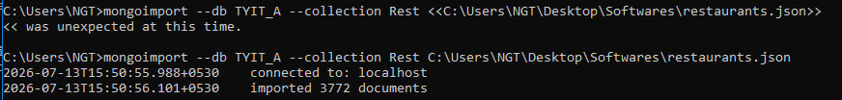
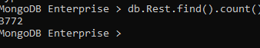

Practical 4: Java with MongoDB
Step 3: Now type the code of java for inserting the document to the mongodb.
Creating database in MongoDBusing Java
Step 1: Set the path of bin folder of java to the path variable of environment variable.
Step 2: Set the path of jar file to the environment variable by creating a new variable under
the system variables with the variable name as “classpath” and variable value as
“.;<complete_path_of_the_jar_file>;”
Step 5: Now execute the java file.
Step 4: Now start the mongo Shell.
Now use the created database by using the ”use” command.
Step 8: To check the document in the collectionwe can type the following command. -
“db.<collection_name>.find()”
Step 6: Switch to mongo Shell and type the following command to check database is created
or not.
- show dbs
Step 7: To check the created collection in the database, we use “show collections” command
Step 1:
Update the document in MongoDB using Java.
Delete the document in MongoDB using Java.

5:PHP WITH MONGODB
To connect with
Place
we can use the following steps:
file in the following folder
STEP 2 :Now we need to edit configuration file by adding the details of newly added
extension in the same file
php
STEP1:
mongodb
php_mongo.dll❖
❖
❖
❖
❖
STEP 3:
STEP 4: notepad
Launch mongo shell
Now type php code in
STEP5 : We have to save this php file in the htdocs folder of xaamp folder with the
extention .php(insert.php) ,while saving this make sure we are selecting save file tpe as
AllFiles.To execute this file we have to start XAMP server ,in XAMP server we need to
start Apache module and then click on Admin button, it will open brower with the
address localhost\dashboard.Here we need to replace dashboard with file name.
(localhost\insert.php)
❖ STEP 6 : To verify the output we can use mongoshell
>show dbs
>use MYDB269761(database name)
>show collections
>db.MyCol(collection name).find()
Update.php:Retrieve.php:Delete. Php

Practical 6: Python with MongoDB
Step 1: In order to connect python with MongoDB, we need to set a path of script folder of
python to system variables path variable of environment variable. If we are not able to
locate the path of python folder in the C Drive then we can use the windows search option
by typing “%localappdata%”. When you open this folder, we have “Program” folder and in
program folder we have python folder.
Step 2: Open new cmd and type “pip install pymongo”
Step 3: Start the MongoShell
Step 4: Now start the python IDLE and type the python code.
Step 5: After execution of python code, you may verify the output in the MongoShell.
PRACTICAL 6
Python with MongoDB
Step1: Set the path of Script folder of python to the system Variable of path
variable of environment variable (if the path of python folder is not found
then we can type %localappdata% in the main window’s search in this folder
we have program folder in the program folder we have python folder)
Step2: Now type the Following command in cmd in order to connect python
with mongodb in cmd:
pip install pymongo
Step3: Start new cmd and type mongod and start one more cmd and type
mongo as a result we will have mongo shell open.
Step4: Now start the python IDLE and type the code and run the code.
Step5: To verify the output we check in mongoshell
1) Insert
from pymongo import MongoClient
client =MongoClient('localhost',27017)
db = client.TYITDB269607
def insert():
try:
name1 =input("Enter the Name:")
age1 = input ("Enter the Age:")
dept1 = input("Enter the Department:")
pin1 = input("Enter the pin no:")
db.MyCol.insert_one({
"name":name1,
"age":age1,
"dept":dept1,
"pin":pin1
})
print("Inserted data successfully!")
except Exception:
print(str(e))
insert()
2) Update
from pymongo import MongoClient
client =MongoClient('localhost',27017)
db = client.TYITDB269607
def update():
try:
name1 =input("Enter the Name:")
age1 = input ("Enter the Age to Update:")
db.MyCol.update_one({"name":name1},{"$set":{"age":age1}})
print("\nRecords updated successfully!")
except Exception:
print(str(e))
update()
3) Read
from pymongo import MongoClient
client =MongoClient('localhost',27017)
db = client.TYITDB269607
def read():
try:
Col = db.MyCol.find()
print("\nAll data from database TYITDB269607.")
for MyCol in Col:
print(MyCol)
except Exception:
print(str(e))
read()
4) Delete
from pymongo import MongoClient
client =MongoClient('localhost',27017)
db = client.TYITDB269607
def delete():
try:
name1 =input("Enter the Name:")
db.MyCol.delete_one({"name":name1})
print("\nData deleted successfully!")
except Exception:
print(str(e)
delete()

Practical 7: Basic jQuery Selectors and Events
* Checking Element Contents: Create an HTML page that includes the jQuery library script.
Wrap your logic in a $(document).ready() function. Attach a .click() event to a specific button ID
that triggers a document.write() method to display text on the screen.
* Using Selectors: Target different DOM elements by chaining the .css() method to change their
background colors. Use a class selector ($(".classname")), an ID selector ($("#idname")), and
an element selector ($("h2")).
* Handling Multiple Events: Implement various mouse and form events on a single page. Attach
a .hover() function to a button, use the .on() method to listen for clicks on a paragraph, utilize
.off() to remove an event listener dynamically, and use .trigger() to simulate a user action
programmatically.

Practical 8: jQuery Effects and Animations
* Show and Hide: Create two buttons that call the .hide() and .show() methods on a paragraph
element to toggle its visibility entirely.
* Simple Toggle: Use a single button tied to the .toggle() method to alternate a paragraph's
visibility back and forth.
* Fade In and Fade Out: Implement the .fadeOut() and .fadeIn() methods, passing a time
parameter (like 5000 milliseconds) so the element gradually disappears and reappears.
* Fade Toggle: Combine the fading actions into a single button by calling the .fadeToggle()
method.
* Slide Effects: Use the .slideUp() and .slideDown() methods on separate buttons to hide and
reveal text using a vertical sliding motion.
* Slide Toggle: Attach the .slideToggle() method to a button to combine both the slide-up and
slide-down behaviors.
* Mouseleave Event: Use the .mouseleave() event on a paragraph to trigger a browser alert()
dialog box when the user moves their cursor off the element.
* Basic Animation: Target an image element and use the .animate() method to change its CSS
left property, causing it to move across the screen.
* Multiple Animations: Call the .animate() method on a <div> element and pass in a list of CSS
properties simultaneously (such as width, height, opacity, and positioning) to perform a complex
animation.
* Method Chaining: Link multiple jQuery actions together in a single, continuous statement. For
example, attach .css(), .slideUp(), and .slideDown() consecutively to the same element.

Practical 9: Callbacks and DOM Manipulation
* Using Callback Functions: Pass a function as a secondary parameter to an effect method,
such as .hide("slow", function() {...}). This ensures an alert box only triggers after the hiding
animation is completely finished.
* Getting and Setting Text: Use the .text() method with no parameters to read the plain text of
an element into a variable, and use .text("New String") to replace the element's content.
* Getting and Setting HTML: Utilize the .html() method to read or replace content. Unlike .text(),
.html() will parse and render HTML tags (like bold or underline formatting) instead of treating
them as literal text strings.

Practical 10: Working with JSON in JavaScript
* Creating JSON Strings: Initialize a JavaScript object containing key-value pairs (e.g., name,
age, and department). Use the JSON.stringify() method to convert the object into a formatted
JSON string. You can also pass an array of specific keys to JSON.stringify() to filter which data
is included in the output.
* Parsing JSON with a Reviver: Convert a JSON string back into a functional JavaScript object
using JSON.parse(). Pass a custom "reviver" function as the second parameter to selectively
filter out or modify specific keys during the parsing process.
* Iterating Over JSON: After parsing a JSON string into a JavaScript object, write a for...in loop
to iterate through it, printing each property key and its corresponding value to the screen using
document.writeln().

