Week 7 Homework — Blue Group (Visual)
Three Levels of Government in Australia
Australia has a special division of government. This system started on 1 January 1901. In that year, six separate colonies joined together to form one country. We call this historic event Federation. Before this, the colonies had different borders, rail lines, and laws. To join them together, the leaders wrote a rulebook for our laws. We call this rulebook the Australian Constitution. Today, we have three levels of government: federal, state, and local. Each level has different leaders and duties to help our people.
The first level is the Federal Government. It is based in Canberra, our capital city. The Prime Minister is the leader of this level. They meet with other representatives at Parliament House. This level looks after the whole country. They manage defence, borders, and immigration. They also handle ties with other countries. They run the post and our currency, like our coins and notes.
The second level is State Government. Australia has six states and two territories. State leaders are based in capital cities like Sydney, Brisbane, and Melbourne. The leader of a state is called the Premier. This level runs public services inside state borders. They manage state schools and hospitals. They run the police, roads, and train systems. State laws control speed limits and school rules.
The third level is Local Government. This is run by local councils to look after suburbs and towns. The leader is usually called the Mayor. Councils look after local community needs. They manage local roads, parks, and public libraries. They collect weekly waste and recycling bins. They also handle pet registrations for dogs and cats. They clean up streets and plan local festivals.
These three levels of government work together as a big team. This division of work keeps Australia safe, organised, and happy.
Part A: Reading Comprehension
1. What system of government did Australia set up in 1901?
A. A single state system B. A federal system
C. A local council system D. A royal system
2. What is the rulebook for Australia's laws called?
A. The Federation B. The Parliament
C. The Constitution D. The Local council
3. Who is the leader of the Federal Government?
A. The Premier B. The Mayor
C. The Prime Minister D. The Governor
4. Where does the Federal Government meet?
A. Brisbane B. Sydney
C. Canberra D. Melbourne
5. Which level of government is responsible for managing national defence and immigration?
A. Federal Government B. State Government
C. Local Government D. All of the above
6. Who is the leader of a state government?
A. The Prime Minister B. The Mayor
C. The Premier D. The President
7. Which public service is run by the state government?
A. Mail delivery B. National defence
C. State schools and hospitals D. Rubbish collection
8. Who runs local governments?
A. The Premier B. Local councils
C. The Prime Minister D. The High Court
9. What is the leader of a local council usually called?
A. The Premier B. The Mayor
C. The Prime Minister D. The Shire President
10. Which task is a responsibility of local councils?
A. Running public libraries and waste bins B. Controlling the national currency
C. Managing public trains and major highways D. Handling international immigration
11. How many states are in Australia?
A. Three B. Six
C. Eight D. Two
12. What is the main purpose of the division of work among the three levels?
A. To make laws harder to understand B. To keep Australia safe and happy by dividing duties
C. To give the Prime Minister absolute control D. To reduce the number of suburbs
13. Where is the Premier based?
A. In the capital city of their state B. In Canberra
C. In Parliament House D. In local suburbs
14. Which of the following is a federal government duty?
A. Local road repairs B. Rubbish collections
C. Post and currency D. Running local schools
15. What do local councils do for pet dogs and cats?
A. They train them for public parks B. They handle pet registrations
C. They buy their pet food D. They write laws about pet diets
Part B: Mathematics Word Problems
16. A fruit stall seller buys 8 boxes of mangoes for $35 per box. Each box has 12 mangoes. If he sells all mangoes for $4 each, what is his total profit?  A. $104 B. $280  C. $100 D. $204  17. A school is given a sports gear budget of $1200. The budget is divided using a bar model. Footballs take 3 parts, Basketballs take 2 parts, and Netballs take 1 part. How much money is spent on Footballs?  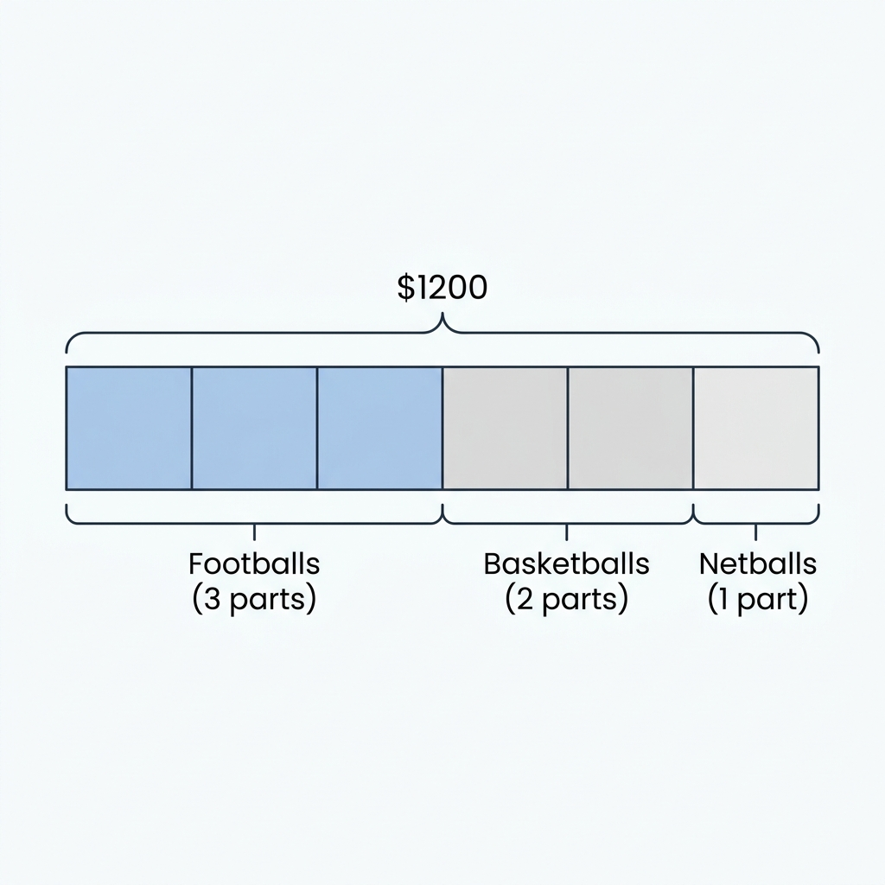  A. $400 B. $600  C. $200 D. $800  18. A company needs to transport 340 boxes of paper. Each delivery truck can hold exactly 15 boxes. If each truck trip costs $45, how much will it cost to transport all the boxes?  A. $1020 B. $1035  C. $990 D. $1080  19. Notebooks are sold for $4.50 each or in packs of 12 for $48. If a teacher needs 36 notebooks, how much money does she save by buying the packs of 12 instead of individual notebooks?  A. $18 B. $162  C. $144 D. $24  20. Five friends split a dinner bill. The total bill was $176. They want to leave a tip of $24. If they split the total cost evenly, how much does each person pay?  A. $35.20 B. $40  C. $38.40 D. $44  21. A farmer is planting potato crops. He has a field that is 45 metres long and 24 metres wide. What is the total area of the field?  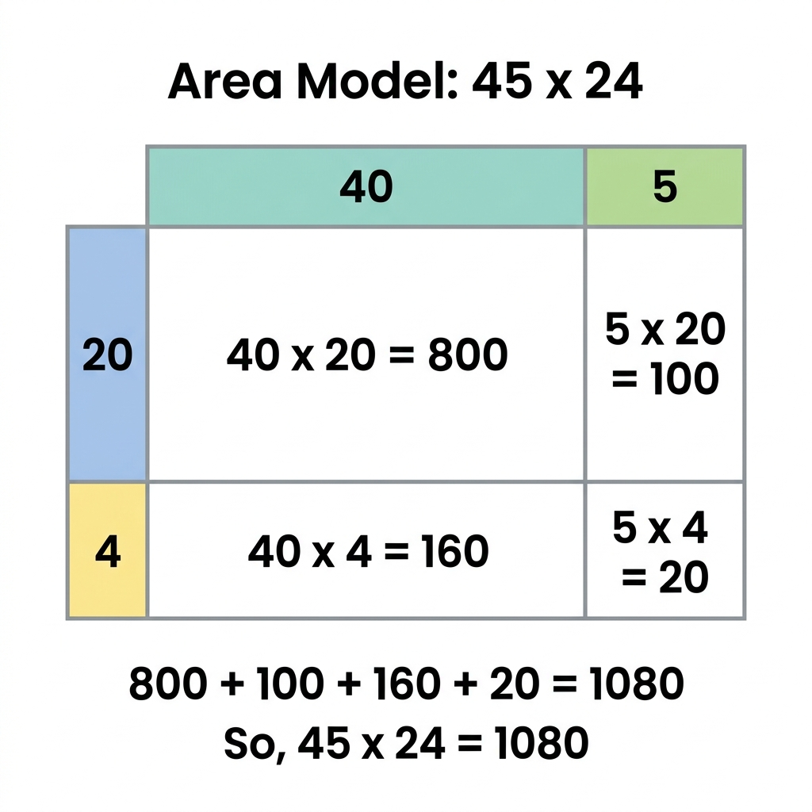  A. 1080 square metres B. 900 square metres  C. 980 square metres D. 1120 square metres  22. An office buys 25 office chairs for $85 each. They are given a bulk discount of $120 on the total bill. What is the final amount they need to pay?  A. $2125 B. $2005  C. $2245 D. $1985  23. A gym membership costs $15 per week. A member signs up for a year (52 weeks) and pays a sign-up fee of $50. If they decide to pay the total amount upfront, how much do they pay?  A. $780 B. $830  C. $730 D. $850 | 24. A factory makes 750 bars of soap daily. The soap is packed in boxes of 8. Any leftover soap is donated. How many full boxes of soap do they pack in a week of 5 working days?  A. 468 boxes B. 460 boxes  C. 465 boxes D. 472 boxes  25. A cinema ticket costs $18. On Tuesday, tickets are 20% off. A family of 2 adults and 3 children buys tickets on a Tuesday. How much do they save in total compared to a weekend?  A. $18 B. $15  C. $20 D. $24  26. A company's monthly budget is $8000. Rent is $3000, salaries is $4000, and the rest is for utilities. If the utility budget is split equally among 4 utility types, how much is spent on electricity?  A. $250 B. $500  C. $1000 D. $750  27. A student invests $200 in a small business. Over 6 months, their investment multiplies by 3. They then withdraw all the money and split it equally into 4 savings accounts. How much goes into each account?  A. $150 B. $600  C. $100 D. $200  28. Brand A sells a box of 18 pencils for $9. Brand B sells a box of 24 pencils for $10.80. Which brand is better value, and what is the difference in cost per pencil?  A. Brand A is better by 5 cents B. Brand B is better by 5 cents  C. Brand A is better by 10 cents D. Brand B is better by 10 cents  29. A community group wants to raise $5000. They sell 350 tickets at $12 each. If their expenses for the event were $750, how much more money do they need to raise to meet their target?  A. $1550 B. $3450  C. $800 D. $1200  30. An employee earns $24 per hour for standard hours (35 hours per week) and $36 per hour for overtime. If they work 42 hours in a week, what is their total wage?  A. $840 B. $1092  C. $1008 D. $1152

