Week 7 Homework — Green Group (Visual)
Who Looks After Our Country?
Australia is a big country. We have three levels of government. They help look after us. Each level has different bosses and jobs. They work as a team.
The first level is the Federal Government. It is based in Canberra. Canberra is our main city. The boss is the Prime Minister. This level looks after the whole country. They take care of our army and mail. They also make the coins and notes we use.
The second level is the State Government. Australia has six states. The boss of each state is the Premier. They look after things inside their state. Their jobs are running schools and health care. They also run the trains and police.
The third level is the Local Council. The boss is usually the Mayor. Councils look after suburbs and towns. They have very easy duties. They keep our streets clean and safe. They collect weekly rubbish and recycling. They also look after parks and libraries.
All three levels work together. This makes Australia a happy place to live.
Part A: Reading Comprehension
1. How many levels of government does Australia have?
A. One B. Two
C. Three D. Four
2. Where is the Federal Government based?
A. Sydney B. Canberra
C. Melbourne D. Brisbane
3. Who is the boss of the Federal Government?
A. The Premier B. The Prime Minister
C. The Mayor D. The President
4. What does the Federal Government look after?
A. Rubbish trucks B. National army and mail
C. Local parks D. State hospitals
5. How many states does Australia have?
A. Four B. Five
C. Six D. Seven
6. Who is the boss of a state government?
A. The Mayor B. The Premier
C. The Prime Minister D. The Captain
7. Which job belongs to state governments?
A. Collecting weekly rubbish B. Running schools and hospitals
C. Delivering national mail D. Making coins
8. Who runs the local government?
A. The Premier B. The Prime Minister
C. The Local Council D. The Police Force
9. Who is the boss of a local council?
A. The Premier B. The Prime Minister
C. The Mayor D. The Principal
10. What is a main duty of local councils?
A. Delivering mail to our houses B. Collecting weekly rubbish and recycling
C. Managing national defence D. Running the trains
11. What is Canberra in Australia?
A. A state B. Our capital city
C. A local council D. An army base
12. Who looks after train and police systems?
A. The Federal Government B. The State Government
C. The Local Council D. The Mayor
13. Which of these is looked after by local councils?
A. National coins B. Post boxes
C. Parks and libraries D. Hospitals
14. How do the three levels of government work?
A. They fight for control B. They work as a big team
C. They have the same boss D. They do the same jobs
15. What is one thing the Federal Government makes?
A. Rubbish bins B. Coins and notes
C. Local parks D. State trains
Part B: Mathematics Word Problems
16. A baker puts 6 cupcakes into each box. If he has 8 boxes, how many cupcakes does he have in total?  A. 48 B. 42  C. 54 D. 36  17. Share 28 strawberries equally among 4 children. How many strawberries does each child get?  A. 6 B. 7  C. 8 D. 5  18. A visual group of cookies. There are 4 plates, and each plate has 5 cookies. How many cookies are there in total?  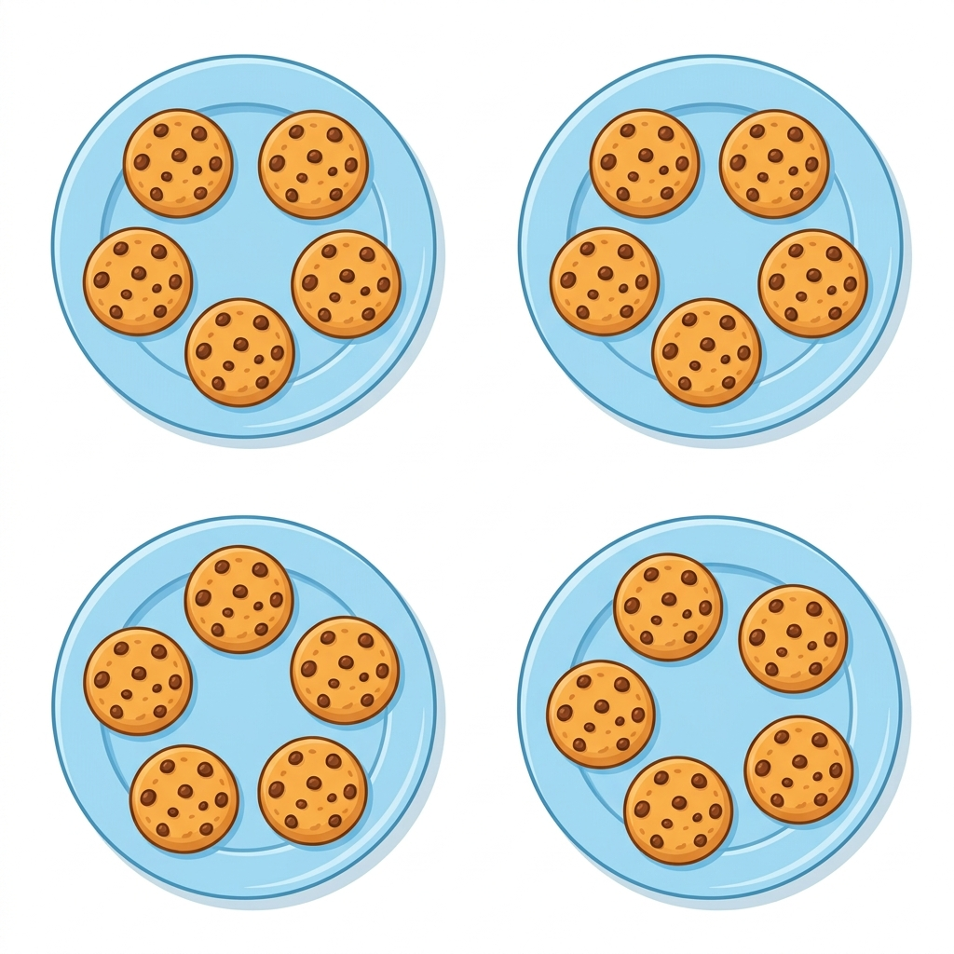  A. 15 B. 25  C. 20 D. 10  19. If 1 toy car costs $4, how much do 7 toy cars cost?  A. $28 B. $24  C. $32 D. $20  20. A gardener plants 5 rows of carrots. Each row has 9 carrots. How many carrots are planted in total?  A. 40 B. 50  C. 45 D. 35  21. A teacher has 30 pencils. She shares them equally among 4 table groups. How many pencils are left over?  A. 2 B. 4  C. 1 D. 0  22. Tom has a $20 note. He buys 3 books for $5 each. How much change does he get?  A. $5 B. $15  C. $10 D. $8  23. 36 children are split into equal teams of 4 for a sports day. How many teams are there?  A. 8 B. 9  C. 10 D. 7 | 24. A box of chocolates has 4 rows of chocolates, with 8 chocolates in each row. How many chocolates are in the box?  A. 24 B. 36  C. 32 D. 40  25. 3 children want to share a pile of coins. The diagram shows 15 coins of $2 value. How much money does each child get if they share the coins equally?  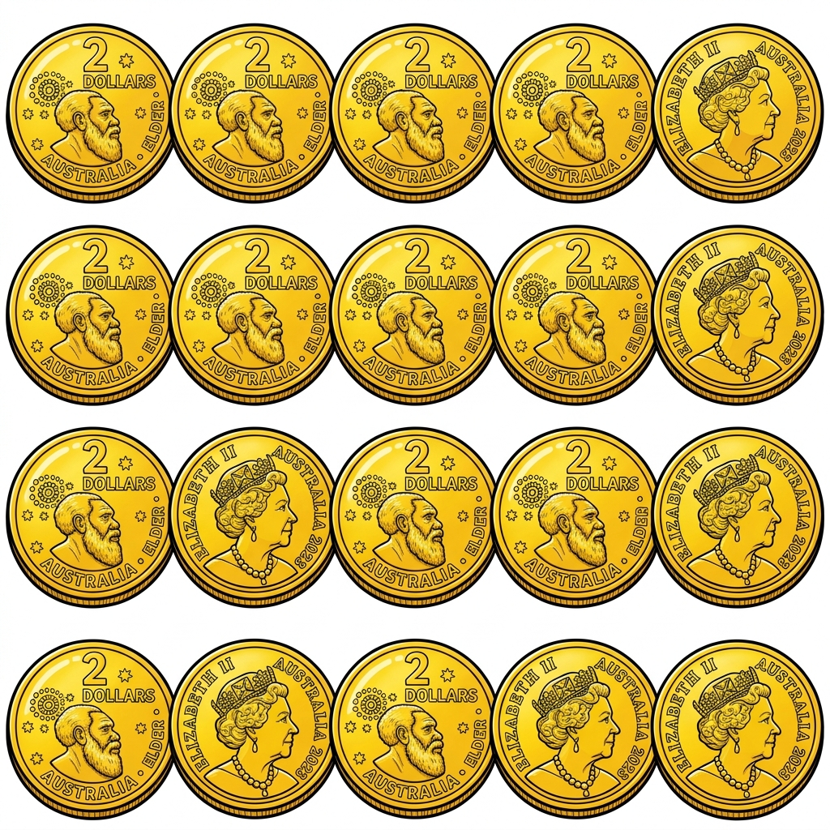  A. $5 B. $10  C. $6 D. $8  26. A student buys a pack of 10 stickers for $2. She sells each sticker to her classmates for 50 cents. What is her profit if she sells all 10 stickers?  A. $3 B. $5  C. $2 D. $4  27. A farmer packs 48 eggs into cartons. Each carton holds 6 eggs. How many cartons does he need?  A. 7 B. 8  C. 9 D. 6  28. A family of 4 goes to the zoo. A child ticket costs $8. How much do they pay in total for the 4 children?  A. $28 B. $36  C. $32 D. $24  29. A pack of 45 sweets is shared equally among 9 party bags. How many sweets go into each bag?  A. 5 B. 6  C. 4 D. 9  30. A pencil case costs $6 and a ruler costs $2. If a parent buys 3 pencil cases and 3 rulers, how much do they pay in total?  A. $24 B. $18  C. $20 D. $22

