Week 7 Homework — Red Group (Visual)
The Australian Federal System: A Division of Power
Australia became a single nation on 1 January 1901. Before this, the six British colonies acted like separate countries. They had their own border posts, railways, and stamps. On this historic day, they joined together. We call this big event Federation. It created the Commonwealth of Australia. To rule this huge continent, the founders chose a federal system of government. In this system, power is split. There is a central national government and regional state governments.
Today, Australia is governed by three levels of government: federal, state, and local. Each level has its own unique jobs. This division ensures that no single level is overwhelmed by tasks, keeping our daily lives running smoothly and keeping Australia safe and happy.
Our supreme law is the Australian Constitution. This important rulebook guides our system. It defines which level of government makes different laws. Under this rulebook, the Federal Parliament looks after the whole nation. These are called national powers. They include defence, trade, immigration, and currency. The Federal Parliament is made of two houses, the Senate and the House of Representatives. They represent voters from all over the country. The Federal Government meets at Parliament House in Canberra and is led by the Prime Minister.
State and territory governments manage services inside their own borders. They do this using residual powers. These are the powers left over that are not listed in the Constitution as federal duties. Under these residual powers, state parliaments pass laws specifically for their state citizens, such as school rules and road speed limits. They manage crucial public services, which include school education and hospitals. They also run the police, fire services, and public train networks. Premiers lead these governments in capital cities.
The third level is local government. Interestingly, local government is not mentioned anywhere in the Australian Constitution. Instead, local councils are made by state laws and get their power from state parliaments. They look after local community needs. Their tasks include local road repairs, weekly rubbish collections, local parks, and libraries. Councils also handle pet registrations for dogs and cats and plan community festivals. The head of a council is called the Mayor.
Finally, we separate our powers. This keeps any single group from having too much control. First is the Legislature, which debates and makes laws. Second is the Executive, which carries out and administers the laws. Third is the Judiciary. The High Court rules on the Constitution and solves legal disputes. This keeps our nation safe.
Part A: Reading Comprehension
1. What was the historical event that united six colonies on 1 January 1901?
A. Federation B. Constitution
C. Separation of Powers D. The Commonwealth
2. Which document acts as the supreme law of Australia?
A. The Magna Carta B. The Australian Constitution
C. The Separation of Powers D. The Canberra Rulebook
3. Which of the following is a power reserved for the Federal Parliament under the Constitution?
A. School education B. Local park upkeep
C. National defence and currency D. Garbage collection
4. Where is the Federal Government based?
A. Sydney B. Melbourne
C. Canberra D. Brisbane
5. What kind of powers do state and territory governments hold?
A. Exclusive powers B. Residual powers
C. Delegated council powers D. Judicial powers
6. Who establishes local governments in Australia?
A. The Federal Parliament B. The Constitution
C. State laws D. The High Court
7. What are the three branches of the Separation of Powers doctrine?
A. Federal, State, and Local B. Legislature, Executive, and Judiciary
C. Prime Minister, Premier, and Mayor D. Parliament, Cabinet, and Council
8. What is the primary role of the Legislature?
A. To administer and carry out laws B. To debate and make laws
C. To interpret the Constitution D. To resolve local council fights
9. Which branch is responsible for carrying out and administering the laws?
A. The Executive B. The Legislature
C. The Judiciary D. The High Court
10. Which body interprets the Constitution and resolves legal fights?
A. The Legislature B. The Executive
C. The High Court D. The Local Council
11. Why did the founders create a federal system of government?
A. To allow the colonies to remain fully independent B. To divide power between a central national government and regional state governments
C. To eliminate the need for a national currency D. To give local councils absolute authority
12. Which public service is specifically managed by state and territory governments?
A. International trade and immigration B. Public libraries and town planning
C. School education and hospitals D. National security and post
13. What is the primary function of the Separation of Powers?
A. To speed up the lawmaking process B. To keep any single group from having too much control
C. To give the High Court legislative power D. To allow the Prime Minister to make all laws
14. Which level of government is NOT mentioned in the Australian Constitution?
A. Federal Government B. State Government
C. Local Government D. None of the above
15. Under what conditions do states manage schools and hospitals?
A. As delegated tasks from local councils B. As exclusive national powers
C. As residual powers within their borders D. As judicial mandates from the High Court
Part B: Mathematics Word Problems
16. A fruit stall seller buys 8 boxes of mangoes for $35 per box. Each box has 12 mangoes. If he sells all mangoes for $4 each, what is his total profit?  A. $104 B. $280  C. $100 D. $204  17. A school is given a sports gear budget of $1200. The budget is divided using a bar model. Footballs take 3 parts, Basketballs take 2 parts, and Netballs take 1 part. How much money is spent on Footballs?  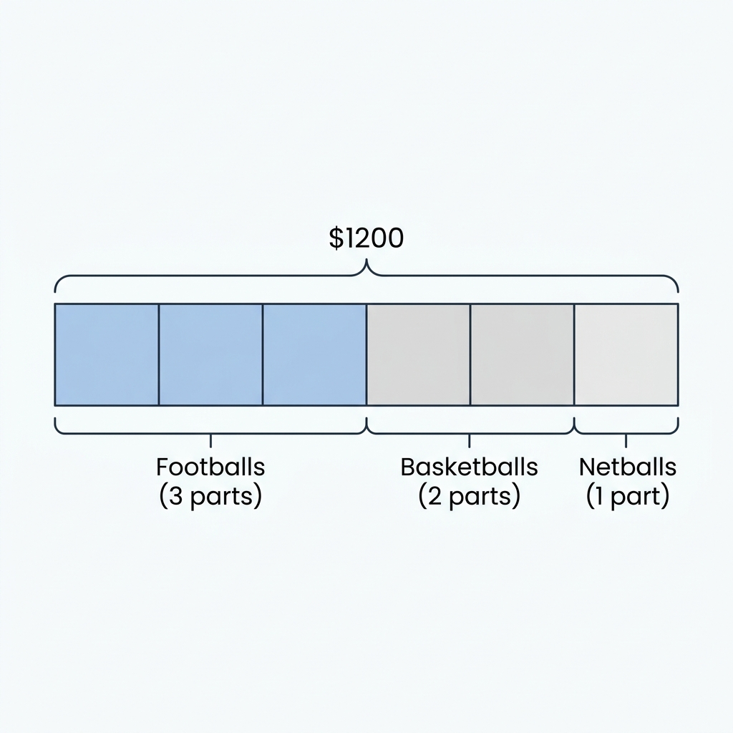  A. $400 B. $600  C. $200 D. $800  18. A company needs to transport 340 boxes of paper. Each delivery truck can hold exactly 15 boxes. If each truck trip costs $45, how much will it cost to transport all the boxes?  A. $1020 B. $1035  C. $990 D. $1080  19. Notebooks are sold for $4.50 each or in packs of 12 for $48. If a teacher needs 36 notebooks, how much money does she save by buying the packs of 12 instead of individual notebooks?  A. $18 B. $162  C. $144 D. $24  20. Five friends split a dinner bill. The total bill was $176. They want to leave a tip of $24. If they split the total cost evenly, how much does each person pay?  A. $35.20 B. $40  C. $38.40 D. $44  21. A farmer is planting potato crops. He has a field that is 45 metres long and 24 metres wide. What is the total area of the field?  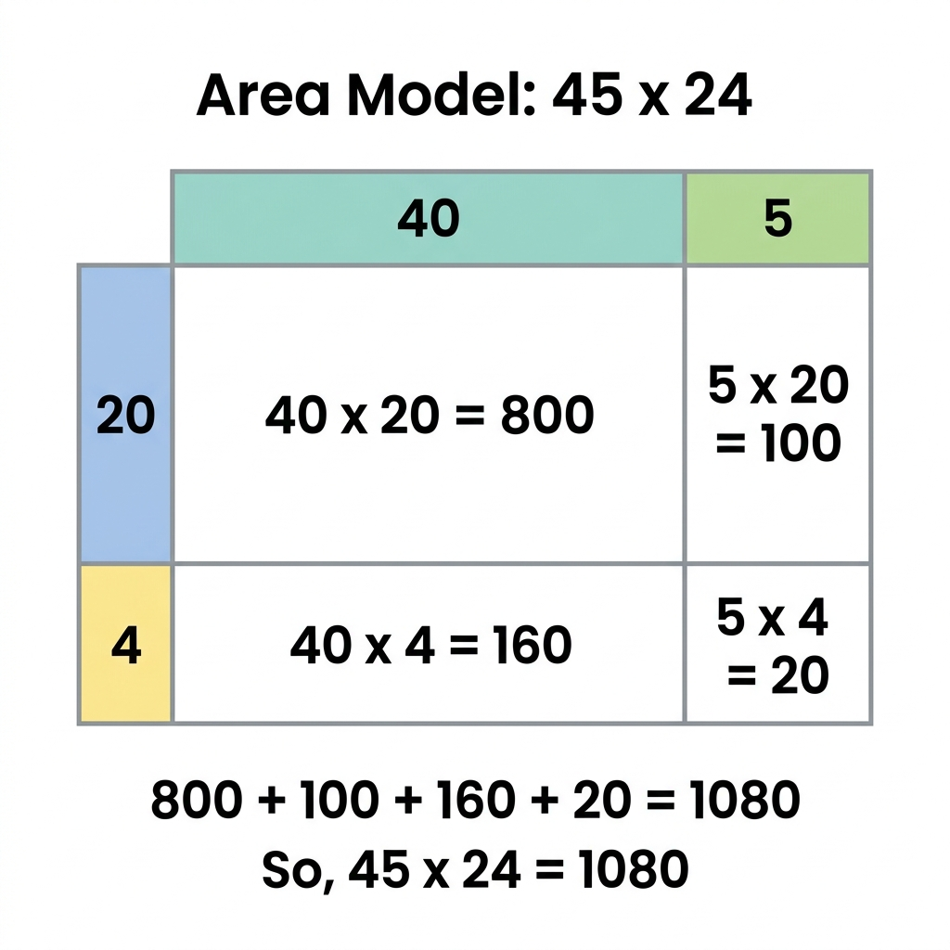  A. 1080 square metres B. 900 square metres  C. 980 square metres D. 1120 square metres  22. An office buys 25 office chairs for $85 each. They are given a bulk discount of $120 on the total bill. What is the final amount they need to pay?  A. $2125 B. $2005  C. $2245 D. $1985  23. A gym membership costs $15 per week. A member signs up for a year (52 weeks) and pays a sign-up fee of $50. If they decide to pay the total amount upfront, how much do they pay?  A. $780 B. $830  C. $730 D. $850 | 24. A factory makes 750 bars of soap daily. The soap is packed in boxes of 8. Any leftover soap is donated. How many full boxes of soap do they pack in a week of 5 working days?  A. 468 boxes B. 460 boxes  C. 465 boxes D. 472 boxes  25. A cinema ticket costs $18. On Tuesday, tickets are 20% off. A family of 2 adults and 3 children buys tickets on a Tuesday. How much do they save in total compared to a weekend?  A. $18 B. $15  C. $20 D. $24  26. A company's monthly budget is $8000. Rent is $3000, salaries is $4000, and the rest is for utilities. If the utility budget is split equally among 4 utility types, how much is spent on electricity?  A. $250 B. $500  C. $1000 D. $750  27. A student invests $200 in a small business. Over 6 months, their investment multiplies by 3. They then withdraw all the money and split it equally into 4 savings accounts. How much goes into each account?  A. $150 B. $600  C. $100 D. $200  28. Brand A sells a box of 18 pencils for $9. Brand B sells a box of 24 pencils for $10.80. Which brand is better value, and what is the difference in cost per pencil?  A. Brand A is better by 5 cents B. Brand B is better by 5 cents  C. Brand A is better by 10 cents D. Brand B is better by 10 cents  29. A community group wants to raise $5000. They sell 350 tickets at $12 each. If their expenses for the event were $750, how much more money do they need to raise to meet their target?  A. $1550 B. $3450  C. $800 D. $1200  30. An employee earns $24 per hour for standard hours (35 hours per week) and $36 per hour for overtime. If they work 42 hours in a week, what is their total wage?  A. $840 B. $1092  C. $1008 D. $1152

