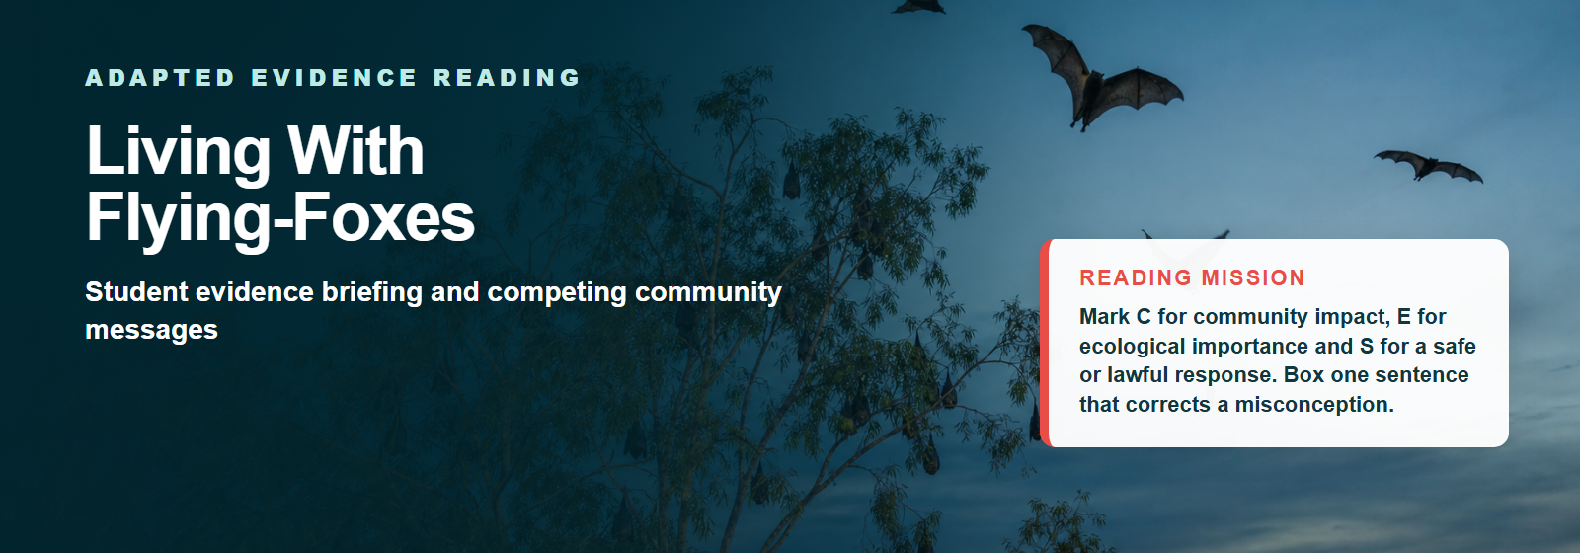

1 | Night travellers and daytime camps

Flying-foxes are large fruit- and nectar-eating bats. They are nocturnal: they rest together in trees during the day, then fly out around dusk to feed. The trees used for resting and breeding are called a camp or roost. Food and camp use change with flowering, fruiting and seasons, so numbers at a camp can rise, fall or move.
As flying-foxes travel between feeding areas, they can carry pollen and seeds. This helps native forests reproduce and connect across the landscape. Their long-distance movement makes them important pollinators and seed dispersers. Australia monitors flying-fox populations because grey-headed and spectacled flying-foxes are nationally listed as threatened.
2 | Why camps appear near people

Flying-foxes need flowering trees, feeding habitat and safe places to rest. Forest loss and fragmentation have reduced some natural habitat. Remaining patches of trees in towns, parks and along waterways can become useful camp sites. This can bring wildlife and people into closer contact.
A large or seasonal camp can create real challenges. Residents may experience noise, strong odour, droppings on cars or washing, damaged vegetation and interrupted sleep. These impacts are not imaginary simply because flying-foxes are ecologically valuable. A fair community message should describe the exact impact instead of labelling the animals.

Quick evidence check
What could be checked? | What detail would make it precise?
The number of bats at a camp | Place, date, counting method and species
Residents reported noise | Who was asked, how many people and when
Flying-foxes move seeds | Which species, plants, distance and research source

Language alert
“A camp is present beside the park” is checkable. “A disgusting invasion has stolen our park” adds loaded judgement and metaphor.

Word help
nocturnal - active at night
camp or roost - trees where flying-foxes rest and breed
pollinator - an animal that moves pollen between flowers
fragmentation - habitat broken into smaller patches
Evidence can hold two truths
Ecological value and community impact can both be true. Strong evidence describes each one precisely.

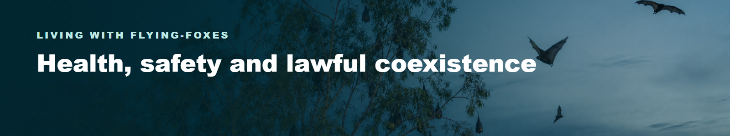

3 | What the health advice actually says

Queensland Government advice says that catching disease directly from flying-foxes is extremely unlikely.
Australian Bat Lyssavirus can be transmitted through an untreated bite or scratch from an infected bat. Living, walking or playing near a camp does not expose a person to the virus. There is no evidence that Hendra virus passes directly from flying-foxes to people.
No touch means safe distance
Never touch, feed or try to rescue a flying-fox. Keep people and pets away from an injured or grounded bat and contact a trained, vaccinated wildlife rescuer. If a person is bitten or scratched, seek medical advice immediately.

4 | Practical responses

People living near a seasonal camp can reduce some impacts by planning ahead. Official suggestions include bringing washing in at night, parking vehicles under cover, covering outdoor items and maintaining buildings or water systems appropriately. Avoiding disturbance can also reduce extra noise and stress.
Flying-foxes and their roosts are protected under Queensland conservation law. Some low-impact activities and council management actions are allowed only when current rules and codes are followed. Management must not harm the animals.
Moving a camp is not a simple “push them away” solution: flying-foxes are mobile, impacts can shift elsewhere, and disturbance can affect animals and nearby residents.

Practical, lawful action
Plan around nightly movement
Bring washing inside, cover outdoor items and park vehicles under cover where possible.

Leave rescue to trained people
Keep people and pets back from an injured or grounded bat and contact a vaccinated wildlife rescuer.

Check the current rules
Council action must follow Queensland conservation law, current codes and animal-welfare requirements.

Management is not simple
Disturbance can create more noise, stress animals and move impacts to another place. A strong response checks evidence, safety, law and likely consequences.

Evidence habit: When a health claim sounds alarming, check the pathway of exposure. “Near a camp” and “bitten or scratched by a bat” are not the same situation.

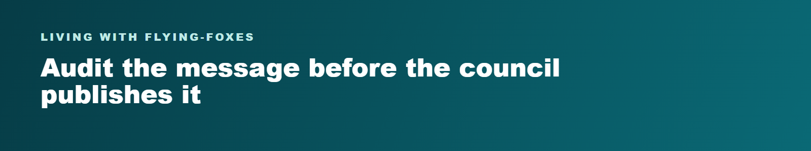
5 | A fair council message needs three things

These messages are fictional and deliberately positioned. Audit the language; neither is the official answer.
Accuracy  Include: Checkable facts and source limits  Avoid: Rumour or certainty without evidence | Respect  Include: Real community impacts and ecological value  Avoid: Mocking residents or demonising wildlife | Action  Include: Safe, lawful and practical steps  Avoid: Handling bats or unauthorised disturbance
Remember
Objective language is not automatically proven. A council should still check its source, date, place, measurement and limits.

Rivergum Council: two draft community messages
MESSAGE A | CLEAR THE CAMP NOW | MESSAGE B | WELCOME OUR NIGHT GARDENERS
RESIDENT ACTION GROUP DRAFT  A deafening invasion has taken over Rivergum Park. Families are forced to endure unbearable noise, foul smells and dangerous animals beside their homes. The camp is ruining our neighbourhood, and every responsible council would clear it immediately. Rivergum residents deserve their peaceful park back - no excuses and no delays. | WILDLIFE NETWORK DRAFT  Our wonderful night gardeners are bringing life to Rivergum Park. Flying-foxes move pollen and seeds through native forests, so their camp is a precious gift. Noise and droppings are only a tiny inconvenience, and there is nothing for residents to worry about. Everyone should welcome the camp and leave nature completely alone.
Audit before you advise
- Underline one checkable claim in each message.
- Circle one judgement, emotion or loaded phrase in each message.
- Place a star beside one statement that mixes information and positioning.
- Write one question the council should answer before publishing either message.
My question for Rivergum Council

Source trail: Evidence briefing: original summary of Queensland Government Living near flying-foxes; Queensland Government Bats and human health; Queensland Flying-fox roost management guideline; and Australian Government DCCEEW flying-fox monitoring and conservation pages. Full links are in the Teacher Guide. Checked 29 July 2026. Hero image is AI-generated and illustrative, not field evidence.

