Bushfire Safety: A Guide to Resilience in Australia
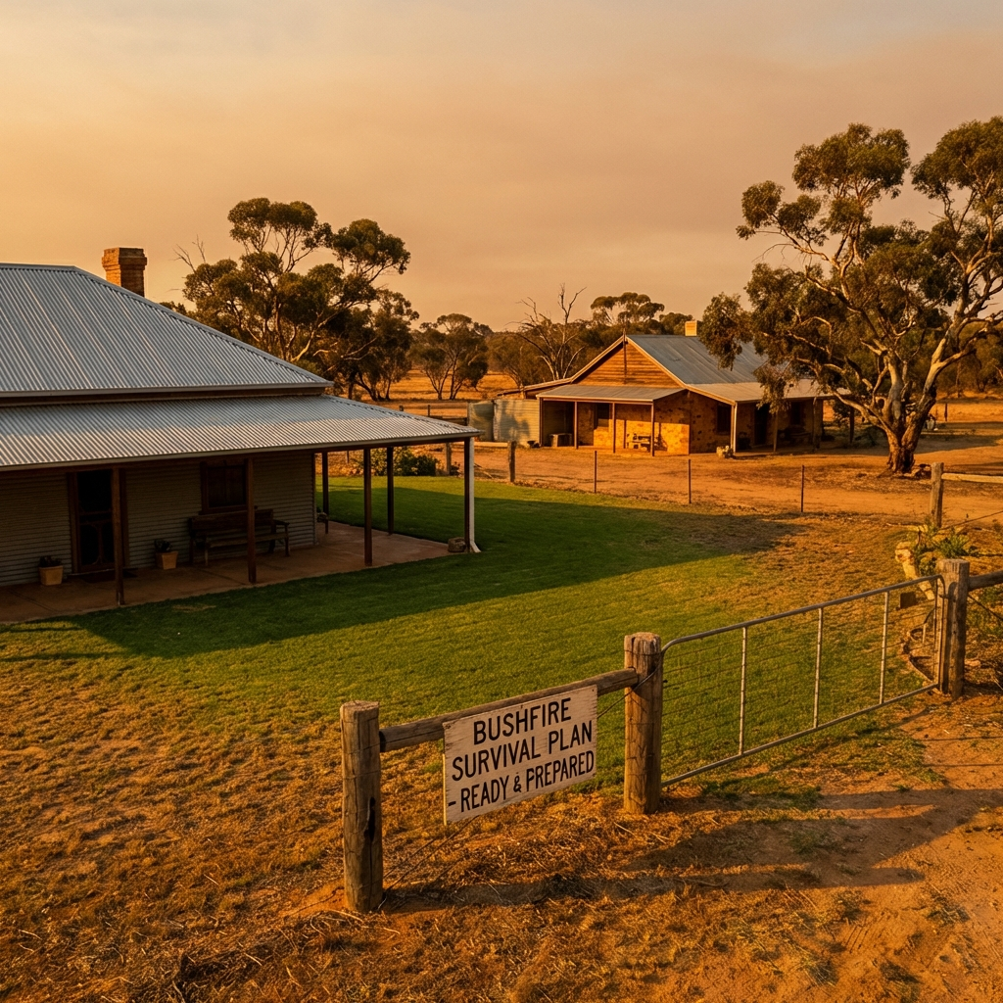

Overview
Bushfires are an intrinsic part of the Australian landscape, playing a vital role in ecosystem regeneration. However, they also present significant risks to lives, communities, and infrastructure. Understanding these risks and preparing effectively is essential for every Australian resident.

The Australian Fire Danger Rating System (AFDRS)
As of September 2022, a nationally consistent fire danger rating system is in place. It simple, action-oriented categories help you decide what to do on high-risk days.
Rating | Action Required
Catastrophic | For your survival, leave bushfire-risk areas. Your home cannot withstand fires in these conditions.
Extreme | Take action now to protect your life and property. Check your bushfire plan and ensure you are ready.
High | Be ready to act. There’s a heightened risk. Decided what you will do if a fire starts.
Moderate | Plan and prepare. Stay informed and be ready to act if a fire starts.

The Dangers of Bushfire

Ember Attack
Embers are burning twigs, bark, and leaves that can travel up to 30km ahead of a fire. They are the most common cause of home loss, as they ignite dry leaves in gutters or find their way into roof cavities.

Radiant Heat
Radiant heat is the heat from a fire that you can feel from hundreds of metres away. It is often intense enough to melt plastic, crack glass, and ignite wood without direct flame contact. Distance and solid barriers like brick walls provide the best protection.

Preparation Strategies
- Create and practice a Bushfire Survival Plan.
- Maintain your property: clear gutters, mow lawns, and remove flammable debris.
- Prepare an Emergency Kit with essentials like water, woollen blankets, and a battery-powered radio.
- Install metal mesh screens on windows and doors to prevent ember entry.

Emergency Contacts
Emergency: 000
VIC (CFA): 1800 226 226
NSW (RFS): 1800 679 737
QLD (QFES): 13 74 68

