Bushfire Safety: A Guide to Resilience in Australia
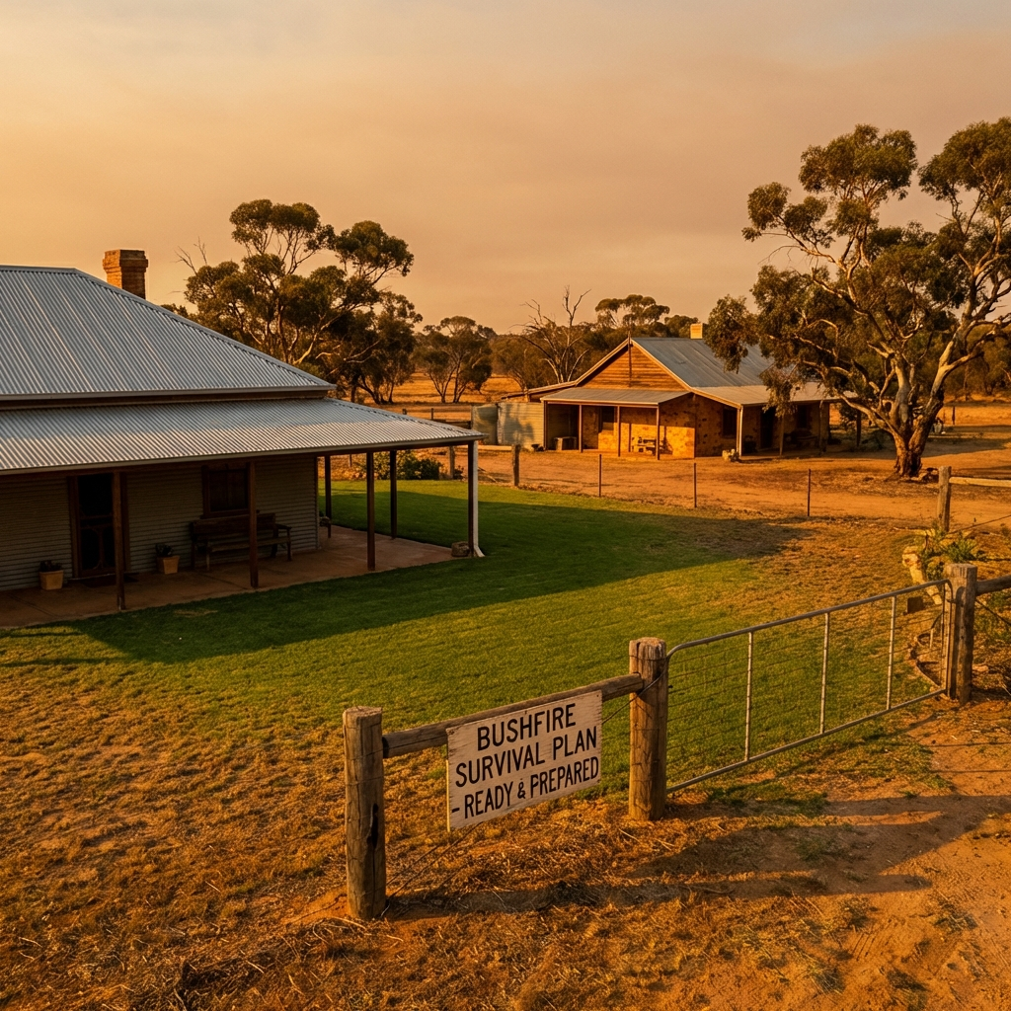

Overview
Bushfires are an intrinsic part of the Australian landscape, playing a vital role in ecosystem regeneration. However, they also present significant risks to lives, communities, and infrastructure. Understanding these risks and preparing effectively is essential for every Australian resident.

The Australian Fire Danger Rating System (AFDRS)
As of September 2022, a nationally consistent fire danger rating system is in place. It simple, action-oriented categories help you decide what to do on high-risk days.

Rating | Action Required
Catastrophic | For your survival, leave bushfire-risk areas. Your home cannot withstand fires in these conditions.
Extreme | Take action now to protect your life and property. Check your bushfire plan and ensure you are ready.
High | Be ready to act. There’s a heightened risk. Decided what you will do if a fire starts.
Moderate | Plan and prepare. Stay informed and be ready to act if a fire starts.

The Dangers of Bushfire

Ember Attack
Embers are burning twigs, bark, and leaves that can travel up to 30km ahead of a fire. They are the most common cause of home loss, as they ignite dry leaves in gutters or find their way into roof cavities.

Radiant Heat
Radiant heat is the heat from a fire that you can feel from hundreds of metres away. It is often intense enough to melt plastic, crack glass, and ignite wood without direct flame contact. Distance and solid barriers like brick walls provide the best protection.

A History of Resilience: Major Bushfire Events
Australia's history is marked by series of catastrophic fire events that have shaped national policy and community awareness.

Year | Event & Impact
1851 | Black Thursday: Burned 5 million hectares in Victoria.
1939 | Black Friday: 2 million hectares burned, leading to the first major fire inquiries.
1983 | Ash Wednesday: Deadliest fires in Australian history at the time, impacting VIC and SA.
2009 | Black Saturday: Deadliest recorded event with 173 fatalities.
2019-20 | Black Summer: Burned 19 million hectares and impacted 3 billion animals.

Uniquely Australian Phenomena

Fire Hawks (The Avian Arsonists)
Indigenous Knowledge, confirmed by recent studies, reveals that raptors like the Black Kite and Brown Falcon intentionally spread fire. By carrying smouldering sticks to unburnt areas, they flush out prey, acting as nature's own arsonists.

Pyrocumulonimbus (Fire Storms)
Intense bushfires can create their own weather. Pyrocumulonimbus clouds form in smoke plumes, generating lightning, fire tornadoes, and erratic winds that can spread the fire even further.

Indigenous Cultural Burning
For over 60,000 years, First Nations people have managed the land with 'cool fires.' These low-intensity burns reduce fuel loads without damaging the canopy, promoting biodiversity and protecting the ecosystem from catastrophic summer blazes.

Preparation Strategies
- Create and practice a Bushfire Survival Plan.
- Maintain your property: clear gutters, mow lawns, and remove flammable debris.
- Prepare an Emergency Kit with essentials like water, woollen blankets, and a battery-powered radio.
- Install metal mesh screens on windows and doors to prevent ember entry.

