Mathematics Unit 2 — Lesson 13
Time Systems, Conversions & Elapsed Time Jumps
Student Name:
Date:

My Learning Intention & Criteria
- I can identify differences between 12-hour (a.m./p.m.) and 24-hour time notations.
- I can convert time back and forth between 12-hour and 24-hour systems.
- I can use the 3-step timeline jump method to calculate the duration of journeys and events.

Quick Conversion Reference
12-Hour System (a.m. / p.m.) | 24-Hour System (Four-Digit)
12:00 a.m. (Midnight) | 0000 hours
6:30 a.m. (Morning) | 0630 hours
12:00 p.m. (Noon) | 1200 hours
3:45 p.m. (Afternoon) — Add 12 to hours | 1545 hours

Whiteboard Practice & Calculations
Read each Australian real-world word problem. Using the timeline graphic embedded below each problem, sketch your timeline jumps. Write down your steps and write the final travel duration in the answer box.

Problem 1: The Outback Mail Run
A mail contractor departs Alice Springs at 8:15 a.m. to deliver packages to remote cattle stations, and finishes the outback run at 3:45 p.m.. How long did the outback mail run take?
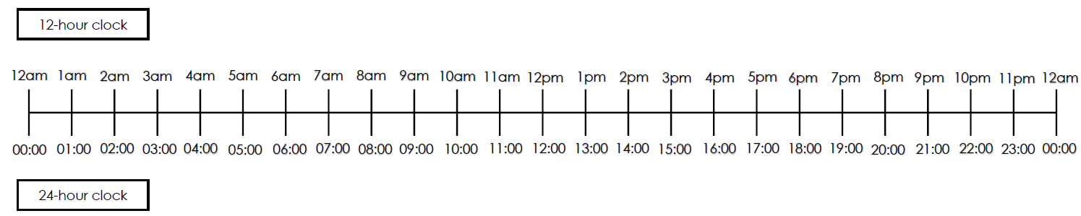
My Calculations (Show Jumps):
Jump 1 (mins to next hour): __________________________________________________
Jump 2 (hours to destination): __________________________________________________
Jump 3 (remaining mins): _____________________________________________________
Final Answer (Duration): ________________________________________________

Problem 2: The Great Barrier Reef Cruise
A tourist catamaran departs Cairns marina at 9:30 a.m. for a Great Barrier Reef cruise and returns back to the marina at 4:20 p.m.. What was the total duration of the reef cruise?

My Calculations (Show Jumps):
Jump 1 (mins to next hour): __________________________________________________
Jump 2 (hours to destination): __________________________________________________
Jump 3 (remaining mins): _____________________________________________________
Final Answer (Duration): ________________________________________________

Problem 3: Sydney to Hobart Yacht Departure
A yacht departs Sydney Harbour at 11:45 a.m. Monday for the Sydney to Hobart Yacht Race. It arrives at the Eden checkpoint at 5:15 p.m. Tuesday. How long did this first leg of the race take?

My Calculations (Show Jumps):
Jump 1 (mins to next hour): __________________________________________________
Jump 2 (hours to destination): __________________________________________________
Jump 3 (remaining mins): _____________________________________________________
Final Answer (Duration): ________________________________________________

Problem 4: Indian Pacific Railway Segment
A passenger train on the Indian Pacific railway departs Adelaide at 1430 on Monday and reaches the remote outpost of Cook on the Nullarbor Plain at 1915 on Tuesday. Calculate the total travel time for this Nullarbor railway segment.

My Calculations (Show Jumps):
Jump 1 (mins to next hour): __________________________________________________
Jump 2 (hours to destination): __________________________________________________
Jump 3 (remaining mins): _____________________________________________________
Final Answer (Duration): ________________________________________________

Problem 5: The Ghan Expedition
The Ghan legendary passenger train departs Darwin at 0615 in the morning and rolls into the station at Katherine at 2245 at night. How long did this train journey take?

My Calculations (Show Jumps):
Jump 1 (mins to next hour): __________________________________________________
Jump 2 (hours to destination): __________________________________________________
Jump 3 (remaining mins): _____________________________________________________
Final Answer (Duration): ________________________________________________

