Converting Capacity Measurements
Name:
Date / Class:

Metric Capacity & Volume Concept: To convert Litres (L) to Millilitres (mL), multiply by 1000.
To convert Millilitres (mL) to Litres (L), divide by 1000.
Volume/Capacity Equivalence: 1 cubic centimetre (cm³) = 1 Millilitre (mL) of fluid displacement.

Part 1: Reading Scales of Calibrated Containers
The contents of each full container was poured into the empty calibrated measuring container. Read the scale to find the capacity of each emptied container.

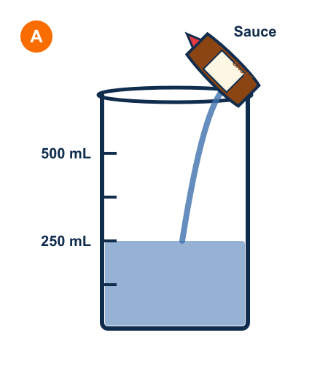  Container A (Sauce):  ______________ mL | 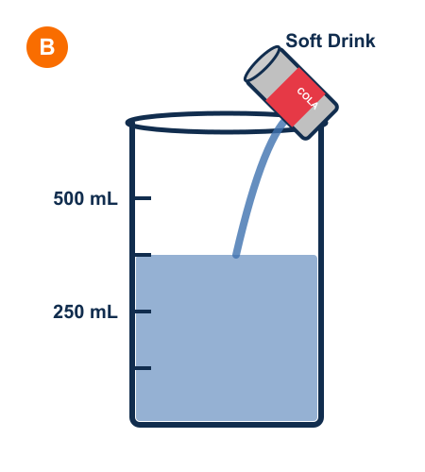  Container B (Soda):  ______________ mL | 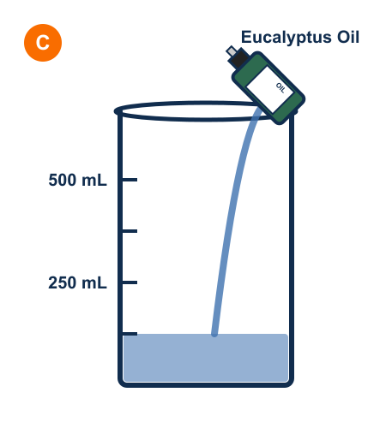  Container C (Oil):  ______________ mL

Question: Order containers A, B and C from smallest to largest capacity:
__________________________________________________________________________________

Part 2: Choose Appropriate Unit (mL or L)
Would you use millilitres (mL) or litres (L) to measure the capacity of the following items?
a) a bath: _______________  c) a sink: _______________ | b) a cup: _______________  d) a drink bottle: _________

Part 3: How many millilitres are in these Litre volumes?
a) 4 L = ________________ mL  c) 22 L = ________________ mL  e) 7.4 L = ________________ mL | b) 10 L = ________________ mL  d) 5.3 L = ________________ mL  f) 3.6 L = ________________ mL

Part 4: How many litres are in these millilitre volumes?
a) 9000 mL = ________________ L  c) 3000 mL = ________________ L  e) 6800 mL = ________________ L | b) 5000 mL = ________________ L  d) 1500 mL = ________________ L  f) 2600 mL = ________________ L

Part 5: Write these compound volumes in Millilitres
a) 1 L 600 mL =  ___________ mL | b) 1 L 950 mL =  ___________ mL | c) 2 L 300 mL =  ___________ mL

Part 6: Write these as Litres and Millilitres
a) 7530 mL =  ____ L ____ mL | b) 1075 mL =  ____ L ____ mL | c) 35700 mL =  ____ L ____ mL

Part 7: Fluid Displacement & 3D Block Models
This model was immersed into the container. An ones block (1 cubic centimetre) displaces exactly 1 mL of fluid.

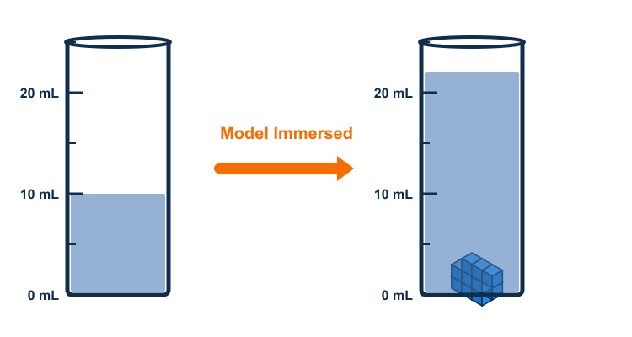

a) 2 layers of 6 ones blocks = ___________ ones blocks.
b) What is the volume of this model? ____________ mL or ____________ cubic centimetres.

Part 8: Convert millilitre capacity to cubic centimetres
a) 42 mL =  ________ cm³ | b) 327 mL =  ________ cm³ | c) 608 mL =  ________ cm³

Part 9: Convert cubic centimetres to millilitre capacity
a) 15 cubic centimetres =  ________ mL | b) 138 cubic centimetres =  ________ mL | c) 569 cubic centimetres =  ________ mL

