STUDENT WORKBOOK
Great Garden Workbook
Name: ________________________________ Date: __________________
LEARNING GOAL I can find a missing side from a rectangle's area and one known side, then prove my answer.

1. Garden detective
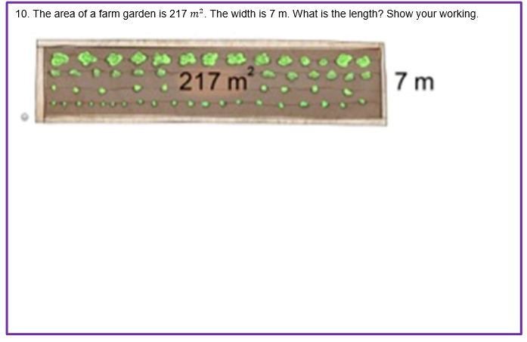
KNOWN AREA  217 m² | KNOWN SIDE  7 m | UNKNOWN  length = ? m
Estimate before calculating
I predict the length is between ______ m and ______ m because…

Notice and wonder
I notice… / I wonder…

Choose and justify
Circle: 217 × 7 217 ÷ 7 217 − 7
I chose this equation because…

2. Build a convincing solution
FOUR MOVES Name the knowns → relate area and sides → solve → check and label.

1 NAME | Area = ________ Known side = ________ Unknown = ________
2 RELATE | ________ = ________ × ? so ? = ________ ÷ ________
3 SOLVE | 217 = ________ + ________  ________ ÷ 7 = ________ ________ ÷ 7 = ________  Length = ________
4 CHECK | ________ × ________ = ________  The garden length is ________ ________.
SELF-CHECK | Equation matches | Division shown | Check shown | Unit is metres

Guided practice
Garden A
Area = 168 m². Width = 6 m. Find the length. Show an equation, division working and a multiplication check.

Garden B
Area = 216 m². Length = 24 m. Find the width. Show an equation, division working and a multiplication check.

3. Design a hidden-side garden
Choose an area and a known side that divide exactly. Draw your rectangle, label the information and prove the missing side.
Choose | Option A | Option B | Option C
Area | 180 m² | 224 m² | 315 m²
Known side | 6 m | 7 m | 9 m
My garden drawing
Area = __________ Known side = __________ Missing side = __________

My proof
Equation: ______________________________________________
Division working:

My check and conclusion
Check: _________________________________________________
The missing __________________ is __________________ m.

Extension
Choose a second factor pair for one area. Which rectangle has the greater perimeter? Prove your comparison.

4. Assessment rehearsal
INDEPENDENT ATTEMPT Read carefully. Show enough working to convince someone who cannot see your thinking.



Working space

[ ] Equation | [ ] Division | [ ] Check | [ ] Metres

5. Exit ticket
New garden
A rectangular garden has an area of 252 m² and a width of 7 m. Find the length. Show your working and check your answer.

Explain the operation
Division is the correct operation because…

Confidence check
[ ] | I can choose the operation and explain why.
[ ] | I can solve it but need help explaining.
[ ] | I need another example with an area model.

One thing I will remember

