WORKSHEET A • QUESTIONS 1–5
Finding a Missing Side from Area
Use division to work backwards from area. Write one clear equation for each problem.
Remember: Area = length × width so missing length = area ÷ width
Name: ____________________________________ Date: __________________
1. The area of a vegetable garden is 168 m². The width is 6 m. What is the length? Show your working.
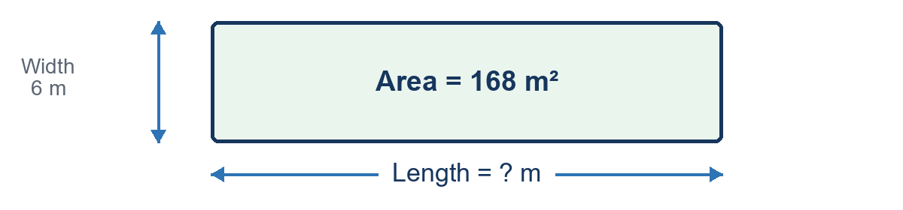
Working: ________________________________________________________________
Answer: ________________ m
2. The area of a rectangular playground is 192 m². The width is 8 m. What is the length? Show your working.
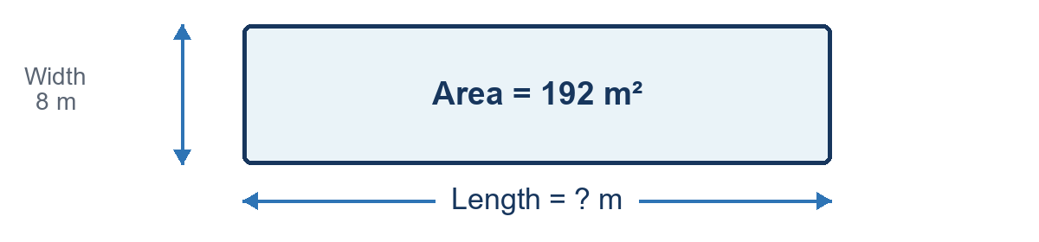
Working: ________________________________________________________________
Answer: ________________ m
3. The area of a chicken enclosure is 225 m². The width is 9 m. What is the length? Show your working.
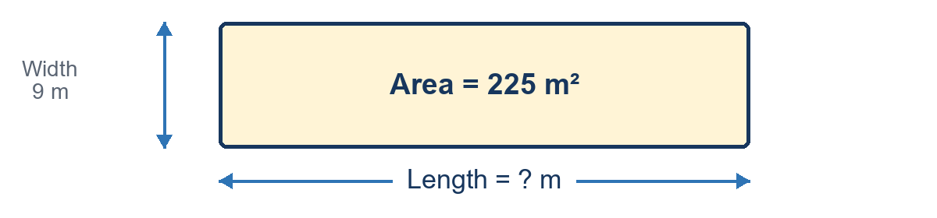
Working: ________________________________________________________________
Answer: ________________ m
4. The area of a flower garden is 156 m². The width is 6 m. What is the length? Show your working.
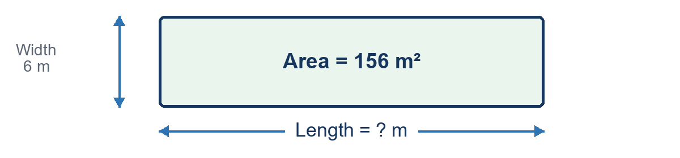
Working: ________________________________________________________________
Answer: ________________ m
5. The area of a farm paddock is 252 m². The width is 7 m. What is the length? Show your working.
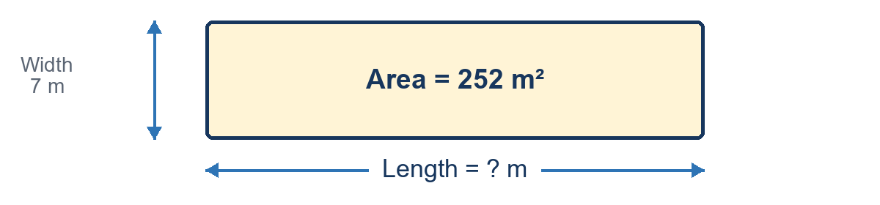
Working: ________________________________________________________________
Answer: ________________ m

WORKSHEET B • QUESTIONS 6–10
Finding a Missing Side from Area
Use division to work backwards from area. Then multiply to check your answer.
Remember: Area = length × width so missing length = area ÷ width
Name: ____________________________________ Date: __________________
6. The area of a rectangular swimming pool is 264 m². The width is 8 m. What is the length? Show your working.
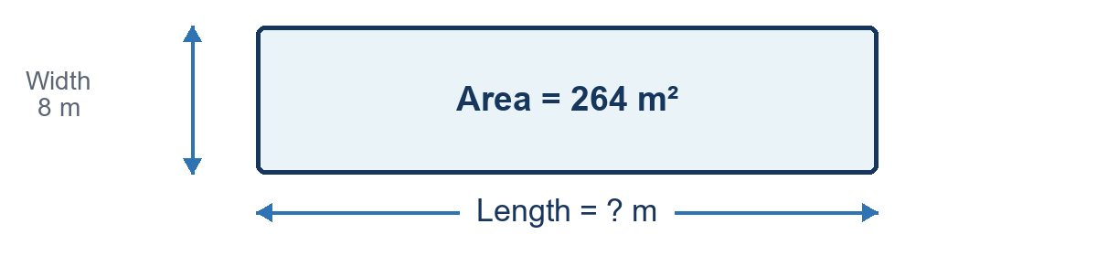
Working: ________________________________________________________________
Answer: ________________ m
7. The area of a school garden is 315 m². The width is 9 m. What is the length? Show your working.
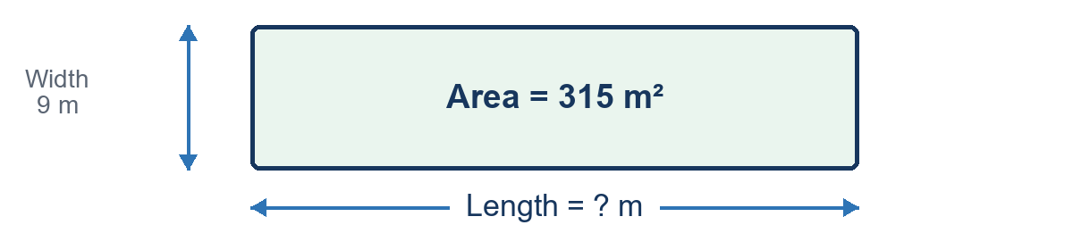
Working: ________________________________________________________________
Answer: ________________ m
8. The area of a rectangular animal pen is 224 m². The width is 7 m. What is the length? Show your working.
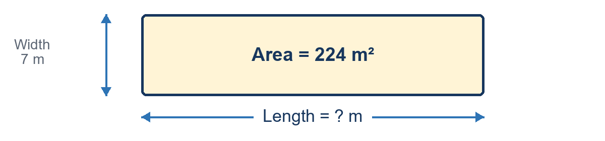
Working: ________________________________________________________________
Answer: ________________ m
9. The area of a sports training area is 288 m². The width is 8 m. What is the length? Show your working.
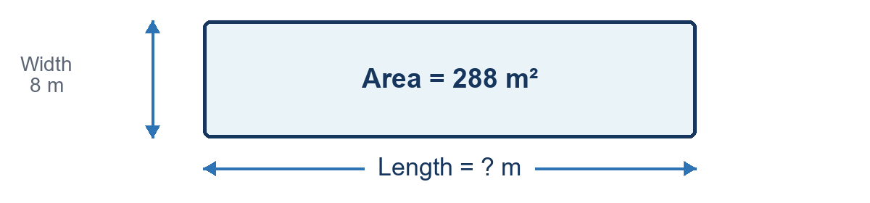
Working: ________________________________________________________________
Answer: ________________ m
10. The area of a community garden is 198 m². The width is 6 m. What is the length? Show your working.
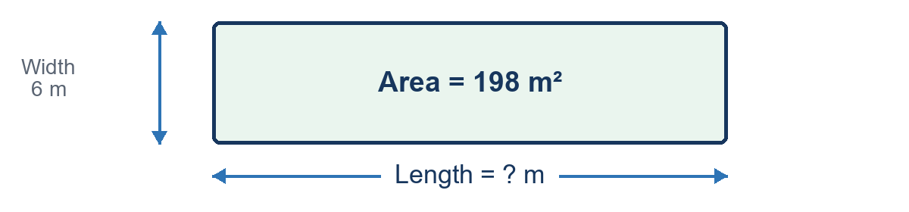
Working: ________________________________________________________________
Answer: ________________ m

TEACHER ANSWER KEY
Finding a Missing Side from Area
Worked method: missing length = area ÷ width. Check by multiplying length × width.
Q | Context | Given | Working and check | Length
1 | Vegetable Garden | A = 168 m²  w = 6 m | 168 ÷ 6 = 28  Check: 28 × 6 = 168 | 28 m
2 | Rectangular Playground | A = 192 m²  w = 8 m | 192 ÷ 8 = 24  Check: 24 × 8 = 192 | 24 m
3 | Chicken Enclosure | A = 225 m²  w = 9 m | 225 ÷ 9 = 25  Check: 25 × 9 = 225 | 25 m
4 | Flower Garden | A = 156 m²  w = 6 m | 156 ÷ 6 = 26  Check: 26 × 6 = 156 | 26 m
5 | Farm Paddock | A = 252 m²  w = 7 m | 252 ÷ 7 = 36  Check: 36 × 7 = 252 | 36 m
6 | Rectangular Swimming Pool | A = 264 m²  w = 8 m | 264 ÷ 8 = 33  Check: 33 × 8 = 264 | 33 m
7 | School Garden | A = 315 m²  w = 9 m | 315 ÷ 9 = 35  Check: 35 × 9 = 315 | 35 m
8 | Rectangular Animal Pen | A = 224 m²  w = 7 m | 224 ÷ 7 = 32  Check: 32 × 7 = 224 | 32 m
9 | Sports Training Area | A = 288 m²  w = 8 m | 288 ÷ 8 = 36  Check: 36 × 8 = 288 | 36 m
10 | Community Garden | A = 198 m²  w = 6 m | 198 ÷ 6 = 33  Check: 33 × 6 = 198 | 33 m
Answers in order: 28 m, 24 m, 25 m, 26 m, 36 m, 33 m, 35 m, 32 m, 36 m, 33 m.

