Converting Length Measurements
Name:
Date / Class:

Metric Conversion Key Concept: To convert millimetres to centimetres, we divide by 10 (shift decimal point 1 place left).
To convert centimetres to metres, we divide by 100 (shift decimal point 2 places left).
To convert metres to centimetres, we multiply by 100 (shift decimal point 2 places right).

Part 1: Reading Ruler Measurements
Record the lengths shown on the ruler below in both millimetres (mm) and centimetres (cm).

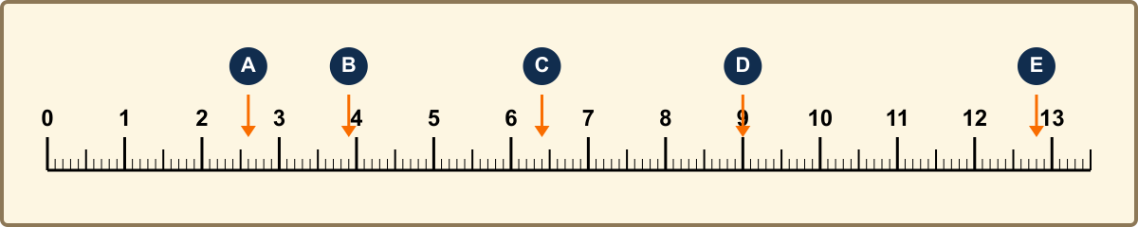

Point A | Point B | Point C | Point D | Point E
________ mm  ________ cm | ________ mm  ________ cm | ________ mm  ________ cm | ________ mm  ________ cm | ________ mm  ________ cm

Part 2: Use decimal form to write these as centimetres
a) 49 mm = __________ cm  c) 83 mm = __________ cm  e) 92 mm = __________ cm  g) 108 mm = __________ cm | b) 64 mm = __________ cm  d) 51 mm = __________ cm  f) 75 mm = __________ cm  h) 123 mm = __________ cm

Part 3: Use decimal form to write these as metres
a) 251 cm = __________ m  c) 375 cm = __________ m  e) 563 cm = __________ m  g) 1021 cm = __________ m | b) 829 cm = __________ m  d) 642 cm = __________ m  f) 925 cm = __________ m  h) 1165 cm = __________ m

Part 4: Write these as centimetres
a) 3.16 m = __________ cm  c) 4.65 m = __________ cm  e) 5.27 m = __________ cm  g) 7.45 m = __________ cm | b) 8.31 m = __________ cm  d) 9.54 m = __________ cm  f) 2.95 m = __________ cm  h) 10.75 m = __________ cm

Part 5: Choose the most suitable unit (km, m, cm, mm)
a) the length of a plane: ___________  c) the length of a river: ___________  e) the thickness of a match: _________ | b) the width of a road: ___________  d) the length of a classroom: _________  f) the distance to Perth: ___________

Part 6: Order Units of Length
Order m, km, mm, and cm in order from smallest unit to longest unit:
__________________________________________________________________________________

Part 7: Classroom Measurement Activity
Measure objects that are less than 1 m. Estimate their length first, then record your actual measurements in both millimetres and centimetres.

Object measurement | Estimate (cm) | Actual (mm) | Actual (cm)
pencil sharpener length | 3 cm | 26 mm | 2.6 cm

