 | Mathematics AC V9 — Year 5
Unit 2: Measurement (Time)
Assessment task — Converting between 12- and 24-hour time☼
The K–6 Curriculum Planning Model (K–6CPM) for Australian Curriculum V9 Mathematics supports systematic curriculum implementation in multilevel contexts across Kindergarten to Year 6. This flexible model streamlines content and assessments through aligned contexts.
The K–6CPM includes supplementary resources to support curriculum implementation in a range of schools including small schools and larger schools with complex and/or multilevel contexts.
This assessment task provides example questions and activities aligned to the aspects of the achievement standard being assessed. Individual school contexts will inform decisions about how the task is to be implemented and how students will engage with the task.
The assessment task gathers evidence of student learning for this aspect of the Year 5 Mathematics achievement standard:
- Convert between 12- and 24-hour time.
The following materials can be used when implementing Unit 2 in the K–6 Curriculum Planning Model Mathematics Year level plan example.
See the Mathematics Unit 2 Curriculum and assessment alignment planner (CAAP) to guide unit planning when developing a teaching and learning sequence and implementing the assessment in the unit.
Assessment conventions and resources
Purpose: To convert between 12-hour and 24-hour time.
Technique: Short response.
Conditions
- This task is to be completed individually.
- Can be completed over multiple sessions.
- Prompt and scribe for students if necessary.
- Adapt the mode and conditions to suit the diverse learning needs of your students and school context.
Other resources
- Analog clock faces may be provided to support students with conversions.

Mathematics teaching and learning resources
Visit the M in STEM website (https://det-school.eq.edu.au/m-in-stem) to access professional learning modules that support development of the mathematical proficiencies: Understanding, Fluency, Reasoning and Problem solving, including the mathematical processes: mathematical modelling, probability simulations and experiments, statistical investigations, and computational thinking.
Implementation advice
- Adapt this assessment task to suit the diverse needs of the students, school and local context.
- When adapting the assessment, maintain alignment to the targeted achievement standard aspects and aligned curriculum elements and consider ways to make the assessment meaningful and accessible for students.
- Answer spaces have not been included to provide flexibility in how and where students will respond.
- Each part of the summative assessment may be conducted as a series of smaller tasks to be used to gather evidence of student learning against the marking guide.
☼ Source: Australian Curriculum www.australiancurriculum.edu.au, CC BY 4.0. © Australian Curriculum, Assessment and Reporting Authority (ACARA) 2010 to present, unless otherwise indicated. This material was downloaded from the Australian Curriculum website (www.australiancurriculum.edu.au) (Website) (accessed 07/01/25) and was modified. The material is licensed under CC BY 4.0 (https://creativecommons.org/licenses/by/4.0). Version updates are tracked in the ‘Curriculum version history’ section on the ‘About the Australian Curriculum’ page (http://australiancurriculum.edu.au/about-the-australian-curriculum/) of the Australian Curriculum website. ACARA does not endorse any product that uses the Australian Curriculum or make
any representations as to the quality of such products. Any product that uses material published on this website should not be taken to be affiliated with ACARA or have the sponsorship or approval of ACARA. It is up to each person to make their own assessment of the product, taking into account matters including, but not limited to, the version number and the degree to which the materials align with the content descriptions and achievement standards (where relevant). Where there is a claim of alignment, it is important to check that the materials align with the content descriptions and achievement standards (endorsed by all education Ministers), not the elaborations (examples provided by ACARA).

 | Mathematics AC V9 — Year 5
Unit 2: Measurement (Time)
Assessment task — Converting between 12- and 24-hour time

Name |  | Class
Teacher |  | Date
- Look at the clock. Is the time in the morning or afternoon?
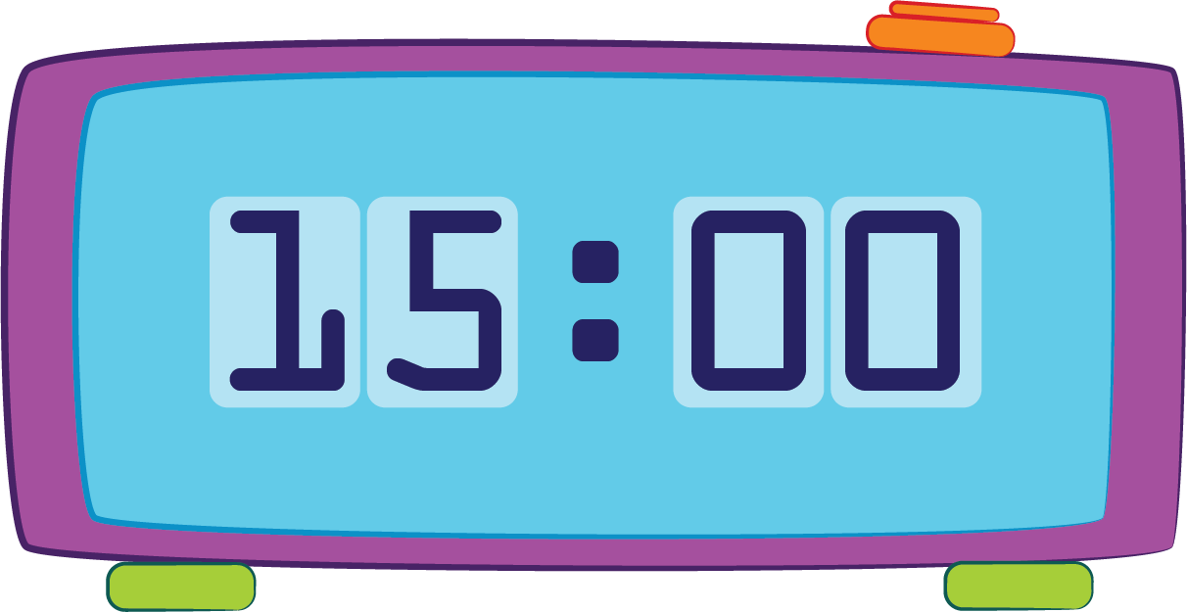
- Draw lines to match the 12- and 24- hour times.
8 pm
1 pm
11 pm
13:00
23:00
20:00
- Convert the 12-hour times into 24-hour time.
12-hour time | 24-hour time
7:00 am
11:56 pm
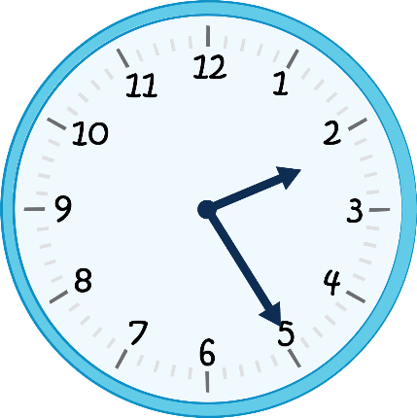
(afternoon)
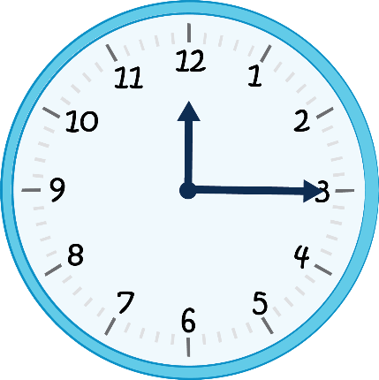
(morning)
- Convert the 24-hour times into 12-hour time.
24-hour time | 12-hour time
11:53
00:03
19:45
23:25 | 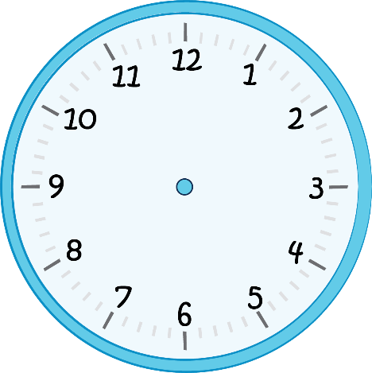
15:10 | 
- Sam is going on a bike riding tour that starts at 15:45 and goes for $3\frac{1}{2}$ hours. She is expecting a very important phone call at 5:30 pm. Will her bike tour be finished in time for the phone call?
Show your working.
- You have been asked to create a camp activity timetable in 12- and 24-hour time. The activities and their durations are in the table below.
Camp activities — Thursday
Activity | Duration | 24-hour time | 12-hour time
Breakfast | 30 minutes | 07:00 –
Giant swing | 30 minutes
Flying fox | 45 minutes
High ropes | 4 hours
Lunch | 30 minutes
Canoeing | 2 hours 45 minutes
Bush survival skills | 60 minutes
Campfire cooking | 2 hours

 | Marking guide — Year 5 Unit 2: Measurement
AC V9 Mathematics | Name:
Assessment task — Converting between 12- and 24-hour time☼
Purpose: To convert between 12-hour and 24-hour time.
 |  | Fluency
 |  | Convert between 12- and 24-hour time.
A | Interprets and converts between 12- and 24-hour time and solves practical duration problems including planning a camp activity timetable in 12- and 24-hour time.
B | Converts between 12- and 24-hour time and solves a practical duration problem.
C | Converts between 12- and 24-hour time.
D | Matches the same times in 12- and 24-hour time.
E | Identifies time of day using 24-hour digital time.
Feedback:

Model response
The model response is a high-standard example. Different responses remain valid as long as students demonstrate the identified aspects of the achievement standard and standard descriptors of the marking guide.
- Look at the clock. Is the time in the morning or afternoon? Afternoon

- Draw lines to match the 12- and 24- hour times.
8 pm
1 pm
11 pm
13:00
23:00
20:00
- Convert the 12-hour times into 24-hour time.
12-hour time | 24-hour time
7:00 am | 07:00
11:56 pm | 23:56
  (afternoon) | 14:25
  (morning) | 00:15
- Convert the 24-hour times into 12-hour time.
24-hour time | 12-hour time
11:53 | 11:53 am
00:03 | 12:03 am
19:45 | 7:45 pm
23:25 | 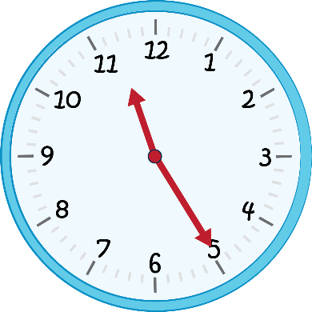
15:10 | 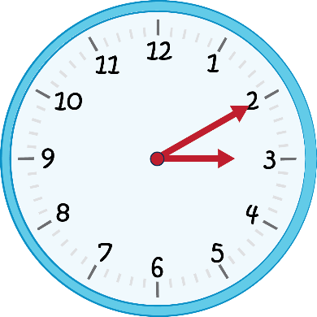

- Sam is going on a bike riding tour that starts at 15:45 and goes for $3\frac{1}{2}$ hours. She is expecting a very important phone call at 5:30 pm. Will her bike tour be finished in time for the phone call?
Show your working.
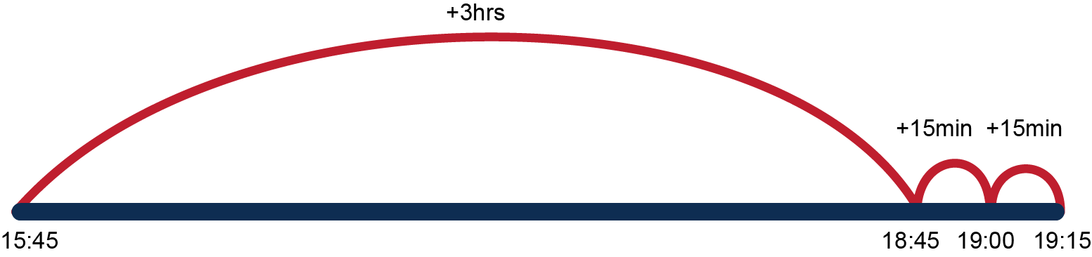
15:45 + 3 = 18:45
+ 15min = 19:00
+ 15 = 19:15 = 7:15 pm
Sam will not be back in time to answer her important phone call because she will finish her bike riding tour at 7:15 pm.
- You have been asked to create a camp activity timetable in 12- and 24-hour time. The activities and their durations are in the table below.
Camp activities — Thursday
Activity | Duration | 24-hour time | 12-hour time
Breakfast | 30 minutes | 07:00 – 07:30 | 7:00 am – 7:30 am
Giant swing | 30 minutes | 07:30 – 08:00 | 7:30 am – 8:00 am
Flying fox | 45 minutes | 08:00 – 08:45 | 8:00 am – 8:45 am
High ropes | 4 hours | 08:45 – 12:45 | 8:45 am – 12:45 pm
Lunch | 30 minutes | 12:45 – 13:15 | 12:45 pm – 1:15 pm
Canoeing | 2 hours 45 minutes | 13:15 – 16:00 | 1:15 pm – 4:00 pm
Bush survival skills | 60 minutes | 16:00 – 17:00 | 4:00 pm – 5:00 pm
Campfire cooking | 2 hours | 17:00 – 19:00 | 5:00 pm – 7:00 pm

