ADAPTED READING
Help the Great Barrier Reef
The Reef is alive, but it is under pressure. What facts can help us explain why it needs protection?
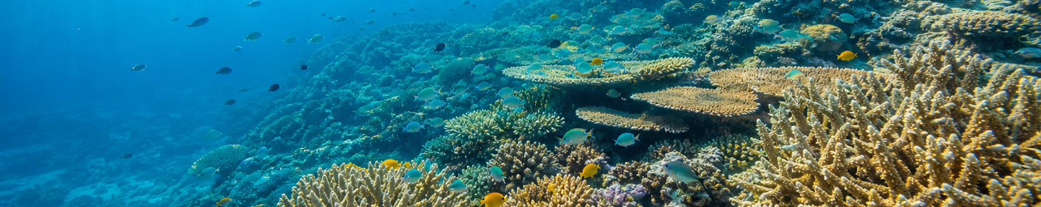
READING MISSION
Underline two facts. Circle one action. Box the sentence that stops an overclaim.

1 A huge living place
The Great Barrier Reef is not one wall of coral. It is a huge living system along the Queensland coast. It has about 3,000 reefs, as well as islands, seagrass, mangroves and deep water. Fish, turtles and many other animals live there.
The Reef is also Sea Country. Aboriginal and Torres Strait Islander Traditional Owners have cared for this area for a very long time. Today, Traditional Owners use cultural knowledge and science to help care for the Reef.

2 What scientists found
Scientists check the Reef to see how it changes. In 2024-25, they checked 124 reefs. They still found living coral in the north, centre and south, but coral cover had fallen. Hot water and other pressures had damaged coral.
KEEP THE FACT ACCURATE
This is evidence that the Reef is alive and needs help. It is not evidence that the whole Reef is dead.
Coral animals live with tiny algae that give them food and colour. Very warm water can make coral push out the algae and turn white. This is called bleaching.
Bleached coral is stressed, but it is not always dead. Some coral can recover if the water cools. Coral can die if the heat is very strong, lasts too long or returns before the coral has recovered.

3 Two ways to help
Help near the Reef. Cleaner water, less rubbish, careful fishing, crown-of-thorns starfish control and Sea Country management can reduce pressure. These local actions can give coral a better chance to recover.
Reduce ocean warming. Greenhouse gases warm Earth and the ocean. Climate action can reduce this warming. Local projects help, but they cannot cool the whole ocean by themselves.
Source note: Simplified summary of the AIMS 2024/25 coral condition report and bleaching information, the Reef Snapshot, the 2024 Scientific Consensus Statement and Reef Authority Traditional Owner information. Facts checked in the parent lesson source trail on 29 July 2026. Image is illustrative, not survey evidence.
STUDENT PACK - PAGE 2
Evidence Detective
A fact becomes useful evidence when it matches your claim and you explain what it shows.

1 Find evidence that matches
CLAIM A  The Reef is alive, but it needs help. | Evidence from the article:  ____________________________________________________________  This evidence shows _________________________________________  ____________________________________________________________

CLAIM B  Hot water is dangerous for coral. | Evidence from the article:  ____________________________________________________________  This evidence shows _________________________________________  ____________________________________________________________

CLAIM C  The Reef needs more than one kind of help. | Evidence from the article:  ____________________________________________________________  This evidence shows _________________________________________  ____________________________________________________________

2 Evidence or opinion?
Statement | Evidence | Opinion
Very warm water can bleach coral. | ( ) | ( )
The Reef is the prettiest place in Australia. | ( ) | ( )
Cleaner water can reduce pressure on the Reef. | ( ) | ( )

3 Stop the overclaim
NOT SUPPORTED
"The whole Great Barrier Reef is dead."
Why is this claim not supported? ____________________________________________________________
___________________________________________________________________________________________
STUDENT PACK - PAGE 3
Write With Evidence
Write a five-to-six-sentence paragraph for people who can help protect the Great Barrier Reef.

1 Read the model
MODEL PARAGRAPH
Australian decision-makers should protect the Great Barrier Reef. In 2024-25, scientists found living coral in the north, centre and south, but coral cover had fallen. This shows that the Reef is alive and needs help. Cleaner water and careful Reef management can reduce pressure on coral. Climate action is also needed because local projects cannot cool the whole ocean. Please use both kinds of action to give the Reef a better chance to recover.

2 Plan the five moves
Move | My plan
1 Claim | We should __________________________________________________________
2 Problem fact | The article says ____________________________________________________
3 Explain | This shows _________________________________________________________
4 Action fact | Another fact is _____________________________________________________
5 Request | Please _____________________________________________________________

3 Write your paragraph
___________________________________________________________________________________________
___________________________________________________________________________________________
___________________________________________________________________________________________
___________________________________________________________________________________________
___________________________________________________________________________________________
___________________________________________________________________________________________
___________________________________________________________________________________________

4 Evidence check and revise
( ) I used two facts. | ( ) I explained one fact. | ( ) I revised one sentence.

EXIT Prove one idea
We should __________________ because the article says _________________________________.
This shows _____________________________________________________________________________.

