E A R T H S C I E N C E S P E C I A L F E AT U R E

The Rising Tide: Causes And Effects Of Tsunamis

tsunami is a series of giant, fast-moving ocean waves. Tsunami is a Japanese word. It means 'harbour wave'. These waves are caused by a sudden displacement (movement out of place) of water. Normal waves are made

KEY TERMINOLOGY
Tsunami
A Japanese word meaning 'harbour wave'; a series of massive, fast-moving waves.

Displacement
A sudden movement of water out of its original position.

Seismic
Relating to earthquakes or earth vibrations.

Propagation
The travel or movement of waves through the deep ocean.

Shoaling
The compression and rapid rising of waves as they enter shallow coastal water.

Inundation
Severe flooding of dry coastal land areas by tsunami waves.
A
by wind, but tsunamis are different. They are triggered by underwater events. These include volcanic eruptions, landslides, or submarine earthquakes.

Most tsunamis start with undersea earthquakes. These happen along tectonic plate boundaries. The plates suddenly break or slip, which releases seismic (earth-shaking) energy. The sea floor pushes up or down, lifting the water column above it. The water shifts and makes powerful waves. The waves spread out in all directions.

"Normal waves are made by wind, but tsunamis are different. They are triggered by underwater events."
— WAVE DYNAMICS

In the deep ocean, tsunamis travel very fast. They can go over 800 kilometres per hour. However, the deep waves are not very high. They are often less than one metre tall. Ships at sea might not notice them. This travel is called wave propagation (how waves move in deep water).

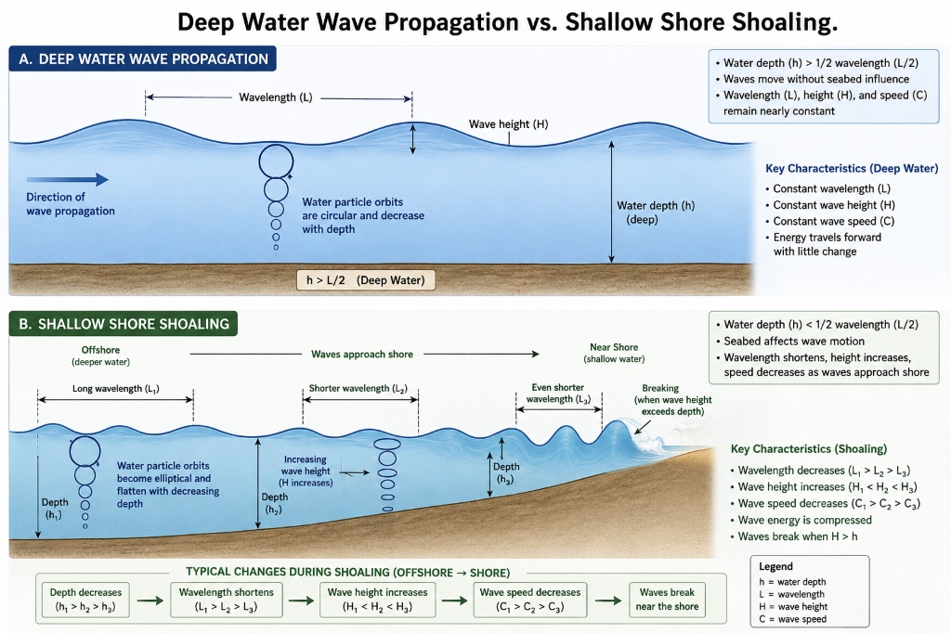

Figure 1 - Wave Shoaling: As a tsunami moves from the deep ocean into shallow water, its speed drops, but its height grows rapidly into a giant wall of water.

Tsunami Wave Characteristics (Deep Ocean vs. Shallow Shore)
Feature | Deep Ocean | Shallow Shore
Wave Speed | Exceeds 800 km/h (Jet plane speed) | Drops to 50 km/h (Car driving speed)
Wave Height | Very low (Usually less than 1 metre) | Grows very tall (Up to 30 metres high)
Wavelength | Extremely long (Up to 200 kilometres) | Shortens (A few kilometres)
Impact on Vessels | Ships at sea do not notice the wave | Extremely dangerous to coastal shipping

The waves slow down as they reach shallow water. They drop to about 50 kilometres per hour. But the water piles up, causing the waves to grow very tall. This growth is called wave shoaling (compressing and rising near land). The water might suddenly pull back from the beach. Then, a massive wall of water hits the shore.

Tsunamis cause severe inundation (extreme flooding) on land. They wash away cars and destroy buildings. They also strip away sand. To protect people, scientists use deep-ocean sensors. These sensors detect tsunami waves early, allowing authorities to order evacuations

QUICK FACTS

✦ Tsunamis are not tidal waves, as they are not caused by the tide or gravity of the moon.
✦ In the deep ocean, tsunami waves can travel at the speed of a passenger jet (over 800 km/h).
✦ Drawback is a warning sign where the water recedes from the beach, exposing the sea floor.

