**Introduction**

Big Mountain resort, located in Montana with access to the Glacier National Park and Flathead National Forest, is a premier ski destination with top-tier facilities. Management believes suspects that the current ticket prices do not fully reflect the quality and scale of these offerings. Furthermore, operating such extensive facilities is costly, and Big Mountain aims to recoup the seasonal operating cost of their newly added chair lift ($1.54 million). Big Mountain management has asked for an analysis to achieve two main goals:

1. Develop a data driven approach to determining the Big Mountain ticket price relative to other resorts in the market.
2. Assess how potential changes to Big Mountain facilities could further influence ticket prices.

**Exploratory Data Analysis**

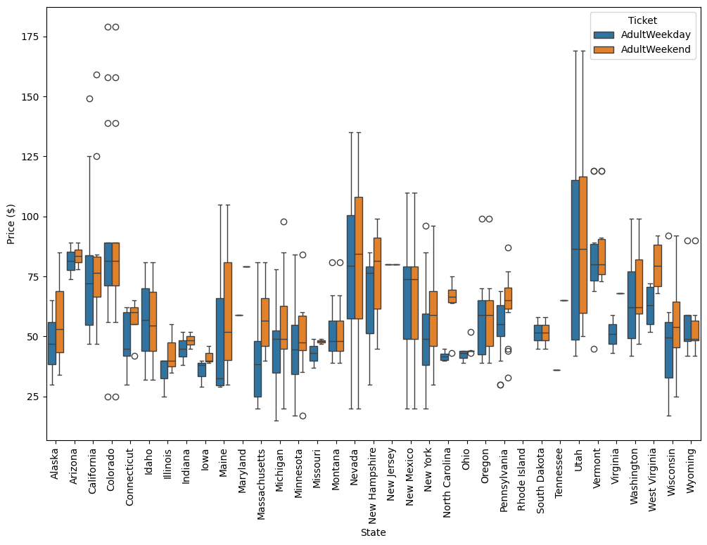

Big Mountain Resort

*Figure 1: The variance of ticket prices by state are shown in this box Plot. Outliers are represented as open circles. The circles representing Big Mountain Resort are indicated.*

The analysis of Big Mountain’s position in the market was performed using a data set of 330 resorts describing the key features of the resorts as well as their location and ticket price. Big Mountain was found to be in the 81rst percentile of all resorts in the data set, suggesting its ticket price is below where it could be, given its amenities and scale. However, it is worth noting that while Montana resorts are relatively inexpensive overall, Big Mountain resort is the most expensive resort in the state. This exploratory analysis identified three key categories of features that positively correlate with ticket price:

* Infrastructure for movement within the resort (numbers and types of lifts, trams and total chairs).
* Ski Experience Features, such as vertical drop, run number, length of the longest run, and the area of skiable terrain
* Conditions-related features, such as snowmaking and night skiing

**Model Development**

We developed a model to estimate the appropriate price of Big Mountain resort tickets by training on the 330-resosrt data set. Several iterations of the model were tested, including Linear Regression and Random Forest Regression, and their performance was compared using R-squared (coefficient of determination) and their mean absolute error (MEA). After cross validation, the Random-Forest regression model with optimization of features selection (SelectKBest) and 5-fold cross validation demonstrated the best balance between accuracy and generalizability. The final model selected the following key features as most predictive of ticket price: vertical drop, number of runs, area covered by snow makers, Fast Quad lifts, total chairs, length of the longest run and total area of skiable terrain.

**Model Prediction**

Big Mountain currently charges $81 for both weekend and weekday tickets. The model predicted an optimal price of $98.76 with a mean absolute error of $10.25, indicating the likely true optimal price falls $88.51 and $109.01.

**Assessment of Model Prediction**

While Big Mountain is already the most expensive resort in Montana, our model clearly indicates that its premium amenities justify a higher ticket price than currently charged. Big Mountain is in the 81st percentile of ticket prices, yet it rates exceptionally well on the features most influential to ticket pricing:

* Vertical Drop – 90th percentile
* Snow Making (acres) – 97th percentile
* Total number of chairs – 94th percentile
* Number of Fast Quads – 93rd percentile
* Number of Runs – 93rd percentile
* Longest Run (miles) – 96th percentile
* Skiable Terrain Area (acres) – 98th percentile

These rankings strongly support a price adjustment to better reflect the resort’s standing in the national market.

Big Mountain resort recently added a new chair lift, increasing its seasonal operating budget by $1.54 million. With approximately 1.75 million tickets sold per year, a 1$ increase per ticket would fully cover the cost. However, I recommend increasing the ticket price by 8$ to 89$ for the following reasons:

1. An $8 increase should increase revenue by $14 million in additional annual revenue, comfortably exceeding the $1.54 million required to offset the cost of the new lift.
2. This is the minimum ticket price recommended by the model, making it the most conservative and low risk option while still providing increased revenue.
3. An increase from $81 to $89 maintains the ticket price in the eighties minimizing psychological resistance among visitors, similar to the retail principle behind pricing items at $9.99 instead of $10.00.

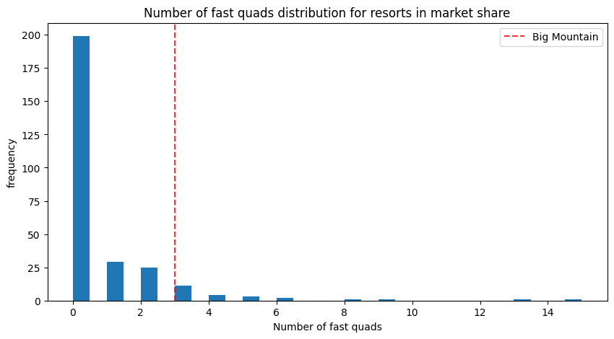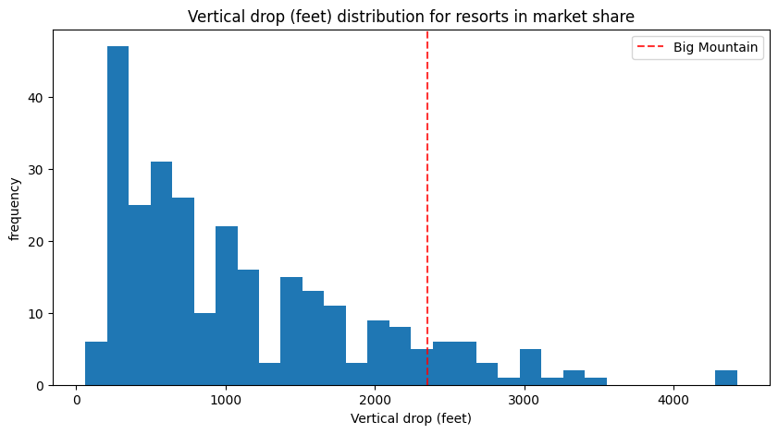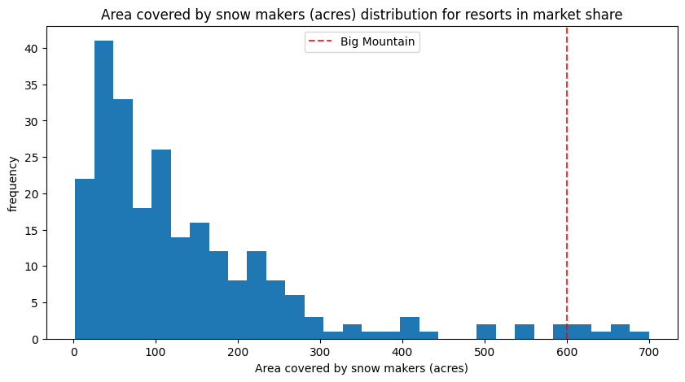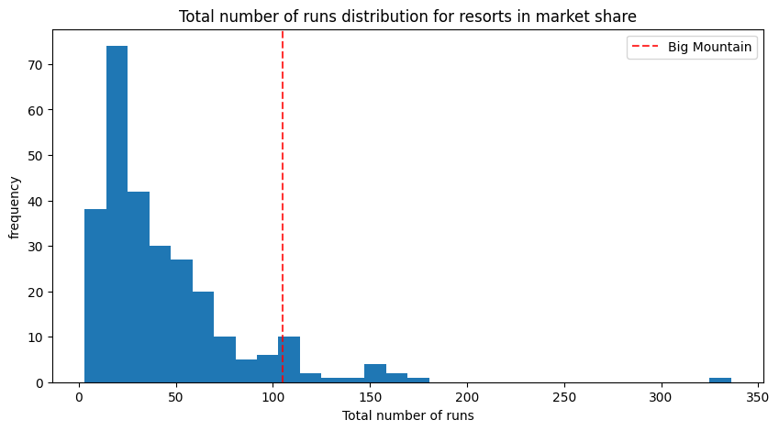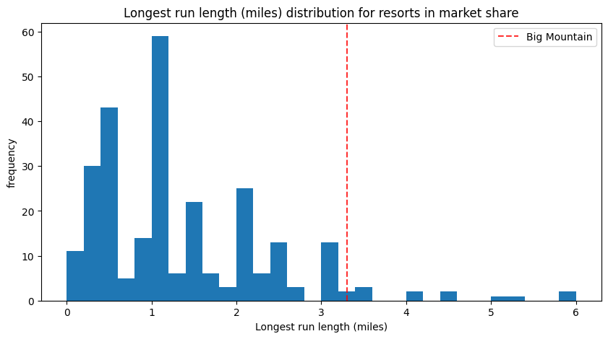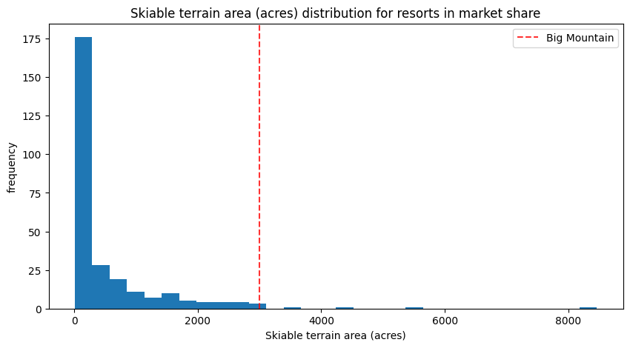

*Figure 2: Big Mountain Resort is shown as a red dotted line within the distributions of each of the most influential features used by the model to estimate ticket price.*

**Additional Changes to Big Mountain Resort**

The above increase in ticket price was calculated for Big Mountain resort as it currently exists. Management is also considering several potential infrastructure changes, and out model predicts the following impacts on price and revenue:

* Closing up to 10 runs to decrease operational costs – closing one run does not impact ticket prices. Closing 2-8 runs accompanies a drop of $1.25 in optimal ticket price
  + Starting from $89, the adjusted price becomes $87.75 with estimated additional revenue of $12 million.
* Increasing the vertical drop by 150 feet through the addition of one run and one chair lift – Our model predicts an additional increase in ticket price of $10.27 and additional $18 million in revenue.
  + New ticket price is now $99 and total revenue is $31.5 million.
* Adding the above run and vertical drop with 2 acres of snow making – Our model predicts an additional increase in ticket price of $11.61 and additional $20 million in revenue
  + New ticket price is now $100.50 and increased revenue is $34 million.
* Increasing the longest run by 0.2 miles and adding 4 acres of snow making – Our model predicts no additional change in ticket price for this scenario.

**These results indicate that increasing the vertical drop by adding a new run and lift would yield the greatest return on investment, even without additional snow making**.

**Further Analysis**

If management wishes to proceed further, the model could be refined by including:

* Operational costs of specific features, such as runs and snow making, to evaluate cost effectiveness.
* Visitor characteristics, including income, home location and travel costs to better estimate price sensitivity.
* Regional market segmentation (example West vs Northeast) to understand national positioning.

Alternatively, the current model could be packaged into a simple interactive tool for management to simulate potential upgrades and instantly view their predicted impact on ticket price and revenue.

**Conclusion**

Based on the analysis, Big Mountain is currently underpriced relative to its peers given its exceptional infrastructure and terrain. Increasing the ticket price to $89 would recoup recent capital expenditure while maintaining market competitiveness and customer goodwill.

Further enhancements, particularly increasing vertical drop, offer promising opportunities for additional revenue growth if aligned with operational budgets.