6-DOF Motion Platform for CARLA Driving Simulator
Project Progress Report
Prepared by: Anirudh Tantry (1RV24EC028), Barath Ganesh SBP (1RV24EC043), D Swanith (1RV24EC057)
Department of Electronics and Communication Engineering
Project Guide: Dr. M Uttara Kumari
Date: 7 August 2026

1. Introduction
This report describes the current status of a project to build a six-degree-of-freedom (6-DOF) Stewart platform motion simulator and integrate it with the CARLA autonomous-driving simulator. The end goal is a hardware-in-the-loop (HIL) rig in which a virtual car driven in CARLA produces real, physically felt motion on a seated platform — acceleration, braking, and cornering translated into platform tilt and displacement in real time.
The system is organised as a four-stage pipeline. CARLA publishes the vehicle's linear acceleration, angular velocity, and pose at roughly 60 Hz. A motion cueing algorithm (MCA) converts this telemetry into a target platform pose: short, sharp transients are passed through a high-pass filter directly as translation, while slow sustained acceleration is reproduced through tilt coordination, exploiting the fact that a tilted seat and gravity together mimic sustained acceleration on the body. A washout stage continuously returns the platform toward neutral within its workspace limits so that it never reaches a mechanical stop. The resulting target pose is passed to an inverse kinematics (IK) solver, which computes a rotation matrix from the desired roll, pitch, and yaw, and from it derives the required length of each of the six actuator legs. These six leg-length commands are sent over serial to an STM32 microcontroller, which closes an independent PID position loop on each actuator using encoder feedback, driving the physical platform to the commanded pose.
The platform itself is being built at 1/5th scale relative to a full-size unit, using six identical linear actuators, each combining a NEMA 23 stepper motor, a DM542 microstepping driver, an SFU1204 ballscrew, an MGN15 linear rail, and a 600 PPR incremental encoder mounted at the ballscrew's free end for direct output-position feedback. Working at reduced scale keeps the mechanical loads, actuator cost, and assembly risk manageable while still exercising the complete control and kinematics pipeline that a full-scale unit would require.
Rather than building all six actuators and discovering a design flaw only after full assembly, the project is structured to validate one actuator completely — mechanical assembly, wiring, open-loop motion, and closed-loop PID tracking — before committing to the remaining five. This single-actuator gate is expected to surface most mechanical and firmware issues (coupler alignment, encoder wiring, driver configuration, homing behaviour) while they are still cheap to fix, and it establishes a repeatable assembly and test procedure for the remaining units. Only once this is validated does the project scale to the full six-actuator platform, followed by the motion cueing and inverse kinematics software, closed-loop tuning across all six legs, and finally a live demonstration driving the platform directly from a CARLA session.

2. Block Diagram
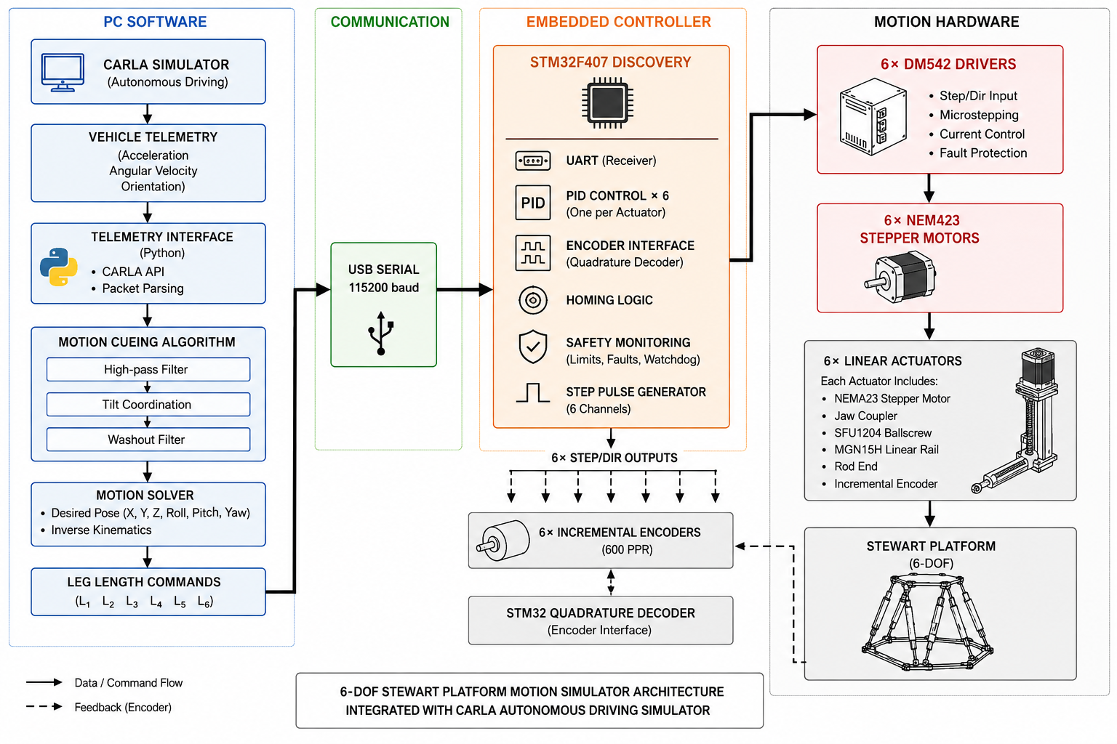

3. Project Schedule
The schedule below is derived from the project timeline and is organised into eight milestones spanning roughly four days each, from architecture lock on 7 August through the full pipeline demonstration on 4–5 September 2026.
Milestone | Dates (2026) | Planned Work | Expected Outcome | Deliverable
M1 — Architecture & Procurement Lock | Aug 7–10 | Finalise system architecture (CARLA → Telemetry Extraction → motion cueing → inverse kinematics → STM32 → actuators); lock actuator topology (NEMA 23 + DM542 + SFU1204 ballscrew + MGN15H rail + 600 PPR encoder on ballscrew free end); freeze BOM; place orders for long-lead external components (ballscrew, rail, bearings). | Design decisions frozen; no further changes expected to actuator topology; procurement initiated for items with longer delivery timelines. | Finalised BOM, procurement tracker updated, architecture block diagram.
M2 — Mechanical Design Pack | Aug 11–14 | CAD detailing of actuator assembly, base plate and top plate hole patterns, motor mount plate and carriage output plate; generate drawings/cut-files for laser cutting; release fabrication jobs to local job-work vendors. | Manufacturing-ready drawings available for every mechanical part; fabrication jobs placed and in queue. | CAD assembly + part drawings, fabrication job orders submitted.
M3 — Single-Actuator Prototype + Motion Check | Aug 15–18 | Assemble one complete actuator (motor → jaw coupler → ballscrew → BK10/BF10 supports → MGN15H carriage); wire DM542 driver; verify open-loop step/dir motion from STM32; check for backlash and misalignment. | Single actuator moves correctly under open-loop commands; mechanical assembly method validated before replication. | Working single-actuator test rig; motion test log.
M4 — Electronics Bring-Up + Safety Baseline | Aug 19–22 | Wire STM32F407 controller, 74HC245 level shifters, 48 V/5 V power distribution, E-stop and AC contactor safety chain, limit switches; verify homing routine on the single actuator. | Electronics stack powered and confirmed safe (E-stop removes AC feed to the 48 V supply); homing routine executes correctly. | Wired electronics enclosure; safety checklist / test record.
M5 — Scale to 6 Actuators + Sync Low-Speed Tests | Aug 23–26 | Replicate the validated actuator build across the remaining five units; mount all six on the base and top plates via rod-end/clevis joints; wire all step/dir and encoder channels to STM32; run a synchronised low-speed multi-axis test. | All six actuators respond individually and in unison at low speed without mechanical interference between legs. | Fully assembled Stewart platform hardware; six-axis synchronisation test log.
M6 — Washout + IK (Software-in-the-Loop) | Aug 27–30 | Build the motion cueing algorithm (high-pass filter for transients, tilt coordination for sustained acceleration, washout return-to-neutral); implement the inverse kinematics solver (rotation matrix, per-leg vector, length extraction); validate entirely in software against recorded/simulated CARLA telemetry, with no physical actuation. | Pipeline produces a feasible target pose and six leg lengths within the platform workspace for representative driving inputs. | MCA + IK software module; SIL validation plots (target pose vs. leg-length outputs).
M7 — Closed-Loop Tuning + Bandwidth Validation | Aug 31–Sep 3 | Tune per-actuator PID gains using encoder feedback; characterise closed-loop step response; confirm all six actuators track commanded leg length within acceptable error and lag at the required update rate. | Closed-loop actuators track commanded position within a defined tolerance at the update rate needed for real-time motion cueing. | PID tuning report with step-response and bandwidth plots.
M8 — Full Pipeline Demo (CARLA → Platform) | Sep 4–5 | Integrate the full pipeline end to end (CARLA → MCA → IK → STM32 → actuators → platform); run a live driving scenario in CARLA and observe platform response; record the demonstration. | Platform reproduces vehicle motion cues (acceleration, braking, cornering) from a live CARLA session in real time. | Recorded demonstration; final progress report.

4. Bill of Materials
The BOM below is drawn from the project's component list and re-grouped by where each item can reasonably be sourced. Items placed under "College" are those involving only basic workshop processes — hand fabrication of simple aluminium brackets, cutting and drilling of stock extrusion, standard fasteners, and electronics-lab wiring — that a college workshop or electronics lab would typically be equipped to handle. This follows the sourcing notes already present in the BOM (for example, the encoder mount bracket is explicitly marked as a DIY option using flat bar stock). Items requiring precision-manufactured mechanical components (ballscrews, linear rails, bearings), purchased electronic parts, or outsourced laser-cutting/job-work — as specified against each item in the original BOM — are listed under external procurement.

4.1 Components Available or Manufacturable Within the College
Item | Qty | Purpose | Source
Encoder mount bracket (custom Al bracket) | 6 | Holds the 600 PPR encoder axially aligned on the BF10 (free) end of each ballscrew. | College workshop
30×30 mm aluminium extrusion, cut to 350 mm length and drilled | 6 | Preparation of the actuator frame member (extrusion stock purchased outside; cutting and hole drilling done in-house). | College workshop
STM32F407VGT6 Discovery board | 1 | Main controller — hardware quadrature decoding for all six encoders, six step-pulse timers. | College electronics lab
Motor Mount Plate | 6 | 4 mm 6061 Al | 47 mm bolt circle | Custom drilled for NEMA 23 | College workshop
Carriage Output Plate | 6 | 3 mm Al plate | Mounts MGN15H carriage + ballscrew nut + rod end | College workshop
Base Plate – 400 mm dia, 8 mm Al | 1 | 6061 Al | 400 mm circular | 6× M8 tapped holes per Stewart geometry | CNC cut | College workshop
Top Plate – 250 mm dia, 8 mm Al | 1 | 6061 Al | 250 mm circular | 6× M8 tapped holes + 4× M8 seat mount holes | College workshop

4.2 Components Requiring External Procurement
Item / Description | Part Number / Spec | Qty | Unit (INR) | Total (INR) | Category | Source / Vendor
Motion System
NEMA 23 Stepper Motor (Single Shaft) | 57HS22 or equiv | 2.2–3 Nm | 4 A | 6.35 mm single shaft | 1.8°/step | 6 | ₹1,800 | ₹10,800 | Motion – Motor | Amazon.in / Robocraze
DM542 Microstepping Driver | DM542 | 18–50 V DC | 1–4.2 A | Step/Dir | 5 V compat | Up to 25600 microstep | 6 | ₹800 | ₹4,800 | Motion – Driver | Amazon.in / Robocraze
600 PPR Incremental Rotary Encoder | 600 PPR | ABZ quadrature | 5 V TTL | 6.35 mm bore | 2400 counts/rev effective | 6 | ₹1,300 | ₹7,800 | Motion – Encoder | Amazon.in – search '600PPR rotary encoder 6.35mm'
6.35 mm Rigid Shaft Coupler (encoder) | 6.35 mm to 6.35 mm rigid coupler | Al body | Connects ballscrew end to encoder shaft | 6 | ₹100 | ₹600 | Motion – Encoder | Amazon.in – search '6.35mm rigid shaft coupler'
SFU1204 Ballscrew + Nut | SFU1204 | 12 mm dia | 4 mm lead | 250 mm length | C7 accuracy | Flanged nut | 6 | ₹1500 | ₹9000 | Motion – Ballscrew | IndiaMart – Delhi/Mumbai vendors
BK10 Fixed End Support Block | BK10 | Angular contact bearing | Motor-side | 10 mm bore (machined stub end of SFU1204) | 6 | ₹700 | ₹4200 | Motion – Ballscrew | IndiaMart – same vendor as ballscrew
BF10 Floating End Support Block | BF10 | Deep groove bearing | Free end | 8 mm bore (machined stub end of SFU1204) | 6 | ₹450 | ₹2700 | Motion – Ballscrew | IndiaMart – same vendor as ballscrew
MGN15H Linear Guide Rail + Carriage | MGN15 | 300 mm rail | 1× MGN15H long carriage | 15 mm rail | 6,370 N dynamic load (C) / 9,110 N static (C0) | 6 | ₹1,700 | ₹10,200 | Motion – Guide | IndiaMart / Amazon.in – search MGN15H 300mm
6.35 mm to 10 mm Jaw Coupler (motor–ballscrew) | Jaw/spider coupler | Al body | PU insert 98 Shore A | Max 5 Nm | ±1° angular | sized to BK10-machined stub | 6 | ₹350 | ₹2100 | Motion – Coupling | Amazon.in – search '6.35 to 10mm jaw coupler'
M8 Spherical Rod End Bearing | M8 male rod end | Steel | PTFE-lined ball | ±25° articulation | 12 | ₹150 | ₹1,800 | Motion – Joints | IndiaMart / local bearing shops
Omron SS-5GL Microswitch (Limit Switch) | SPDT roller lever | 5 A 250 VAC | 3.3 V logic safe | 12 | ₹65 | ₹780 | Motion – Safety | Amazon.in / Robocraze / SP Road Bangalore
Mechanical Structure
30×30 Aluminium Extrusion Profile — Bulk length | 30×30 T-slot extrusion | 6063 Al | 350 mm per actuator frame | 6 | ₹325 | ₹1,950 | Structure – Frame | Local Al supplier Bangalore / Robu.in
Motor Mount Plate | 4 mm 6061 Al | 47 mm bolt circle | Custom drilled for NEMA 23 | 6 | ₹200 | ₹1200 | Structure – Frame | Peenya Vendor
Carriage Output Plate | 3 mm Al plate | Mounts MGN15H carriage + ballscrew nut + rod end | 6 | ₹200 | ₹1,200 | Structure – Frame | Peenya Vendor
Base Plate – 400 mm dia, 8 mm Al | 6061 Al | 400 mm circular | 6× M8 tapped holes per Stewart geometry | CNC cut | 1 | ₹1000 | ₹1000 | Structure – Plates | Peenya Vendor
Top Plate – 250 mm dia, 8 mm Al | 6061 Al | 250 mm circular | 6× M8 tapped holes + 4× M8 seat mount holes | 1 | ₹1000 | ₹1000 | Structure – Plates | Peenya Vendor
M8 Clevis / Rod End Bracket (custom fab) | 4 mm steel bent bracket | M8 tapped | Bolts to base/top plate | 12 | ₹65 | ₹780 | Structure – Joints | Local fabricator / weld shop
Electronics
74HC245 Octal Bus Transceiver | 3.3 V → 5 V level shift | 8 ch per IC | DIP or SOIC | 2 | ₹35 | ₹70 | Electronics – Signal | SP Road Bangalore / Amazon.in
METEK 48V 10A 480W SMPS | METEK | 48 V DC | 10 A | 480 W | 230 VAC input | Screw terminals | 1 | ₹2,000 | ₹2,000 | Electronics – Power | Robu.in / IndiaMart – search METEK 48V 10A SMPS
5 V 3 A Logic SMPS | 5 V DC | 3 A | 230 VAC input | Compact module | 1 | ₹200 | ₹200 | Electronics – Power | Robu.in
40 mm E-Stop Mushroom Button (NC) | Panel mount | Normally Closed | Latching | Red | 1 | ₹160 | ₹160 | Electronics – Safety | Robu.in / IndiaMart
25 A AC Contactor | Schneider LC1D25 or equiv | 230 VAC coil | Cuts AC to 48 V SMPS on E-stop | 1 | ₹600 | ₹600 | Electronics – Safety | Robu.in / IndiaMart / local electrical shop
DIN Rail + Terminal Blocks | 35 mm DIN rail 500 mm | Phoenix-type terminal blocks ×10 | End stops | 1 | ₹400 | ₹400 | Electronics – Wiring | Amazon.in / SP Road Bangalore
18 AWG Stranded Wire (48 V power) | Red + Black | 5 m each | Silicone insulation preferred | 1 | ₹250 | ₹250 | Electronics – Wiring | Amazon.in / local electronics
24 AWG Shielded Signal Cable | 4-conductor shielded | 5 m | Step/Dir/Enable + encoder + limit switch runs | 1 | ₹250 | ₹250 | Electronics – Wiring | Amazon.in / SP Road Bangalore
Indicator LED Panel (3-LED) | Green: Power ON | Red: Fault | Blue: Homing complete | 12 V with resistors | 1 | ₹100 | ₹100 | Electronics – Indicator | Amazon.in / SP Road Bangalore
Fasteners & Consumables
M5 × 10 mm Socket Head Bolts + T-Slot Nuts | Grade 8.8 | Pack of 50 bolts + 50 T-nuts | 1 | ₹350 | ₹350 | Fasteners | Robu.in / local hardware
M8 × 20 mm Socket Head Bolts | Grade 8.8 | Pack of 25 | 1 | ₹120 | ₹120 | Fasteners | Robu.in / local hardware
M8 Nyloc Nuts | Pack of 25 | 1 | ₹80 | ₹80 | Fasteners | Robu.in / local hardware
M3 × 8 mm Bolts (electronics) | Pack of 30 | 1 | ₹60 | ₹60 | Fasteners | Robu.in
Loctite 243 Medium Threadlock | 5 ml | Blue | Medium strength | 1 | ₹300 | ₹300 | Consumables | Amazon.in / local hardware
Cable Ties 200 mm | Pack of 100 | Nylon | 1 | ₹80 | ₹80 | Consumables | Amazon.in
Spiral Cable Wrap 2 m | 10 mm dia | PE | Wire management | 1 | ₹120 | ₹120 | Consumables | Amazon.in
Software
Claude Pro Subscription | claude.ai/pro | claude-sonnet-4-6 | 1 month | 1 | ₹2000 | ₹2000 | Software / AI Tools | claude.ai — upgrade in settings
Total: ₹69,050
Note: the raw 30×30 mm aluminium extrusion, Mount Plate, Base and Top Plates stock is listed under external procurement since it must be purchased as material, while the cutting-to-length and drilling operation on that stock is listed separately under college fabrication.

5. Procurement Strategy
Splitting the BOM this way follows directly from what each part actually requires. Brackets, cut extrusion, fasteners, and wiring do not need tolerances tighter than a college workshop or electronics lab can hold, so building them in-house avoids vendor lead time and job-work cost on parts that are simple enough to make correctly on the first attempt.
The motion-system components — ballscrews, linear rails, bearing blocks, encoders, and rod-end bearings — are a different case. Platform positioning accuracy depends directly on backlash and straightness in these parts, which is why the BOM specifies a C7-grade ballscrew and notes that the base and top plates must be CNC- or laser-cut, since joint-position error there propagates directly into platform pose error. These tolerances are outside what general-purpose workshop equipment can guarantee, so they are sourced from vendors who manufacture to a specified grade. Similarly, the stepper motors, drivers, controller board, and power electronics are standard catalogue parts; there is no benefit to attempting to reproduce them in-house.
In practice this split keeps cost down on the parts where in-house fabrication is genuinely equivalent to a bought part, while directing the budget toward the small number of components where precision or certification actually determines whether the platform behaves predictably.

6. Expected Deliverables
The table below summarises what is expected to be in place at the end of each project phase.
Phase | Window | Expected Deliverable(s)
Design & Procurement | Aug 7–14 | CAD assembly complete; BOM finalised; fabrication and long-lead procurement orders placed.
Single-Actuator Validation | Aug 15–18 | One actuator built and validated under open-loop control.
Electronics Commissioning | Aug 19–22 | Controller, power distribution, and safety chain wired and verified on the single actuator; homing routine functional.
Six-Actuator Platform Assembly | Aug 23–26 | Complete Stewart platform mechanically assembled; six-axis low-speed synchronisation verified.
Motion Cueing & Kinematics | Aug 27–30 | Washout filter and inverse-kinematics solver implemented and validated in software-in-the-loop.
Closed-Loop Tuning | Aug 31–Sep 3 | PID-tuned closed-loop control across all six actuators, with validated tracking bandwidth.
CARLA Integration & Demonstration | Sep 4–5 | Full pipeline (CARLA → MCA → IK → STM32 → platform) demonstrated with a live driving scenario.

