**Ansible:**

**What is conf management?**

Process of managing system/software/hardware.

Suppose in an org we have 100’s of servers either on prem or cloud.We need to manage these servers installation of packages /upgrade the software/mandatory install of security patches.

To do manual it is difficult as there might be diff flavors of OS end up writing multiple scripts.

To avoid we can use single tool.

**Ansible is better than other conf tools.??**

Ansible is agentless.

Enable passwordless authentication between the host where ansible is installed and all the other servers that should be configured.

There is no master/slave arch like other tools.

It used basic protocols like linux(ssh) windows(winrm) to connect to the servers

Yaml scripting

**Write ansible playbook to install http service and get it running**.

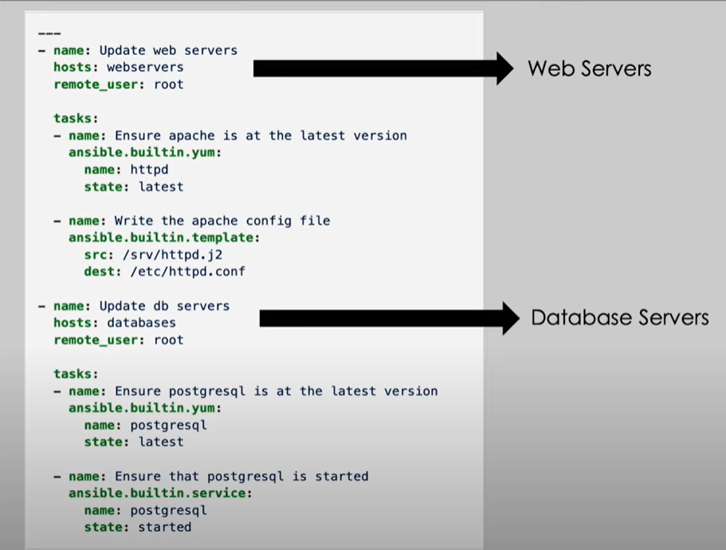

**Dynamic Inventory**

Ansible keeps looking at the Vm’s that are created in the azure and autoconfigure those vm’s.

**Ansible tower**

Enterprise model of ansible. Provides fancy graphical UI

**Ansible Galaxy command**

Used to bootstrap. It creates required folders and files.

**Explain Structure of playbook using Roles**

**Handlers in ansible : conditional task**

**Notify:**

**I would like to run specific set of tasks only on windows vms and not linux vms is it possible?**

Tags (or )

Env variable

**Parrallel executions of tasks.**

Tasks runs in prarallel in hosts

Next tasks runs in serial or sequence.

**Variable precedence**

Group_vars, role vars and extra vars

**How do you handle Secrets in ansible**

Hashicorp Vault

**Can we use ansible for iac?**

Ansible supports as Iac

**What do you think Ansible can improve?**

Doesnot provide option to increase the verbosity.

Ansible windows support can be improved.

**Ansible playbook VS ansible adhoc commands.**

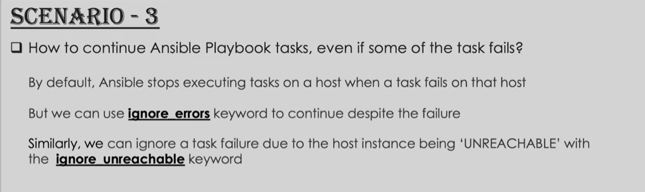

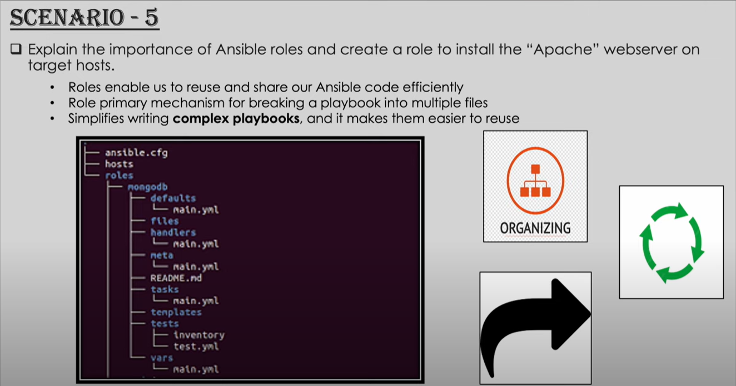

**Ansible-galaxy init apache-role**



