**Docker:**

Open source containerzation platform.It enables developers to package applications into containers.

**Docker containers:**

Components like App source code+OSlibraries+dependencies required to run that code in any env.

Light in weight .as it does not has any OS.

**Docker file:**

Users would create a file with set of instructions or commands that defines a docker image.

Ex: which base image to choose what dep should be installed for the application to run?

**Image:**

An image is a read-only template with instructions for creating a Docker container.

From 1 image we can run multiple containers to increase performance

**Docker components:**

Docker client: CLI commands

Docker host: which has daemon to execute docker commands listens and responds to commands.

Docker Registry: to host docker images

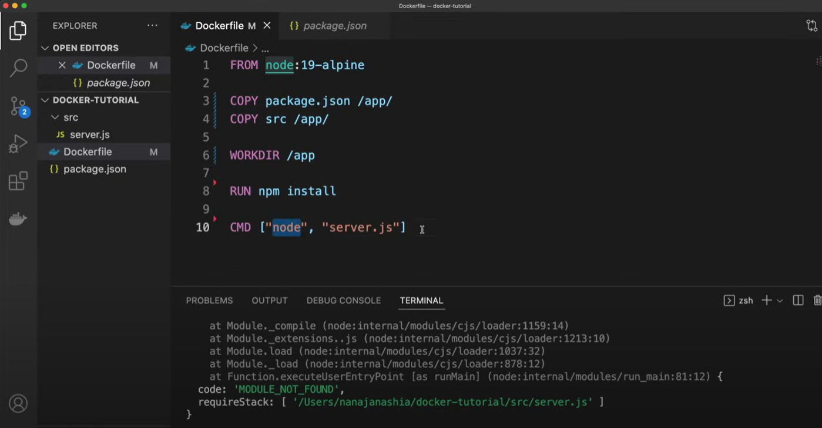**ADD:** can copy the files from URL

**COPY:** copies files/directories from host into filesystem of the container.copy is executed on the host

**WORKDIR:** Sets the working directory for all following commands.

**RUN**: Executed in the container.

**CMD:** instruction that is to be executed when a docker container starts. There can be only 1 CMD instruction.

**ENTRYPOINT:**

**Transfer file from one container to another container**

Docker cp : manual. (copy from 1 doc to host and then host to another container)

(Or) Shared volume( Automation)

**Docker file:** Using this we can create a single container.

**Docker compose:** create one or more than one container

**Docker swarm:**

Container orchestration platform.

c-c communication

**Multi-stage build:**

Allows to create containers in multiple stages allowing to copy artiacts from one stage to another.

Adv: builds light weight containers

**Distroless images**

More light in weight than the docker images as it contains only min os libraries and it doesnot contain packager managers ,shells or other programs.