**Terraform:**

**Providers:**

These are plugins for terraform.

This helps terraform to work with cloud providers.

**Null resource:**

It does nothing.It does not create any infrastructure.

Instead it is used along with provisioners to execute commands/run scripts/playbooks or python program..etc.

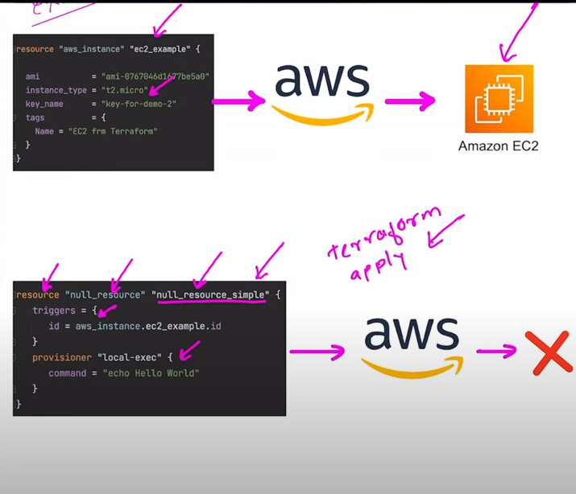

**NOTE:**

**1)If triggers are not used with null resources,commands within provisioners will execute only once.**

**2)If triggers are used and triggers outputs different value each time then on evry terraform run ,provisioner commands gets executed.**

**What will appear in terraform plan, if a comment is placed for a resource block.???**

**How to create 10 VM’s with incremental values like 0,1,2**

**How to terminate 9 vms and leave one?**

**statefile and where do you store.**

**Terraform refresh**

**Terraform import:**

If any resources which are created outside terraform ,which should be managed further within terraform we need to use import.

**Terraform Taint**

If we have to destroy and recreate any resource we can use taint

**Meta arguments:**

**Count :**

Create multiple instances of a resource.

Use count.index to handle each unique instance.

**For_each**

Create multiple instances of a resource.

Use a map or set of strings.

**Depends_on:**

**Lifecycle:**

Create before destroy.

**Data sources:**

To use any existing resource which are not created by terraform.

Data block

**Provisioners:**

Used to implement certain taks which cannot be implemented by terraform.

**File provisioner:**

Used to copy files /direc from the machine running terraform to newly created resource.

Supports both ssh and winrm type connections.

**Local-exec:**

This can be used to invoke a local executable after a resource is created.

Invokes a process on the machine where terraform is running.

**Remote-exec:**

This can be used to invoke an executable after a resource is created.

Invokes a process on newly created resource not on terraform running machine.

Variables:

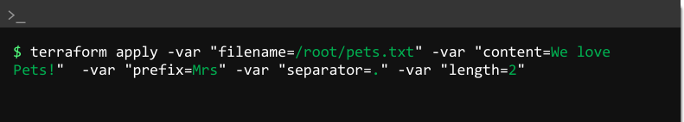

LOGS:

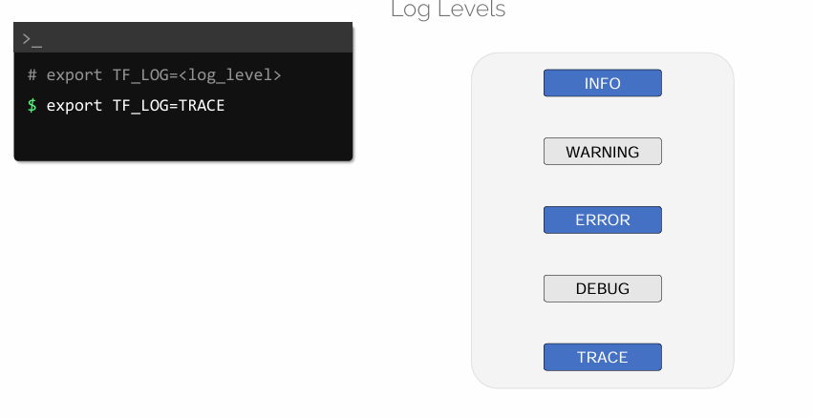

**Terraform Modules:**

**Terraform functions:**

**Numeric : max,min,ceil,floor**

**String : split,upper,lower,substr**

**Terraform workspaces:**