Service Learning Practicum:

JAUNT Reservation and Time-Off Management System

Stephen Boris

University of Virginia

sjb4cd at virginia.edu

Stephanie Colen

University of Virginia

slc4ga at virginia.edu

Garbo Cheng Ye

University of Virginia

gc2bt at virginia.edu

Frank Manns

University of Virginia

frm5tu at virginia.edu

Connor Cheong

University of Virginia

csc4pg at virginia.edu

David Yang

University of Virginia

dsy3hc at virginia.edu

**ABSTRACT**

# Through the Service Learning Practicum capstone course at the University of Virginia, a team of Computer Science students worked with JAUNT, a local nonprofit paratransit company, to produce a CakePHP web application named “StarPort.” Whereas clients previously could only submit reservations by phone or email, StarPort streamlines JAUNT’s reservation process by allowing clients to submit reservations online. Using a custom calendar app, StarPort allows employees to request time off, eliminating the need for paperwork. By allowing reservations and time off requests to be submitted electronically, StarPort empowers JAUNT to more efficiently serve the local community.

# INTRODUCTION

The Service Learning Practicum (SLP) is a capstone program for Computer Science students at the University of Virginia’s School of Engineering and Applied Science. The program involves a yearlong project in which teams of six to seven students develop a software system for a nonprofit organization. Nonprofits are selected based on their compatibility with the SLP program and its yearlong structure.

The exact nature of the project varies with each group, due to the unique needs of each nonprofit. For most of the project, SLP maintains a hands-off approach, interacting only as needed for organizational or legal reasons. The course has checkpoints for specific requirements of each project, as determined during the early customer meetings. The project was built using CakePHP, which combines PHP, HTML, and JavaScript. Mobile compatibility is enabled through the use of the Twitter Bootstrap CSS framework.

# BACKGROUND

Started in 1975, JAUNT is a nonprofit organization that provides scheduled transportation in the City of Charlottesville and its surrounding counties. Though reduced rates are available for people with disabilities, JAUNT’s services are available to anyone. To schedule a ride, clients call or email to make a request for a given trip and JAUNT staff tries to fit the particular request into the overall trip of a given bus. After receiving the reservation, JAUNT inputs the reservation into their computer system.

While JAUNT does have a web presence, their website does not allow for online reservations. Requiring clients to place reservations by phone or email is problematic. Phone lines are only manned during business hours, and strict formatting of information cannot be enforced via email, meaning that clients may accidentally omit necessary information. An online form can resolve both of these issues by allowing clients to submit reservations at any time via an interface that ensures that all necessary information is present and in a format that is easily digestible.

JAUNT also handles their internal employee time-off system in a similar manner. All time-off requests are filled out on paper and then submitted to a scheduler. The scheduler approves requests and returns a form to the person’s mailbox with the details of their approved request. Besides the large time investment and mass of paper required, this method requires far more user effort to both execute and record. A computer system could handle both the time-off requests and reservation process far more efficiently and improve the scheduler’s workflow.

# RELATED WORK

While similar programs exist, none address all of JAUNT’s needs. An Oregon company named *Ride Connection* provides transportation services similar to JAUNT. Ride Connection’s website allows for online reservations and provided a guideline for JAUNT’s expectation of the final system. While close to what JAUNT needed, Ride Connection’s solution lacked certain necessary features such as a way for reservationists to negotiate pickup times with clients. Thus, if a client requests a time that is unavailable, Ride Connection needs to resolve the conflict over the phone. As a result, we could not simply copy Ride Connection’s system.

Internally, JAUNT uses a reservation management system named *Trapeze* to help keep track of reservations and dispatch drivers to service those reservations. While Trapeze adequately meets JAUNT needs internally, it does not provide any customer facing functionality or tools for managing employee time off. JAUNT requires a system that works in conjunction with Trapeze to provide these absent features.

# SYSTEM DESIGN

The system is built from the CakePHP MVC framework, which can internally create MySQL database queries. StarPort’s data is held and organized within a few models that represent objects in the system such as users and reservations. Numerous controllers are responsible for StarPort’s business logic, bridging the gap between the object models and the user interface.

## Entities

### User

StarPort, at its core, is a user management system, so the user model is very well defined and contains information about the user such as name, email address, password, Charlottesville Area Transit (CAT) disability information, and the role of the user. These user roles are pulled from a list of 5 valid roles: Administrator, Client, Scheduler, Hourly, and Driver. Each user type has different capabilities based on their role in the JAUNT business model. For example, clients are able to submit reservations only for themselves, while administrators and other staff members are able to submit reservations for any client. Finally, the user model contains a client ID, which corresponds to a client ID from JAUNT’s Trapeze database.

### Reservation

The reservation entity models any reservation request submitted by a client for themselves, or by an administrator for another client. The reservation entity contains a pickup date, time, and location, as well as a drop-off location. The reservation can contain a return time for the reservation, or it will have an indication of a one way trip or a doctor’s appointment to indicate a return trip that will be scheduled via will call. A reservation also contains a client ID linking to a specific user within the system, a booking number that uniquely identifies the reservation, and any comments or additional riders that will accompany the reservation.

*Figure 1.Reservation Request Form (Partial)*

### Time-off Request

The time-off entity models a time-off request submitted by a JAUNT staff member. It contains the type of time-off request - sick, annual, or bonus - as well as any and all options selected by the staff member. Each time-off request has between one and three options where each option is a date range. Last but not least, the time-off request entity contains any comments that accompany the request.

### Settings

The settings entity contains all global configurable settings for the system. The rows in this table contain a description of the setting as well as the value of the configuration.

## Features

### Reservations

#### Making a Reservation

All activated client accounts are able to make reservations for themselves - reservations record a pickup time and location as well as a return time, information on extra passengers, and any comments. Reservations can also be one way to account for one way trips - such trips can simply be made as multiple reservations, each accounting for one leg of the one way trip. Lastly, reservations for medical appointments can designate the return trip as a will call - indicating that the client will call JAUNT when the medical appointment is over to return to their starting location. Administrators can also make reservations for any other client account, though they need the client’s name and client ID in order to complete the reservation.

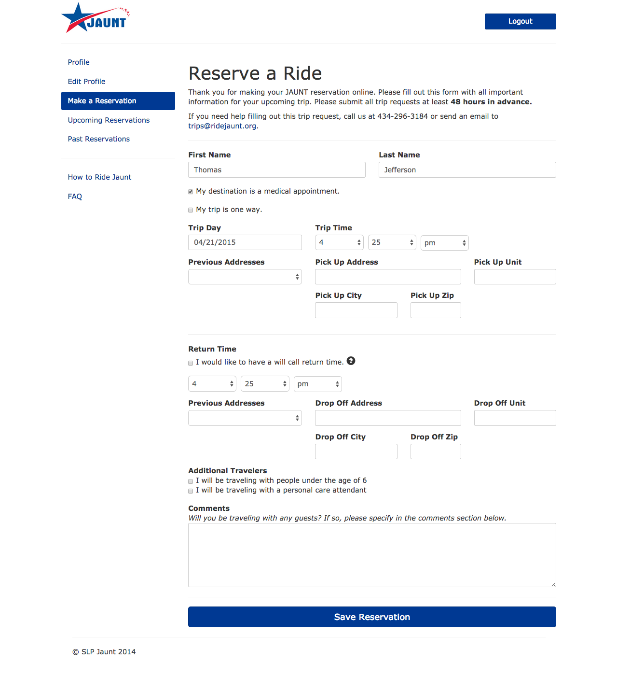

#### Approving or Denying a Reservation

Administrators and schedulers are able to change the status of a reservation by approving or denying it. Reservations are displayed on different tabs based on the status, i.e. whether or not they are approved, denied, or pending. Once a reservation has been approved, an administrator may still deny it, and vice versa - once a reservation has been denied, an administrator may still approve it. Each tabbed page of reservations with similar status may be sorted via submission date, client last name, or trip date. By default, clients will receive an email whenever a new reservation of theirs is approved, though this email reception is a system configurable setting.

#### Trip Negotiation

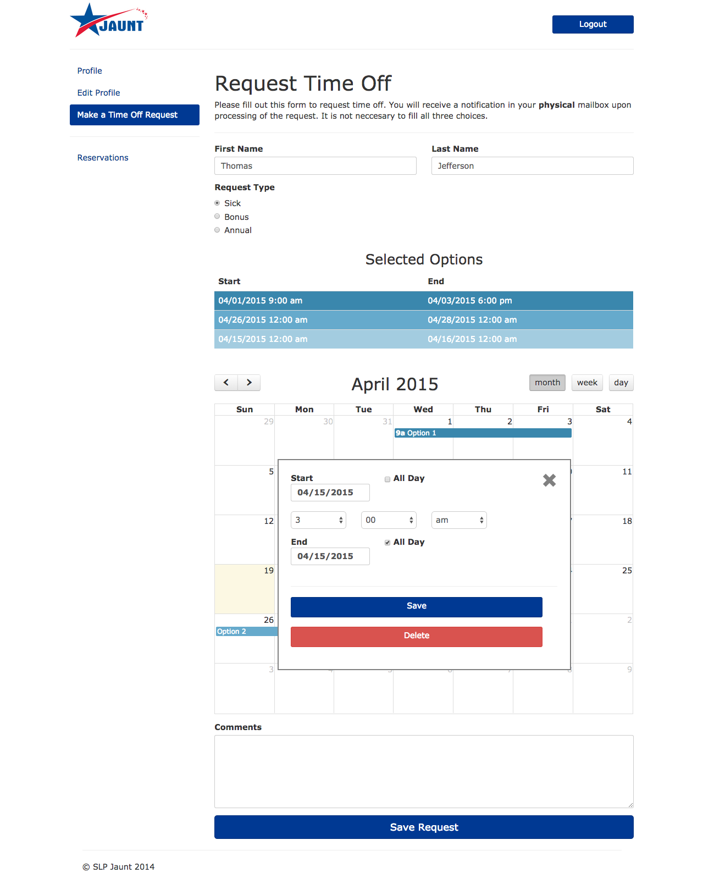Administrators and schedulers can negotiate a trip time by simply editing it - editing a trip will allow the scheduler to change the pickup date or time and the return time, if applicable. Saving edits to a reservation request will automatically approve the reservation and send an email to the appropriate client if the system configurable setting is set to send these emails.

#### Report Generation

Administrators can generate PDF reports for any reservation, and clients can generate PDF reports for their own reservations. These reports will contain the reservation status, the pickup date, time, and location, and any information available for the return trip, as well as information on the client associated with that reservation.

### Time-Off System

#### Calendar Input

*Figure 3.Time-Off Request Calendar View*

Time-off requests are completed using a calendar - all selected options are displayed visually on the same calendar so that the user can see all of the options they have selected so far. The user can choose to submit an all day request or choose a more specific time frame via a modal that appears over the calendar once a date has been chosen. This calendar input works on all major browsers and operating systems.

#### Macintosh HD:Users:Steph:Sites:jaunt:docs:screenshots:screenshot-3.pngTime-off Options

Users are able to choose between one and three options for any given time-off request, though it is never guaranteed that any one option will be approved. If more than one option is submitted on one time off request, only one option will be approved. By default, the options are ordered by preference in the order they were created - the first one is the staff member’s most preferred option. While filing a time-off request, employees can change the ordering of their options by clicking and dragging to rearrange the list of options.

#### Types of Leave

The time-off request form allows staff members to indicate what type of time-off request they are submitting in accordance with JAUNT’s policies: sick, annual, or bonus.

#### PDF Reports

An administrator can generate a PDF report for every time-off request - approved, pending, and denied - which allows time off requests to be printed out and placed into staff member’s mailboxes, which can help ease the transition between the old, paper system, and this new electronic system. Staff members can also generate PDF reports to be downloaded and printed for their own time-off requests. The PDF report displays the status of the reservation, the time preferences, and any comments submitted with the request. If the request was already approved, only the approved time option will be displayed.

*Figure 2.Reservation Request Card (for Administrators)*

### Staff Capabilities

#### Multi-Language

Many users in JAUNT’s diverse client base speak Spanish as a primary language, so the system includes the ability to translate all phrases to Spanish as they are displayed to the user. The system also has the ability to add new language options as the client base requires them, and administrators are able to edit translations already in the system. The default language for all users is English, though clients can change their preferred default language during the sign-up process or via the Edit Profile page. Administrators can set a preferred language when they create a new user account.

#### User Management

Administrators have extensive capabilities for user management - they are able to search users by partial or full name or email match, filter users based on their account type (Administrator, Client, Scheduler, Hourly, or Driver), and whether or not the user’s account has been activated. Administrators can batch approve user accounts by filtering user accounts to just “Pending” accounts, which enables a textbox in the client ID field. Administrators are also able to sort all users by a few fields displayed in the table - email, client ID, role, CAT expiration date, and activity status. Any of these fields can be sorted in ascending or descending order. Administrators can also create client or staff accounts, and delete any account from the users table. Finally, administrators can edit accounts and change a user’s name, email, role, language, and add any additional information if necessary based on the user’s role.

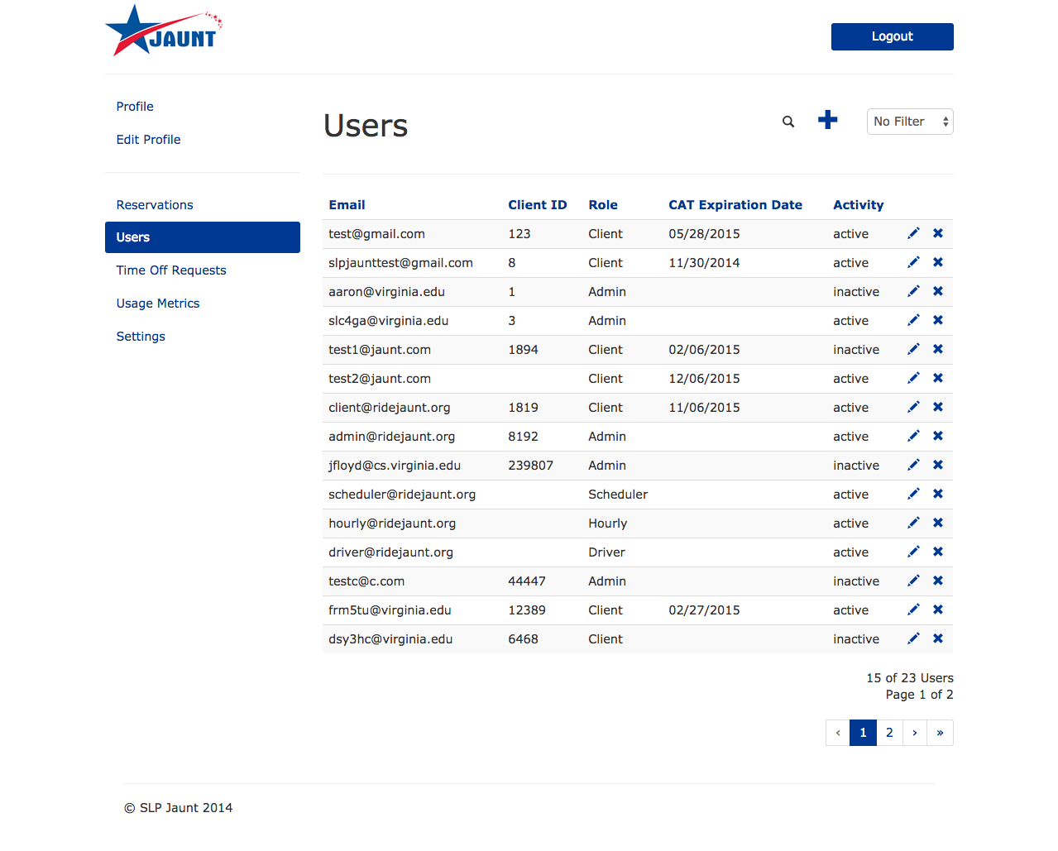

*Figure 4.User Management Home Page*

#### Metrics

Administrators have the ability to view metrics reports for the system. Metrics reports can be generated in four different ways: 1) system wide for the lifetime of the system, 2) system wide for a specific date range, 3) specific to a certain user for the lifetime of the user, or 4) specific to a certain user for a certain date range. The system also graphs the number of reservations, the number of new users, and the number of time-off requests (separated by type - sick, annual, and bonus) by month over the last year. In addition to PDF reports, administrators can also generate CSV files for each metric, allowing JAUNT to import StarPort’s metrics into spreadsheets.

#### Settings

Administrators can change system wide settings pertaining to automatic system emails and time sensitive notices. Administrators can configure whether or not clients get emails after their reservation is approved, the length of time that must pass without any activity before a user is considered inactive, the minimum number of days in advance required for reservations, the default email template, and whether or not schedulers receive emails when new time-off requests are submitted.

## Design Decisions

### Trapeze Integration

We initially planned to integrate with JAUNT’s existing database, Trapeze, in order to provide real-time bus location information and comprehensive trip history to clients. After our initial meeting with JAUNT, we realized that real-time bus location information would not be possible for two reasons. First, JAUNT’s bus tracking system only records bus locations every 5 minutes, meaning the location data would be stale and therefore unhelpful to clients. Additionally, the customer had some concern that clients may look at the map and assume that because the bus was nearby it would be arriving shortly when in fact it may be picking up another client first.

While no longer supporting real-time bus tracking, we still hoped to be able to pull some data from Trapeze in order to provide helpful trip history to clients. In order to interface with Trapeze, we needed direct access to Trapeze or a test database that closely resembled it. Due security concerns we could not be given direct access to the database and were instead provided with sample data to use in a test database. Unfortunately, due to the scale and complexity of the database, the test data we were given was not enough to figure out how all of the data was stored. Ultimately we decided that we would not be able to integrate with Trapeze at all. We are still able to give clients trip history, but only for reservations made through StarPort.

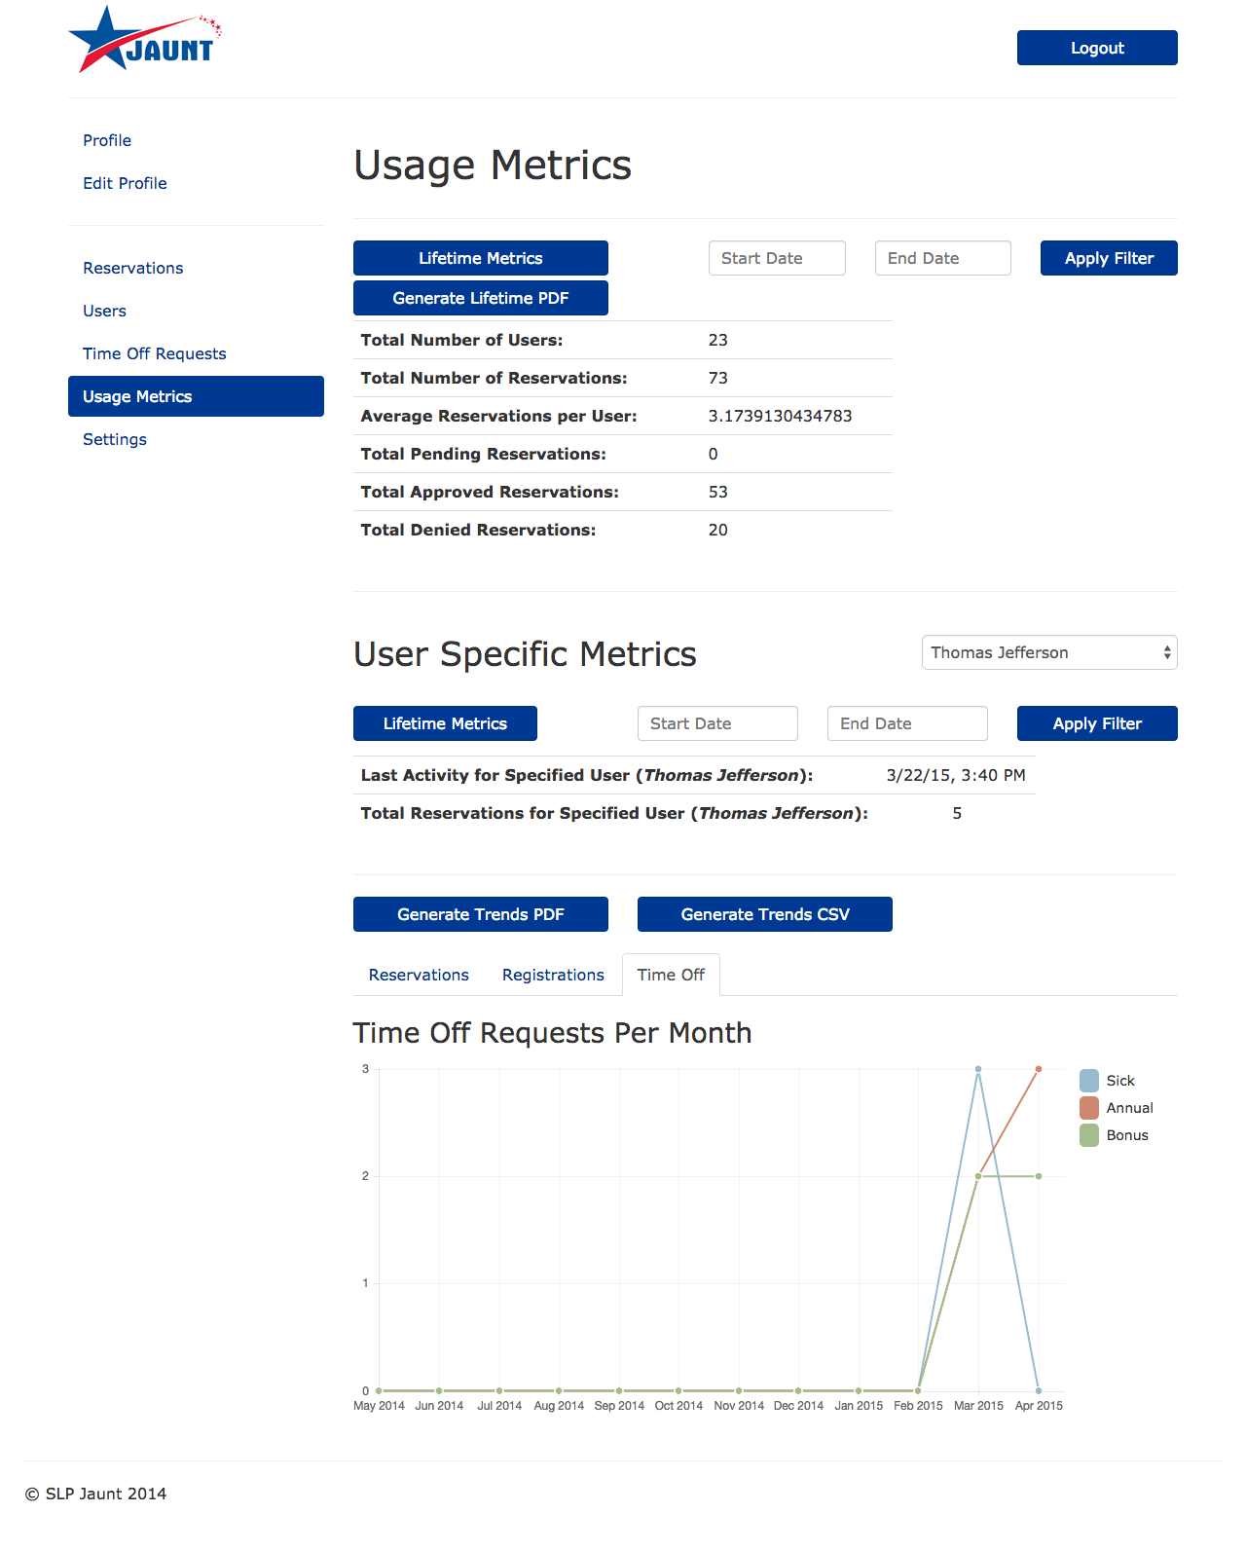

### Client and Employee User Types

Because we were no longer integrating the real-time system, JAUNT requested that we integrate a portal through which employees can file time off requests. In order to accommodate these time off requests, our system needed to be able to support not only client user types, but also employee user types. Our biggest challenge in integrating employee user types was figuring out how employee user accounts should be created. The existing registration page is very client-centric and asks questions such as “Have you ridden JAUNT before?” which were not applicable to employees. Rather than create a separate registration page for employees, we decided that only administrators could create administrative accounts. This decision came with its own set of design challenges. One notable challenge was figuring out how to create a password for the newly created employee accounts. Our first idea was to generate a temporary password, which would be emailed to the email account associated with the new account. However, this method requires employees to copy and paste the temporary password from the email prior to logging in and changing the password. Our final solution sends a secure link via email to the newly registered email address. After clicking on the link, employees are taken directly to the password setup page.

*Figure 5.Sample Metrics Graphs*

### Simplifying the Time-Off Request Form

Employees are able to indicate up to three options for each time off request. Schedulers balance preference with the schedule when deciding which option to approve. Our initial form had inputs for all three options, which resulted in a large and complex form that implied that you needed to specify three options rather than *up to* three. We also sought to improve the method by which employees selected the date ranges for their time off requests. We removed all of the date and time drop downs and replaced them with a single calendar view. The calendar application we chose to use comes standard with the ability to select a date range by clicking and dragging on the calendar. This application works great for time off requests that span entire days such as “all day Monday” through “all day Wednesday”. However, figuring out how to handle requests that begin or end in the middle of the day was left up to us. We created a solution where a window pops up within the calendar that allows the user to specify either “All Day” or a specific time of day for both the start and end dates, though only after the user selects a date range.

### Informing Schedulers

JAUNT expressed concern that schedulers may be slow to respond to new reservations on the system because the system likely won’t initially receive much traffic and the schedulers will not be in the habit of checking the system regularly. Accordingly, they asked that the system automatically send notification emails to JAUNT staff for events such as new reservations and new time off requests. As we discussed the email notification system, the customer worried that the scheduler may become inundated with emails as the user base increases. We solved this potential problem by allowing admins to use the settings page to determine when emails are sent. In the event that schedulers are receiving too many “New Reservation” emails, they can simply turn them off.

# PROCEDURE

## Getting Started

The system is available online as a website - all users are required to login. There are five user roles - client, driver, scheduler, hourly, and administrator - that determine what capabilities the user has within the system.

If a user already has an account they can simply login from the home page. The home page also includes links to reset a forgotten password and create a new account. Any new users must have ridden with JAUNT previously in order to set up a client profile - otherwise, new users must call JAUNT to set up a new profile. If new users already have a client profile with JAUNT, then they can proceed to sign up for an account. Only client accounts can be created from the external sign up form.

## User Roles and Features

Every user type will have access to a “Profile” and “Edit Profile” tab on the left sidebar menu. A user’s profile lists account information such as name, email address, and recent activity including the date and time of the last time the user was active. For scheduler and hourly user accounts, a calendar displays pending and approved time off requests or reservations made by the user. The “Edit Profile” tab allows the user to change their email address, password, and their desired language for the website.

### Clients

Clients will use StarPort to make reservations to ride with JAUNT. Their profile will display additional data such as the expiration date of their CAT disability certification and the average number of reservations made per month. A calendar will display any pending or confirmed reservation requests. On the left sidebar menu, they also have options to make reservations, view upcoming reservations, and see past reservations. The menu also has links to the JAUNT “FAQ” and “How to Ride JAUNT” pages.

To make a reservation, clients must go to the “Make a Reservation” form and enter their desired trip information. Clients are sent an email confirmation containing the trip information when the form has been submitted, and can also check the status of their reservation request on their profile. When the reservation is approved, the client will receive an email with the trip information. This information can also be seen in the “Upcoming Reservations” tab.

### Administrators

Administrators have the most abilities of any StarPort users - they can manage reservations, approve time off requests, create and manage users, view the website usage statistics, and change the system-wide settings of StarPort. Administrators can create reservation requests for other users, view pending requests, and approve, deny, or edit them. Finally, administrators can generate PDF reports for both time-off and reservation requests submitted via StarPort. Finally, administrative users can see the list of all users on StarPort, where they can edit and delete users, or make new staff level user accounts.

Administrators are able to view the “Usage Metrics” page, which displays statistics and metrics for StarPort such as the number of reservations made, the number of users, and the number of time off reservations per month. These metrics are displayed in tables and is available for download in a PDF or CSV format. The information can be filtered to show metrics for the lifetime of the system or for a desired date range, and can calculate metrics for one specific user.

The “Settings” page, allows administrators to manage the system-wide settings options for StarPort. These settings include whether or not to send clients an email when their reservation has been approved, the amount of time before a user is considered inactive, how long in advance a reservation must be made, the template for emails, and whether or not to send schedulers an email when a time off request is made.

### Drivers

Drivers are employees of JAUNT who provide transportation to the clients. They use the website in order to make time off requests, view the status of pending requests, and are able to see any approved time off requests that they made.

### Hourly Employees

Similar to drivers, hourly employees also work for JAUNT and are able to submit time-off requests and view any approved requests on a calendar. Hourly employees also have the ability to approve and deny trip reservations that have been made by clients.

### Schedulers

Schedulers are JAUNT employees so they use the system for administrative purposes. They have the same permissions as the hourly employees and drivers - they are able to submit time-off requests and view their approved requests - but they also have the ability to approve or deny time off requests submitted by other staff members.

# RESULTS

Previously, the there was no web portal in JAUNT and all business processes were completed and tracked via phone, email, or paper. With the StarPort system, clients have a more efficient way to make reservations that is available at any time. This new system also reduces the risk of human error by consolidating information - making a new reservation can no longer be compromised by a faulty phone connection or a lost email. Clients also now have the ability to see their upcoming and pending reservation requests on a website, which helps track past usage of the site.

Employees also have a streamlined process for submitting time off requests. Previously, these requests were made by paper and now using the system, the benefits of having the online time off request option are the same as the online reservation benefits for clients. The system also provides the ability to view the usage metrics of common JAUNT business processes.

According to JAUNT, the system allows staff members to create reservations in 20 – 60 seconds, which is must faster than their previous processes: previously, a phone reservation could take between 60 seconds to 10 minutes, while an email reservation could take 4 – 15 minutes. Over the course of a full workday, a staff member makes close to 70 reservations, so the system saves each scheduler close to 80 minutes per shift, or 6.8 hours over the course of one week.

Before this system was created, the JAUNT Director of Operations was able to process one time-off request in 120 seconds. This processing time has been cut in half with StarPort: with approximately 40 time-off requests submitted weekly, this system has saved JAUNT 40 minutes per week that was previously devoted to processing time-off requests. A larger difference can be seen in the amount of time it takes for employees to submit these 40 time-off requests: previously, it took employees an average of 240 seconds to write and submit a time-off request, while drivers can complete and submit the online form in fewer than 90 seconds. This system has saved employees 1.6 hours weekly as they can more efficiently complete these forms. As one hour translates to $13 savings, this system has saved JAUNT $676 a year with just a streamlined time-off request system.

The StarPort system provides both the employees and clients of JAUNT with a more efficient way of handling their activities.

# CONCLUSION

The team designed an accessible website that provides both a reservation system and a time-off system, usable by both JAUNT and JAUNT’s clients. The reservation system helps makes handling reservation easier and faster for JAUNT staff members by better organizing the pending reservations to be approved, denied, or negotiated. As the reservations are approved, denied, or negotiated, an automatic email is sent to the client which reduces the need to manually and repeatedly write and send emails to clients reducing the workload on the staff members. At the same time, the reservation system provides a way for clients an easy way to reserve rides at their own convenience without having to wait in phone calls. In addition, the availability of a robust time-off system provides an improvement to the previous workflow for the time-off scheduler and enjoys the similar advantages of the reservation system.

Furthermore, usage statistics are now readily available to any system administrator. The information provided by the usage statistics can be used to help JAUNT understand where to allocate their resources to make the company run more efficiently and reduce cost.

# FUTURE WORK

Due to time constraints and complications regarding both JAUNT policies and the implementation of Trapeze, we

could not connect our system to the Trapeze database. With this connection, we would be able to provide clients with detailed metrics such as average fare and total expenditures for each month as well as some real-time bus information. This connection would vastly improve the overall quality and impact of both systems and thus would be a primary focus of any expansion of the system. Additionally, incorporating an online payment system that allows clients to pay for trips ahead of time would give added convenience to clients and reduce the burden of fare collection on drivers.

# ACKNOWLEDGEMENTS

The group would like to extend a special thank you to Lucas Lyons, John Overton, David Parks, and the entire JAUNT organization for their support and willingness to work with us throughout the past year.