DriveAbility
User Guide
Your Guide to Mobility Solutions

1. Introduction
Welcome to DriveAbility, a platform created as part of the Eco-Car project and dedicated to providing expert, in-depth reviews of assistive driving technology for people with disabilities. Our goal is to help you find the right mobility solutions by connecting people with reviews from others who have real, first-hand experience with the products.

Who Is This Guide For?
DriveAbility has three types of accounts, each with different capabilities. This guide is designed to explain the purposes and capabilities of each account type and how these features work.

General Users (Non-Reviewer)
Anyone who creates an account can browse and read reviews, view anonymized reviewer profiles, and search and filter content. General users can apply to become a reviewer at any time from their profile page.

Reviewers (Approved)
Approved reviewers can do everything a general user can, plus write and publish reviews, save review drafts to finish later, and display an anonymized reviewer profile to help readers find relevant reviews.

Administrators
Admin accounts have full access to the platform including the ability to manage user accounts and reviewer applications, and moderate published content. Users can be promoted to Admin or be manually added to the system. Admin-specific features are covered in Section 8 of this guide.

2. Getting Started

Creating an Account
To create an account, click the Login button in the top-right corner of any page, then select the option to register a new account. You will be asked to provide your name, email address, and a password of at least 8 characters, along with additional demographics information such as type of disability, type of vehicle, etc.

Logging In
Click the Login button in the top-right corner and enter your registered email address and password. Once logged in, you will be taken to your account dashboard, and the login button should be replaced by a profile image.

Navigating the Site
The navigation bar at the top of every page gives you quick access to all areas of the site:
- Home — Returns to the DriveAbility homepage
- Reviews — Browse published product reviews
- Resources— Read related articles, find reviewers with similar needs to yours, and more
- ErgoRig — Learn about the testing apparatus used in our reviews
- Contact — Get in touch with the DriveAbility team

3. Browsing Reviews

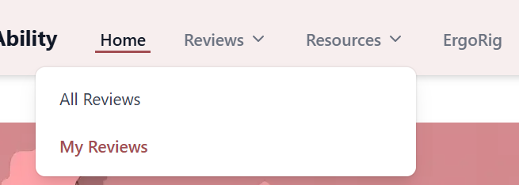

Finding Reviews
Navigate to the Reviews section using the top navigation bar. You can browse all reviews, look at reviews you have made or search and filter for a specific category.

Search and Filters
At the top of the reviews page you will find a search bar and a Filters panel. You can search by product name, reviewer code, or impairment type. The filter panel lets you narrow results by:
- Product category
- Minimum star rating
- Reviewer impairment type
- Sort order (newest, highest rated, most viewed)

Reading a Review
Click any review card to open the full review. Each review includes a summary, detailed written content, pros and cons, test results from our ErgoRig testing system, vehicles tested, and an overall rating broken down by ease of use, installation, comfort, durability, and value. The reviewer's anonymized profile information is shown at the bottom so you can assess how relevant their experience is to your own situation.

4. Resources

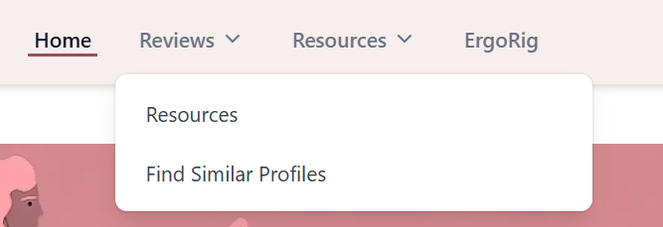

Resources
The Resources section contains five tabs: All resources, Blog posts, tutorials, videos, and useful links. These contain information on how to use various devices, ways to get into your car unassisted, as well as articles about different mobility aids. New resources can be added to the site by Admins. This section also contains Find Similar Profiles, where users can find others with similar disabilities, or type of vehicle, and see which devices they liked and reviewed.

Find Similar Profiles
Use the Find Similar Profiles button on the Reviewer Profiles page to search for reviewers who share similar characteristics to a given profile. This can help you identify the most relevant reviews for your specific situation.

Viewing a Reviewer's Detail Page
Click any reviewer card to open their full profile page. This page shows their demographic information, impairments, vehicle types, favorite products, bio, and a list of all their published reviews. No personal information such as name or email is ever shown — only their anonymized reviewer code.

5. Your Account

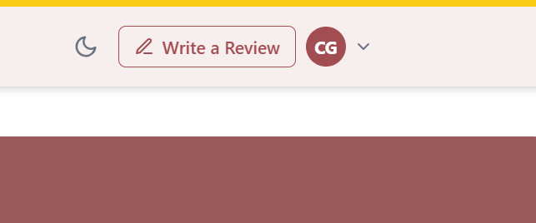
Access your account settings at any time by navigating to /profile after logging in. The left sidebar has tabs for each area of your account.

Profile Information
The Profile Information tab lets you update your first name, last name, email address, and other demographic information. Click Save when done.

Change Password
The Change Password tab lets you update your password. You will need to enter your current password before setting a new one. Passwords must be at least 8 characters long.

Signing Out
Click the Sign Out button at the bottom of the left sidebar to log out of your account.

6. Becoming a Reviewer

Submitting an Application
To apply to become a reviewer, navigate to your profile page and click the Reviewer Profile tab. If you have not yet applied, you will see the reviewer application form. Fill in your demographic information, impairments, vehicle types, bio, and an optional personal message to the review team, then click Submit Application.

Application Status: Pending
Once you submit your application, the Reviewer Profile tab will show a Pending Approval notice. Your application is being reviewed by the DriveAbility team. You will receive an email notification once a decision has been made.

Once Approved
When your application is approved, the Reviewer Profile tab will update to show:
- A green Approved status badge
- Your unique Reviewer ID (in the format RXXX-XXXX) — this is displayed alongside your reviews instead of your name to maintain your privacy
- An editable form where you can update your reviewer profile information at any time

Your Reviewer ID is read-only and cannot be changed. It is assigned by the DriveAbility team upon approval.

7. Writing & Managing Reviews
This section applies to approved reviewers only. If your reviewer application is still pending or you have not yet applied, you will not have access to review creation.

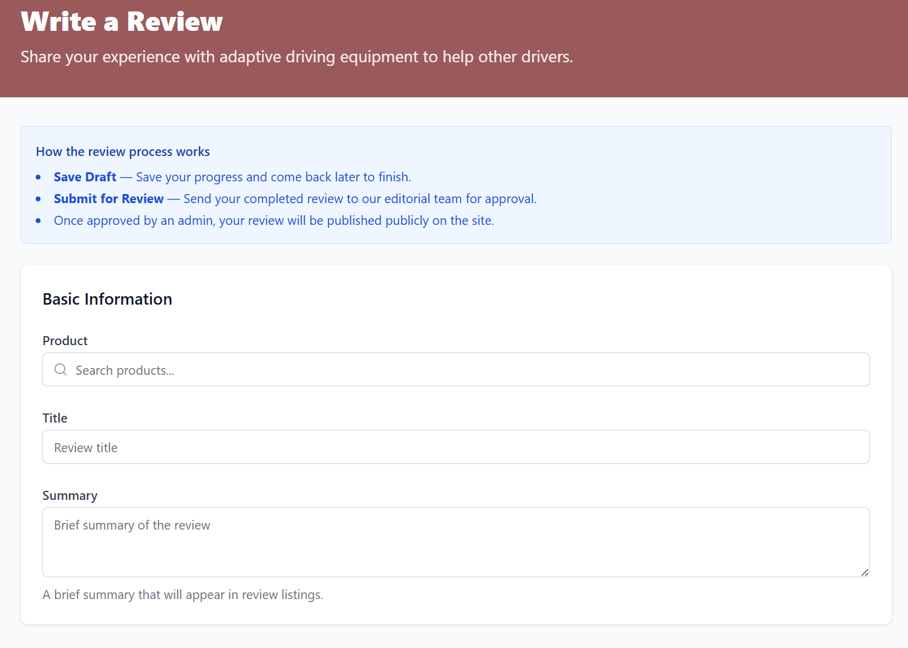

Creating a New Review
Next to your profile image in the top right is a button labeled Write a Review. Click this button to open the review creation form. The form includes the following sections:
- Product and reviewer selection
- Title and summary
- Full review content (rich text editor)
- Pros and cons
- Ratings (overall, ease of use, installation, comfort, durability, value)
- Test results
- Vehicles tested
- Media (video URL and images)
- Recommendations and status

Saving a Draft
If you are not ready to publish, click Save as Draft at the bottom of the review form. Your progress will be saved and the review will appear in your My Reviews table with a yellow Draft badge. You can come back and continue editing it at any time.

Continuing a Draft
To reopen a saved draft, go to the My Reviews tab on your profile page and click the edit icon (pencil) next to the draft. This will open the review form pre-populated with everything you have written so far. You can continue editing, save it as a draft again, or submit it for publishing.

Publishing a Review
When your review is complete, set the Status dropdown to Published and click Create Review (or Update Review if editing a draft). Once published, your review will appear on the relevant product page and in the public reviews listing.

Managing Your Reviews
The My Reviews tab shows a table of all your reviews with their current status. From this table you can:
- View — open the published review page
- Edit — reopen the review form to make changes
- Delete — permanently remove the review (you will be asked to confirm)

8. Admin Functions
Admin accounts have access to additional tools for managing the DriveAbility platform. Admin functionality is accessible via the admin dashboard, which is only visible to users with an admin role. The Admin Dashboard allows administrators to look through all products, reviews, and reviewer accounts in order to approve, moderate and manage anything that needs tending to. Upon logging in, an Admin is immediately taken to this Dashboard page. Clicking the website logo in the top left corner will take Admins back to the website’s home page.

Approving or Rejecting Reviewer Applications
Once logged in, an Admin can select the Reviewers option on their side bar. This takes them to the Reviewer Profiles page where they can look through all created profiles, see which ones are still pending approval, and approve or reject as need be. By clicking on the view option next to the application’s submission date, Admins can see the information provided at time of application and decide whether to approve or reject the application. When rejecting, a reason should be written in the provided box. Clicking the arrow labeled Back To Reviewer Profiles, returns the Admin to the Reviewer Profiles dashboard. Admins are also able to moderate and delete already approved accounts if the need arises.

Approving or Rejecting Product Reviews
By clicking Reviews on their sidebar, Admins are taken to a page where all reviews can be managed. Submitted reviews must be approved or rejected before they are published. Admins can search for a particular review by keywords, or filter by status, category or reviewer. Previously approved reviews can also be deleted or rejected at a later date if the need arises.

Add Products
By clicking Products on the sidebar, Admins are shown a dashboard with all products listed. The Add Product button in the top right corner, takes Admins to a form to be filled out with product information, and a checkbox to mark the product as ‘Active’, meaning it is visible to users on the website. Once the form is completed and submitted, the new product’s page is added to the website, and reviewers can see it and leave reviews.

Admins can also search for a particular product using keywords or filter by category or status. Each product listing includes the product name, brand, category, price, control type, status, and several icons for various actions. Admins can click on the eye icon to see a more detailed description of the product; the arrow to go directly to the product page; the pencil to make edits to the product description; or the trash can to delete the product from the website. Clicking the medal icon, will add the product to the featured products list.

Add Resources
By clicking Resources on the sidebar, Admins are shown a dashboard with all resources listed. The Add Resource button in the top right corner takes Admins to a form to be filled out with resource information. Once the form is completed and submitted, the new resource’s page is added to the website, for users to see. Admins can also search for a particular resource using keywords or filter by status or category.

Accessing Platform Analytics and Content Management Tools
The option labeled Analytics on the sidebar takes Admin’s to an overview dashboard with various statistics listed on it, including:
- Review Pipeline, with numbers and percentages of:
  - Published reviews
  - Submitted reviews pending approval
  - Drafted reviews
  - Rejected reviews
  - Archived reviews
- Percentage of Products with Reviews
- Products by Category and Brand
- Top Rated Products
- Most Reviewed Products
- Most Active Reviewers
- Reviewer Approval Funnel with Status percentages
- Reviewer Demographics

Feedback
The Feedback option on the sidebar allows Admins to view feedback surveys from users. Admins can search through these surveys by keyword, or filter based on type, status, or sources.

Create User
Admin accounts have the ability to manually add users in any role, or modify an existing user, such as promoting a Reviewer account to an Admin account. Admins can select Create User on their sidebar and fill out the form to create an new account or search for an existing user account to modify. Admins are not able to modify their own role.

Need help?
Use the Contact page to get in touch with the DriveAbility team.

