To-Hieu Dao is a lecturer with a Master’s degree at the Phenikaa School of Engineering, Phenikaa University. He has conducted approximately 12 institutional-level scientific research projects and supervised many student-level research projects. In 2019 and 2021, he received commendation certificates from the Director of Thai Nguyen University. In 2022, he was honored to receive a commendation certificate from the Minister of Education and Training. From 2022-2024, he received a commendation certificate from the President of Phenikaa University | 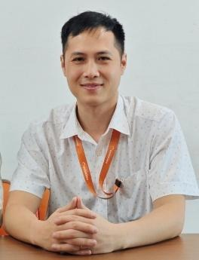
Duc-Nghia Tran is a PhD at the Institute of Information Technology, Vietnam Academy of Science and Technology (VAST). He received his PhD degree from Sorbonne Paris Cité (France). In his thesis, he focuses on signal processing of EPR spectra for in vivo experiments. His research interests are AI, IoT, Electron Paramagnetic Resonance, parameter estimation, and data analysis. He serves as a technical committee program member and reviewer of many international conferences and journals. | 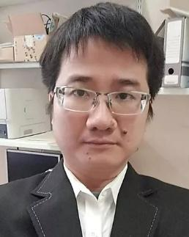
Viet-Hoan Bui is a dedicated Biomedical Engineering undergraduate at the Phenikaa School of Engineering. His academic journey is distinguished by several notable achievements, including first prizes in scientific research at Phenikaa University and prestigious awards in national competitions such as the "Science and Technology Awards for Students in Higher Education Institutions." His work encompasses integrated sensors, machine learning, and advanced signal processing for healthcare applications. | 
Van Son Nguyen received a B.E. degree in Electrical Engineering and an M.S. degree in Electronics and Telecommunications Engineering from Hanoi Open University, Vietnam. He is currently a Lecturer with the Faculty of Electrical and Electronic Engineering, at Hanoi Open University. His research interests include signal processing in B5G/6G systems and ML/AI applications in big data processing. | 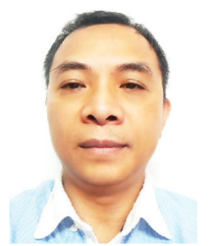
Dang Khanh Hoa graduated from Hanoi University of Science and Technology in 2002, majoring in Electronics and Telecommunications. In 2005, he graduated with a master’s degree in Electronic Engineering from Hanoi University of Science and Technology. In 2020, he was awarded a doctorate in Electronic Engineering at the School of Electrical and Electronics Engineering, Hanoi University of Science and Technology. His research focuses mainly on computer vision, applied to wheeled robot control. | 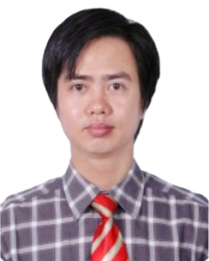
Pham Van Thanh was born in 1990. He received the M.Sc. degree in Electronics and Telecommunication at University of Engineering and Technology in 2012 and he was a PhD student at this university. He also is a full-time lecturer at University of Fire Prevention and Fighting. His research interest covers areas that include Signal and Image Processing, Personal Safety Equipment, Firefighter Supporting Devices, and Fire Protection Systems. He successfully defended his doctoral thesis in 2022. | 
Duc-Tan Tran is a Professor and Dean of the Faculty of Electrical and Electronic Engineering, Phenikaa School of Engineering, Phenikaa University. He has published over 150 research papers. His main research interests include the representation, processing, analysis, and communication of information embedded in signals and datasets. He serves as a TP Co-chair, technical committee program member, track chair, session chair, and reviewer of many international conferences and journals. | 