The Design and Implementation of an Educational Perceptron Simulator

Submitted in part fulfilment for the degree of BEng in Computer Science

Department of Computer Science

Daniel Turnes

Supervisor: Dr. Simon O’Keefe

Date:

Number of words = , as counted by MS Word.
Number of pages = .
These counts include the body of the report but exclude all contents pages, References and Appendices.

Abstract

The Perceptron is the simplest implementation of a neural network, consisting of a single computational neuron. It acts as a binary pattern classifier, separating input patterns into two distinct categories by placing a hyperplane between them. The most useful aspect of neural networks is their ability to learn, with Google’s AlphaGo successfully learning how to play Go. As their popularity has grown, it has become apparent that more resources should be available to study neural networks. This project has used educational principles to design and implement a simulator that illustrates the learning process of a Perceptron in order to reinforce and consolidate student knowledge. This is done by providing a graphical means of presenting concepts such as the hyperplane, error landscape and threshold function which make up the core of the Perceptron’s learning process. Results of user evaluations show that the simulator was generally successful in showing how the Perceptron learns. Further results show high satisfaction, ease of use and enjoyability but lower than expected intuitiveness due to an overcrowded GUI and lack of tooltips. Conclusions drawn include prioritising assistance in the form of tooltips and a help guide, hiding functionality to avoid clutter and performing further user evaluations to thoroughly test the learning objectives.

Acknowledgements
I would like to express my deepest thanks to my supervisor Dr. Simon O’Keefe for his constant support and guidance throughout this project, without whom this would not be possible.

I would also like to thank my mentor and friends for keeping me focused through hard times and whose proof reading and feedback have helped direct and shape this report.

Table of Contents
Abstract 2
Acknowledgements 2
Table of Contents 3
Table of Figures 8
Table of Tables 10
Table of Equations 10
1. Introduction 11
1.1 Motivation 11
1.2 Aim 12
1.3 Parameters and Limitations 12
1.4 Audience and Report Summary 12
1.5 Summary of Outcomes 12
1.6 Statement of Ethics 13
1. Literature Review 14
2.1 The Perceptron 14
2.1.1 How a Perceptron functions 14
2.1.2 How a Perceptron learns 16
2.2 Previous Work 18
2.2.1 MATLAB Neural Network Toolkits 18
2.2.2 Neural Net Playground 18
2.3 Educational Research and Design Implications 19
2.3.1 Retrieval Practice 19
2.3.2 Learning styles 19
2.3.3 Wanting, Doing, Feedback and Digesting 20
2.3.4 Educational Software Design Principles 20
2.3.5 The Learning Objectives 21
2.4 Literature Review Conclusion 21
3. Requirements 22
3.1 Single Statement of Need (SSON) 22
3.2 Stakeholders 22
3.3 System Development Life Cycle: Agile Model 23
3.4 Requirements Elicitation 23
3.4.1 Primary Stakeholder 23
3.4.2 Secondary Stakeholder 23
3.4.3 Elicitation Conclusion 23
3.5 Requirements Analysis and Negotiation 24
3.5.1 Project Scope 24
3.5.2 Purpose of the application 24
3.5.3 Data Collection 24
3.5.4 Requirements Validation and Verification 24
3.6 System Model - Data-flow model 25
3.7 Critical Requirements Definition 25
3.8 Constraints 26
3.9 Risk Assessment 27
3.10 Requirements Hierarchy 28
4. Design 29
4.1 System Architecture 29
4. 2 General Use Cases 29
4.3 Perceptron Learning Process Algorithm 30
4.4 GUI Design and Learning Objectives 30
4.4.1 Design 0: Main Menu 30
4.4.2 Design 1: The Perceptron 30
4.4.3 Design 2: The Perceptron Learning Process 31
4.5 Accessibility and Usability 32
4.5.1 Layout 32
4.5.2 Colour 32
4.5.3 Text 32
4.5.4 Network Parameters 32
4.5.5 Tooltips and Help Guide 32
4.5.6 User mistakes and error handling 33
4.6 Extensibility 33
4.7 Modifiability 33
4.8 Maintenance 33
5. Implementation 34
5.1 Implementation Language 34
5.2 Implementation and Learning Objectives 34
5.2.1 Plotting the Learning Process Graph 34
5.2.2 Plotting Error Graph 35
5.2.3 Plotting Threshold Graph 35
5.2.4 Step Through 36
5.2.5 History Slider 37
5.2.6 Generate dataset 37
5.2.7 Handles and data passing 37
5.2.8 GUIDE limitations 38
5.3 Implementation Conclusion 38
6. Testing 39
6.1 Testing Methodology 39
6.1.1 Unit Testing 39
6.1.2 Functional Testing 39
6.2 User Evaluation Methodology 40
6.2.1 Introduction to Perceptrons 40
6.2.2 User Evaluation Tasks 40
6.2.3 Post-Task Questionnaire 40
7. Results and Evaluation 41
7.1 Methodology Review 41
7.1.1 Introduction to Perceptrons 41
7.1.2 User evaluation tasks 41
7.2.3 Questionnaire 42
7.2 Learning Objectives 43
7.3 Other notable issues 44
7.3.1 Help guide and tooltips 44
7.3.3 History Slider 44
7.3.4 Step Through 44
7.3.5 Colour 45
7.3.6 Dialog Issues 45
8. Conclusion 46
8.1 Further work 47
8.2 Reflection 47
References 48
Appendix: E 51
E.1 Neural network learning tool: Informed Consent 51
Appendix: L 52
L.1 Neural Net Playground 52
Appendix: R 53
R.1 Functional Requirements Definition 53
R.2 Non-functional Requirements Definition 61
Appendix: D 62
D.1 Perceptron Learning Algorithm 62
D.2 Data Dictionary 63
D.2.1 Algorithm Design Data 63
D.2.2 User Learning Methods Data 65
D.2.3 Accessibility Requirements Data 66
D.3 Requirements Met in Design 67
D.4 GUI Designs 68
Appendix: I 70
I.1 perceptron_skeleton_filled.m 70
I.2 Functional Requirements fulfilled in Implementation 72
I.3 Final GUI Deliverables 73
Appendix: T 75
T.1 Screenshot Tests 75
T.2 The Perceptron Learning Process Unit Test 78
T.3 Test Screenshots 80
T.4 Requirements Testing 84
Appendix: RE 95
RE.1 Neural Network Learning Tool: User Evaluation Tasks 95
RE.2 Neural Network Learning Tool Questionnaire 98
RE.3 User Evaluation Tables of Results 101
RE.3.1 Questionnaire results table 101
RE.3.2 Task time taken table 101
RE.3.3 Task error rate table 102
RE.3.4 Task success rate table 102
RE.3.5 Task ease of completion table 103
R.4 User Evaluation Table Summary Charts 104
Appendix: Code 107

Table of Figures
Figure 2.1: Hyperplane classifying input patterns 14
Figure 2.2: XOR problem 14
Figure 2.3: The Perceptron [14] 14
Figure 2.4: The Step threshold function [14] 15
Figure 2.5: The Sigmoid function [15] 16
Figure 2.6: Threshold boundary moves to classify input patterns correctly [18] 17
Figure 2.7 Error landscape of the learning process 17
Figure 2.8: MATLAB nntraintool 18
Figure 2.9: MATLAB nntraintool error graph 18
Figure 3.1: Agile model [33] 23
Figure 3.2: System data-flow model 25
Figure 3.3: Requirements Hierarchy 28
Figure 4.1: System Architecture 29
Figure 5.1: Appending the sum of the squared error 35
Figure 5.2: Plotting the sum of the squared error 35
Figure 5.3: Plotting the Step function using three different plots 35
Figure 5.4: Plotting the bipolar Sigmoid function 35
Figure 5.5: Plotting the desired and actual output on the Sigmoid function 36
Figure 5.6: Holding the Threshold Graph 36
Figure 5.7: Initialising the minimum and maximum block counters 36
Figure 5.8: Incrementing the block counters to use the next set of data points 36
Figure 5.9: Prevent the maximum block counter from going out of bounds 36
Figure 5.10: Reset the block counters once a full pass of the data has been completed 37
Figure 5.11: Saving the handles structure 37
Figure 5.12: Getting an updated copy of the handles structure 38
Figure 7.1: Error rate vs. Success rate 41
Figure L.1: Neural Net Playground [19] 52
Figure L.2: Neural Net Playground Optional Functionality [19] 52
Figure D.2: Widrow-Hoff delta rule [34] 62
Figure D.1: Perceptron Learning Algorithm [34] 62
Figure D.4: The Perceptron Page GUI design 68
Figure D.3: Main Menu GUI design 68
Figure D.5: The Perceptron Learning Process Page GUI design 69
Figure I.1: Functional Requirements fulfilled in Implementation. Fulfilled(grey), Unfulfilled(red). 72
Figure I.3: Final GUI The Perceptron Page 73
Figure I.2: Final GUI Main Menu 73
Figure I.4: Final GUI The Perceptron Learning Process Page 74
Figure T.1: Main Menu requirements screenshot tests 75
Figure T.2: The Perceptron requirements screenshot tests 76
Figure T.3: The Perceptron Learning Process requirements screenshot tests 77
Figure T.4: The Perceptron Learning Process convergence 79
Figure T.5: F35: Initialising random weights. 80
Figure T.6: F26: Updating the neuron architecture and F31: Redrawing the threshold boundary 81
Figure T.7: F33: Implement the learning rate. Learning rate = 1. 82
Figure T.8: Implement the learning rate. Learning rate = 0.01. 83
Figure RE.1: Mean task ease of completion rating 104
Figure RE.2: Mean ease of completion rating per participant for all tasks 104
Figure RE.3: Mean number of errors per task 104
Figure RE.4: Total number of errors per participant 105
Figure RE.5: Mean task success rating 105
Figure RE.6: Total number of tasks successfully completed. 105
Figure RE.7: Mean time taken per task (excluding participant 1) 106
Figure RE.8: Total time taken per participant 106
Figure RE.9: Mean questionnaire scores 106

Table of Tables
Table 3.7.1: Functional Requirements 25
Table 3.7.2: Non-functional Requirements 26
Table 3.9: Risk Assessment 27
Table 6.1 Perceptron Unit Testing 39
Table 7.1 Average Task Results 42
Table R.1 Functional Requirements Definition 53
Table R.2 Non-functional Requirements Definition 61
Table D.2.1.1 The Perceptron Data Dictionary 63
Table D.2.1.2 The Perceptron Learning Process Data Dictionary 64
Table D.2.2 User Learning Methods Data Dictionary 65
Table D.2.3 Accessibility Requirements Data Dictionary 66
Table D.3 Requirements Met in Desigm 67
Table T.2 The Perceptron Learning Process Unit Test 78
Table T.4 Requirements Testing 84
Table RE.3.1 Questionnaire results 101
Table RE.3.2 Task time taken 101
Table RE.3.3 Task error rate 102
Table RE.3.4 Task success rate 102
Table RE.3.5 Task ease of completion 103

Table of Equations
Equation 2.1: Weighted sum and threshold function 14
Equation 2.2: Simplified threshold function 14
Equation 2.3: Sigmoid function 14
Equation 2.4: Error term 15
Equation 2.5: Updating the weights 16
Equation 2.6: Sum of the squared error 16

1. Introduction
Neural networks are now, more than ever, pushing the boundaries of possibilities. Using vast quantities of data, they can be used to implement self-driven cars [1], determine the location of any geographical image [2], and even successfully play Go [3,4] which was previously thought to be an intractable problem. More everyday uses include detecting fraudulent credit card transactions, tracking stock market fluctuations and optical character recognition, as mentioned by Callan [5].

Neural networks are, in very general terms, a computer simulation of how the human brain makes decisions. Computers are high speed, sequential machines composed of ordered hardware components. They perform tasks such as arithmetic and recalling data in a fraction of the time humans can. Human brains however are highly parallel but slow, ordered into a complex structure that we do not fully understand. They are composed of billions of units called neurons that act as individual processors but maintain phenomenally high interconnectivity, with each neuron potentially being connected to thousands of others.

Artificial neural networks implemented on computers consist of individual, interconnected, parallel processors which take inspiration from biological neural networks. Each neuron receives signals as input patterns from a sensory input layer and processes these inputs using weights which act as modifiable synapses. When an output signal is produced, it is sent along the computational axon to all connected neurons who use this signal as input, thus continuing the cycle. While networks of these neurons can accomplish extraordinary tasks, a single neuron can still be useful and they are known as Perceptrons.

The goal of neural computing is to abstract and exploit the highly-interconnected parallelism of biological neurons to solve problems such as classification and regression. The scope of neural networks is immense and fantastic; they challenge other paradigms of computation and can help to understand our own thought processes.

1.1 Motivation
The University of York’s Department of Computer Science at the time of writing this report offers a third-year module titled “Introduction to Neural Computing and Applications” (INCA) lead by Simon O’Keefe. Having studied this module and having a desire to pursue a career in teaching and education, this project was the perfect opportunity to develop my knowledge and skills in both neural computing and educational pedagogy.

Neural networks are becoming increasingly used these days in machine learning to solve problems such as those outlined earlier. They are however initially difficult to understand due to the complex algorithms underlying their learning processes.

The neural network toolkits offered by the MATLAB development environment are currently inadequate in offering an intuitive and visual understanding of neural network concepts. That is not to say that these toolkits are of no value, only that they could be improved, as detailed in the Literature Review. Offering a graphical tool in addition to the toolkits used by MATLAB would be of great benefit to students studying on the INCA module by allowing them to visualise the learning process of neural networks.

1.2 Aim
The purpose of this project is to design and implement a neural network simulator aimed at students that illustrates the behaviour of Perceptrons, with an emphasis on interactability and usability.

The primary learning outcome for students will be to reinforce and consolidate their knowledge of Perceptrons by interacting with this simulator which will visually display the Perceptron learning process.

1.3 Parameters and Limitations
Requirements obtained from the Primary Stakeholder (Simon O’Keefe) initially called for several neural networks to be implemented but given report length and time restrictions, this project’s scope was only able to cover the Perceptron.

MATLAB was the implementation language of choice as neural networks make heavy use of matrix algebra. The main trade-off was that the GUI development environment was more primitive than other languages, with mild to negative user evaluation feedback in terms of aesthetics.

1.4 Audience and Report Summary
This report’s intended audience is fellow students who are interested in neural networks, educational pedagogy and software design. It will explain in as much detail as possible the process of designing and implementing the Perceptron simulator making use of principles such as Tognazzini’s Usability Principles [6] and Nielsen’s Heuristics [7].

Conventional software engineering processes are followed, consisting of requirements, design, implementation, testing and evaluation. The Agile development method is also used as discussed in the Requirements section.

1.5 Summary of Outcomes
Due to time constraints, not all requirements were able to be fulfilled within this project. Among these was the help guide and tooltips, whose exclusion was noted critically by user evaluations.

User evaluations and testing revealed several bugs and errors that were not caught during implementation such as dialogs declaring that the data is classified when it is in fact not and vice versa.

Overall, while many critical usability issues were flagged, user questionnaires rated the application highly. Average satisfaction rating was 8/10, average ease of use rating was 7.7/10 and 7.4/10 during and after the evaluation respectively. Recommendation ratings of the application to students studying neural networks was 8.6/10. Intuitiveness on the other hand was unfortunately not highly rated with an average score of 6.2/10 due to issues mentioned above.

1.6 Statement of Ethics
This neural network software engineering project is intended for educational purposes only. This project is in no way intended to cause harm, either physical or emotional, or otherwise contradict participant’s best interests.

Written informed consent was obtained from all participants for the user evaluations and questionnaires which were the sole interactions. Participants were briefed before user evaluations, explaining what to expect, including being observed, and made aware of the project purpose and background.

Participants were also made aware that:
- Their participation was entirely voluntary and that they may withdraw consent at any time for any reason and have any data collected about their evaluation destroyed.
- All data collected would be anonymised, kept confidential between the project author (Daniel Turnes) and project supervisor (Simon O’Keefe) and that any publications would not disclose their identity.
- All data would be kept on record as per University policy and may be shared with researchers within the University.
- All personal data would be kept secure on password protected machines.
- Hard copies of personal data, including consent forms, would be kept in a secure place.

Academic and safety principles were strictly adhered to to prevent the unethical situation of using incorrect information from educational research and incorrect testing and evaluation methods.
The informed consent form can be located in Appendix: E.

- Literature Review

This Literature Review will firstly detail what the Perceptron is, what it does and how it learns. It will then discuss previous work into neural network learning tools before finally elaborating on the educational theory required to design the application.

The Perceptron is a well-founded computational concept, with the basic model not having changed much since its inception. As this project does not intend to discover or implement a novel solution, the primary resources used to discuss the Perceptron include Callan [8], Anderson [9] and Beale and Jackson [10].

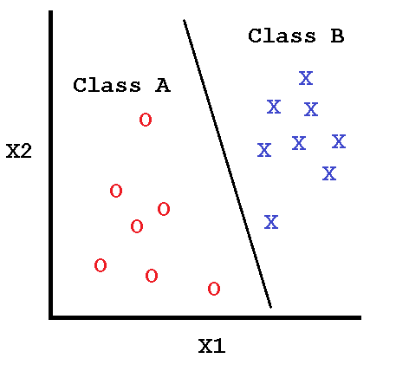
2.1 The Perceptron
The model of the artificial neuron was proposed by McCulloch and Pitts [11] and later coined as “The Perceptron” by Frank Rosenblatt [12]. This model is an abstraction of the biological neuron but does not consider complex biological activity such as electrical impulses or chemicals.
The Perceptron is a binary pattern classifier. It separates input patterns in a pattern space by drawing a hyperplane between them, thus classifying the patterns into one of two categories (Figure 2.1). If such a hyperplane exists then the problem is said to be linearly separable.
Figure 2.1: Hyperplane classifying input patterns
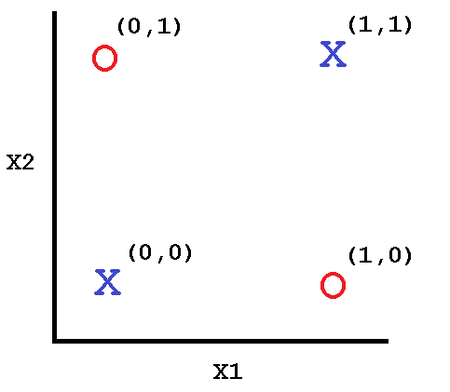
Perceptrons cannot solve linearly inseparable problems such as the XOR problem (Figure 2.2), first shown by Minsky and Papert [13]. In this case, a hyperplane cannot be drawn between the data such that the patterns are separated.

2.1.1 How a Perceptron functions
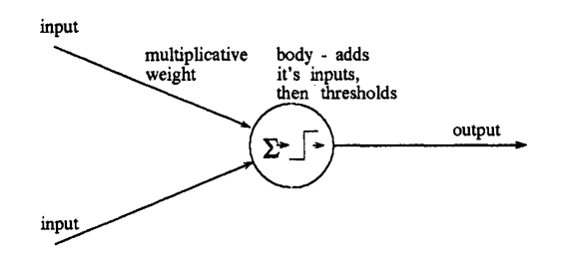
A Perceptron is connected to inputs. The connections to these inputs are called the weights, which reflect biological synaptic efficiency. This is shown in Figure 2.3. Large weight values reflect stronger pathways while small weights reflect weaker pathways. Weights are also excitatory (positive) or inhibitory (negative), as per the biological neuron.
Figure 2.2: XOR problem

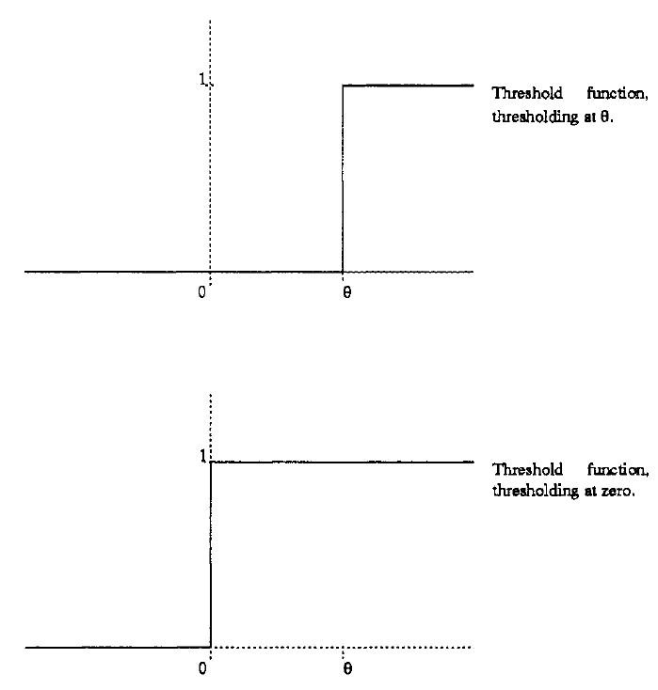
Every input is applied to a corresponding multiplicative weight, which produces a “weighted input”, representing the amount of excitatory or inhibitory neurotransmitter able to cross the synapse. These weighted inputs are then summed to a single value, known as the “weighted sum”. The Perceptron then compares this weighted sum to a threshold value θ, which represents the biological excitation threshold. If this weighted sum is greater than the threshold value θ, a binary output of 1 is produced, otherwise a binary output of 0 is produced. This output is a representation of the object class; whether it is in category A or category B; for example, is it raining or is it not raining. The act of comparing the weighted sum to a threshold value θ is known as the Step (or Heaviside) threshold function (Figure 2.4).
Figure 2.3: The Perceptron [14]

Mathematically, the process is as follows:
Figure 2.4: The Step threshold function [14]
$$\begin{aligned}f_{h}= w_{1}x_{1}+w_{2}x_{2}+…+ w_{n}x_{n}> θ \\ =\sum_{i=1}^{n}{w_{i}x_{i}>θ} \#(2.1) \\ where f_{h}\left(x\right)= \left\{\begin{aligned}1, &x>θ \\ 0, &x≤θ\end{aligned}\right. \#\end{aligned}$$
To simplify presentation while preserving mathematical meaning, the Step threshold function is rearranged to include θ as a weight variable, with a corresponding input of +1 (Figure 2.4).
Mathematically this is expressed as:
$$\begin{aligned}f_{h}=\sum_{i=1}^{n}{w_{i}x_{i}- θ>0} \\ =\sum_{i=0}^{n}{w_{i}x_{i}>0,}\#(2.2) \\ where w_{0}=θ,x_{0}= +1 and \\ f_{h}\left(x\right)= \left\{\begin{aligned}1, &x>0 \\ 0, &x≤0\end{aligned}\right. \#\end{aligned}$$
Other kinds of threshold functions exist such as the Sigmoid function, which produces an output in the range [0, 1], or [-1, 1] in the case of a bipolar sigmoid. The Sigmoid function (Figure 2.5) is defined as:
$$\begin{aligned}f_{s}\left(x\right)= \frac{1}{1+ e^{-x}} \#\left(2.3\right)\end{aligned}$$
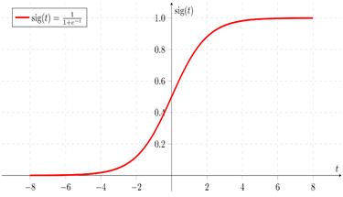
Unlike the Step function, Sigmoids are useful as their output tells us not only the classification but also the certainty. For example, if the output is “0.9” we are confident that the class is A, while an output of “0.1” means we are confident the class is B. If the output is “0.5” we can’t be sure which class the input pattern is in. In general, if the output is equal to or above 0.5, we label the class as 1, otherwise we label the class as 0.

Figure 2.5: The Sigmoid function [15]

2.1.2 How a Perceptron learns
For a Perceptron to learn we need to use supervised learning. Hebbian Learning, proposed by Donald Hebb [16] is an example of this. In short, it encompasses reinforcement learning, the act of reinforcing positive behaviour, and punishing bad behaviour.

Every input pattern to the Perceptron can be given a corresponding desired output or class of {0, 1} or {-1, 1}. This represents the response we want the Perceptron to produce when exposed to the input pattern.

The weights are initialised to small random values when learning begins so the Perceptron has an equal chance of classifying the input pattern correctly. Each input pattern is presented to the Perceptron in turn. The weighted sum is calculated and applied to the Step or Sigmoid threshold function. The output generated is known as the actual output, representing the Perceptron’s actual response to the input pattern. If this actual output is not the same as the desired output of the pattern then the weights must be changed to produce the behaviour we want.

An example learning rule is the Widrow-Hoff delta rule, proposed by Widrow and Hoff [17]. It is the idea that if at time t the actual output is far away from the desired output then a proportionally large change should be made to the weights. If the actual output is close to the desired output then only a proportionally small change needs to be made. If they are the same then no change is made. The difference between the desired output and actual output is known as the “error” (Equation 2.4).

$$\begin{aligned}∆ =d\left(t\right)-y\left(t\right), \\ where d\left(t\right)= \left\{\begin{aligned}1 \\ 0\end{aligned} and\right. y\left(t\right)= \left\{\begin{aligned}f_{h}\left(x\right), for Step function \\ { f}_{s}\left(x\right), for Sigmoid function\end{aligned}\right. \#\left(2.4\right)\end{aligned}$$
The Sigmoid function uses its raw output as the actual output to calculate the error rather than its thresholded output of {0, 1} or {-1, 1}. This is because the raw output can affect the weight changes in a more meaningful way. This is unlike the Step function where the error does not give any context to the classification confidence other than that it is right or wrong.

Weights are changed by adding or subtracting a proportional amount of the corresponding input. This proportional amount is determined by the multiplicative error applied to the input. If the Perceptron produces bad behaviour, it is punished with a proportional input penalty to the weights. If it produces good behaviour, it is rewarded with a proportionate weight increase.
To further control how quickly the Perceptron learns, a learning rate value η between [0, 1] is also applied to the input as well as the error. A higher rate speeds ups learning while a lower rate slows down learning.
Mathematically, the change to the weights is:
$$\begin{aligned}w_{i}\left(t+1\right)=w_{i}\left(t\right)+ ηΔx_{i}\left(t\right), \#(2.5) \\ where 0 ≤η ≤1\end{aligned}$$
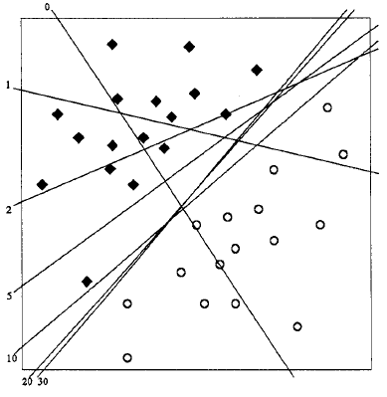
The Perceptron separates patterns in the pattern space by trying to place a hyperplane, or threshold boundary, between them. This threshold boundary, defined by the weight vector, is what the Perceptron eventually learns. As the weights are initially randomised, the threshold boundary is unlikely to correctly classify the given patterns. But as learning progresses, the weights are changed using the corresponding error of each input. This causes the boundary to shift closer to the ideal set of weights that will classify the dataset correctly. This is illustrated in Figure 2.6.
Learning the correct weights takes time. An iteration, or epoch, is one full pass of the dataset given to the Perceptron. For each iteration, the sum of the squared error is calculated using the desired and actual output of each input pattern (Equation 2.6).
Figure 2.6: Threshold boundary moves to classify input patterns correctly [18]
$$\begin{aligned}E=\sum_{i=0}^{n}{{\left[\begin{aligned} \\ d_{i}-y_{i} \\ \end{aligned}\right]}^{2}} \#\left(2.6\right)\end{aligned}$$
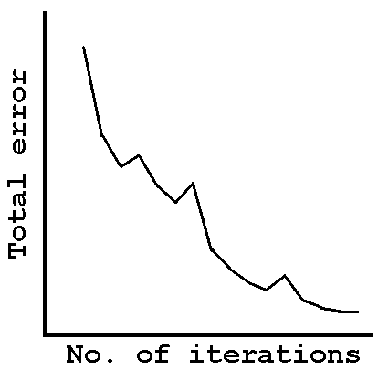
This total error can increase or decrease depending on how well the Perceptron is learning. This forms an error landscape where a global minimum exists (Figure 2.7). The goal of the Perceptron is to reduce the total error as close to zero as possible and find this global minimum which implies an optimal weight vector that correctly classifies the dataset.

Figure 2.7 Error landscape of the learning process

2.2 Previous Work

2.2.1 MATLAB Neural Network Toolkits
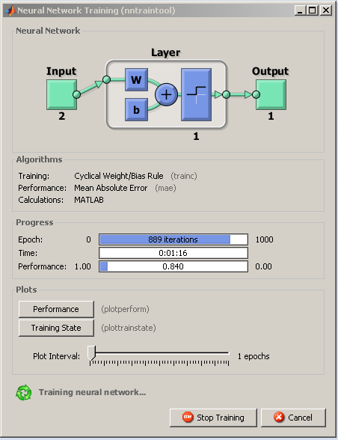
The inspiration for this project is the educationally inadequate functionality of the MATLAB neural network toolkits which include the Neural Net Clustering, Fitting, Pattern Recognition and Time Series tools. While they are useful, they are primarily used for analysis and problem solving.
These toolkits show the error through training, iteration number, time taken and current performance of the network, as shown in Figure 2.8 and Figure 2.9. Of these, the error and iteration number will be the most useful measurements.

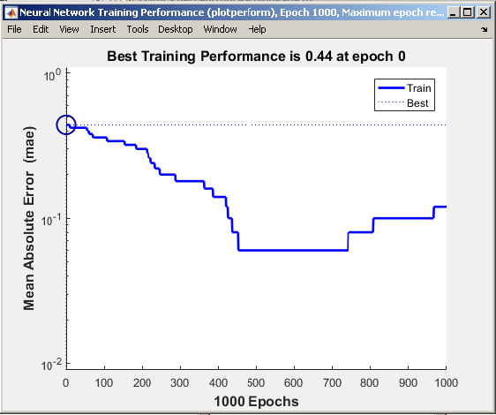
The network architecture is not shown meaning the user cannot visualise the changes in inputs and outputs of the Perceptron easily. No plot of the Step or Sigmoid threshold function is available to show the weighted sum classification. Its inclusion would allow quick confirmation of each data point's class and confidence, in the case of the Sigmoid function. Also, the toolkits do not show visually the pattern space and the threshold boundary that moves across it to separate the data into classes.
Figure 2.8: MATLAB nntraintool

2.2.2 Neural Net Playground
Neural Net Playground [19] offers a much simpler approach to neural networks. It is web browser based so it doesn’t require any specific software environments to run. The user can decide how many neurons to use, how many layers to use, what kind of data to use, the connectivity, and much more (Appendix: L). It is impressive in its scope and simplicity.

The page includes enough information on neural networks to get started as well as optional functionality (Appendix: L) that the user can toggle on/off. Hues and tones of colour are used to separate classes in the pattern space instead of a hard threshold boundary. Hues represent the class while tone represents the confidence. Users with a colour vision deficiency may find it hard to use this software so it is likely better to use a hard threshold boundary.
Figure 2.9: MATLAB nntraintool error graph

Overall, Neural Net Playground embodies the goal of this project, providing inspiration and a guide to follow. Although, I believe it could be improved by including a tutorial and explanations of its various components through a help guide or tooltips.

2.3 Educational Research and Design Implications
Given the sheer breadth of educational pedagogy, the following will attempt to be a focused discussion on educational design implications and how the project fits into current student learning within the INCA module.

2.3.1 Retrieval Practice

Retrieval Practice, also known as testing, is often considered the most optimal method of learning, with Carpenter et al [20] suggesting that testing is more effective than restudying material. Kornell and Bjork [21] also show that students tend to recognise that self-testing is an effective tool for assessing knowledge, with 68% using self-testing to test how well they have understood the material.

Roediger and Karpicke [22] further conclude that frequent testing should encourage more study, improves engagement, increases test scores and reduces test anxiety.

These days however, it is generally acknowledged that students are over tested. Search engine results flag dozens of news articles and discussions on the issue. Testing also induces anxiety and pressure to perform, with Akinsola and Nwajei [23] showing a negative correlation between anxiety and test performance.

The application could be designed as a self-testing tool but given students aversion to testing and anxiety induced it may not be an amicable decision. Resources also exist on the university’s Virtual Learning Environment such as past exam papers and quiz material that can used for testing.

2.3.2 Learning styles

Prominently, Pashler et al [24] performed a review of several studies into testing the validity of learning styles. They found very few with a design capable of testing this validity and several that contradicted the learning styles hypothesis. They say that this doesn’t suggest that all learning style theories and methods are invalid, only that there aren’t enough rigorous studies to support the claim that students learn in only one particular manner.

They go on to state that instruction in a particular learning style may not be valid for all disciplines or curriculums and that the learning method should match the subject in question:

“For instance, the optimal curriculum for a writing course probably includes a heavy verbal emphasis, whereas the most efficient and effective method of teaching geometry obviously requires visual–spatial materials.”

Given the visual nature of neural networks in terms of threshold function, boundary and error landscape, this is an encouraging result for the development of a visual learning tool.

2.3.3 Wanting, Doing, Feedback and Digesting

Richards [25] suggest several guidelines for educational software designers.

Wanting improves motivation by providing an enjoyable experience such as using “game-playing strategies”. Research yielded no examples of neural network games, making it an interesting design direction but reconciling this with the specific stakeholder requirements would be difficult.

Doing must prevent passive interactions by enabling students to investigate concepts and control simulations, as well as prioritise trial and error learning to record, correct and avoid errors. A tutorial on Perceptrons would not be necessary as students already receive Perceptron teaching in INCA. This application will therefore assume basic Perceptron knowledge. What is missing, based on Previous Work examples, is the ability to explore the ideas in an interactive way that also gives feedback on the learning process. A simulator may therefore be a useful basis for the application design, especially given the conclusions of Pashler et al’s review.

Feedback involves making learning objectives and goals clear, as well as providing useful feedback on progression in social settings, such as from lecturers or peers. Given the application only implements the Perceptron, the INCA module leader can easily and effectively administer predetermined learning objectives and goals from INCA practicals.

Digesting involves using computer-based evaluation techniques to allow students to analyse concepts and formulate new ideas. Recording the learning process data of the Perceptron would give students the chance to review the learning process at their own pace. Richards also recommends students review the content away from the computer, which would fit perfectly with the seminar group discussions of the INCA module.

2.3.4 Educational Software Design Principles

Beale and Sharples [26] suggest the following principles to achieve an effective educational design:

- Define the educational aims and objectives: The purpose of this application is to facilitate and support student learning of Perceptrons by helping them visualise and explore the concepts in more depth.

- Identify the learning needs: Students require a basic knowledge of Perceptrons such as how weighted sums and errors are calculated. How the Perceptron classifies datasets is difficult without visual aid. Storing learning process data allows users to review the learning process at their own pace to clarify misunderstandings and explore more deeply Perceptron concepts.

- Decide which needs could be addressed by computer: Simulation of the learning process can only be realistically achieved by a computer, especially with given a large dataset.

- Determine the general teaching and learning approach: The application is learner directed and discovery based, but can be used either individually or collaboratively.

- Determine the teaching strategy: The application requires students to input various datasets and adjust parameters such as iterations or learning rates. It will be used during practicals alongside existing applications and provide discussion material for seminars.

- Choose the teaching components: This application will be a simulator to allow students to visualise the concepts and interact in a trial-and-error manner.

2.3.5 The Learning Objectives
The primary learning objective is to “reinforce and consolidate Perceptron concepts taught in the INCA lectures”.

These concepts are:
- Understanding how the threshold boundary moves around the pattern space given a set of weights.
- Understanding how the error changes as the learning process progresses.
- Understanding what it means for inputs to be classified correctly or not given a desired output.

These will be met by providing an easy way to present data to the Perceptron algorithms and visualise the outcomes of the learning process including threshold boundaries, error landscapes and threshold functions.

2.4 Literature Review Conclusion
Given this research, the application will not be a testing tool due to the negative associations with testing and the ample resources already available. It will also not provide a tutorial due to the teaching material presented in the INCA module.

Research shows students learn better when material is presented in an appropriate manner, such as spacial concepts being presented visually. Perceptrons make use of threshold boundaries, error landscapes and threshold functions meaning a visual approach will be necessary. As such, this application will be implemented as a simulator that allows students to explore and consolidate existing knowledge about Perceptrons.

3. Requirements
The following Requirements section details the process of requirement elicitation, analysis and negotiation with the Primary Stakeholder. Resources used include: Requirements Engineering: a good practice guide [27], Requirements Engineering [28], and Software Engineering [29].

3.1 Single Statement of Need (SSON)
The purpose of this project is to design and implement a neural network simulator aimed at students that illustrates the behaviour of Perceptrons, with an emphasis on interactability and usability.

3.2 Stakeholders
Primary Stakeholder: Simon O’Keefe
Role: Project supervisor, domain expert
Description: Module leader of “Introduction to Neural Computing & Applications” (INCA). Commissioned the design of the application to improve student experiences of neural networks.

Secondary Stakeholder: Students
Role: Users
Description: Will use the application for an interactive experience of the Perceptron learning process.

Indirect Stakeholder: IT Support
Role: Service Provider
Description: IT Support will provide sufficient resources to use the application within and out of the department.

Indirect Stakeholder: Prospective Student
Role: Future Developer
Description: This Stakeholder will not influence the requirements for this project but will have a future stake in the project if they decide to develop it further.

3.3 System Development Life Cycle: Agile Model
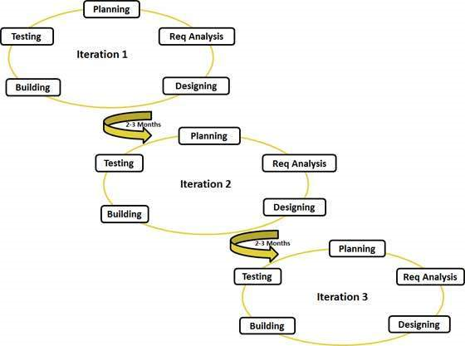
The Agile model (Figure 3.1) builds on the Incremental and Iterative models [30, 31] which breaks the development process into small, manageable stages. The software is built up incrementally with a focus on quickly producing working demonstration software to receive constant stakeholder interaction and feedback. The incremental nature of this model lends itself to smaller development teams.

Each requirement is ranked from high to low priority and implemented using the “Waterfall” model [32]. Requirements changes are unlikely to cause code refactoring or overhauls due to the modular nature of the development cycle. This allows for a more dynamic and fluid design and implementation process. Frequent testing between iterations reduces the likelihood of risks and errors.
Figure 3.1: Agile model [33]

3.4 Requirements Elicitation

3.4.1 Primary Stakeholder
Requirements gathering took place by interviewing the Primary Stakeholder, Simon O’Keefe. During these interviews, several issues were discussed regarding the scope and feasibility of certain design decisions.

3.4.2 Secondary Stakeholder
After initial discussions with the Primary Stakeholder, it was decided that students would not be consulted to give project requirements. This is because they would not have as much knowledge or experience about what requirements to implement compared to the domain expert.

Students who have competent experience of neural networks via the INCA module would not be particularly viable due to graduation. Those who progress to fourth-year would be few and may not be available due to course commitments, making requirements validation difficult due to the necessity of repeated contact.

3.4.3 Elicitation Conclusion
To approach the project, the Primary Stakeholder was the main source of requirements. Scientific and educational literature formed the basis for decisions relating to usability and interface design.

3.5 Requirements Analysis and Negotiation

3.5.1 Project Scope
From Primary Stakeholder interviews, I decided to limit the initial scope of the project to Perceptrons using the Agile development life cycle. As further detailed in the Risk Assessment, a large project will be more prone to failure. Once initial requirements are fulfilled, the scope can be increased to other networks.

3.5.2 Purpose of the application
Given the Educational and Previous Work research as well as the Primary Stakeholder requirements, I decided to implement a simulator rather than a teaching tool, which was the original outlined project aim. Many resources including the INCA module are available for learning about neural networks but not many are available to explore these networks and consolidate learning in a visual way.

The intended context will be for students to use this application in practicals alongside the MATLAB neural network toolboxes and in their own private study. It is not intended as a substitute for any teaching given by the University. As mentioned in the Educational research, this application will not be a testing tool due to resources already available on the University of York’s VLE. A tutorial was discussed but due to being complex and potentially time consuming it was decided to leave this functionality until after the initial requirements have been fulfilled.

3.5.3 Data Collection
As this application is not a testing environment, no student data such as names, password, scores, or even questions and answers will need to be stored. This means database design will be unnecessary due to minimal data storage.

3.5.4 Requirements Validation and Verification
The Agile method and frequent Primary Stakeholder meetings meant requirements validation and verification for consistency, completeness and accuracy took place throughout development. As the domain expert in neural networks, the Primary Stakeholder could give specific requirements for the application which meant validation and verification was simple to achieve.

3.6 System Model - Data-flow model

Given the system will not require database design, semantic and object data models involving entity relationships and class structure will not be necessary. Instead, a data processing model will be used showing how data given by the user is transformed.

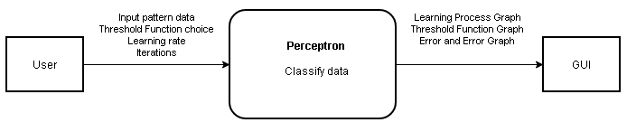

Figure 3.2: System data-flow model

3.7 Critical Requirements Definition
The primary learning objective is to “reinforce and consolidate Perceptron concepts taught in the INCA lectures”.

These concepts are:
- Understanding how the threshold boundary moves around the pattern space given a set of weights, learning rate and using the error term.
- Understanding how the error changes as the learning process progresses.
- Understanding what it means for inputs to be classified correctly or not using the Step and Sigmoid threshold functions, given a desired output.

The following requirements will meet these objectives by providing an easy way to present data to the Perceptron algorithm and visualise the learning process and its outcomes. Users will also be able to step through the data at a specified pace and review the learning process after it is completed. Inputs and outputs will be displayed in a table of data as well as on the network architecture with weights, weighted sum and threshold function choice. Further requirements definitions with rationale and success criteria can be found in Appendix: R.

Table 3.7.1: Functional Requirements
Index | Functional Requirements
F01 | The system shall implement a Perceptron simulator.
F07 | The system shall implement the Perceptron algorithm.
F13 | The system should implement mouse over tooltips for GUI components.
F14 | The system should implement a help guide.
F16 | The system shall display the neuron architecture.
F23 | The system should display a graph of the threshold function that plots the weighted sum on the neuron architecture.
F24 | The system shall display a graph of the sum of the squared error on the neuron architecture for the Perceptron Learning Process page.
F28 | The system shall display a Learning Process Graph.
F32 | The system shall implement the Perceptron Learning Process algorithm.
F36 | The system should allow the user to load preset datasets.
F37 | The system should allow the user to generate a dataset.
F38 | The system should implement an “Add data point by graph” button.
F39 | The system should implement an “Add data point by textbox” button.
F40 | The system shall allow the user to adjust the Learning Rate via textbox.
F43 | The system should implement a Step Through button.
F44 | The system should implement a History Slider for recording the learning process.
F45 | The system should display the inputs in a Table of Data.

Table 3.7.2: Non-functional Requirements
Index | Non-functional Requirements
N01 | The system shall be “easy to use”.
N02 | The system shall be “intuitive”.
N03 | The system should be “enjoyable to use”.
N04 | The system shall provide sufficient feedback to the user on their actions.

3.8 Constraints
- The system shall only allow for two inputs to the networks at any time, allowing the data to be easily visualised graphically in a 2D space.
- The system shall be able to run on departmental machines that run MATLAB programs. ICT services will distribute the software for students to use outside of the department.
- The most recent MATLAB version used as of 01/12/2016 is R2016b. Any previous versions may be incompatible.
- No personal data is stored so no database design or legal issues involving data protection will be necessary.
- The system shall be developed between 01/12/2016 date and 02/05/2017 date, and so must be realistic in its development.

3.9 Risk Assessment

Table 3.9: Risk Assessment
Index | Risk | Category | Severity | Likelihood | Solution
R01 | Incomplete application | Commercial | High | Medium | New functionality will only be added when other requirements have been met and tested. Planning and regular meetings will ensure tasks are completed on time and if not, redact and amend the initial requirements.
R02 | Incorrect implementation | Scientific | High | Medium | Testing using linearly separable data.
R03 | Too many requirements and/or superfluous features | Technical | Medium | Low | As R01.
R04 | Schedule pressure | Commercial | High | High | As R01.
R05 | Lack of technical skills | Technical | Medium | Medium | The internet and other learning resources will allow issues to be quickly solved.

3.10 Requirements Hierarchy
Figure 3.3: Requirements Hierarchy
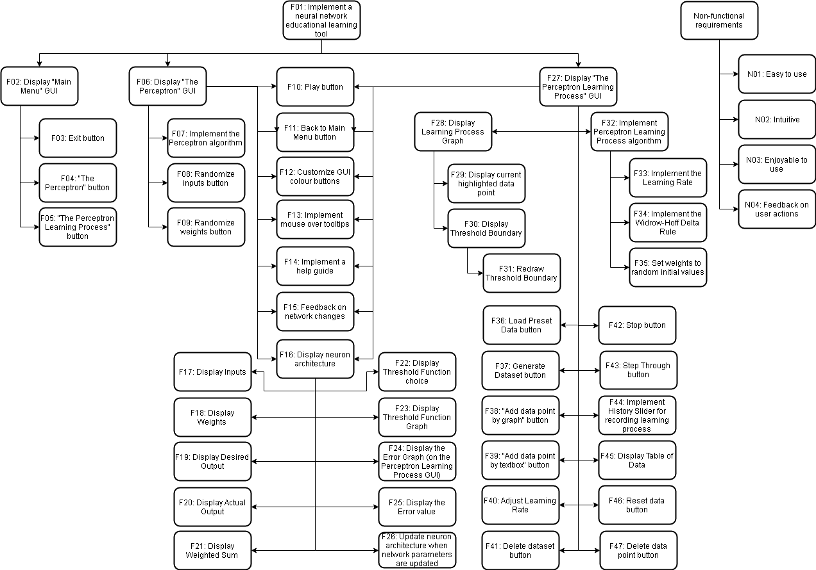

4. Design

This Design section will begin by detailing the system architecture, general use cases and the Perceptron algorithm used to fulfil the learning objectives. How the design meets the requirements and learning objectives will then be discussed followed by accessibility and usability issues that addresses the non-functional requirements.

4.1 System Architecture
The system will be split into three modules: The Main Menu, the Perceptron Page and the Perceptron Learning Page, with each interacting with a corresponding GUI.
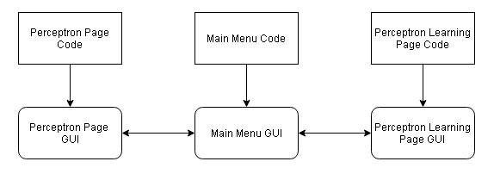
Figure 4.1: System Architecture

4. 2 General Use Cases
These use cases are intended to be an example of how the user can meet the learning objectives set out in the Requirements section.

- The user can load data from file and run the learning process. During the learning process the user can use the Learning Process Graph to see how the Threshold Boundary moves and see how each data point classifies on the Threshold Boundary Graph. For each iteration, the Error Graph should display a drop in error if the data is linearly separable.
- The user can create custom data points and step through these data points at a specified pace using the Step Through button. Once classified the user can review the learning process using the History Slider. This will update the Learning Process Graph and Threshold Function Graph with relevant information for that time point. The user can then reset the data to restart the learning process or delete the data and input a new dataset.

4.3 Perceptron Learning Process Algorithm
The algorithm used to implement the Perceptron learning process has been taken from Beale and Jackson [34] due to its intuitive description and simple presentation. An explanation of how the algorithm works has been discussed in the Literature Review. Given this algorithm and the requirements generated in the Requirements section, a data dictionary has been generated that addresses the data needs of the application. This algorithm, using the Adapt weights- Widrow-Hoff delta rule, and data dictionary can be found in Appendix: D.

4.4 GUI Design and Learning Objectives
This section will attempt to justify how the learning objectives are fulfilled in the GUI design. A specific list of requirements fulfilled by each GUI design can be found in Appendix: D.

4.4.1 Design 0: Main Menu

A Main Menu was used as it is a conventional navigation tool that most users would be familiar with. It separates “The Perceptron” from “The Perceptron Learning Process” in order to distinguish the difference between these tools.

4.4.2 Design 1: The Perceptron

This design is also embedded in Design 2: “The Perceptron Learning Process” but textboxes are implemented as labels. This is so users are not able to enter data during the learning process and potentially corrupt the learning process.

Network Architecture
The network architecture GUI design imitates as closely as possible the structure of a Perceptron by using lines to connect inputs, weights, the weighted sum and outputs. The sum of the squared error and threshold function choice are also displayed. Users can randomise inputs and weights using buttons to quickly generate random network parameters to test.

Play Button
Play on “The Perceptron” page will compute the weighted sum, threshold it using the Step or Sigmoid function and produce an actual output. The sum of the squared error will be calculated using the desired output entered by the user.

Threshold Function Graph
The weighted sum is plotted against the output of the Step or Sigmoid function, as chosen by the user, showing the classification of the current data point. This, with the Play button and the network architecture’s desired output textbox and actual output label will fulfill learning objective 3.

4.4.3 Design 2: The Perceptron Learning Process
Play Button
The Play button initiates a continuous learning process until convergence, iteration limit or the user ends the process.

Step Through Button
This button allows the user to progress through the learning process using a specified number of data points at a time rather than a continuous playthrough like Play. A minimum and maximum index will keep track of each “data block” as the application iterates through the dataset. Once all points have been evaluated, the algorithm will return to the start of the dataset.

Learning Process Graph
The Learning Process Graph shows all data points entered by the user and the Threshold Boundary which moves around and separates the data into two classes. Currently evaluated data points on this graph are highlighted using a circle. This, with the Play and Step Through buttons, fulfills learning objective 1.

The learning rate parameter is located with the Play and Step Through parameters, iteration number and number of data points to step through, so all editable parameters are grouped.

Error Graph
The Error Graph shows the user how the error landscape changes during the learning process. This fulfills learning objective 2. This will act as a diagnostic tool that tells the user whether the dataset is likely to classify. If the error oscillates or flatlines the user can stop the learning process with the Stop button.

Table of Data
This is simply a table of raw data showing the inputs, desired and actual outputs so the user can view all the data at any time.

History Slider
A record of inputs, weights, weighted sum, outputs, error, playthrough number and iteration number are stored for each data point. Each slider increment matches one data point. When the user moves the slider, the stored data is loaded onto the network architecture and table of data. The Threshold Boundary is also drawn on the Learning Process Graph and the data point plotted on the Threshold Function Graph. This allows users to retroactively review the learning process once finished and fulfills learning objective 1,2 and 3 and Richard’s Digesting guideline, as mentioned in the Educational research.

Data Entry
Data can be loaded from file, generated using specified means and standard deviations or created either by clicking on the graph or entering inputs and desired output into a textbox. These means allow the user to practice trial and error by testing different datasets and seeing how and if they classify. This, as well as altering the learning rate, number of iterations and data points to step through, fulfills Richard’s Doing guideline.

4.5 Accessibility and Usability
The following discussion of the application design encompasses Tognazzini’s Usability Principles [6] primarily, as well as Nielsen’s Usability Heuristics [7].

4.5.1 Layout
Tog’s “Fitts Law” states that frequently used controls must be larger and placed adjacent to their affecting elements. Tog’s “Discovery” principle further elaborates that “controls do not belong in the middle of the content area” and should be visible at all times, while “Consistency” says grouped controls should always be in the same area on GUI’s which use them.

4.5.2 Colour
A traffic light system will allow the user to identify whether the learning process is in progress, with grey as “not running”, yellow as “processing” and green as “completed”. These are the “status” colours. Grey was chosen as it represents inactivity while red suggests an error or warning, which is not the case.

Tog’s “Colour” principle states “use clear, secondary cues to convey the information to those who cannot see the colours presented.” Considering this, graphical data points shall be distinguished by symbols, for instance, “x”, “o” or “#”. Class and threshold colours can be changed to make it convenient for users who cannot see a small subset of colours.

4.5.3 Text
Intuitively, and supported by Tog’s “Readability” principle, text should be presented in large fonts, with a simple style, such as 14pt Arial or Verdana.

4.5.4 Network Parameters
In furtherance to Tog’s “Consistency” principle; “Autonomy”, “Anticipation” and Nielsen’s “Visibility of system status” state that users should be kept up to date and be presented with all information and tools necessary to perform their tasks. This was discussed in the GUI Design and Learning Objectives section under “Network Architecture” and “Table of Data”. As learning progresses the network parameters and table will be updated.

4.5.5 Tooltips and Help Guide
Nielsen’s “Help and Documentation”, supported by Tog’s “Discoverability” and “Explorable Interface” principles suggest that tooltips and/or help guides be available for the user. Tooltips will give brief details of GUI functionality such as what a button does, or what a label means in a mouse over, popup manner. A help guide will explain in more detail how the application functionality works.

4.5.6 User mistakes and error handling
Nielsen’s “User control and freedom” and “Error prevention” heuristic detail that the user should have dialogs available asking them to confirm their actions before committing to them. The implementation must also be error-free. If an error does occur, the dialog feedback must be precise and explained in simple language with an appropriate solution, as per Nielsen’s “Help users recognise, diagnose and recover from errors” heuristic.

4.6 Extensibility
Extensibility options are detailed in the Further Work section.

4.7 Modifiability
A Prospective Student wishing to implement larger networks will likely need to implement class structures for multiple neuron instantiations. Database design will also need to be considered if a tutorial or self-testing tool is to be implemented in the future.

4.8 Maintenance
MATLAB versions will need to be kept up to date as version incompatibility will cause errors or the application to crash.
Unlike other scientific areas where new evidence alters current theories, the Perceptron concepts haven't changed much since its inception. This means updates to the application will likely not need to be made apart from improving efficiency.

5. Implementation

5.1 Implementation Language
Two languages were discussed with the Project Supervisor for the implementation of this application, Python or MATLAB [35, 36, 37].

Both Python and MATLAB are well documented, easy to use languages that are platform independent. While Python is simpler to use, MATLAB processes matrices quicker and more efficiently, without needing extensive libraries and packages, which is beneficial as neural networks make heavy use of matrices.

While Python has many GUI toolkits available, MATLAB makes use of a built-in GUIDE (GUI Development Environment) to quickly and easily develop GUI’s by dragging and dropping components.

MATLAB’s implementation is interpreted meaning the command line can be used to quickly write and test code. This however means the application is slower to run than a compiled implementation which can be offered by Python.

For the most part, both languages offer the same functionality. MATLAB however is used in the INCA module, with resources already available for implementing the Perceptron algorithm. Special purpose toolbox functions for programming neural networks are also available in MATLAB if necessary. For these reasons, especially matrix algebra functionality, MATLAB will be the chosen implementation language.

5.2 Implementation and Learning Objectives
This section will discuss how the learning objectives were fulfilled and any other prominent issues that arose that had to be dealt with. A list of requirements met during implementation can be found in Appendix: I.

5.2.1 Plotting the Learning Process Graph
The Perceptron learning process algorithm was adapted from INCA “Practical One: Perceptron exercises” solutions, “perceptron_skeleton_filled.m” [38] as shown in Appendix: I. The implementation of the algorithm can be located in the “playButton_Callback” and “stepThroughButton_Callback” functions in Appendix: Code, where comments and embedded function callbacks offer further clarification. Due to the scale of the learning process implementation, it is not possible to discuss it in detail without neglecting other learning objectives and problems encountered. Testing and user evaluations will however confirm the algorithm’s ability to function correctly.

MATLAB neural network functions were considered as another solution but offered less control over program flow and algorithm implementation.

5.2.2 Plotting Error Graph
The Error Graph was simple to program. For every iteration, the sum of the squared error is produced.

Figure 5.1: Appending the sum of the squared error

These errors are plotted on every iteration via:

Figure 5.2: Plotting the sum of the squared error

5.2.3 Plotting Threshold Graph
For the Step function, three separate plots needed to be drawn, corresponding to the hard threshold boundary as detailed in the Literature Review. Two plots are then placed on top of these other plots. First, the weighted sum against actual output, and the weighted sum against desired output. This allows the user to see whether the classification is correct or not.
Figure 5.3: Plotting the Step function using three different plots
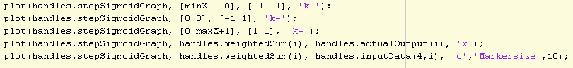

The Sigmoid function required scaling to the [-1, +1] range as I decided to use bipolar outputs for the implementation rather than [0, 1] as per Beale and Jackon’s algorithm.

Figure 5.4: Plotting the bipolar Sigmoid function

The actual output also used this scaling in order to be plotted correctly against the weight sum. As the Sigmoid actual outputs had already been thresholded above or below 0.5 to get a classification, the original Sigmoid outputs had to be recovered using the desired output and error. The weighted sum against desired output in this case shows the error of the classification for the data point.

Figure 5.5: Plotting the desired and actual output on the Sigmoid function

The Threshold Graph had to be held specifically during the plotting using:

Figure 5.6: Holding the Threshold Graph

otherwise the plots would not be drawn correctly. The reason for this is not clear, but the problem is solved using this method. The only issue is that “Current plot held” is repeatedly printed to the command line each time this hold function is called.

5.2.4 Step Through
Step Through evaluates a user specified number of data points at a time rather than a continuous playthrough.

The starting points are set by:

Figure 5.7: Initialising the minimum and maximum block counters
which are then incremented by:

Figure 5.8: Incrementing the block counters to use the next set of data points
each time the “Step Through” button is pressed.

Error checks are necessary to make sure the matrices do not go out of bounds:

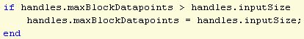
Figure 5.9: Prevent the maximum block counter from going out of bounds

and for resetting these handles once all data points have been considered at the end of “stepThroughButton_Callback”:

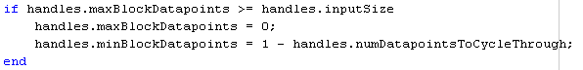
Figure 5.10: Reset the block counters once a full pass of the data has been completed

5.2.5 History Slider
The main issue with the History Slider is data storage. Datasets can be created with thousands of data points that cannot classify. So much data could potentially cause an error or slow down the application due to MATLAB’s interpreted nature. While not implemented, two solutions would be to either: limit the number of data points the user can enter and/or if the error term flatlines or oscillates for long enough, such as for ten to twenty consecutive iterations, then end the learning process.

5.2.6 Generate dataset
Code taken from stackoverflow.com [39], in Appendix: I, was used to generate datasets using the mean and standard deviation of both X1 and X2 input.

The inputdlg() function is used to receive this data from the user but uses too many input textboxes. Regular expressions were considered to separate data entered such as “[X1 X2]” Class A Mean but would require extensive error checking and time to program. This idea was abandoned due to more important requirements.

5.2.7 Handles and data passing
Data inconsistencies and sometimes corruptions result from the use of GUI object handles when control flow passes between GUI callbacks. MATLAB GUI callbacks use by-Value copies of an object handles data structure. When control is transferred between callbacks and functions, a current copy of this handles structure is given to the transferred/called function or callback.

Changes made to the handles structure in this new callback must be saved before returning to the calling function or callback. The calling function must then request an updated copy of the handles structure. If this is not done then the calling function will use the copy of the handles structure it made at the time it itself was called. This will then likely cause data inconsistencies and at worst errors that will cause the program to crash. When the calling function or callback is finished, it must save the handles structure in the same manner so other functions and callbacks can use the updated data. Handles are also deleted after the current GUI is no longer in use.

The code to save the handles structure is:

Figure 5.11: Saving the handles structure

The code to get an updated copy of the handles structure is:

Figure 5.12: Getting an updated copy of the handles structure

5.2.8 GUIDE limitations
The network architecture was unable to be drawn as planned due to MATLAB’s GUIDE tool limitations. Images may only be drawn on axes. In order to draw the lines between the inputs, weights, cell body and actual output an axes would be needed for each line, or a single, large axes appropriately scaled and coloured to reflect the background colour. As useful as a faithful depiction of the network architecture would be, its absence is a minor hindrance to the learning objective.

5.3 Implementation Conclusion
Screenshots of the final GUI deliverables can be located in Appendix: I and the code used to implement the application can be found in Appendix: Code.

6. Testing

6.1 Testing Methodology
Testing was done throughout the implementation using the Agile development method. This meant functionality could be tested before new functionality was added.

6.1.1 Unit Testing
As the Perceptron is deterministic given the same inputs and weights, it could be easily tested using manual unit tests. Unit test samples for requirement F07: “Implement the Perceptron algorithm” are shown below.
Table 6.1 Perceptron Unit Testing
X0 | X1 | X2 | W1 | W2 | W3 | Weighted Sum | Actual Output | Pass
1 | 1 | 0 | 0.658676 | 0.097146 | 0.732038 | 0.755821962 | 1 | Pass
1 | -1 | 1 | 0.155079 | 0.69348 | 0.463397 | -0.075003286 | -1 | Pass
1 | 0 | -1 | 0.599041 | 0.270299 | 0.057469 | 0.541572129 | 1 | Pass
1 | -1 | 1 | 0.395362 | 0.291583 | 0.132484 | 0.236262743 | 1 | Pass
1 | 1 | -1 | 0 | 0 | 0 | 0 | -1 | Pass

Unit testing requirement F32: “Implement the Perceptron Learning Process algorithm”, and by extension F34: “Implement the Widrow-Hoff Delta Rule”, is more difficult manually. However, a table showing the learning process given some inputs and predetermined weights is presented in Appendix: T. The actual result of supplying these inputs and weights to the application are shown in Figure T.4 following said table. Manual calculations of the learning process match the actual results output by the program. This provides some evidence of algorithmic correctness.

Further evidence of correctness for requirement F07 and F32 will be provided during Functional Testing.

6.1.2 Functional Testing
Functional testing was carried during User Evaluations. Feedback from users will provide evidence as to whether the functional requirements have been met. These results can be found in Appendix: T.

Almost all tests as part of the User Evaluation were successful under perfect conditions. These tests did however raise several bugs and unexpected errors. For example, when adding a data point by clicking on the graph, if the user performs another action or presses a button while the getpts() function is executing then a MATLAB error will appear in the development environment. Another would be that graphically created data points can be selected from anywhere on the GUI. While these points are scaled and placed on the graph due to being saved in the graph object handle, it is undesirable that the user can select points from anywhere on the GUI.

Most bugs and errors found were not necessarily because of the application implementation, but rather the MATLAB functions that underlie the implementation which require some compensating. As many of these bugs did not outright cause the application to fail, users were able to recover by resetting or deleting data and starting again. Researched solutions were too complex and extensive to implement given time restrictions so many of these issues were not able to be corrected.

6.2 User Evaluation Methodology
The purpose of the user evaluations was to test the non-functional requirements as stated in the Requirements section. I carried out the evaluations in a quiet study area during daylight hours to control for test conditions that would affect participant results such as tiredness or noise. A desktop machine running the latest version of MATLAB (R2016b) was used.

As per Nielsen’s [40] recommendations, five participants were gathered to complete the user evaluation tasks and questionnaire. Finding students who had studied neural networks was difficult as the user evaluation took place during the spring term holidays where students were not available and course deadlines were approaching.

Participants were initially debriefed about the nature of the experiment and asked to give informed consent using the Informed Consent form located in Appendix: E.

6.2.1 Introduction to Perceptrons
Participants were briefly introduced to Perceptrons to provide content to the experiment due to a lack of students available with neural network experience.

6.2.2 User Evaluation Tasks
Participants were asked to complete six tasks on “The Perceptron” and six tasks on “The Perceptron Learning Process”. Participants were encouraged using the “Think Aloud” method to provide feedback during the experiment rather than during the questionnaire where they may forget particular experiences.

The tasks were designed to be suitably vague but meaningful. This was done to test the “intuitiveness” of the application’s labelling and controls. For example, “Run the learning process” should translate to “Press the Play button”. If users were given specific tasks such as “Press the Play button located in the centre of the GUI”, it wouldn’t be possible to test “intuitiveness” of labelling, controls and GUI organisation.

It is a risk to use this kind of design but instructions in practicals are sometimes not explicit and help isn’t always available. Being able to easily locate controls and information without explicit direction means the application will likely be easier to use and more enjoyable. As the help guide and tooltips were not implemented in time, this methodology tests the worst-case scenario, providing a baseline for potential improvements.

User Tasks are located in Appendix: RE.

6.2.3 Post-Task Questionnaire
After completing all tasks, participants were given a questionnaire to provide feedback. All question scales are rated from negative experiences (1) to positive experiences (10), such as (1-very hard, 10-very easy) or (1-not very useful, 10-very useful). This was done to make analysis easier and consistent.

The questionnaire is located in Appendix: RE.

7. Results and Evaluation

This review will evaluate the methodology used to conduct the user evaluations and the quantitative and qualitative results found. Due to the low number of participants used, these results cannot be viewed as completely reliable. Nevertheless, they do give an indication to how well the learning objectives and usability issues of the application have been addressed in terms of design and implementation. Full questionnaire and task results and charts can be found in Appendix: RE.

7.1 Methodology Review

7.1.1 Introduction to Perceptrons

The introduction to Perceptrons was generally well received with all participants acknowledging a basic understanding of the concepts involved. This was adequate to test usability but not enough to test the learning objectives.

Questionnaire results show that participants claimed a marginal increase in understanding the application graphs and network architecture given the introduction (7.6/10) compared to if they hadn’t received the introduction (7/10). Unfortunately, given no control group these results cannot be validated and this conclusion relies entirely on hindsight and retrospect.

7.1.2 User evaluation tasks
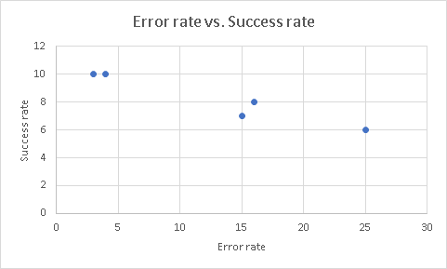
Some participants noted that there were too many tasks. Due to the number of features to test, this is perhaps a flaw in the project scope. Smaller task sets with larger participant samples would reduce fatigue while still testing the required functionality.

Another observation was that only two participants took time to read each task more thoroughly before starting them. The result of this is may be the vastly reduced error rate and high success rate for these two participants compared to other participants (Figure 7.1). When questioned, these two participants revealed they were familiar with vague practical worksheet tasks. As practical instructions aren’t always explicitly detailed they said they took time to make sure they understood the tasks as much as possible before starting them.
Figure 7.1: Error rate vs. Success rate

Some ease of completion scores such as task no. 9 (6.9/10) and task no. 11 (7.1/10) contradict the corresponding success ratings of 0.2 and 0.2 respectively. This shows participants rated their own success at these tasks highly despite not actually successfully completing the task as explicitly written. This therefore provides further evidence that not reading tasks thoroughly potentially led to more errors. Equally, this could be due to participants not associating the instruction to the correct GUI controls, for example, loading a dataset when the task states “generate a dataset”. “Generate a dataset” can be considered vague, though such a button does exist on the GUI as shown on the final GUI designs in Appendix: I.

Data analysis of tasks are shown below. One participant produced anomalous time scores due to providing extensive feedback during the user evaluation so their scores have been omitted to provide more accurate measurements.
Table 7.1 Average Task Results
Task no. | 1 | 2 | 3 | 4 | 5 | 6 | 7 | 8 | 9 | 10 | 11 | 12
Average time taken | 1:36 | 0:27 | 0:27 | 0:38 | 1:12 | 0:04 | 2:49 | 2:46 | 4:19 | 0:39 | 4:20 | 3:24
Average success rate | 0.8 | 1 | 0.8 | 1 | 0.4 | 1 | 0.8 | 0.6 | 0.2 | 0.8 | 0.2 | 0.6
Average ease of completion | 8.5 | 9.34 | 8.8 | 8.6 | 7.46 | 8.26 | 6.2 | 5.76 | 6.94 | 8.6 | 7.12 | 7.34
Average error | 0.8 | 0.2 | 0.4 | 0.2 | 1 | 0.2 | 1.6 | 1.4 | 2.2 | 0.2 | 2.2 | 2.2

7.2.3 Questionnaire

Users felt that they were quick to learn how the application worked (7.4/10) but noted that it was not intuitive (6.2/10) which is consistent with how easy they found it to locate information and controls they were looking for (6.4/10). When users got used to the layout of controls and information, which they felt was organised relatively well (7.2/10), they found the program easier to use (7.4/10), with an average ease of task completion rating of (7.7/10).

Text and characters were reported as easy to see (7.6.10) but could have been bigger given the design specification. Error dialogs provided useful information (7.4/10) but bugs and unexpected errors were hard to recover from (5.4/10).

The Step Through functionality was not well understood (6/10) but the History Slider was unanimously praised (9.8/10).

Users stated they were likely to remember how to use the program (8.6/10) if they chose to use it again (8.6/10). Satisfaction (8/10) and enjoyability (8.2/10) were rated highly with most users likely to recommend it to students studying Perceptrons (8.6/10).

In summary, the non-functional requirements N01: “Ease of use” and N03: “Enjoyable to use” have been reasonably met. N02: “Intuitive”, and N04: “Sufficient feedback” in the form of error dialogs, were not reasonably met.

7.2 Learning Objectives
Learning objective 1: Understanding how the threshold boundary moves around the pattern space given a set of weights, learning rate and using the error term.

The design and implementation of this objective was successful, as shown by testing completed in Appendix: T.

While participants could not explicitly explain how the Threshold Boundary classified data using the weights, learning rate and error term, all showed a basic understanding of the premise. Participants also became reasonably enthused by the Threshold Boundary trying and sometimes failing to classify the datasets. This immersiveness was unexpected but highlights an important element of enjoyability.

Learning objective 2: Understanding how the error changes as the learning process progresses.

The Error Graph was generally well understood with most participants giving correct interpretations to the meaning of the plotted error during the learning process. Participants found it useful as an indicator of whether the data was likely to classify or not, as intended.

Two users found it difficult to locate the graph, instead using the “sum of the squared error” value on the network architecture. Making the graph bigger with better labelling would solve this problem.

Sometimes the Error Graph bugged, causing a straight line to be overlaid on or replace the old plot. The cause of this is uncertain as it was not caught during development and testing. The error landscape does not always converge to zero even when classified correctly. This is likely due to the error plotting function not being called on the last iteration of the learning process.

Learning objective 3: Understanding what it means for inputs to be classified correctly or not using the Step and Sigmoid threshold functions, given a desired output.

This functionality was not available at the time of the user evaluation but was implemented and tested after for completeness sake. Implementation of the Threshold Function Graph using History Slider was not possible due to time constraints.

From testing, the Threshold Function Graph fulfils its purpose, though users will have to be notified using tooltips perhaps, that the “x” represents the actual output while the “o” represents the desired output. The difference between these two symbols also denotes the error which is more prominent when using the Sigmoid function.

7.3 Other notable issues

7.3.1 Help guide and tooltips
All users requested a help guide and tooltips in the questionnaire. In hindsight, priority was placed on correctly implementing the algorithms rather than ensuring users had a means to understand how they functioned. While this is a problem, it can be argued that if a help guide and tooltips were implemented but no algorithm, or a substandard algorithm, then these tools would be ineffective or useless. If the algorithm is implemented but no help guide or tooltips then the program is still at least usable. This is evidenced by the low intuitiveness rating (6.2/10) which is contrasted by higher organisation (7.2/10), general ease of use (7.4/10) and average task ease of use (7.7/10) scores when participants became familiar with the program.

7.3.2 GUI layout and design

Users initially found the GUI layout overcrowded and overwhelming but eventually got used to it. Excess controls such as loading and deleting data should have been made hidden using a drop-down menu to prevent overcrowding and clutter.

There were not enough labels, and button and font sizes were not big enough despite being planned in the Design section.

The GUI was also considered not be aesthetically pleasing though this is due to MATLAB’s limited GUIDE functionality. More emphasis was placed on implementing the functional requirements than creating an attractive GUI, which should be a final consideration in development.

7.3.3 History Slider
The History Slider was unanimously praised with an average questionnaire score of (9.8/10). It currently only enables if the data classifies correctly leading users to believe they caused an error if it did not enable. Iteration and playthrough information do not automatically display when enabled meaning all participants failed to locate this information. The slider must always be enabled after the learning process and all information being made explicitly available.

7.3.4 Step Through
Most participants did not use the Step Through button in task no. 11. This is likely due to the vague nature of the task and GUI associations, and participants not thoroughly reading the tasks. One participant scored 1/10 on question no. 13 stating they had not read anything about stepping through the data in the task list. When used, it was used correctly, though overall it was not deemed particularly useful (6/10). Each time the Step Through button is pressed, an iteration is recorded on the Error Graph. This is an oversight as an iteration is one pass through the data, not a user defined data block. This can be seen in Appendix: T.2 where the unit test shows seven iterations while the implementation shows roughly forty.

7.3.5 Colour
“Status colour” was not understood at all due to the lack of tooltips or help guide. Users also tried changing the colour using the colour display box adjacent to the button rather than the button itself. Status colours also do not change until after the learning process is ran. Like other controls, this feature should be hidden in a drop-down menu and colours made to change immediately.

7.3.6 Dialog Issues
Dialogs after the learning process are meant to confirm whether the data is classified and if not, ask the user if they want to continue the learning process. Continuing should automatically start the learning process rather than having to manually do so.

Sometimes the dialogs appeared after the learning process stating the data had been classified when clearly not, or not classified when it clearly had. This confused all users. This issue will need to be solved by paying closer attention to the error checking conditions at the start of the “playButton_Callback” and “stepThroughButton_Callback”.

7.4 Results and Evaluation Conclusion
Due to document length, not all issue

8. Conclusion
The purpose of this project was to design and implement a neural network simulator aimed at students that illustrates the behaviour of Perceptrons, with an emphasis on interactability and usability. I believe this overall objective has mostly been achieved. This is shown by the requirements met in Appendix: I and the non-functional requirements met as mentioned in the Results and Evaluation section.

The Educational research presented a strong case for producing a testing tool. Given resources already available and being hesitant to induce student anxiety this approach was not considered. Such a testing tool would also likely not be considered as enjoyable. User evaluation results showed high enjoyability (8.2/10) and satisfaction (8/10) providing some evidence that this was the right decision. Pashler et al’s review conclusion of matching subject matter to presentation method was also strong evidence for implementing a simulator. This was further supported by Richard’s “Doing” guideline and previous work, including the Neural Net Playground.

Defining the learning objectives under the Agile development model focused the design and implementation on the essential features. Primary Stakeholder meetings supported this with frequent validation and verification of the requirements. This strategy alleviated potential risks such as R02: “Incorrect Application” and R03: “Too many requirements”. While not all requirements were fulfilled, thus fulfilling R01: “Incomplete application”, consulting the Primary Stakeholder for requirements rather than students was prudent. This is due to expert domain knowledge of the Primary Stakeholder providing precise and useful requirements and to prevent R04: “Schedule pressure”.

As new features were added to the application during Implementation, the Agile development model also meant that these features were tested before more features were added. For this reason, and time constraints, the help guide and tooltips were not implemented in time. Feedback on the number of user evaluation tasks and requests for a help guide and tooltips means that for future development, the scope of the application should be reduced. This will still allow for a working application while also prioritising user assistance. Until a help guide is made available, students will also have to rely on the Primary Stakeholder to provide guidance on how to use the application and provide the learning objectives.

Qualitative results also confirmed that users thought the GUI was overcrowded and did not understand what the “status colour” meant due to poor labelling and lack of help guide or tooltips. This seems to have been a misinterpretation and misjudgment of the usability principles and heuristics presented in the Design section. Drop-down menus should have been implemented to reduce the amount of functionality on screen.

While many problems had to be overcome in using MATLAB, such as learning to use the handles structure correctly, I believe it was the right language to use. GUIDE allowed for quick GUI generation and the use of INCA module resources helped kick-start development. Few packages and libraries needed to be installed and MATLAB’s innate matrix algebra functions meant implementation was quicker and more efficient. It should be noted for future developers that MATLAB versions must be kept up to date to prevent incompatibilities with the application.

Despite initially being unintuitive (6.2/10) and hard to locate information and controls (6.4/10), users quickly learned how to use the application (7.8/10). This is supported by users ease of use scores during (7.7/10) and after (7.4/10) the evaluation. Reasons for high errors and low success rates of course include poor labelling and GUI overcrowding. Other reasons may be because most users did not fully read the task instructions or correctly associate task instructions with GUI functionality. This would therefore be an issue with the methodology attempting to imitate practical worksheet structures rather than providing the user with explicit, bullet pointed instructions.

As participants with neural network experience were not available, the user evaluations had to be compensated with a brief introduction to Perceptrons. While the learning objectives couldn't be tested reliably, participants rated their understanding fairly high (7.6/10). Participants claimed that they would likely have understood the basic premise of the application had they not received this introduction (7/10). While this warrants additional testing with a larger participant sample and control group, these results show a positive outcome in meeting the learning objectives. This is also supported by user recommendation ratings to students who study neural networks (8.6/10).

If the experiment were conducted again, participants with neural network experience would be sought in advance and put on a contact list, assuming consent is given.

This does however show that perhaps a deeper knowledge of Perceptrons is not required to make effective use of the application.

Overall, the application seems to have been reasonably successful though there are many problems to solve including bugs discovered during testing and the user evaluations. Users for the most part enjoyed using the application and could understand the learning process to a reasonable extent.

8.1 Further work
Incomplete Requirements

Incomplete requirements, including the help guide, tooltips and deleting individual data points should be implemented before adding additional features.

Multilayer Neural Networks: Radial Basis Function Network (RBFN)
The RBFN is a multilayer network that uses Gaussians to fit functions and classify data. This means they can be used visually in a simpler manner than having multiple threshold boundaries moving around simultaneously as per the Multilayer Perceptron. RBFN’s also use matrix algebra meaning the learning process will be almost instantaneous.

Tutorial
Despite teaching material already being available to INCA students, a tutorial would help to show neural network concepts and guide student learning. It would also mean students with no experience of neural networks could use the application more effectively.

Self-testing tool
As mentioned, strong evidence supports the implementation of a testing tool such as a quiz program.

8.2 Reflection
From completing this project, I have gained a greater appreciation of neural networks and educational pedagogy as well as developed my organisation and MATLAB skills. These will assist me in my future educational career or in the software development sector.

References
[1] K. Bourzac, "Bringing Big Neural Networks to Self-Driving Cars, Smartphones, and Drones", IEEE Spectrum: Technology, Engineering, and Science News, 2016. [Online]. Available: http://spectrum.ieee.org/computing/embedded-systems/bringing-big-neural-networks-to-selfdriving-cars-smartphones-and-drones. [Accessed: 18- Oct- 2016].
[2] "Google Unveils Neural Network with “Superhuman” Ability to Determine the Location of Almost Any Image", MIT Technology Review, 2016. [Online]. Available: https://www.technologyreview.com/s/600889/google-unveils-neural-network-with-superhuman-ability-to-determine-the-location-of-almost/. [Accessed: 18- Oct- 2016].
[3] "AlphaGo | DeepMind", DeepMind, 2016. [Online]. Available: https://deepmind.com/research/alphago/. [Accessed: 18- Oct- 2016].

[4] W. Knight, "The Game of Go Is No Longer Insurmountable for AI", MIT Technology Review, 2016. [Online]. Available: https://www.technologyreview.com/s/546066/googles-ai-masters-the-game-of-go-a-decade-earlier-than-expected/. [Accessed: 18- Oct- 2016].
[5] R. Callan, The Essence of Neural Networks, 1st ed. Prentice Hall Europe, 1999, p. 2.
[6] B. Tognazzini, "First Principles of Interaction Design (Revised & Expanded)", askTog, 2014. [Online]. Available: http://asktog.com/atc/principles-of-interaction-design/. [Accessed: 06- Nov- 2016].
[7] J. Nielsen, Usability engineering, 1st ed. Amsterdam [u.a.]: Kaufmann, 2009, pp. 115-155.

[8] R. Callan, The Essence of Neural Networks, 1st ed. Prentice Hall Europe, 1999.

[9] J. Anderson, An introduction to neural networks, 1st ed. Cambridge Mass.: MIT Press, 1997.

[10] R. Beale and T. Jackson, Neural Computing: an introduction, 1st ed. Bristol: Institute of Physics, 1990.
[11] W. McCulloch and W. Pitts, "A logical calculus of the ideas immanent in nervous activity", The Bulletin of Mathematical Biophysics, vol. 5, no. 4, pp. 115-133, 1943.
[12] F. Rosenblatt, Principles of neurodynamics, 1st ed. Washington D.C.: Spartan books, 1962.
[13] M. Minsky and S. Papert, Perceptrons: an introduction to computational geometry, 1st ed. Cambridge: The Massachusetts of Technology, 1988.
[14] R. Beale and T. Jackson, Neural Computing: an introduction, 1st ed. Bristol: Institute of Physics, 1990, pp. 41-42
[15] M. Thoma, "File:Sigmoid-function-2.svg - Wikimedia Commons", Commons.wikimedia.org, 2014. [Online]. Available: https://commons.wikimedia.org/wiki/File:Sigmoid-function-2.svg. [Accessed: 15- Nov- 2016].
[16] D. Hebb, The organisation of behavior, 1st ed. New York: Wiley and Sons, 1949.
[17] B. Widrow and M. Hoff, "Adaptive switching circuits.", IRE WESCON convention record, vol. 4, no. 1, pp. 96-104, 1960.
[18] R. Beale and T. Jackson, Neural Computing: an introduction, 1st ed. Bristol: Institute of Physics, 1990, p. 53
[19] D. Smilkov and S. Carter, "Tensorflow — Neural Network Playground", Playground.tensorflow.org. [Online]. Available: http://playground.tensorflow.org. [Accessed: 16- Nov- 2016].
[20] S. Carpenter, H. Pashler, J. Wixted and E. Vul, "The effects of tests on learning and forgetting", Memory & Cognition, vol. 36, no. 2, pp. 438-448, 2008.

[21] N. Kornell and R. Bjork, "The promise and perils of self-regulated study", Psychonomic Bulletin & Review, vol. 14, no. 2, pp. 219-224, 2007.

[22] H. Roediger and J. Karpicke, "The Power of Testing Memory: Basic Research and Implications for Educational Practice", Perspectives on Psychological Science, vol. 1, no. 3, pp. 181-210, 2006.

[23] E. Akinsola and A. Nwajei, "Test Anxiety, Depression and Academic Performance: Assessment and Management Using Relaxation and Cognitive Restructuring Techniques", Psychology, vol. 04, no. 06, pp. 18-24, 2013.

[24] H. Pashler, M. McDaniel, D. Rohrer and R. Bjork, "Learning Styles", Psychological Science in the Public Interest, vol. 9, no. 3, pp. 105-119, 2008.

[25] S. Richards, "Educational software design: applying models of learning", Research in Learning Technology, vol. 4, no. 3, 1996.

[26] R. Beale and M. Sharples, Design guide for developers of educational software, 1st ed. British Educational Communications and Technology Agency (Becta), 2002.

[27] I. Sommerville and P. Sawyer, Requirements engineering, 1st ed. Chichester [u.a.]: Wiley, 2006.

[28] E. Hull, Requirements engineering, 1st ed. Springer, 2014.

[29] I. Sommerville, Software engineering, 1st ed. Harlow: Addison-Wesley Publishing, 1995.

[30] "SDLC Iterative Model", www.tutorialspoint.com. [Online]. Available: https://www.tutorialspoint.com/sdlc/sdlc_iterative_model.htm. [Accessed: 20- Nov- 2016].

[31] A. Behforooz and F. Hudson, Software Engineering Fundamentals, 1st ed. New York: Oxford University Press, 1996, pp. 40-41.

[32] I. Sommerville, Software engineering, 1st ed. Harlow: Addison-Wesley Publishing, 1995, p. 9.

[33] "SDLC Agile Model", www.tutorialspoint.com, 2017. [Online]. Available: https://www.tutorialspoint.com/sdlc/sdlc_agile_model.htm. [Accessed: 20- Nov- 2016].

[34] R. Beale and T. Jackson, Neural Computing: an introduction, 1st ed. Bristol: Institute of Physics, 1990, pp. 48-49.

[35] S. Chapman, MATLAB® programming for engineers, 5th ed. Cengage Learning, 2016, pp. 2-3.

[36] "MATLAB vs. Python: Top Reasons to Choose MATLAB - MATLAB & Simulink", Uk.mathworks.com. [Online]. Available: https://uk.mathworks.com/products/matlab/matlab-vs-python.html. [Accessed: 29- Nov- 2016].

[37] "Python vs Matlab — Pyzo - Python to the people", Pyzo.org, 2016. [Online]. Available: http://www.pyzo.org/python_vs_matlab.html. [Accessed: 29- Nov- 2016].

[38] S. O'Keefe, vle.york.ac.uk. [Online]. Available: https://vle.york.ac.uk/bbcswebdav/pid-1880736-dt-content-rid-5139747_2/xid-5139747_2. [Accessed: 04- Dec- 2016].

[39] W. Payne, "Implementing and ploting a perceptron in MATLAB", Stackoverflow.com, 2011. [Online]. Available: http://stackoverflow.com/questions/4882367/implementing-and-ploting-a-perceptron-in-matlab. [Accessed: 11- Jan- 2017].

[40] J. Nielsen, "How Many Test Users in a Usability Study?", Nngroup.com, 2012. [Online]. Available: http://nngroup.com/articles/how-many-test-users. [Accessed: 13- Mar- 2017].

Appendix: E

E.1 Neural network learning tool: Informed Consent

This project is about implementing a neural network learning tool for students studying neural networks within The University of York. The objective is to create an application that is intuitive, easy to use and enjoyable.

Before using the tool, you will be given a brief summary of how a Perceptron functions. You will then be asked to perform several tasks a typical student may want to perform when training a Perceptron. Example tasks include loading data, adjusting variables and running the learning process. During these tasks, you will be observed by the project author (Daniel Turnes) and data about your interactions recorded. After you will be asked to complete a questionnaire about your experience.

This experiment is to test the software's intuitiveness, ease of use and enjoyability only, not your ability. Any data recorded will be used solely for the purpose of improving the software. You may have access to all data gathered about your interactions during the experiment. If you have any problems or questions before, during or after the experiment, the project author will be on hand to assist you. You also may freely take breaks throughout the experiment if required.

There are no known risks for participation in this experiment and your participation is also entirely voluntary. You may withdraw from the experiment at any time for any reason and have any data collected about your session destroyed. Your participation however will be greatly appreciated in achieving the objective of this project.

All data collected in this experiment will be kept private and secure, seen only by the project author (Daniel Turnes) and the project supervisor (Simon O’Keefe). Before analysis, your data will be anonymised and any report produced will not disclose your identity. Your anonymised data will also be kept on record in line with University policy and may be shared between other researchers within The University of York.

Statement of Informed Consent
I have read the above description and my rights as a participant. I voluntarily agree to participate in the experiment.
Print Name: _______________________________
Signature: _______________________________
Date: _______________________________

Appendix: L

L.1 Neural Net Playground
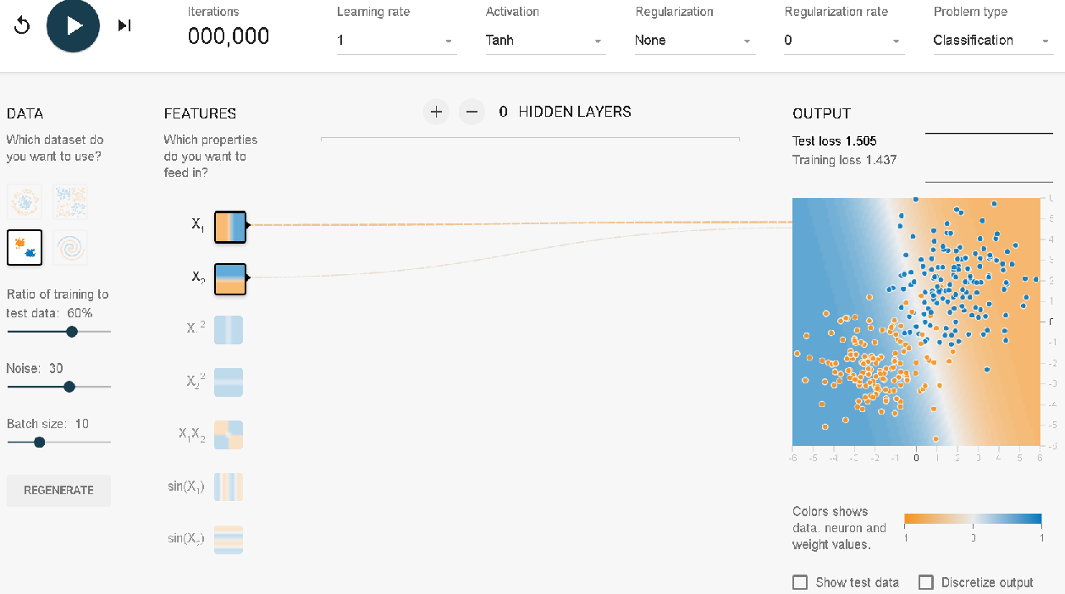
Figure L.1: Neural Net Playground [19]
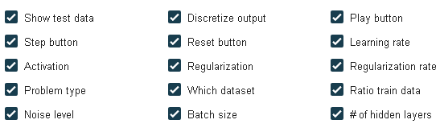
Figure L.2: Neural Net Playground Optional Functionality [19]

Appendix: R

R.1 Functional Requirements Definition
GUI screenshot: Visual evidence of the implementation.
User Evaluation feedback: If a requirement has been met then user testing will confirm this. Commentary will be provided on each requirement if necessary.
Unit Testing: Some requirements cannot be tested by visual means or user feedback. These will be unit tested to make sure they are met.
Table R.1 Functional Requirements Definition
Index | Source | Description | Priority | GUI | Rationale | Success Criteria
F01 | Primary Stakeholder | The system shall implement a Perceptron simulator. | High | - | A formal statement of the overall goal of the project. | All “shall” requirements fulfilled.  User Evaluation feedback.
F02 | Designer | The system should display a Main Menu GUI. | Low | MM | A Main Menu is a conventional way to navigate a program. Other methods discussed in the Design documentation. | GUI screenshot.
F03 | Designer | The system should implement an Exit button. | Medium | MM | Used to close the program from the Main Menu. | GUI screenshot.  User Evaluation feedback.
F04 | Designer | The system should implement a “The Perceptron” button to navigate to “The Perceptron” page. | Low | MM | Used to navigate to “The Perceptron” page. | GUI screenshot.  User Evaluation feedback.
F05 | Designer | The system should implement a “The Perceptron Learning Process” button to navigate to “The Perceptron Learning Process” page. | Low | MM | Used to navigate to “The Perceptron Learning Process” page. | GUI screenshot.  User Evaluation feedback.
F06 | Designer | The system should display “The Perceptron” GUI. | High | P | “The Perceptron” page is a lightweight input-output page to get to understand how a Perceptron works. | GUI screenshot.
F07 | Primary Stakeholder | The system shall implement the Perceptron algorithm. | High | P | The simplest neural network is the single Perceptron. The use can enter inputs and weights and receive outputs. No learning is involved in this process. | Unit testing.  User Evaluation feedback.
F08 | Designer | The system should implement a “Randomize inputs” button. | Low | P | This allows the user to quickly see the effects of different kinds of inputs. | GUI screenshot.  User Evaluation feedback.
F09 | Designer | The system should implement a “Randomize weights” button. | Low | P | As F08, but with weights instead of inputs. | GUI screenshot.  User Evaluation feedback.
F10 | Primary Stakeholder | The system shall implement a Play button that executes the Perceptron and the Perceptron Learning Process algorithms. | High | P  PLP | The primary way of running the Perceptron algorithms is via a continuous play through using a Play button. | GUI screenshot.  User Evaluation feedback.
F11 | Designer | The system should implement a “Back to Main Menu” button. | Low | P  PLP | The user may want to move between the “The Perceptron” and “The Perceptron Learning Process” pages, or exit the program. | GUI screenshot.  User Evaluation feedback.
F12 | Primary Stakeholder | The system shall implement customisable GUI colour buttons. | Medium | P  PLP | Some users may be colour vision deficient and must be catered for. | GUI screenshot.  User Evaluation feedback.
F13 | Designer | The system should implement mouse over tooltips for GUI components. | Medium | P  PLP | Allows users to understand GUI components, the network architecture and parameters as well as the Perceptron algorithms. | GUI screenshot.  User Evaluation feedback.
F14 | Designer | The system should implement a help guide. | Medium | P  PLP | A help guide will allow users to better understand application functionality and how the learning process works. | GUI screenshot.  User Evaluation feedback.  .
F15 | Primary Stakeholder | The system shall give feedback on network changes to the user. | High | P  PLP | Feedback is essential, as stated in the Design document and Educational research. | GUI screenshot.
F16 | Primary Stakeholder | The system shall display the neuron architecture. | High | P  PLP | Learning is improved when the user can make associations with the neuron architecture and the network parameters. | GUI screenshot.
F17 | Primary Stakeholder | The system shall display the inputs on the neuron architecture. | High | P  PLP | As F16 | GUI screenshot.
F18 | Primary Stakeholder | The system shall display the weights on the neuron architecture. | High | P  PLP | As F16 | GUI screenshot.
F19 | Primary Stakeholder | The system shall display the desired output on the neuron architecture. | High | P  PLP | As F16 | GUI screenshot.
F20 | Primary Stakeholder | The system shall display the actual output on the neuron architecture. | High | P  PLP | As F16 | GUI screenshot.
F21 | Primary Stakeholder | The system shall display the weighted sum on the neuron architecture. | High | P  PLP | As F16 | GUI screenshot.
F22 | Primary Stakeholder | The system shall display a choice of threshold function, step or sigmoid on the neuron architecture. | High | P  PLP | Allows the user to experience the effects of different kinds of threshold functions. | GUI screenshot.  User Evaluation feedback.
F23 | Primary Stakeholder | The system should display a graph of the threshold function that plots the weighted sum on the neuron architecture. | High | P  PLP | Allows the user to visualise the classification of a data point based on the weighted sum. | GUI screenshot.  User Evaluation feedback.
F24 | Primary Stakeholder | The system shall display a graph of the sum of the squared error on the neuron architecture for the Perceptron Learning Process page. | High | PLP | Allows the user to visualise the error. | GUI screenshot.  User Evaluation feedback.
F25 | Primary Stakeholder | The system shall display the sum of the squared error value on the neuron architecture. | High | P  PLP | Allows the user to see the error value for the current iteration. | GUI screenshot.  User Evaluation feedback.
F26 | Primary Stakeholder | The system shall update the neuron architecture when changes are made to the network parameters. | High | P  PLP | Allows the user to visualise the Perceptron processing each data points, and provides feedback to changes to the network parameters. | GUI screenshot.  User Evaluation feedback.
F27 | Primary Stakeholder | The system shall display “The Perceptron Learning Process” GUI. | High | PLP | “The Perceptron Learning Process” GUI is the most important GUI as its contents shows how a Perceptron learns. | GUI screenshot.
F28 | Primary Stakeholder | The system shall display a Learning Process Graph. | High | PLP | The learning process graph is the most important feature for showing how the Perceptron classifies data using a threshold boundary. | GUI screenshot.
F29 | Designer | The system should highlight the current data point being evaluated by the Perceptron learning process algorithm on the Learning Process Graph. | Medium | PLP | Highlighting the current data point allows the user to see how the Threshold Boundary moves around in relation to that point. | GUI screenshot.
F30 | Primary Stakeholder | The system shall display a Threshold Boundary on the Learning Process Graph. | High | PLP | The Threshold Boundary is the most important feature of the Learning Process Graph. It shows the classification of the data. | GUI screenshot.
F31 | Primary Stakeholder | The system shall redraw the Threshold Boundary when changes are made to the weights. | High | PLP | The Threshold Boundary moves around the Learning Process Graph depending on what the current weights are. When the weights are changes the Threshold Boundary must be redrawn. | GUI screenshot.  User Evaluation feedback.
F32 | Primary Stakeholder | The system shall implement the Perceptron Learning Process algorithm. | High | PLP | The most important feature of the application is the implementation of the learning process which shows how the Perceptron classifies data. | Unit testing.  User Evaluation feedback.
F33 | Primary Stakeholder | The system shall implement the Learning Rate. | High | PLP | The learning rate slows down learning, allowing the Perceptron Learning Process algorithm to converge more accurately to the correct classification. | GUI screenshot.  User Evaluation feedback.
F34 | Primary Stakeholder | The system shall implement the Widrow-Hoff Delta Rule. | High | PLP | The Widrow-Hoff Delta Rule allows the weights to be updated based on the error between the desired and actual output. | Unit testing.
F35 | Primary Stakeholder | The system shall set the weights to initial random values. | High | PLP | Randomized weights allow the Perceptron Learning Process to begin from different starting points given the same data, potentially leading to a different Threshold Boundary when classified. | GUI screenshot.  User Evaluation feedback.
F36 | Designer | The system should allow the user to load preset datasets. | Medium | PLP | Allows the user to classify predetermined datasets. | GUI screenshot.  User Evaluation feedback.
F37 | Designer | The system should allow the user to generate a dataset. | Medium | PLP | Allows the user to create new datasets to classify. | GUI screenshot.  User Evaluation feedback.
F38 | Designer | The system should implement an “Add data point by graph” button. | Medium | PLP | Allows the user to quickly create new data points. | GUI screenshot.  User Evaluation feedback.
F39 | Designer | The system should implement an “Add data point by textbox” button. | Medium | PLP | Allows the user to manually enter specific data point parameters to create a new data point. | GUI screenshot.  User Evaluation feedback.
F40 | Primary Stakeholder | The system shall allow the user to adjust the Learning Rate via textbox. | High | PLP | Allows the user to interact with the Perceptron Learning Process algorithm by slowing down the Learning Rate. As F33. | GUI screenshot.  User Evaluation feedback.
F41 | Designer | The system should implement a “Delete dataset” button. | Medium | PLP | Allows the user to get rid of all data, and load, generate or create new data points. | GUI screenshot.  User Evaluation feedback.
F42 | Primary Stakeholder | The system shall implement a Stop button. | Medium | PLP | Allows the user to stop the Perceptron Learning Process. | GUI screenshot.  User Evaluation feedback.
F43 | Designer | The system should implement a Step Through button. | Medium | PLP | Allows the user to step through the dataset at a specified pace, slowing down the Perceptron Learning Process. | GUI screenshot.  User Evaluation feedback.
F44 | Designer | The system should implement a History Slider for recording the learning process. | Medium | PLP | Allows the user to retroactively go through the learning process one data point at a time. | GUI screenshot.  User Evaluation feedback.
F45 | Designer | The system should display the inputs in a Table of Data. | Low | PLP | Displays all of the user entered inputs in one place. | GUI screenshot.  User Evaluation feedback.
F46 | Designer | The system should implement a Reset Data button. | Medium | PLP | Resetting the data allows the user to run the Learning Process again. | GUI screenshot.  User Evaluation feedback.
F47 | Designer | The system should implement a “Delete data point” button. | Medium | PLP | Allows the user to remove an unwanted datapoint. | GUI screenshot.  User Evaluation feedback.

R.2 Non-functional Requirements Definition
Table R.2 Non-functional Requirements Definition
Index | Requirement | Rationale | Success Criteria
N01 | The system shall be “easy to use”. | An easy to use system leads to a more enjoyable experience and repeated use of the system. | Feedback in the form of a questionnaire and task based evaluation.
N02 | The system shall be “intuitive”. | Users must be able to grasp the system functionality quickly. | As N01.
N02 | The system should be “enjoyable to use” | A system that isn’t enjoyable will not be used again. | As N01.
N04 | The system shall provide sufficient feedback to the user on their actions. | This can be achieved using colour, highlighting and error messages. | Implementing colour and highlighting of prominent GUI components and error messages when an invalid action is taken.

Appendix: D

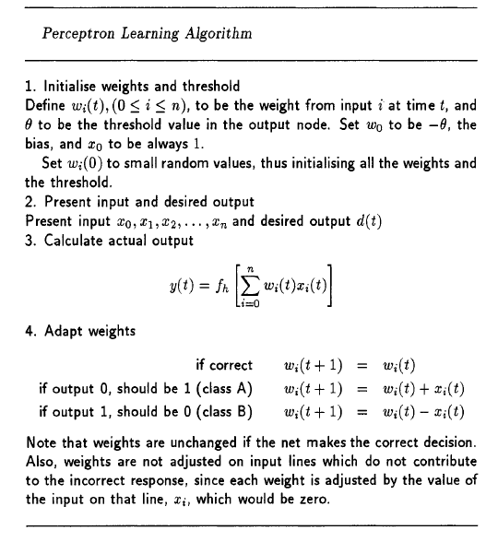
D.1 Perceptron Learning Algorithm

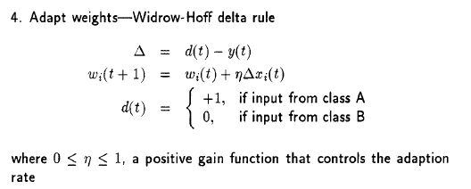
Figure D.2: Widrow-Hoff delta rule [34]
Figure D.1: Perceptron Learning Algorithm [34]

D.2 Data Dictionary

D.2.1 Algorithm Design Data
The Perceptron: As a simple input-output algorithm, not much data storage will be required. n = 1 (for ‘The Perceptron’ only).
Table D.2.1.1 The Perceptron Data Dictionary
Data | Data Type | Size | Description | Example
Input data | Real | [3 x n] | [𝓍₀ ; 𝓍₁ ; 𝓍₂] A vector of inputs to the Perceptron. 𝓍₀ is always set to 1. | [1 ; -0.12 ; 0.43]
Weights | Real | [3 x 1] | [w₀ ; w₁ ; w₂] A vector of weights, applied to the input data by the inner product and used to draw the Threshold Boundary. W₀ is the bias/offset θ of the neuron. | [-0.17 ; 0.084 ; 0.6]
Weighted sum | Real | [1 x 1] | Result of the inner product of the input data and the weights. | [-12.045]
Desired output | Integer | [1 x n] | The class of an input data element. Restricted to [-1,+1] or [0, 1]. | [-1]
Actual output | Integer | [1 x n] | The calculated actual class of an input data element based on the current weights.  Step function:  sign [+/-] of the weighted sum.  Sigmoid function:  actualOutput >= 0.5 then actualOutput = 1  actualOutput < 0.5 then actualOutput = -1 | Step: [1]  Sigmoid:[-1]
Error | Real | [1 x n] | The error term for how far away from the desired output the actual output is.  Error = Desired Output - Actual Output.  Sigmoid function:  Before thresholding the actualOutput (as above), the actualOutput is used to calculate the error, otherwise it would be the same as the Step function error which is not wanted. | Step: [2], [-2] Sigmoid:  [-1.342]

The Perceptron Learning Process: The Perceptron learning process requires more data storage for keeping track of time, iterations, learning variables etc. All data that applies to ‘The Perceptron’ above applies here, where n = no. of data points.
Table D.2.1.2 The Perceptron Learning Process Data Dictionary
Data | Data Type | Size | Description | Example
Learning rate | Real | [1 x 1] | The learning rate controls how big the change to the weights is. It must be in the range of [0 -1]. Large learning rates (tending to 1) cause big changes, small learning rates (tending to 0) cause small changes. | [0], [1], [0.1], [0.67]
Sum of the squared error | Real | [1 x 1] | As the learning process continues, the sum of the squared error should be decreasing to show that the learning process is converging to the correct classification. | [40], [8], [13.231], [0]
Current iteration | Integer | [1 x 1] | Keeps track of the current iteration (or time steps t) | [1],[23],[45]
Maximum iteration | Integer | [1 x 1] | The maximum number of iterations (or time steps t) | [10],[1000]
Threshold Boundary | - | - | The threshold boundary will be created by using the weights and sample input data points. It has been listed here for completeness sake. | -
Correct classification | Bool | [1 x 1] | Whether or not the input data has been correctly classified. | [1]
Data present | Bool | [1 x 1] | Whether or not the user has entered any data. The algorithm cannot run without data. | [0]
Original data used for reset | Real | [3 x n] | A copy of the original data the user entered in case the network is reset. | [1 ; -0.12 ; 0.43]

D.2.2 User Learning Methods Data
User learning methods include the use of the ‘Play’ button and the ‘Step Through’ button, allowing users to move through the learning process at their own pace and the ‘History Slider’, allowing a retrospective look at the learning process. For ‘History Slider’, n = no. of data points considered in the learning process. Each data point can be considered multiple times over several iterations and several play throughs until there is a correct classification.
Table D.2.2 User Learning Methods Data Dictionary
Data | Data Type | Size | Description | Example
Step Through size | Integer | [1 x 1] | The number of datapoints the user has specified to step through when using the ‘Step Through’ button. | [20]
Minimum index of Step Through “block” | Integer | [1 x 1] | Step Through: The minimum index of the input data to step through. | [1]
Maximum index of Step Through “block” | Integer | [1 x 1] | Step Through: The maximum index of the input data to step through. | [20]
Play history | Integer | [1 x n] | History Slider: Keeps track of which playthrough (‘Play’ or ‘Step Through’) the user is currently viewing using the slider. | [1, 1, 1, 2, 2, 2]
Iteration history | Integer | [1 x n] | History Slider: Keeps track of which iteration within a play through the user is currently viewing using the slider. | [1, 2, 3, 4, 1, 2]
Datapoint history | Real | [5 x n] | History Slider: Every data point considered in the learning process is stored, even if no changes are made to the network. | [1; -0.1; 0.45; -1, 1]
Weight history | Real | [3 x n] | History Slider: As Datapoint history but storing weights for every data point. | [-0.39; 1.2; 3.4]
Step Through initialization | Bool | [1 x 1] | Step Through: Step Through size and the indexes cannot be changed once Step Through has started as this would cause unnecessary complications with the learning process and consistency of variables. | [0]
Play counter | Integer | [1 x 1] | Number of playthroughs needed so far to correctly classify the data. | [2]

D.2.3 Accessibility Requirements Data
Colour is the main accessibility data requirement. The user can change these colours at any time.
Table D.2.3 Accessibility Requirements Data Dictionary
Data | Data Type | Size | Description | Example
Status colour | Real | [1 x 3] | Status colour is composed of: Not Running, Processing and Completed. These allow the user to see the current status of the learning process. | [.8 .8 .8];  [1 1 0];  [0 1 0];
Class colour | Real | [1 x 3] | Class colour is composed of: Class A and Class B. On the learning graph data points represent each class with each class having a different colour (and shape ‘x’ or ‘o’). | [0 0 1];  [1 0 0];
Threshold colour | Real | [1 x 1] | The colour of the Threshold Boundary line on the learning graph. | [0 0 0];

D.3 Requirements Met in Design
Requirement Number  \ GUI | F01 | F02 | F03 | F04 | F05 | F06 | F07 | F08 | F09 | F10 | F11 | F12 | F13 | F14 | F15 | F16 | F17 | F18
Main Menu | X | X | X | X | X
The Perceptron | X |  |  |  |  | X | X | X | X | X | X | X | X | X | X | X | X | X
The Perceptron Learning Process | X |  |  |  |  |  |  |  |  | X | X | X | X | X | X | X | X | X
Requirement Number  \ GUI | F19 | F20 | F21 | F22 | F23 | F24 | F25 | F26 | F27 | F28 | F29 | F30 | F31 | F32 | F33 | F34 | F35 | F36
Main Menu

The Perceptron | X | X | X | X | X |  | X | X
The Perceptron Learning Process | X | X | X | X | X | X | X | X | X | X | X | X | X | X | X | X | X | X
Table D.3 Requirements Met in Desigm
Requirement Number  \ GUI | F37 | F38 | F39 | F40 | F41 | F42 | F43 | F44 | F45 | F46 | F47
Main Menu

The Perceptron

The Perceptron  Learning Process | X | X | X | X | X | X | X | X | X | X | X

D.4 GUI Designs

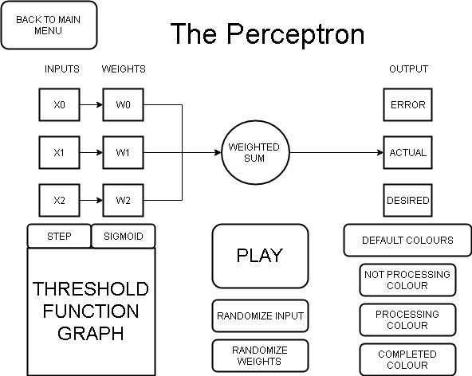
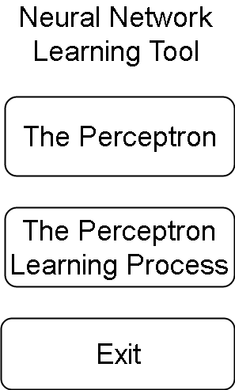

Figure D.4: The Perceptron Page GUI design
Figure D.3: Main Menu GUI design

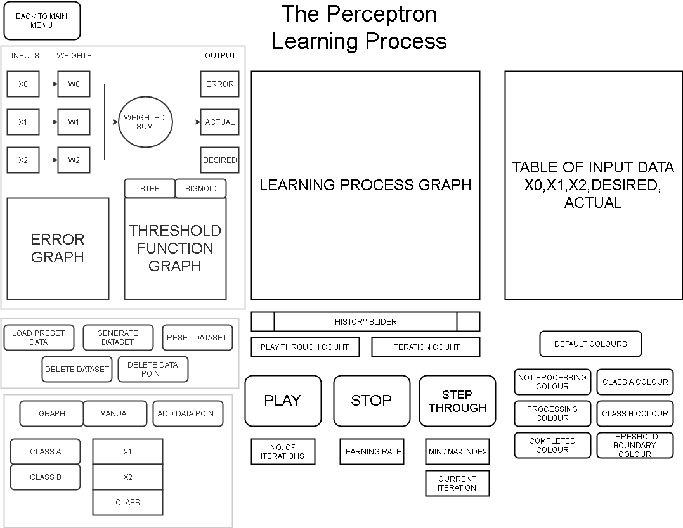
Figure D.5: The Perceptron Learning Process Page GUI design

Appendix: I

I.1 perceptron_skeleton_filled.m
function [loop, w] = perceptron(dataM,classN,maxL)

% dataM - datamatrix, variables as rows and obervations as columns
% classN - vector of class labels (must be +1 or -1)
% maxL - maximum iterations of the algorithm
% loop - returns number of iterations
% w - weight vector, including bias

eta = 0.1; % learning rate

% get number of data points and number of variables
N = size(dataM,2);
v = size(dataM,1);

% Add row of 1's to data matrix for bias inputs
dataM = [ ones(1,N) ; dataM ];

% initialise weight vector (v+1 weights includes the bias)
w = rand(v+1,1);

% set a "correctness" flag
correct = -1;

% initialise vector for calculated class
class = zeros(1,N);

loop = 0;
while (correct == -1) && (loop < maxL)
% check patterns classified
correct = 1;
loop = loop + 1;
%% INSERT YOUR CODE HERE TO CALCULATE CLASS
class = sign(w' * dataM);

% compare claculated class and desired class
if any(class ~= classN)
correct = -1;
end

% if any datum is classified incorrectly, adjust weights
if correct == -1
%% INSERT YOUR CODE HERE TO ADJUST WEIGHTS
% This uses all the training data (one epoch)
% alternatively, you can select one point at random to adjust the weights
% and check again
for i = 1:N
if class(1,i) ~= classN(1,i)
w = w + eta * classN(1,i) * dataM(:,i);
end
end
end
end

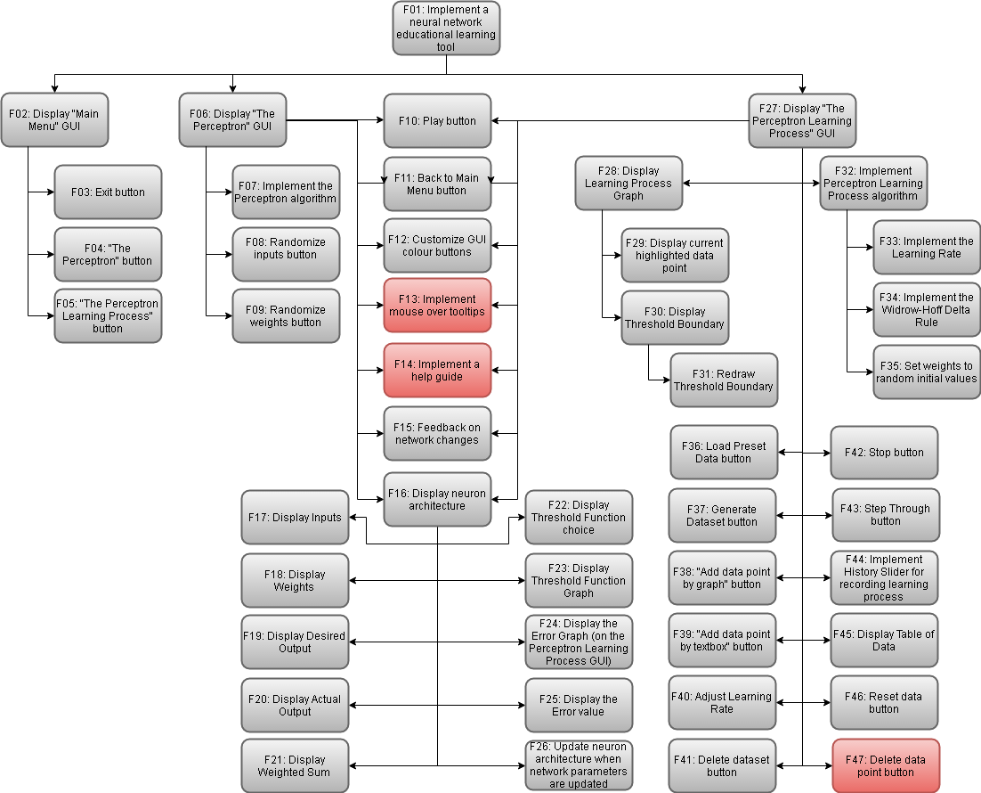
I.2 Functional Requirements fulfilled in Implementation
Figure I.1: Functional Requirements fulfilled in Implementation. Fulfilled(grey), Unfulfilled(red).

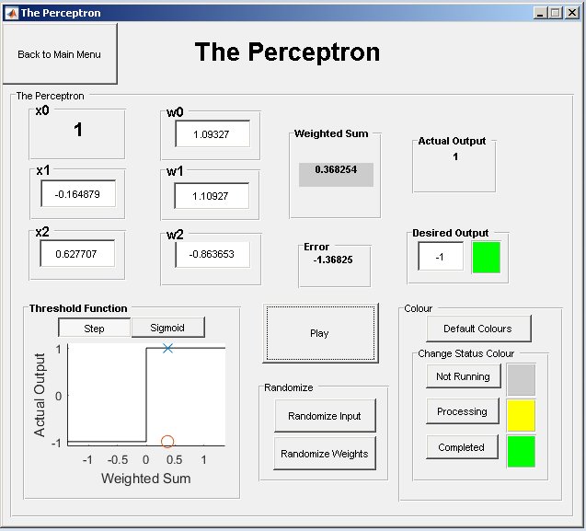
I.3 Final GUI Deliverables
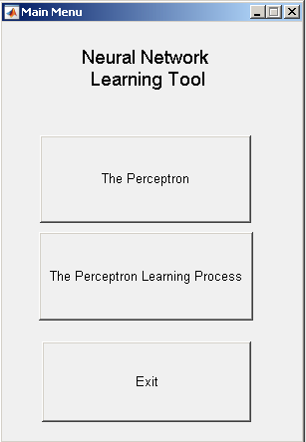
Figure I.3: Final GUI The Perceptron Page
Figure I.2: Final GUI Main Menu

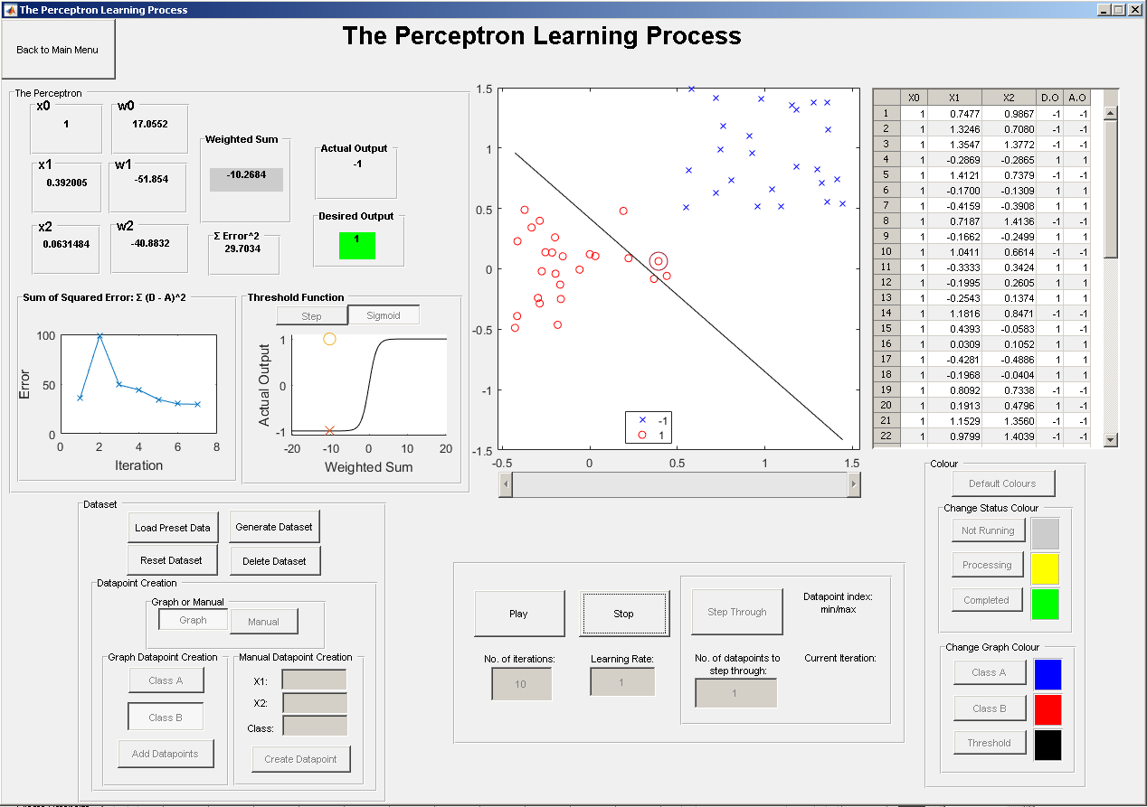
Figure I.4: Final GUI The Perceptron Learning Process Page

Appendix: T

T.1 Screenshot Tests
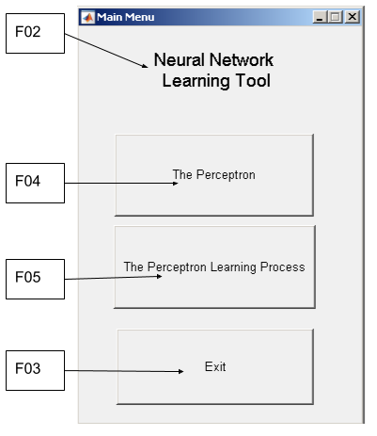
Figure T.1: Main Menu requirements screenshot tests
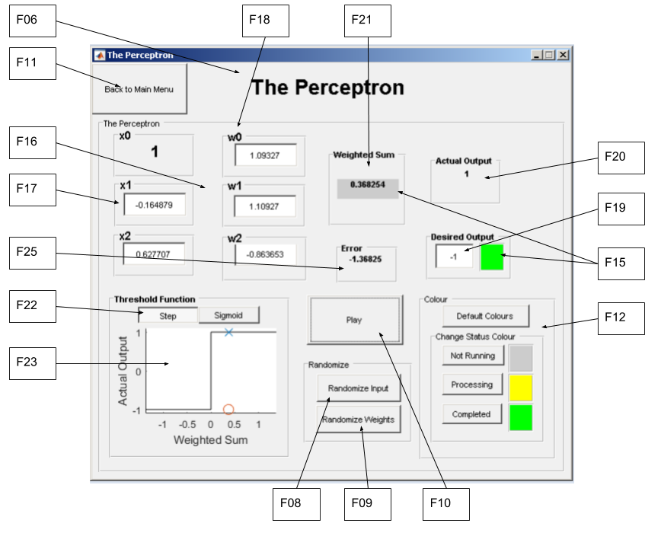
Figure T.2: The Perceptron requirements screenshot tests
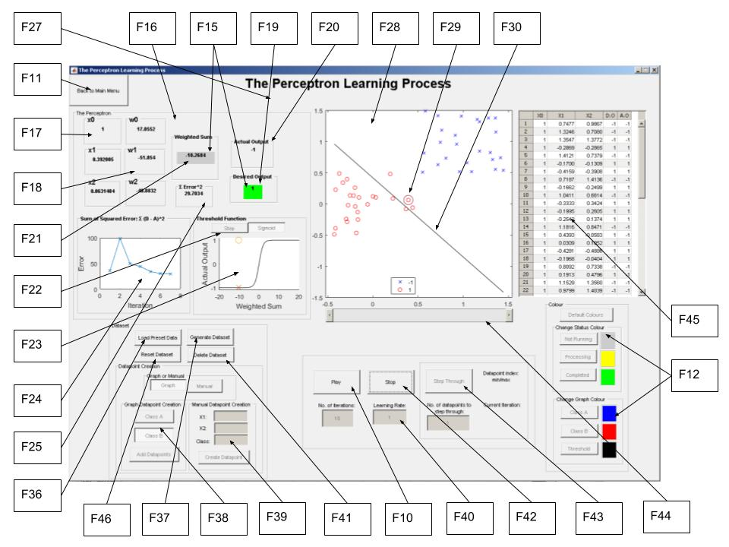
Figure T.3: The Perceptron Learning Process requirements screenshot tests

T.2 The Perceptron Learning Process Unit Test
Table T.2 The Perceptron Learning Process Unit Test
 | X0 | X1 | X2 | Desired Output | Weighted Sum | Actual Output | Error | W1 | W2 | W3
 |  |  |  |  |  |  |  | 0.1 | -0.5 | 1.5
It1 | 1 | 1 | 1 | 1 | 1.1 | 1 | 0 | 0.1 | -0.5 | 1.5
 | 1 | 0 | 0 | 1 | 0.1 | 1 | 0 | 0.1 | -0.5 | 1.5
 | 1 | 0.5 | 0.5 | 1 | 0.6 | 1 | 0 | 0.1 | -0.5 | 1.5
 | 1 | 0 | 1 | -1 | 1.6 | 1 | -2 | -1.9 | -0.5 | -0.5
 | 1 | 0 | 0.5 | -1 | -2.15 | -1 | 0 | -1.9 | -0.5 | -0.5
 | 1 | 0.5 | 1 | -1 | -2.65 | -1 | 0 | -1.9 | -0.5 | -0.5
It2 | 1 | 1 | 1 | 1 | -2.9 | -1 | 2 | 0.1 | 1.5 | 1.5
 | 1 | 0 | 0 | 1 | 0.1 | 1 | 0 | 0.1 | 1.5 | 1.5
 | 1 | 0.5 | 0.5 | 1 | 1.6 | 1 | 0 | 0.1 | 1.5 | 1.5
 | 1 | 0 | 1 | -1 | 1.6 | 1 | -2 | -1.9 | 1.5 | -0.5
 | 1 | 0 | 0.5 | -1 | -2.15 | -1 | 0 | -1.9 | 1.5 | -0.5
 | 1 | 0.5 | 1 | -1 | -1.65 | -1 | 0 | -1.9 | 1.5 | -0.5
It3 | 1 | 1 | 1 | 1 | -0.9 | -1 | 2 | 0.1 | 3.5 | 1.5
 | 1 | 0 | 0 | 1 | 0.1 | 1 | 0 | 0.1 | 3.5 | 1.5
 | 1 | 0.5 | 0.5 | 1 | 2.6 | 1 | 0 | 0.1 | 3.5 | 1.5
 | 1 | 0 | 1 | -1 | 1.6 | 1 | -2 | -1.9 | 3.5 | -0.5
 | 1 | 0 | 0.5 | -1 | -2.15 | -1 | 0 | -1.9 | 3.5 | -0.5
 | 1 | 0.5 | 1 | -1 | -0.65 | -1 | 0 | -1.9 | 3.5 | -0.5
It4 | 1 | 1 | 1 | 1 | 1.1 | 1 | 0 | -1.9 | 3.5 | -0.5
 | 1 | 0 | 0 | 1 | -1.9 | -1 | 2 | 0.1 | 3.5 | -0.5
 | 1 | 0.5 | 0.5 | 1 | 1.6 | 1 | 0 | 0.1 | 3.5 | -0.5
 | 1 | 0 | 1 | -1 | -0.4 | -1 | 0 | 0.1 | 3.5 | -0.5
 | 1 | 0 | 0.5 | -1 | -0.15 | -1 | 0 | 0.1 | 3.5 | -0.5
 | 1 | 0.5 | 1 | -1 | 1.35 | 1 | -2 | -1.9 | 2.5 | -2.5
It5 | 1 | 1 | 1 | 1 | -1.9 | -1 | 2 | 0.1 | 4.5 | -0.5
 | 1 | 0 | 0 | 1 | 0.1 | 1 | 0 | 0.1 | 4.5 | -0.5
 | 1 | 0.5 | 0.5 | 1 | 2.1 | 1 | 0 | 0.1 | 4.5 | -0.5
 | 1 | 0 | 1 | -1 | -0.4 | -1 | 0 | 0.1 | 4.5 | -0.5
 | 1 | 0 | 0.5 | -1 | -0.15 | -1 | 0 | 0.1 | 4.5 | -0.5
 | 1 | 0.5 | 1 | -1 | 1.85 | 1 | -2 | -1.9 | 3.5 | -2.5
It6 | 1 | 1 | 1 | 1 | -0.9 | -1 | 2 | 0.1 | 5.5 | -0.5
 | 1 | 0 | 0 | 1 | 0.1 | 1 | 0 | 0.1 | 5.5 | -0.5
 | 1 | 0.5 | 0.5 | 1 | 2.6 | 1 | 0 | 0.1 | 5.5 | -0.5
 | 1 | 0 | 1 | -1 | -0.4 | -1 | 0 | 0.1 | 5.5 | -0.5
 | 1 | 0 | 0.5 | -1 | -0.15 | -1 | 0 | 0.1 | 5.5 | -0.5
 | 1 | 0.5 | 1 | -1 | 2.35 | 1 | -2 | -1.9 | 4.5 | -2.5
It7 | 1 | 1 | 1 | 1 | 0.1 | 1 | 0 | -1.9 | 4.5 | -2.5
 | 1 | 0 | 0 | 1 | -1.9 | -1 | 2 | 0.1 | 4.5 | -2.5
 | 1 | 0.5 | 0.5 | 1 | 1.1 | 1 | 0 | 0.1 | 4.5 | -2.5
 | 1 | 0 | 1 | -1 | -2.4 | -1 | 0 | 0.1 | 4.5 | -2.5
 | 1 | 0 | 0.5 | -1 | -1.15 | -1 | 0 | 0.1 | 4.5 | -2.5
 | 1 | 0.5 | 1 | -1 | -0.15 | -1 | 0 | 0.1 | 4.5 | -2.5

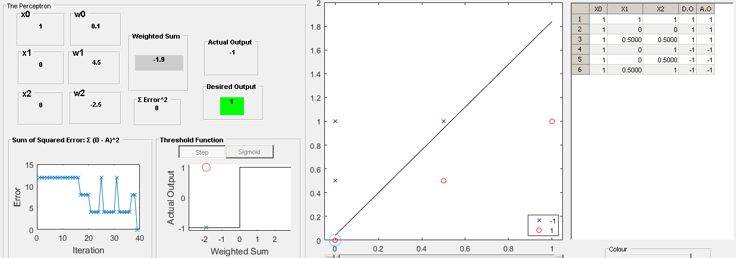
Figure T.4: The Perceptron Learning Process convergence

T.3 Test Screenshots
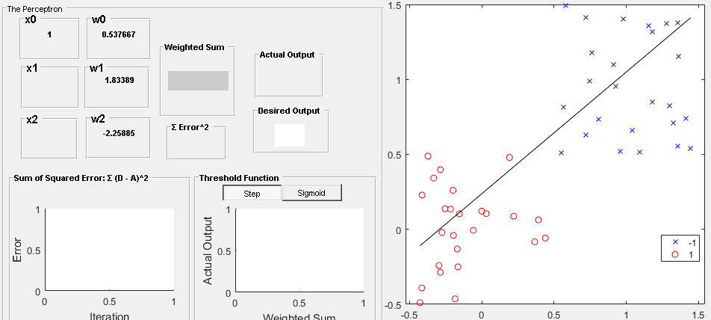
Figure T.5: F35: Initialising random weights.
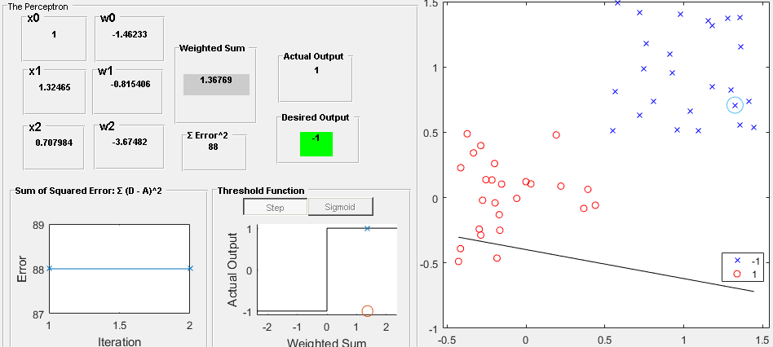
Figure T.6: F26: Updating the neuron architecture and F31: Redrawing the threshold boundary
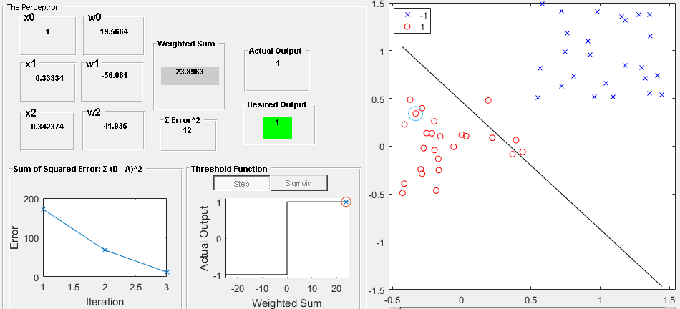
Figure T.7: F33: Implement the learning rate. Learning rate = 1.
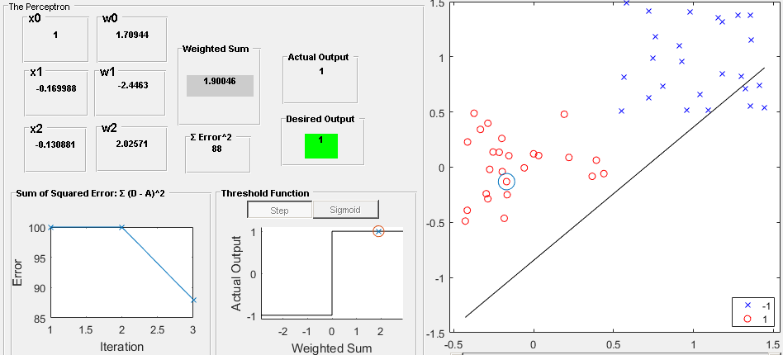
Figure T.8: Implement the learning rate. Learning rate = 0.01.

T.4 Requirements Testing
Table T.4 Requirements Testing
Index | Description | Unit Testing | GUI screenshot | User Evaluation Comments | Success?
F01 | The system shall implement a Perceptron simulator. | - | - | See section 7.2.3 and further comments. | Yes
F02 | The system should display a Main Menu GUI. | - | Figure T.1 | - | Yes
F03 | The system should implement an Exit button. | - | Figure T.1 | - | Yes
F04 | The system should implement a “The Perceptron” button to navigate to “The Perceptron” page. | - | Figure T.1 | - | Yes
F05 | The system should implement a “The Perceptron Learning Process” button to navigate to “The Perceptron Learning Process” page. | - | Figure T.1 | - | Yes
F06 | The system should display “The Perceptron” GUI. | - | Figure T.2 | - | Yes
F07 | The system shall implement the Perceptron algorithm. | Table 6.1 | - | Worked correctly for all users. | Yes
F08 | The system should implement a “Randomise inputs” button. | - | Figure T.2 | Worked correctly for all users.  Task instructions confused the users. Most assumed they had to manually enter random inputs and weights rather than pressing the “Randomise Inputs/Weights” buttons. This may be a problem with the methodology not explicitly mentioning these buttons. | Yes
F09 | The system should implement a “Randomise weights” button. | - | Figure T.2 | Worked correctly for all users. | Yes
F10 | The system shall implement a Play button that executes the Perceptron and the Perceptron Learning Process algorithms. | - | Figure T.2  Figure T.3 | Worked correctly for all users.  For “The Perceptron”, one user mentioned they were used to automatic calculations as webpages do when inputting data, rather than having to press a button to calculate the output. | Yes
F11 | The system should implement a “Back to Main Menu” button. | - | Figure T.2  Figure T.3 | Worked correctly for all users. | Yes
F12 | The system shall implement customisable GUI colour buttons. | - | Figure T.2  Figure T.3 | Users pressed the small colour box next to the button rather than the button itself.  “Status colours” did not immediately change until the learning process was ran. This must be corrected.  Mostly worked for all users.  Class and threshold boundary colours worked for all users. | Mostly
F13 | The system should implement mouse over tooltips for GUI components. | - | NOT IMPLEMENTED | Users requested tooltips. | No
F14 | The system should implement a help guide. | - | NOT IMPLEMENTED | Users requested a help guide. | No
F15 | The system shall give feedback on network changes to the user. | - | Figure T.2  Figure T.3 | Users did not understand what “status colours” meant.  Colours changed when users pressed Play. | Mostly
F16 | The system shall display the neuron architecture. | - | Figure T.2  Figure T.3 | Some users did not like that the neuron architecture textbox inputs on “The Perceptron” were automatically populated. They would prefer that they were always defaulted to empty to prevent confusion. This was done however so that users could see an example of the kind of data they could enter.  The tab function on “The Perceptron” does not move in an ordered way between inputs, weights and desired output. One user noted they tab often when entering data into various webpages or programs meaning this issue would need to be addressed. | Yes
F17 | The system shall display the inputs on the neuron architecture. | - | Figure T.2  Figure T.3 | - | Yes
F18 | The system shall display the weights on the neuron architecture. | - | Figure T.2  Figure T.3 | - | Yes
F19 | The system shall display the desired output on the neuron architecture. | - | Figure T.2  Figure T.3 | - | Yes
F20 | The system shall display the actual output on the neuron architecture. | - | Figure T.2  Figure T.3 | - | Yes
F21 | The system shall display the weighted sum on the neuron architecture. | - | Figure T.2  Figure T.3 | - | Yes
F22 | The system shall display a choice of threshold function, step or sigmoid on the neuron architecture. | - | Figure T.2  Figure T.3 | Worked correctly for all users.  One user requested the sigmoid function be placed far away from the step function option. This is so users can know step is the default. | Yes
F23 | The system should display a graph of the threshold function that plots the weighted sum on the neuron architecture. | - | Figure T.2  Figure T.3 | Was not available at the time of user evaluations. | Yes
F24 | The system shall display a graph of the sum of the squared error on the neuron architecture for the Perceptron Learning Process page. | - | Figure T.3 | Most users could give an accurate interpretation to what the Error Graph meant.  Sometimes a new error line would be drawn on the current plot, or the plot was deleted and the new line drawn.  Users were sometimes confused when asked to find iteration numbers. This was because the History Slider does not automatically display iteration and playthrough information. Users therefore looked at the Error Graph to get iteration values. | Mostly
F25 | The system shall display the sum of the squared error value on the neuron architecture. | - | Figure T.2  Figure T.3 | Worked correctly for all users.  All users could identify the error. | Yes
F26 | The system shall update the neuron architecture when changes are made to the network parameters. | - | Figure T.6 | - | Yes
F27 | The system shall display “The Perceptron Learning Process” GUI. | - | Figure T.3 | - | Yes
F28 | The system shall display a Learning Process Graph. | - | Figure T.3 | All users could understand the basic premise of the Learning Process Graph.  “o” used to identify points was confusing as when the Threshold Boundary moved through the point, users could not tell which class the point was in. | Yes
F29 | The system should highlight the current data point being evaluated by the Perceptron learning process algorithm on the Learning Process Graph. | - | Figure T.3 | All users were able to identify the highlighted point as the current point being evaluated. | Yes
F30 | The system shall display a Threshold Boundary on the Learning Process Graph. | - | Figure T.3 | All users could understand the basic premise of how the Threshold Boundary moves around on the Learning Process Graph.  Some users noticed it was possible to draw a vertical line to separate some datasets. This could be addressed in future development rather than using the two most extreme data points to draw the Threshold Boundary.  As very large and small X2 values could be generated based on the weights, the Threshold Boundary would cause the graph to expand to accommodate for these high values. This caused the dataset to be squashed in the X2 axis, which users noted was not aesthetically pleasing. | Yes
F31 | The system shall redraw the Threshold Boundary when changes are made to the weights. | - | Figure T.6 | - | Yes
F32 | The system shall implement the Perceptron Learning Process algorithm. | Section 6.1.1  Table T.1  Figure T.4 | - | The algorithm worked correctly for all users when classifying the data. Some datasets did not classify but this was because not enough iterations were specified to classify the datasets. | Yes
F33 | The system shall implement the Learning Rate. | - | Figure T.7  Figure T.8 | All users could understand the effect of the Learning Rate on the learning process. | Yes
F34 | The system shall implement the Widrow-Hoff Delta Rule. | Section 6.1.1  Table T.1  Figure T.4 | - | - | Yes
F35 | The system shall set the weights to initial random values. | - | Figure T.5 | - | Yes
F36 | The system should allow the user to load preset datasets. | - | Figure T.3 | Worked correctly for all users.  Users noted they were confused between the Load Preset Dataset button and other nearby buttons due to layout and close proximity. | Yes
F37 | The system should allow the user to generate a dataset. | - | Figure T.3 | Most users did not correctly identify the Generate Dataset button, instead mistaking the instruction for the Load Preset Dataset button. | Yes
F38 | The system should implement an “Add data point by graph” button. | - | Figure T.3 | All users were confused on how to add data points graphically. Labelling was not well done.  Users did not understand they had to press “Add data point”. They assumed the data point would automatically appear on the graph. Also, MATLAB’s implementation means that users must right click, or press enter when they wish to add their final point. This had to be explained prior. This would need to be addressed in a help guide or via tooltips.  The graphical crosshair was bugged several times causing the crosshair to remain after users have finished adding data points.  Users could select data points from all over the GUI rather than just the Learning Process Graph. While these points scaled to fit on the graph, this problem would need to be addressed. | No
F39 | The system should implement an “Add data point by textbox” button. | - | Figure T.3 | Users were confused about the association between Class A and B and the values [-1, 1] to represent these classes. Labelling in this regard was poor and should be changed to numerical values instead.  Users could not make the correct association between adding manual data points and using the manual textbox function. This is due to an incorrect methodology and poor labelling. | Mostly
F40 | The system shall allow the user to adjust the Learning Rate via textbox. | - | Figure T.3 | Worked correctly for all users.  Users found it difficult to find the Learning Rate textbox due to poor labelling.  Users understood the basic premise of the Learning Rate on the learning process. | Yes
F41 | The system should implement a “Delete dataset” button. | - | Figure T.3 | Worked correctly for all users.  Some users were confused between deleting and resetting datasets. They would delete data then load it again via the Load Dataset button. | Yes
F42 | The system shall implement a Stop button. | - | Figure T.3 | Worked correctly for all users. | Yes
F43 | The system should implement a Step Through button. | - | Figure T.3 | Most users did not understand how to use the Step Through button. This is likely due to poor labelling, lack of help guide and tooltips as well as a poor association between task instructions and GUI functionality. | No
F44 | The system should implement a History Slider for recording the learning process. | - | Figure T.3 | The History Slider was well received by all users.  The History Slider does not correctly display the number of iterations and playthroughs immediately after being enabled. Users had to be told to press either arrow on the slider to load this data.  If the data does not classify then the History Slider does not appear. This should be correct so it always appears when the learning process has ended. Users assumed they had caused an error in this instance when they had not.  It had to be pointed out that the slider could be held down to move quickly through the learning process. | Mostly
F45 | The system should display the inputs in a Table of Data. | - | Figure T.3 | All users successfully understood the Table of Data. | Yes
F46 | The system should implement a Reset Data button. | - | Figure T.3 | Users could effectively use the Reset Data button if they needed to start again with the learning process.  The prompt asking users if they wish to keep user created data points was poorly defined. Users could not initially understand what was meant by “user created” data points. | Yes
F47 | The system should implement a “Delete data point” button. | - | NOT IMPLEMENTED | - | No

Appendix: RE

RE.1 Neural Network Learning Tool: User Evaluation Tasks
THE PERCEPTRON

TASK 1
Enter the following data on “The Perceptron” page using the “Step” threshold function then run the learning process:
X1: 0.2 W0: 0.34
X2: -0.1 W1: 1.81
Desired Output: -1 W2: -0.57

- Does the Actual Output match the Desired Output?
- What is the value of the error?

TASK 2
Change the status colour of the “Not Running” to “Red”.
- What happens?

TASK 3
Using the same data entered in Task (1), change the threshold function to “Sigmoid” then run the learning process:
- Does the Actual Output match the Desired Output?
- What is the value of the error?

TASK 4
Change the value of X1: 0.2 to X1: “-1.4 + i” then run the learning process.
- Does the Actual Output match the Desired Output?
- What is the value of the error?

TASK 5
Randomise the weights using the same data entered in Task (1) and rerun the program with the “Step” threshold function using a Desired Output: 1.
- Does the Actual Output match the Desired Output?
- What is the value of the error?

TASK 6
Set the status colours to “default”.
- What happens?

THE PERCEPTRON LEARNING PROCESS

TASK 7
Load the file “data2d.m” on “The Perceptron Learning Process” page. Choose the “Step” threshold function and run the learning process for “7” iterations.
- Does the program classify the data correctly i.e. draw a line separating the two different classes of data? If not, rerun the learning process.
- How many iterations and playthroughs did it take to classify the data?
- What does the Error Graph tell you about the learning process you just ran?

TASK 8
Reset the data and add a new data point with: X1: 0, X2: 0, Desired Class: -1 and rerun the learning process with “12” iterations.
- Does the program classify the data correctly i.e. draw a line separating the two different classes of data?
- If so, how many iterations and playthroughs did it take to classify the data?
  - If not, rerun the learning process. Does the program classify the data correctly, if not why not, and in your opinion, is the classification satisfactory?
- What does the Error Graph tell you about the learning process you just ran?

TASK 9
Reset the data, discarding the data point created in the previous task (Task (2)). Graphically add a Class A (1) with: X1: 0.5, X2: 1 and run the learning process with a learning rate of “0.1” and iteration number of “20” using the “Sigmoid” threshold function.
- Does the program classify the data correctly i.e. draw a line separating the two different classes of data?
- If so, how many iterations and playthroughs did it take to classify the data?
  - If not, rerun the learning process. Does the program classify the data correctly, if not why not?
- What does the Error Graph tell you about the learning process you just ran?
- From observation, can the program draw a line separating the two different classes of data?

TASK 10
Using the History Slider, run a continuous play through of the learning process from the start to half way through the classification.

TASK 11
Delete the data. Graphically add six data points of Class A, and seven data points of Class B. Set the number of iterations to “30”, a learning rate of “0.1” and set the number of data points to step through to “3”. Set the threshold function to “Step”.

- Step through the data twice. What is the min/max data point index currently?
- Step through until the program classifies correctly or the number of iterations has been reached. How many iterations and playthroughs have occurred?
- What does the error graph tell you about the learning process?

TASK 12
Generate a dataset with 10 Class A data points and 6 Class B data points. Set Class A X1 Standard Deviation to “1.17” and Class B X2 Mean to “-0.9”.

- Set the colour of Class A to green and the threshold boundary to red.
- Run the learning process for “25” iterations with a learning rate of “0.5” using the “Sigmoid” threshold function.
- Using the History Slider, run through the learning process from start to finish.
- What does the error graph tell you?
- Using the table of data, are all data points classified correctly?

RE.2 Neural Network Learning Tool Questionnaire

1. How easy did you find the application to use? (1- very hard, 10- very easy)

1 2 3 4 5 6 7 8 9 10

COMMENTS:

2. How quickly do you feel you learned to use the application? (1- very slow, 10- very quick)

1 2 3 4 5 6 7 8 9 10

COMMENTS:

3. How likely do you think you would be in remembering how to operate the application if you were to use it again? (1- very unlikely, 10- very likely)

1 2 3 4 5 6 7 8 9 10

COMMENTS:

4. How intuitive do you think the program was to use? (1- not intuitive, 10- very intuitive). For example, did you find it easy to understand what the application controls do, such as what buttons do without being told?

1 2 3 4 5 6 7 8 9 10

COMMENTS:

5. How enjoyable did you find the program to use? (1- not enjoyable, 10- very enjoyable)

1 2 3 4 5 6 7 8 9 10

COMMENTS:

6. How easy was it to read text and characters on the screen? (1-very hard, 10- very easy)

1 2 3 4 5 6 7 8 9 10

COMMENTS:

7. How easy was it to find the information or controls you were looking for during the tasks? (1- very hard, 10- very easy)

1 2 3 4 5 6 7 8 9 10

COMMENTS:

8. How well organised do you think the controls and information were on the screen? (1- not organised at all, 10- very well organised)

1 2 3 4 5 6 7 8 9 10

COMMENTS:

9. How useful were the information and error prompts if / when they occurred? (1- not very useful, 10 - very useful)

1 2 3 4 5 6 7 8 9 10

COMMENTS:

10. If / when a mistake or error occurred, how quickly do you feel you recovered from it? (1- very slow, 10- very quick)

1 2 3 4 5 6 7 8 9 10

COMMENTS:

11. How likely would you be to use the application again? (1- very unlikely, 10- very likely)

1 2 3 4 5 6 7 8 9 10

COMMENTS:

12. How likely would you be to recommend the application to students studying Perceptrons as part of a Neural Network module or course? (1- very unlikely, 10- very likely)

1 2 3 4 5 6 7 8 9 10

COMMENTS

13. How useful did you find the “Step Through” function in terms of pacing the learning process? (1- not very useful, 10- very useful)

1 2 3 4 5 6 7 8 9 10

COMMENTS:

14. How useful did you find the “History Slider” function in terms of reviewing the learning process? (1- not very useful, 10- very useful)

1 2 3 4 5 6 7 8 9 10

COMMENTS:

15. After using the application, how useful do you feel the graphs and data displays (inputs, weights, outputs) were in understanding how Perceptrons functioned? (1- not very useful, 10 - very useful)

1 2 3 4 5 6 7 8 9 10

COMMENTS:

16. If you received a briefing on how a Perceptron functions, do you feel the visual elements such as the graphs and data displays (inputs, weights, outputs) would be confusing to understand if you had not received such a briefing? (1- very confusing, 10- not confusing)

1 2 3 4 5 6 7 8 9 10

COMMENTS:

17. If you received a briefing on how a Perceptron functions, do you think including a built-in tutorial or help guide would be useful for students who have not studied Perceptrons before?

18. What did you like about the application?

19. What did you not like about the application?

20. Rate your overall satisfaction with the application. (1- not satisfying at all, 10- very satisfying)

1 2 3 4 5 6 7 8 9 10

COMMENTS:

21. Do you have any recommendations for future improvements to the application?

RE.3 User Evaluation Tables of Results

RE.3.1 Questionnaire results table
Table RE.3.1 Questionnaire results
Question \ Participant | Q1 | Q2 | Q3 | Q4 | Q5 | Q6 | Q7 | Q8 | Q9 | Q10 | Q11 | Q12 | Q13 | Q14 | Q15 | Q16 | Q20
P1 | 7 | 8 | 5 | 3 | 8 | 4 | 4 | 5 | 7 | 5 | 8 | 9 | 7 | 9 | 6 | 9 | 7
P2 | 7 | 9 | 10 | 5 | 7 | 9 | 5 | 5 | 9 | 3 | 8 | 7 | 3 | 10 | 5 | 3 | 7
P3 | 8 | 9 | 10 | 9 | 10 | 10 | 9 | 10 | 8 | 8 | 10 | 10 | 9 | 10 | 9 | 7 | 9
P4 | 8 | 9 | 9 | 8 | 9 | 10 | 7 | 8 | 5 | 4 | 9 | 9 | 1 | 10 | 8 | 7 | 9
P5 | 7 | 4 | 9 | 6 | 7 | 5 | 7 | 8 | 8 | 9 | 8 | 8 | 10 | 10 | 10 | 9 | 8
Average | 7.4 | 7.8 | 8.6 | 6.2 | 8.2 | 7.6 | 6.4 | 7.2 | 7.4 | 5.8 | 8.6 | 8.6 | 6 | 9.8 | 7.6 | 7 | 8

RE.3.2 Task time taken table
Table RE.3.2 Task time taken
Task (time taken)  \ Participant | T1 | T2 | T3 | T4 | T5 | T6 | T7 | T8 | T9 | T10 | T11 | T12 | Participant  Total
P1 | 4:18 | 1:49 | 1:40 | 7:00 | 3:58 | 11:18 | 13:20 | 6:58 | 5:41 | 1:53 | 5:22 | 16:04 | 79:21
P2 | 2:01 | 1:20 | 0:25 | 0:29 | 1:37 | 0:06 | 2:50 | 2:08 | 4:47 | 0:13 | 6:26 | 5:00 | 27:22
P3 | 2:23 | 0:21 | 0:38 | 0:48 | 2:58 | 0:04 | 1:29 | 4:12 | 5:21 | 0:28 | 6:39 | 5:01 | 30:22
P4 | 1:46 | 0:12 | 0:40 | 1:14 | 1:03 | 0:04 | 7:42 | 4:40 | 4:57 | 2:01 | 4:43 | 3:32 | 32:34
P5 | 1:54 | 0:25 | 0:34 | 0:41 | 0:26 | 0:06 | 2:04 | 2:51 | 6:30 | 0:36 | 3:53 | 3:28 | 23:28
Average | 2:28 | 0:49 | 0:47 | 2:02 | 2:00 | 2:19 | 5:29 | 4:09 | 5:27 | 1:02 | 5:24 | 6:37 | 38:37
Average (excluding P1) | 2:01 | 0:34 | 0:34 | 0:48 | 1:31 | 0:05 | 3:31 | 3:27 | 5:23 | 0:49 | 5:25 | 4:15 | 28:26

RE.3.3 Task error rate table
Table RE.3.3 Task error rate
Task (error rate)  \ Participant | T1 | T2 | T3 | T4 | T5 | T6 | T7 | T8 | T9 | T10 | T11 | T12 | Participant  Total
P1 | 2 | 1 | 2 | 1 | 2 | 1 | 2 | 2 | 4 | 0 | 2 | 6 | 25
P2 | 2 | 0 | 0 | 0 | 1 | 0 | 1 | 1 | 4 | 1 | 3 | 3 | 16
P3 | 0 | 0 | 0 | 0 | 2 | 0 | 0 | 0 | 1 | 0 | 1 | 0 | 4
P4 | 0 | 0 | 0 | 0 | 0 | 0 | 5 | 3 | 2 | 0 | 3 | 2 | 15
P5 | 0 | 0 | 0 | 0 | 0 | 0 | 0 | 1 | 0 | 0 | 2 | 0 | 3
Average | 0.8 | 0.2 | 0.4 | 0.2 | 1 | 0.2 | 1.6 | 1.4 | 2.2 | 0.2 | 2.2 | 2.2

RE.3.4 Task success rate table
Table RE.3.4 Task success rate
Task (success rate)  \ Participant | T1 | T2 | T3 | T4 | T5 | T6 | T7 | T8 | T9 | T10 | T11 | T12 | Participant  Total
P1 | 0 | 1 | 0 | 1 | 1 | 1 | 0 | 1 | 0 | 1 | 0 | 0 | 6
P2 | 1 | 1 | 1 | 1 | 0 | 1 | 1 | 1 | 0 | 0 | 0 | 1 | 8
P3 | 1 | 1 | 1 | 1 | 0 | 1 | 1 | 1 | 0 | 1 | 1 | 1 | 10
P4 | 1 | 1 | 1 | 1 | 0 | 1 | 1 | 0 | 0 | 1 | 0 | 0 | 7
P5 | 1 | 1 | 1 | 1 | 1 | 1 | 1 | 0 | 1 | 1 | 0 | 1 | 10
Average | 0.8 | 1 | 0.8 | 1 | 0.4 | 1 | 0.8 | 0.6 | 0.2 | 0.8 | 0.2 | 0.6

RE.3.5 Task ease of completion table
Table RE.3.5 Task ease of completion
Task (ease of completion)  \ Participant | T1 | T2 | T3 | T4 | T5 | T6 | T7 | T8 | T9 | T10 | T11 | T12 | Participant  Total
P1 | 7.5 | 8.7 | 8 | 10 | 4.3 | 2.3 | 3 | 2.8 | 5.7 | 5 | 5.6 | 3.7 | 5.5
P2 | 8 | 9 | 10 | 7 | 7 | 10 | 8 | 5 | 5 | 9 | 6 | 7 | 7.5
P3 | 10 | 10 | 10 | 10 | 8 | 10 | 8 | 9 | 8 | 10 | 7 | 9 | 9
P4 | 10 | 10 | 8 | 9 | 9 | 10 | 6 | 7 | 9 | 10 | 9 | 9 | 8.8
P5 | 7 | 9 | 8 | 7 | 9 | 9 | 6 | 5 | 7 | 9 | 8 | 8 | 7.6
Average | 8.5 | 9.34 | 8.8 | 8.6 | 7.46 | 8.26 | 6.2 | 5.76 | 6.94 | 8.6 | 7.12 | 7.34 | 7.7

R.4 User Evaluation Table Summary Charts
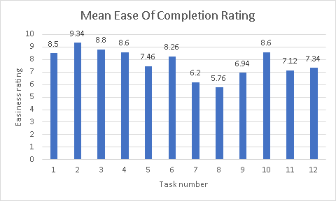
Figure RE.1: Mean task ease of completion rating
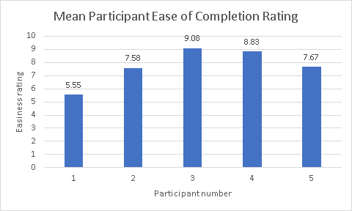
Figure RE.2: Mean ease of completion rating per participant for all tasks
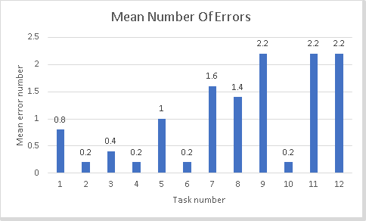
Figure RE.3: Mean number of errors per task
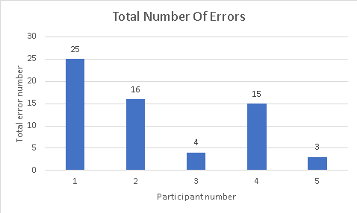
Figure RE.4: Total number of errors per participant
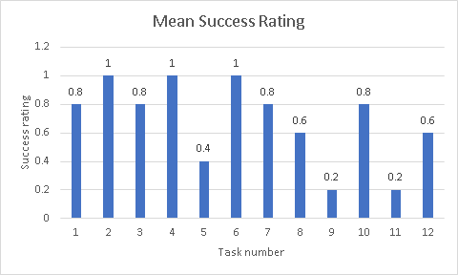
Figure RE.5: Mean task success rating
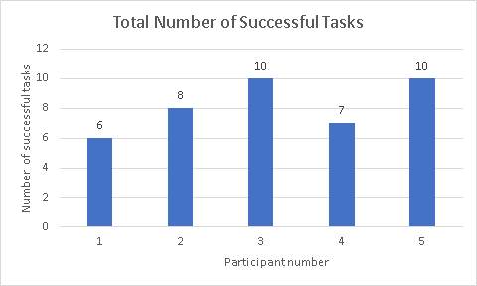
Figure RE.6: Total number of tasks successfully completed.
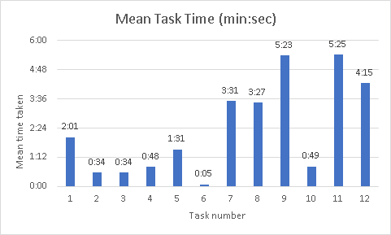
Figure RE.7: Mean time taken per task (excluding participant 1)
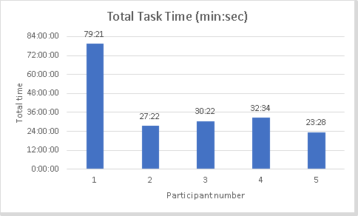
Figure RE.8: Total time taken per participant
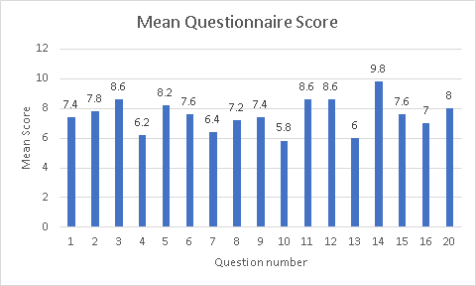
Figure RE.9: Mean questionnaire scores

Appendix: Code

Main Menu:
function varargout = mainMenu(varargin)

gui_Singleton = 1;
gui_State = struct('gui_Name', mfilename, ...
'gui_Singleton', gui_Singleton, ...
'gui_OpeningFcn', @mainMenu_OpeningFcn, ...
'gui_OutputFcn', @mainMenu_OutputFcn, ...
'gui_LayoutFcn', [] , ...
'gui_Callback', []);
if nargin && ischar(varargin{1})
gui_State.gui_Callback = str2func(varargin{1});
end

if nargout
[varargout{1:nargout}] = gui_mainfcn(gui_State, varargin{:});
else
gui_mainfcn(gui_State, varargin{:});
end

function mainMenu_OpeningFcn(hObject, eventdata, handles, varargin)

handles.output = hObject;

guidata(hObject, handles);

function varargout = mainMenu_OutputFcn(hObject, eventdata, handles)

varargout{1} = handles.output;

function perceptronPageButton_Callback(hObject, eventdata, handles)
close(mainMenu)
perceptronPage

function PerceptronLearningPageButton_Callback(hObject, eventdata, handles)
close(mainMenu)
perceptronLearningPage

function exitButton_Callback(hObject, eventdata, handles)
close(mainMenu)

The Perceptron:
function varargout = perceptronPage(varargin)
% PERCEPTRONPAGE MATLAB code for perceptronPage.fig
% PERCEPTRONPAGE, by itself, creates a new PERCEPTRONPAGE or raises the existing
% singleton*.
%
% H = PERCEPTRONPAGE returns the handle to a new PERCEPTRONPAGE or the handle to
% the existing singleton*.
%
% PERCEPTRONPAGE('CALLBACK',hObject,eventData,handles,...) calls the local
% function named CALLBACK in PERCEPTRONPAGE.M with the given input arguments.
%
% PERCEPTRONPAGE('Property','Value',...) creates a new PERCEPTRONPAGE or raises the
% existing singleton*. Starting from the left, property value pairs are
% applied to the GUI before perceptronPage_OpeningFcn gets called. An
% unrecognized property name or invalid value makes property application
% stop. All inputs are passed to perceptronPage_OpeningFcn via varargin.
%
% *See GUI Options on GUIDE's Tools menu. Choose "GUI allows only one
% instance to run (singleton)".
%
% See also: GUIDE, GUIDATA, GUIHANDLES

% Edit the above text to modify the response to help perceptronPage

% Last Modified by GUIDE v2.5 01-Apr-2017 21:57:14

% Begin initialization code - DO NOT EDIT
gui_Singleton = 1;
gui_State = struct('gui_Name', mfilename, ...
'gui_Singleton', gui_Singleton, ...
'gui_OpeningFcn', @perceptronPage_OpeningFcn, ...
'gui_OutputFcn', @perceptronPage_OutputFcn, ...
'gui_LayoutFcn', [] , ...
'gui_Callback', []);
if nargin && ischar(varargin{1})
gui_State.gui_Callback = str2func(varargin{1});
end

if nargout
[varargout{1:nargout}] = gui_mainfcn(gui_State, varargin{:});
else
gui_mainfcn(gui_State, varargin{:});
end
% End initialization code - DO NOT EDIT

% --- Executes just before perceptronPage is made visible.
function perceptronPage_OpeningFcn(hObject, eventdata, handles, varargin)
% This function has no output args, see OutputFcn.
% hObject handle to figure
% eventdata reserved - to be defined in a future version of MATLAB
% handles structure with handles and user data (see GUIDATA)
% varargin command line arguments to perceptronPage (see VARARGIN)

% Choose default command line output for perceptronPage
handles.output = hObject;

% Update handles structure
guidata(hObject, handles);

%initialise handle variables and colours
handles.inputData = [];
handles.weights = [];
handles.weightedSum = 0;

set (handles.weightedSumLabel,'String','');
set (handles.actualOutputLabel,'String','');
set (handles.errorLabel,'String','');

%set the stepSigmoigGraph labels
xlabel(handles.stepSigmoidGraph,'Weighted Sum');
ylabel(handles.stepSigmoidGraph,'Actual Output');

setDefaultColours(hObject,handles);
handles = guidata(hObject);

%randomise the initial inputs and weights
randInputButton_Callback(hObject, eventdata, handles);
randWeightsButton_Callback(hObject, eventdata, handles);

%randomly set the desired output to 1 or -1
set (handles.desiredOutputEdit,'String',2*(rand > 0.5) - 1);

guidata(hObject,handles);

function setDefaultColours(hObject,handles)

% create and initialise colour variables
handles.notRunningColour = [.8 .8 .8];
handles.processingColour = [1 1 0];
handles.completedColour = [0 1 0];

set (handles.weightedSumLabel,'BackgroundColor',handles.notRunningColour);
set (handles.notRunningPanel,'BackgroundColor',handles.notRunningColour);
set (handles.processingPanel,'BackgroundColor',handles.processingColour);
set (handles.completedPanel,'BackgroundColor',handles.completedColour);

set (handles.desiredOutputPanel,'BackgroundColor','w');

guidata(hObject,handles);

% --- Outputs from this function are returned to the command line.
function varargout = perceptronPage_OutputFcn(hObject, eventdata, handles)
% varargout cell array for returning output args (see VARARGOUT);
% hObject handle to figure
% eventdata reserved - to be defined in a future version of MATLAB
% handles structure with handles and user data (see GUIDATA)

% Get default command line output from handles structure
varargout{1} = handles.output;

function backToMainMenu_Callback(hObject, eventdata, handles)
close(perceptronPage)
mainMenu

function playButton_Callback(hObject, eventdata, handles)

%get the weights from the textboxes
handles.weights = [str2double(get(handles.w0Edit,'String'));...
str2double(get(handles.w1Edit,'String'));...
str2double(get(handles.w2Edit,'String'))];

%get the inputs from the textboxes
handles.inputData = [1; str2double(get(handles.x1Edit,'String'));...
str2double(get(handles.x2Edit,'String'));...
str2double(get(handles.desiredOutputEdit,'String'))];

%change the status colours and pause to show the Perceptron is processing
set (handles.desiredOutputPanel,'BackgroundColor','w');
set (handles.weightedSumLabel,'BackgroundColor',handles.processingColour);
pause(0.5);

handles.weightedSum = handles.weights' * handles.inputData(1:3,1);

%clear the stepSigmoidGraph
cla(handles.stepSigmoidGraph);
reset(handles.stepSigmoidGraph);

%if the user selects the step function
if (get(handles.stepToggle,'Value')== 1)

%threshold the weighted sum to get the actual output
handles.actualOutput(handles.weightedSum <= 0) = -1;
handles.actualOutput(handles.weightedSum > 0) = 1;

handles.error = handles.inputData(4) - handles.actualOutput;

%plot the stepSigmoidGraph using three different plots
hold on;
minX = -abs(handles.weightedSum)-1;
maxX = abs(handles.weightedSum)+1;
plot(handles.stepSigmoidGraph, [minX 0], [-1 -1], 'k-');
plot(handles.stepSigmoidGraph, [0 0], [-1 1], 'k-');
plot(handles.stepSigmoidGraph, [0 maxX], [1 1], 'k-');

%plot the desired output vs. the actual output
plot(handles.stepSigmoidGraph, handles.weightedSum, handles.actualOutput, 'x','Markersize',10);
plot(handles.stepSigmoidGraph, handles.weightedSum, handles.inputData(4), 'o','Markersize',10);

%size the graph appropriately
set (handles.stepSigmoidGraph, 'YLim',[-1.1 1.1]);
set (handles.stepSigmoidGraph, 'XLim',[minX maxX]);

elseif (get(handles.sigmoidToggle,'Value')==1)

%calculate the raw sigmoid output
handles.actualOutput = 1 ./ (1 + exp(-handles.weightedSum));
handles.error = handles.inputData(4) - handles.actualOutput;

%plot the sigmoid with the actual and desired output overlaid
range = [-abs(handles.weightedSum)-10 abs(handles.weightedSum)+10];
hold on;
fplot(handles.stepSigmoidGraph, @(x) 2 ./ (1 + exp(-x))-1, 'k-');
plot(handles.stepSigmoidGraph, handles.weightedSum, 2*handles.actualOutput-1, 'x','Markersize',10);
plot(handles.stepSigmoidGraph, handles.weightedSum, handles.inputData(4), 'o','Markersize',10);

%size the graph appropriately
set (handles.stepSigmoidGraph, 'YLim',[-1 1]);
set (handles.stepSigmoidGraph, 'XLim', range);

%sigmoid squashes to [0,1] range. Need classes [-1,+1] so
%if x < 0.5 then -1 else +1
handles.actualOutput(handles.actualOutput < 0.5) = -1;
handles.actualOutput(handles.actualOutput >= 0.5) = 1;

else
%Should not reach this stage. elseif's used to be specific with
%options available
end

xlabel(handles.stepSigmoidGraph,'Weighted Sum');
ylabel(handles.stepSigmoidGraph,'Actual Output');

set (handles.weightedSumLabel,'String',handles.weightedSum);
set (handles.actualOutputLabel,'String',handles.actualOutput);

set (handles.errorLabel,'String',handles.error);

set (handles.desiredOutputPanel,'BackgroundColor',handles.completedColour);
set (handles.weightedSumLabel,'BackgroundColor',handles.notRunningColour);

function desiredOutputEdit_Callback(hObject, eventdata, handles)

desiredOutput = str2double(get(handles.desiredOutputEdit,'String'));

if ~ismember(desiredOutput,[1,-1])
msgbox('Desired Output must be either 1 or -1', 'Error', 'error');
set (handles.desiredOutputEdit, 'String', -1);
end
function desiredOutputEdit_CreateFcn(hObject, eventdata, handles)
if ispc && isequal(get(hObject,'BackgroundColor'), get(0,'defaultUicontrolBackgroundColor'))
set(hObject,'BackgroundColor','white');
end
function x1Edit_Callback(hObject, eventdata, handles)
x1Edit = str2double(get(handles.x1Edit,'String'));

if ~(isnumeric(x1Edit) && ~isnan(x1Edit)&& isreal(x1Edit))
msgbox('x1 input must be a number (not NaN or imaginary)', 'Error', 'error');
set (handles.x1Edit, 'String', randn);
end
function x1Edit_CreateFcn(hObject, eventdata, handles)

if ispc && isequal(get(hObject,'BackgroundColor'), get(0,'defaultUicontrolBackgroundColor'))
set(hObject,'BackgroundColor','white');
end
function x2Edit_Callback(hObject, eventdata, handles)
x2Edit = str2double(get(handles.x2Edit,'String'));

if ~(isnumeric(x2Edit) && ~isnan(x2Edit) && isreal(x2Edit))
msgbox('x2 input must be a number (not NaN or imaginary)', 'Error', 'error');
set (handles.x2Edit, 'String', randn);
end
function x2Edit_CreateFcn(hObject, eventdata, handles)

if ispc && isequal(get(hObject,'BackgroundColor'), get(0,'defaultUicontrolBackgroundColor'))
set(hObject,'BackgroundColor','white');
end
function w0Edit_Callback(hObject, eventdata, handles)
w0Edit = str2double(get(handles.w0Edit,'String'));

if ~(isnumeric(w0Edit) && ~isnan(w0Edit) && isreal(w0Edit))
msgbox('w0 input must be a number (not NaN or imaginary)', 'Error', 'error');
set (handles.w0Edit, 'String', randn);
end
function w0Edit_CreateFcn(hObject, eventdata, handles)

if ispc && isequal(get(hObject,'BackgroundColor'), get(0,'defaultUicontrolBackgroundColor'))
set(hObject,'BackgroundColor','white');
end
function w1Edit_Callback(hObject, eventdata, handles)
w1Edit = str2double(get(handles.w1Edit,'String'));

if ~(isnumeric(w1Edit) && ~isnan(w1Edit) && isreal(w1Edit))
msgbox('w1 input must be a number (not NaN or imaginary)', 'Error', 'error');
set (handles.w1Edit, 'String', randn);
end
function w1Edit_CreateFcn(hObject, eventdata, handles)
if ispc && isequal(get(hObject,'BackgroundColor'), get(0,'defaultUicontrolBackgroundColor'))
set(hObject,'BackgroundColor','white');
end
function w2Edit_Callback(hObject, eventdata, handles)

w2Edit = str2double(get(handles.w2Edit,'String'));

if ~(isnumeric(w2Edit) && ~isnan(w2Edit) && isreal(w2Edit))
msgbox('w2 input must be a number (not NaN or imaginary)', 'Error', 'error');
set (handles.w2Edit, 'String', randn);
end
function w2Edit_CreateFcn(hObject, eventdata, handles)
if ispc && isequal(get(hObject,'BackgroundColor'), get(0,'defaultUicontrolBackgroundColor'))
set(hObject,'BackgroundColor','white');
end

function notRunningColourChoice_Callback(hObject, eventdata, handles)
handles.notRunningColour=uisetcolor;

if handles.notRunningColour == 0
return;
end

set (handles.notRunningPanel,'BackgroundColor',handles.notRunningColour);
guidata(hObject,handles);
function processingColourChoice_Callback(hObject, eventdata, handles)
handles.processingColour=uisetcolor;

if handles.processingColour == 0
return;
end

set (handles.processingPanel,'BackgroundColor',handles.processingColour);
guidata(hObject,handles);
function completedColourChoice_Callback(hObject, eventdata, handles)
handles.completedColour=uisetcolor;

if handles.completedColour == 0
return;
end

set (handles.completedPanel,'BackgroundColor',handles.completedColour);
guidata(hObject,handles);
function defaultColoursButton_Callback(hObject, eventdata, handles)
setDefaultColours(hObject,handles);
%======================
function randInputButton_Callback(hObject, eventdata, handles)
set (handles.x1Edit,'String',randn);
set (handles.x2Edit,'String',randn);
function randWeightsButton_Callback(hObject, eventdata, handles)
set (handles.w0Edit,'String',randn);
set (handles.w1Edit,'String',randn);
set (handles.w2Edit,'String',randn);

The Perceptron Learning Process:

