**BE/BAT 485/585**

**First Midterm – March. 4th, 2022**

**Due Monday, March 7th, 2022 @ 12 AM**

* Make sure you write your name and identify yourself on your work
* Your answers need to be in a single **JupyterLab** or **Jupyter Notebook** file/project
  + Turn 2 copies: the executed code/notebook (**\*. ipynb**) and an <**html or PDF**> exported copy (that has the answers + code).
* Show and annotate all necessary steps
* No group work please, just do your best
* You should have no issues turning in a perfect exam

**Tips**: For some questions, you will copy/paste the question text from the exam, paste it in the Notebook using Markdown and provide the answers right below using markdown/html style text (see example).

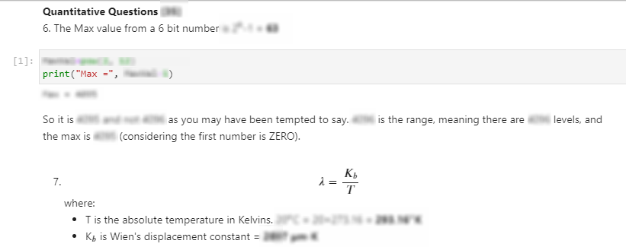

**Multiple Choice Questions [15]**

1. [3] Scattering causes the atmosphere to have its own brightness which helps illuminate objects in the shadow
   1. True
   2. False
2. [3] If the speed of light (**c)** is **3 x 108 m/s** what is the wavelength (**λ**) of radiation for a frequency (**ν**)= **500,000 x 109 Hz** (cycles per seconds):
3. 16 x 10-5 m
4. 6 x 10-7 m
5. 1.6 x 10-5 m
6. 0.6 x 10-7 m
7. [3] What is the approximate color of this wavelength?
8. [3] Read the question carefully  
   Which of the following statement(s) is/are an **INCORRECT** explanation of why most remote sensing systems avoid detecting and recording wavelengths in the ultraviolet and blue portions of the spectrum.
9. detecting and recording the ultraviolet and blue wavelengths of radiation is difficult because of scattering and absorption in the atmosphere.
10. ozone gas in the upper atmosphere absorbs most of the ultraviolet radiation of wavelengths shorter than about 0.25 mm.
11. after scattering the greater portion of the ultraviolet and blue wavelengths energy reaches and interacts with the Earth's surface
12. Rayleigh scattering affects the shorter wavelengths more severely than longer wavelengths causing the remaining UV radiation and the shorter visible wavelengths to be scattered much more than longer wavelengths
13. [3] Pick all correct answers:

The ideal atmospheric conditions for remote sensing in the visible portion of the spectrum are at Noon on a Sunny, Dry day with no Clouds and no Pollution?

1. Dry, pollutant-free conditions would maximize the scattering and absorption that would take place due to water droplets and other particles in the atmosphere.
2. Cloud-free conditions guarantee that there will be uniform illumination
3. Cloud-free conditions ensure there will be no shadows from clouds.
4. At noon the sun would be at its most directly overhead point thus reducing the distance radiation has to travel and therefore the effects of scattering to a minimum.

**Quantitative Questions [35]**

1. [3] What is the **Maximum value** of the digital number (DN) when the radiometric resolution is **12 bits**?
2. [3] What is the wavelength of maximum emission of a blackbody with temperature = **20oC**?
3. [3] If a distant star emission peaks at a wavelength **= 0.25 μm**, compute its surface temperature?
4. [3] What is the difference between Irradiance and Radiance?
5. ***Eta Carinae*** is a blue hypergiant star, located about 7,500 light-years from the Sun. Its temperature is 66,500oF, and it is probably one of the hottest stars in the Universe.

Assume:

* σ (the Stefan-Boltzmann constant) = 5.7×10-8 W/m2K4 and
* Wien’s displacement constant, k = 2897 µm. K
  1. [5] Compute its emissive power (M) and peak emission wavelength (**λ**)
  2. [5] Can you compute how much ‘***insolation’*** hits the Earth at the Equator (at the spring equinox) at local noon if this was our sun (same size and distance of our actual sun)?

1. [3] Derive the **COSINE** law and explain its value to EMR energy interaction?

1. The figure below shows how Landsat maps the Earth and collects data. Scan width, swath width, spatial resolution, and satellite altitude are all shown in the figure. Answer the following questions:
2. [2] What is the **scanning configuration** of the system?
3. [2] What is the **type of orbit** of the satellite?
4. [3] How many pixels each **scan line** has?
5. [3] If the satellite moves at a speed of about 7 km/s, how many scans will be in each second?

**Answer with annotated, clean, and nicely designed Python book [50]**

**Note:** Do not forget to import the proper and necessary packages/libraries/modules

1. Load the BSQ NEON image from D2L<**NEON_ExamData.bsq**> (all 426 bands). Additional ancillary and supporting files are in the same Exam directory in particular the wavelength metadata file <**NEON_wavelength_values.txt**>.

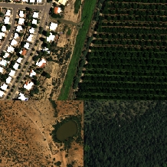

**NOTE**: This is a composite image made up of three separate segments.

**BONUS:** [5] Pick and work with one of the HDF5 (h5) files below instead of the above BSQ file we have been using in the lab so far. Just pay attention to the objects you are asked to study in the image, they will depend on the image selected.

Files are stored in this link <https://vip.arizona.edu/classes/BE485/NEON_1KM/>

|  |  |  |  |  |  |
| --- | --- | --- | --- | --- | --- |
| NEON_D01_HARV_DP3_725000_4712000_reflectance.h5 | NEON_D09_WOOD_DP3_476000_5221000_reflectance.h5 | NEON_D16_ABBY_DP3_551000_5070000_reflectance.h5 | NEON_D14_JORN_DP3_31600_361300_reflectance.h5 | NEON_D14_SRER_DP3_502000_3523000_reflectance.h5 | NEON_D14_SRER_DP3_502000_3524000_reflectance.h5 |
|  |  |  |  |  |  |

* 1. [5] Create and label (at least title identifying the location, but more is better) Grayscale images from the Blue, Green, Red, NIR, SWIR-1*, SWIR-2* (see example below).   
     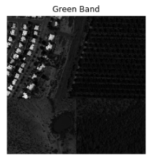
  2. [5] Now, apply a reasonable colorbar/scale to each of these grayscale images (see example below).  
     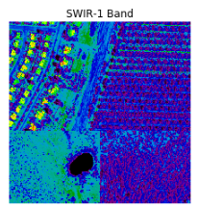
  3. [5] Create a true color RGB (you will need to pick which bands to assign to the RGB planes), Create a [SWIR-NIR-Red] and [NIR-Red-Green] False Color Composite images.
  4. [5] Compare the Natural true-color image with the false-color composite images? Which one conveys more information in your opinion? Why?
  5. [5] Which band combination would you use to study vegetation? Why?

1. [10] Extract, plot, and label the spectral signatures for a Pine Tree, Pecan Tree, Patch of Green Grass, Bare Soil, Dry Grass, Road, Water tank, Roof/House (see example below). If you picked an HDF5 file with different land covers, then select a few of those objects to study.

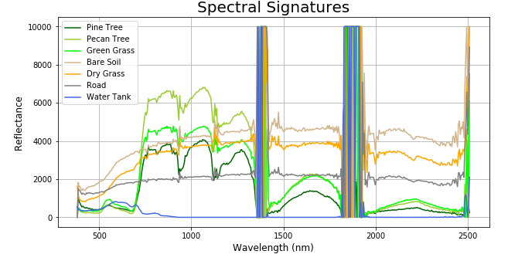

1. [10] Add labels (circle or other shapes and annotate the image properly) to indicate the locations of you extracted the spectral signatures and what is there.

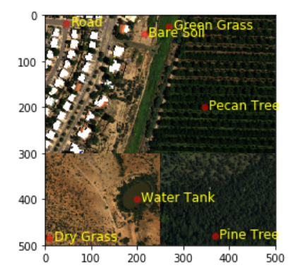

1. [5] Where do these objects separate the most (in what region of the spectrum)? Do you notice any patterns?

**Bonus questions, and please try them all**

1. [5] Create a new image [2-D NumPy Array] and fill it with data following this NDVI equation:

You will need to decide which of the bands to use for NIR and Red

* + Make sure you do not divide by ZERO, so you will need an exception handler (logic in your code to skip division by ZERO). It would be great if you could design a separate ***user defined function*** that you would call.
  1. Plot this image and use the ‘**YlGn’** or ‘**Greens’** cmap colorbar/scale and add the color legend, labels, etc. to the image.
  2. Scatterplot NDVI values for the objects from above (Q.13), Y = NDVI and X = Index or a Label of the point

**Super Bonus Question**

1. [5] Can you now re-extract, plot, and label the spectral signatures for the objects in Q13 but this time using a 3x3 window average around each location and not through a single pixel.

**Hint**: Each Y value is the average of the 3x3 pixels around the location.

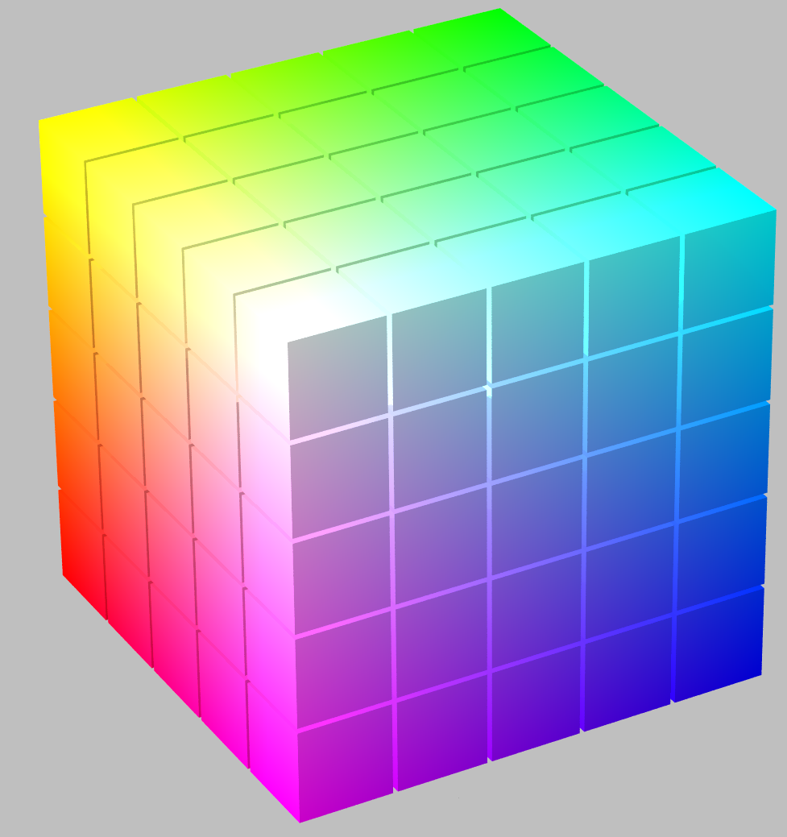

**NOTE**

1. SWIR-1 and SWIR-2 are as defined for Landsat OLI (consult Lab-4).
2. Here are some color bar names

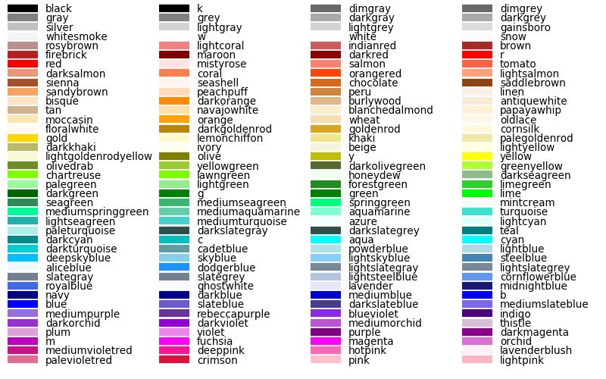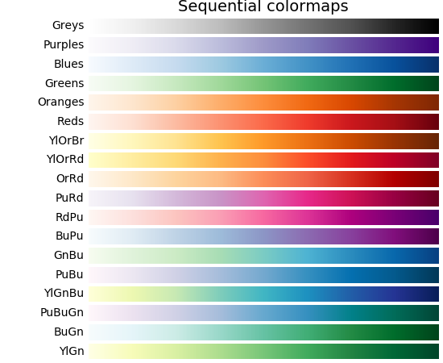

1. Example of how your images should look like

