# Skills assessment

# Teacher & Assessor marking guide

## Criteria

### Unit code and name

ICTCLD401 | Configure cloud services

ICTICT428 | Select cloud storge solutions

### Qualification/Course code and name

ICT40120 - Certificate IV in Information Technology

## Student details

### Student number

### Student name

## Assessment declaration

* *Note: If you are an online student, you will be required to complete this declaration on the TAFE NSW online learning platform when you upload your assessment.*

This assessment is my original work and has not been:

* plagiarised or copied from any source without providing due acknowledgement.
* written for me by any other person except where such collaboration has been authorised by the Teacher/Assessor concerned.

### Student signature and date

Version: *20220407*

Date created: *19 July 2018*

For queries, please contact:

Technology and Business Services SkillsPoint

Building B, Level G, Corner Harris Street and Mary Ann Street, Ultimo NSW 2007

© 2022 TAFE NSW  
RTO Provider Number 90003 | CRICOS Provider Code: 00591E

This assessment can be found in the: [Learning Bank](https://share.tafensw.edu.au/share/access/searching.do?doc=%3Cxml%2F%3E&in=P7ac4831b-430a-4b8d-8b56-f7b32ed5b9cf&q=&type=standard&sort=rank&dr=AFTER)

The contents in this document is copyright © TAFE NSW 2022 and should not be reproduced without the permission of TAFE NSW. Information contained in this document is correct at the time of printing: 4 July 2022. For current information please refer to our website or your Teacher/Assessor as appropriate.

## Assessment instructions

Table 1 Assessment instructions

| Assessment details | Instructions |
| --- | --- |
| **Instructions for the Teacher/Assessor** | This is a skills-based assessment that assesses the student on their ability to demonstrate skills required in the unit.  This assessment has one part:   1. Practical assessment with six tasks   And is supported by:   * Observation Checklist/s * Assessment feedback (not included here)   This is an open book, 3 hour, in-class assessment.  This Assessment is based on practical labs from the AWS Academy, AWS Cloud Foundations (ACF) course, Version 2, which consists of 10 Modules, with 6 Lab activities.  The rational for basing this assessment on the AWS is because ICTCLD401 was written around the knowledge and skills in the AWS ACF course.  Teachers need to be an AWS Cloud Foundations Instructor, with access to create ACF classes in the AWS LMS and enrol students. <https://awsacademy.instructure.com/>  All assessment tasks are performed in the AWS Cloud via the AWS LMS, which provides single sign on access to the Vocareum Lab Platform.  Students will need to be enrolled in the ACF course to gain access to the AWS cloud and preconfigured labs in Vocareum in order to complete this assessment.  This assessment may be completed after the delivery of all 10 ACF modules,  or in stages as per suggested below.  Model answers, sample responses or criteria for each task or activity is provided below.   |  |  |  |  |  |  |  | | --- | --- | --- | --- | --- | --- | --- | | Deliver ACF Module --> | 1 -4  Lab 1 | 5  Lab2 | 6  Lab 3 | 7  Lab 4 | 8  Lab 5 | 9, 10  Lab 6 | | **Complete Assessment Task -->** | **Task 1** | **Task 2** | **Task 3** | **Task 4** | **Task 5** | **Task 6** |   Sample screenshots for each task and subtasks are provided below.  Complete the Observation Checklist for each task and subtask and provide Assessment Feedback to the student. Ensure you have taken a copy of the assessment, if the student has not submitted online.  See specific instructions below on gathering evidence of student completion of assessment tasks  The assessment feedback page must be signed by both the student and the Teacher/Assessor so the student displays that they have received, understood and accepted the feedback.  For guidance on applying reasonable adjustment refer [Assessment Guidelines for TAFE NSW (WDETG18411)](https://staff.tafensw.edu.au/documents/2018/10/wdetg18411-guidelines-assessment-guidelines.pdf/) |
| **About this marking guide** | The student’s response to each task or activity must contain the criteria indicated in this marking guide in order for their response to be correct.  All tasks and activities must be completed correctly in order to satisfactorily complete this assessment event.  Assessors will need to make a judgement call as to whether each response meets the criteria based upon the rules of evidence and principles of assessment. |
| **Student must provide** | TAFE NSW student account username and password.  You will be using the pre-configured Vocareum lab environment in the AWS Academy website to complete this assessment.  <https://awsacademy.instructure.com>  Your teacher will enrol you the AWS Cloud Foundations course on the AWS Academy website using your TAFE email.  You will receive an email from the AWS Academy with a registration link.  Click on the link, register and login to the AWS Academy website to complete the assessment tasks. |
| **Assessor must provide** | Access to ICT workplace or simulated environment  Equipment/resources, including:   * PC with internet access   Enrol students in the AWS Academy ACF course and provide access to resources and AWS Cloud. |
| **Due date**  **Time allowed**  **Venue** | 3 hours (indicative only)  TAFE NSW campus/ TAFE Digital Campus/ TAFE NSW Moodle/ a location determined by your Teacher/Assessor |

## Specific task instructions

The instructions and the criteria in the tasks and activities below will be used by the Teacher/Assessor to determine whether the tasks and activities have been satisfactorily completed. Use these instructions and criteria to ensure you demonstrate the required skills and knowledge.

If this assessment requires you to record information, your Teacher/Assessor will provide you with an appropriate document/template.

The tasks in this assessment are based on the AWS Academy Cloud Foundations (ACF) course.

The instructions for performing the demonstration tasks in this assessment can be found in the detailed AWS lab instructions within each Module.

The task numbers in this assessment correspond to the respective AWS ACF Labs (1 to 6), The assessment sub-tasks correspond to the tasks each ACF Lab.

Once students complete the ACF labs and familiarise themselves with tasks, they can perform the assessment tasks in the same Lab environment within ACF course.

The assessment tasks may be observed in class, and students can post screenshot of the completed state of the task as additional evidence.

The Assessment tasks, assessment screenshot evidence and the observation checklist are all combined into one table below.

Assessment evidence may be gathered by the following methods:

1. Teachers/Assessors can observe the students as they complete the labs in class.
2. In addition, students can past the final screenshot of the completed task in the table below. (Sample screenshots provided)
3. Individual feedback on each task may be provided in the table under the students’ screenshots if required.
4. Teachers may also use the analytics section on AWS Academy LMS to verify the student engagement and lab completion. (Go to – Module -> Lab no -> Dashboard->Select student ->lab sessions) – Screenshot below.

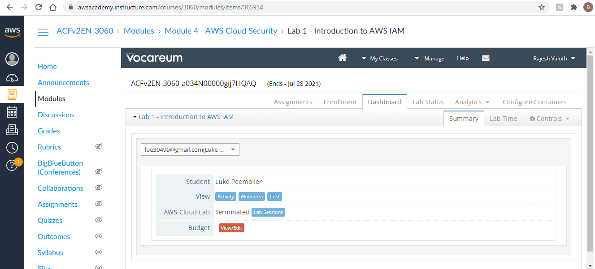

## Part 1: Practical

For the successful completion of this assessment, you will need to perform a series of practical activities that demonstrate your ability to perform skills-based tasks to industry standards in a cloud platform.

This assessment is based on the AWS Cloud Platform, accessed via the Amazon Web Services (AWS) Academy Cloud Foundations (ACF) Course website.

Your practical tasks will be observed by your Teacher/Assessor. You will also need to provide screens shots showing the completion of the tasks in the table below.

Your responses will be used as part of the overall evidence requirements of the unit.

On completion, submit this assessment to your Teacher/Assessor for marking.

### Scenario and overview of tasks to be performed

Gelos Enterprises has an internal department that is scaling up their section and has moved their in-house managed web purchasing hub to the AWS cloud hosted service.

Gelos is also in the process of increasing its use of AWS web services and has hired a number of new employees and temporary contractors who need to be given access to cloud services.

As the Assistant Cloud Technician, you will be required to access accounts and complete a number of tasks to deploy and configure cloud services as required by the Cloud Engineer according to business requirements and needs.

These tasks are based around the requirements of the Gelos Enterprises.

Completion of the following 6 tasks and sub tasks will demonstrate your competence in configuring cloud services using the AWS Cloud Platform.

| Task  Task numbers correspond to the respective ACF Labs 1 to 6  Subtasks correspond to tasks within the ACF labs. | Approx. Time |
| --- | --- |
| 1. Create users and groups to create and manage infrastructure    1. Login, view and Identify the permissions, security credentials and policies    2. Add Users to Groups as per Gelos requirements and policies    3. Sign-In and Test Users permissions | 40 mins |
| 1. Create virtual multi-tier network, core services and autoscaling    1. Create a VPC    2. Create subnets for Gelos VPC    3. Create a VPC security group for Gelos.    4. Launch an Amazon EC2 instance into the VPC & configure the instance as a web server.    5. Test and fix errors on the Gelos Webserver Instance | 30 mins |
| 1. Create and configure EC2 virtual machine    1. Create and Launch Virtual Machine (Instance)    2. Monitor Virtual Machine for performance and errors    3. Update your security Group and access the web server.    4. Resize Your Instance Type and EBS Volume    5. Configure and fix Termination Protection error | 35 mins |
| 1. Configure Cloud Storage    1. Create a New Storage Volume (EBS)    2. Attach the EBS Storage Volume to a Virtual Machine    3. Connect to Your Amazon EC2 Instance    4. Create and Configure Your File System    5. Create a snapshot of your EBS volume    6. Restore a snapshot to new EBS Volume | 30 mins |
| 1. Deploy a managed database in a cloud platform    1. Create a Security Group for a Relational Database Service DB Instance    2. Create a DB Subnet Group    3. Create an Amazon RDS DB Instance    4. Interact with Your Database | 30 mins |
| 1. Setup Auto Scaling    1. Create an AMI for Auto Scaling    2. Create an Application Load Balancer Load Balancer for the Gelos Cloud    3. Create a Launch Configuration and an Auto Scaling Group    4. Test and verify that Load Balancing is working on the Gelos Cloud    5. Test and fix error in load estimate of 2 instances scales to 4 instances by Auto Scaling | 30 mins |
| Total time : | 2 hrs : 45 mins |

### Demonstration 1:

#### Create users and groups, secure and manage cloud infrastructure -40mins

This task is aligned to the AWS Academy ACF course Lab 1 and should be performed using the preconfigured environment in this lab.

For this demonstration you will show the use of a cloud Identity and Access management system to manage users, user permissions and other security credentials.

##### Scenario

The Gelos Cloud Engineer has asked you to perform the following tasks in the Gelos cloud platform in order to explore the properties of three Gelos contractor accounts and allocate them to groups and apply permissions:

* Explore pre-created **IAM Users and Groups in the Gelos cloud**
* Inspect **IAM policies** as applied to the pre-created groups
* Add users to groups with specific capabilities enabled
* Locate and use the **IAM sign-in URL**
* **Test and verify** with the effects of policies on service access

Ensure you post screenshots in the Observation and Evidence checklist below.

These tasks are contained in the corresponding AWS ACF lab.

* For **classroom-based** students, tasks may be observed in class by your assessor and/or through screenshots requested by your assessor.
* For **TAFE digital** students, you should post a screenshot(s) of the completed state(s) of each of the tasks as part of your evidence.  
  Table 2 Observation Checklist

| Task | Task/Activity performed | S | U/S | | Student screenshots and assessor comments |
| --- | --- | --- | --- | --- | --- |
| 1.1 | Login, view and Identify the permissions, security credentials and policies Login to the Gelos cloud using the credentials provided by the Cloud Engineer.  View and Identify the permissions (access protocols), security credentials and policies of the following user |  |  | |  |
|  | accounts for contractors and user groups that have been created on the Gelos cloud as per below  **Gelos User accounts for contractors**   * user 1 * user 2 * user 3   **Groups**   * EC2-Admin * EC2-Support * S3-Support |  |  | |  |
| 1.2 | Add Users to Groups as per Gelos requirements and policies Gelos is increasing its use of AWS web services, including Virtual Machines and Storage. A number of new employees have been hired and need to be given access to web services.  Perform the following access configuration changes to assign security responsibilities for the following users/groups. Ensure that the permissions align with the security policies, business protocols and work  functions of the users as outlined in the table below provided by the cloud engineer: 2.1 Add user-1 to the S3-Support Group2.2 Add user-2 to the EC2-Support Group2.3 Add user-3 to the EC2-Admin Group |  |  | |  |
|  | **User 1**  **username**: user 1  **Password**: Lab-Password1  **In Group** S3-Support  **Permissions**  Read-Only access to Amazon S3  **User 2**  **username**: user 2  **Password:** Lab-Password3  **In Group** EC2-Support  **Permissions**  Read-Only access to Amazon EC2  **User 3**  **username:**user3  **Password**: Lab-Password3  **In Group** EC2-Admin  **Permissions**  View, Start and Stop Amazon EC2 instances |  | |  |  |
| 1.3 | **Sign-In and Test Users permissions**  Sign-In and test User/Group permissions as per business requirements outlined in the table below:  Note: Use private browser windows to ensure credentials are not saved locally  **User 1**  **username**: user 1  **Password**: Lab-Password1  **Verify the following Permissions**  Read-Only access to Amazon S3  Since your user is part of the **S3-Support** Group in IAM, they have permission to view a list of Amazon S3 buckets and their contents.  They should not have access to Amazon EC2 instances  **User 2**  **username**: user 2  **Password**: Lab-Password3  **Verify the following Permissions**  Read-Only access to Amazon EC2  This user should be able to see an Amazon EC2 instance but will not be able to make any changes to Amazon EC2 resources. Test this by stopping the instance.  **User 3**  **username**: user 3  **Password**: Lab-Password3  **Verify the following Permissions**  View, Start and Stop Amazon EC2 instances  User should have permissions to start and stop the instances. |  | |  |  |

### Demonstration 2:

#### Create virtual multi-tier network, core services and autoscaling -30mins

This task is aligned to the AWS Academy ACF course Lab 2 and should be performed using the preconfigured environment in this lab.

For this demonstration you will deploy a virtual multi-tier network to support core cloud services and enable autoscaling.

##### Scenario

The Gelos Cloud Engineer has asked you to create a separate Virtual Private Cloud (VPC) with additional components to produce a customized network.

He requires Security Groups created for and EC2 instance which needs to be customised to run a Web Server in this VPC.

He has asked you to perform the following tasks.

* Create a VPC.
* Create subnets.
* Configure a security group.
* Launch an EC2 instance into the VPC.

Ensure you post screenshots in the Observation checklist to show each of the following:

These tasks are contained in the corresponding AWS ACF lab.

* For **classroom-based** students, tasks may be observed in class by your assessor and/or through screenshots requested by your assessor.

For **TAFE digital** students, you should post a screenshot(s) of the completed state(s) of each of the tasks as part of your evidence.

| Task | Task/Activity performed | S | U/S | Student screenshots and assessor comments |
| --- | --- | --- | --- | --- |
| 2.1 | **Create a VPC**  Use the VPC Wizard to create a VPC an Internet Gateway and two subnets in a single Availability Zone as per the following configuration details:   * + **VPC name:** Lab VPC   + **Availability Zone:** Select the first Availability Zone   + **Public subnet name:** Public Subnet 1   + **Availability Zone:** Select the first Availability Zone (the same as used above)   + **Private subnet name:** Private Subnet 1   + **Elastic IP Allocation ID:** Click in the box and select the displayed IP address   The Public Subnet has a CIDR |  |  |  |
|  | of **10.0.0.0/24**  The Private Subnet has a CIDR of **10.0.1.0/24** |  |  |  |
| 2.2 | **Create subnets for Gelos VPC**  Create additional Subnets for your Gelos VPC, to ensure High Availability, enabling the creation of resources in multiple Availability Zones.  The resources in the Private Subnet should be able to connect to the Internet while keeping the resources private.  Create two additional subnets and NAT Gateway in a second Availability Zone as per the following configuration details:  1.Public Subnet  **VPC ID:** Lab VPC   * + **Subnet name:** Public Subnet 2   + **Availability Zone:** Select the second Availability Zone   + **IPv4 CIDR block:** 10.0.2.0/24   Route Table details:  **Main = NO** and **VPC = Lab VPC**  **Destination 0.0.0.0/0**  **Route Table Name**: Public Route Table  Subnet Associations:  **Public Subnet 1** and Public **Subnet 2**.  2. Private Subnet   * + **VPC ID:** Lab VPC   + **Subnet name:** Private Subnet 2   + **Availability Zone:** Select the second Availability Zone   + **CIDR block:** 10.0.3.0/24   Route Table details:  **Main = Yes** and **VPC = Lab VPC**  **Destination 0.0.0.0/0**  **Route Table Name**: Private Route Table  Subnet Associations: **Private Subnet 1** and **Private Subnet 2**. |  |  |  |
| 2.3 | **Create a VPC security group for Gelos.**  This will act as a virtual firewall for all associated instances you create in the Gelos VPC, defining rules to allow traffic.  Create a security group with the following configuration:  **Security group name**: Web Security Group  **Description**: Enable HTTP access  **VPC**: Lab VPC  **Inbound rules**  **Type**: HTTP  **Source**: Anywhere  **Description**: Permit web requests |  |  |  |
| 2.4 | **Launch an Amazon EC2 instance into the VPC and configure the instance as a web server.**  Use the following configuration settings for this instance:  **Amazon Machine Image (AMI) Operating System :**  Amazon Linux 2  Instance Type: t2. micro  **Network**: Lab VPC  **Subnet:** Public Subnet 2 (not Private!)  **Auto-assign Public IP**: Enable  **Advanced Details** - paste following code into the User data  #! /bin/bash  # Install Apache Web Server and PHP  yum install -y httpd mysql php  # Download Lab files  wget https://aws-tc-largeobjects.s3.us-west-2.amazonaws.com/CUR-TF-100-ACCLFO-2/2-lab2-vpc/s3/lab-app.zip  unzip lab-app.zip -d /var/www/html/  # Turn on web server  chkconfig httpd on  service httpd start  Add Storage: Use default settings for storage of 8 GiB disk volume  Add a Tag:  Key: Name  Value: Web Server 1  **Security Group Configuration:** Web Security Group you created earlier.  **Security group name**: Web Server security group  **Description:** Security group for my web server  Delete the existing SSH rule. |  |  |  |
| 2.5 | **Test and fix errors on the Gelos Webserver Instance as per configuration below**:  **Note:** This is a continuation of the above task in the AWS ACF Lab 2  Start the Gelos Webserver Instance  **Note:** When you click Review and Launch you will be prompted with an error that you will not be able to connect to the instance through port 22, click Continue  Acknowledge Select an existing keypair dialog  Click Launch Instances and then click View Instances  Web Server 1 should show 2/2 checks passed in the Status Checks column.  Click refresh every 30 seconds for updates.  Test and verify external network access by connecting to the web server running on the EC2 instance, using the Public DNS (IPv4) from a browser on your local PC.  You should see a web page displaying a logo and instance meta-data values. |  |  |  |

### Demonstration 3:

#### Create, Configure, Test Virtual Machines and Fix Errors - 35 mins

This task is aligned to the AWS Academy ACF course Lab 3 and should be performed using the preconfigured environment in this lab. For this demonstration you will create virtual machines in the Gelos cloud, configure, test and fix errors.

##### Scenario

The Gelos Cloud Engineer has asked you to create and configure an EC2 Virtual Machine and perform some tests. The Cloud Engineer has also come across and error on another Instance where he is unable to terminate the Instance.

He has asked you to test and find a solution to fix this error.

You have been asked to perform the following tasks:

* Create a virtual machine to Launch a web server with termination protection enabled
* Monitor Your EC2 instance
* Modify the security group that your web server is using to allow HTTP access
* Resize your Amazon EC2 instance to scale
* Explore EC2 limits
* Fix instance termination error.
* Terminate your EC2 instance

Ensure you post screenshots in the Observation checklist to show each of the following tasks.

Screenshots should show the AWS website URL with your login username where possible

These tasks are contained in the corresponding AWS ACF lab.

* For **classroom-based** students, tasks may be observed in class by your assessor and/or through screenshots requested by your assessor.
* For **TAFE digital** students, you should post a screenshot(s) of the completed state(s) of each of the tasks as part of your evidence.

| Task | Task/Activity performed | S | U/S | | | Student screenshots and assessor comments |
| --- | --- | --- | --- | --- | --- | --- |
| 3.1 | **Create and Launch Virtual Machine (Instance)**  This task involves creating and launching an Amazon EC2 instance with termination protection and deploying your instance with a User Data script, which deploys a simple web server.  Launch an EC2 virtual Machine with the following configuration:   * **Amazon Machine Image (AMI): Amazon Linux 2 AMI** * **Instance type: t2. micro (**1 virtual CPU and 1 GiB of memory) |  | |  | |  |
|  | * **Network: Lab VPC** * **Enable termination protection:** select “**Protect against accidental termination”**   **Advanced Details.**   * **User data:** Copy the following commands and paste them into the **User data** field   #!/bin/bash  yum -y install httpd  systemctl enable httpd  systemctl start httpd  echo '<html><h1>Hello From Your Web Server!</h1></html>' > /var/www/html/index.html  This script will: |  | |  | |  |
| * + Install an Apache web server (httpd)   + Configure the web server to automatically start on boot   + Activate the Web server   + Create a simple web page |  | |  | |  |
| * **Storage**: Default lactic Block Store. 8 GiB disk volume. (root volume) * **Tags:**    + **Key:** Name   + **Value:** Web Server * **Security Group**   + **Security group name:** Web Server security group   + **Description:** Security group for my web server   + Delete existing SSH rule   On Launching the Instance: |  | |  | |  |
| Click the **Choose an existing key pair** drop-down and select Proceed without a key pair.  **Select: I acknowledge that**  **On successful launch of the instance, the following should be displayed.**   * **Instance State:** running * **Status Checks:** 2/2 checks passed   **Select:** I **acknowledge that on successful launch of the instance, the following should be displayed.**   * **Instance State:** running * **Status Checks:** 2/2 checks passed |  | |  | |  |
| 3.2 | **Monitor Virtual Machine for performance and errors**  Monitoring your instance maintains the reliability, availability, and performance of your Amazon Elastic Compute Cloud (Amazon EC2) instances  Check the “Status Checks” tab and “Monitoring” Tabs to review the following:   * whether Amazon EC2 has detected any problems that might prevent your instances from running applications * hardware and software issues * Amazon CloudWatch metrics |  | |  | |  |
| 3.3 | **Update your security Group and access the web server**   * On your EC2 Instance from the above tasks, go to the EC2 Management Console, select the webserver security group, and change “Edit Inbound rules” setting as below:   + **Type:** HTTP   + **Source:** Anywhere * Verify that you can access the Web Server from your browser - (copy the **IPv4 Public IP** from the details tab) |  |  | | |  |
| 3.4 | **Resize Your Instance Type and EBS Volume**  You have been asked to change the configuration of your instance by the senior solutions architect at Gelos.  Make the following changes to the instance type and EBS volume   * Instance Type: Change this to t2. small * EBS Volume: - Increase this from 8Gib to 10GiB |  | | |  |  |
| 3.5 | **Configure and fix Termination Protection error**   * Try terminating the instance it shouldn’t allow you to shut it down. This is the error that the Cloud Engineer has asked you to find a solution for. * Research and identify a solution to fix this error. * Apply fix for this error   Terminate the instance once you have found the error. |  | | |  |  |

### Demonstration 4:

#### Configure Cloud Storage – 30 mins

This task is aligned to the AWS Academy ACF course Lab 4 and should be performed using the preconfigured environment in this lab.

For this demonstration you will show the addition and modification of cloud storage.

##### Scenario

The Gelos cloud engineer has asked you to perform the following configurations according to business requirements and needs for the cloud storage for one of the Virtual Machines.

* Create an Amazon EBS volume
* Attach and mount your volume to an EC2 instance
* Create a snapshot of your volume
* Create a new volume from your snapshot
* Attach and mount the new volume to your EC2 instance

Screenshots should show the AWS website URL with your login username where possible

These tasks are contained in the corresponding AWS ACF lab.

* For **classroom-based** students, tasks may be observed in class by your assessor and/or through screenshots requested by your assessor.
* For **TAFE digital** students, you should post a screenshot(s) of the completed state(s) of each of the tasks as part of your evidence.

| Task # | Task/Activity performed | | S | | U/S | Assessor comments (Describe the student’s ability in demonstrating the required skills and knowledge) | |
| --- | --- | --- | --- | --- | --- | --- | --- |
| 4.1 | **Create a New EBS Volume**   * Launch the instance in the Gelos cloud. * The instance volume that is being used by the Amazon EC2 is 8 GiB, create a new volume of 1 GiB size to expand the storage for the Virtual Machine, with the following configuration   + **Volume Type:** General Purpose SSD (gp2)   + **Size (GiB):** 1. **NOTE**: You may be restricted from creating large volumes.   + **Availability Zone:**   + Select the same availability zone as your EC2 instance.   + Click **Add Tag**   + In the Tag Editor, enter:     - **Key:** Name     - **Value:** My Volume |  | |  | | |  |
|  | Check that you can view the volume by refreshing the console. | |  | |  |  | |
| 4.2 | **Attach the Volume to an Instance**  Attach the volume you created in the above step to your Amazon EC2 instance. | |  | |  |  | |
| 4.3 | **Connect to Your Amazon EC2 Instance**   * Using the **Download PPK** button, download and save the **labsuser.ppk** file * Download and configure PuTTY to SSH to the EC2 Instance * Open **putty.exe and using the labuser.ppk file, login as**, enter: ec2-user * You should be connected to the EC2 instance. | |  | |  |  | |
| 4.4 | **Create and Configure Your File System**  In this task, you will add the new volume to a Linux instance as an ext3 file system under the /mnt/data-store mount point.  These are the sub tasks you would need to perform   1. View the storage available on your instance: 2. Create an ext3 file system on the new volume: 3. Create a directory for mounting the new storage volume: 4. Mount the new volume 5. View the configuration file to see the setting on the last line: 6. View the available storage again:    1. The output will now contain an additional line - /dev/xvdf: 7. On your mounted volume, create a file and add some text to it. 8. Verify that the text has been written to your volume. | |  | |  |  | |
| 4.5 | **Create a snapshot of your EBS volume**  Create a snapshot of your EBS volume with the following configuration:  Tag:   * + **Key:** Name   + **Value:** My Snapshot | |  | |  |  | |
| 4.6 | **Restore a snapshot to new EBS Volume**  The Gelos Cloud engineer has identified that there has been an error in some data wants to retrieve some data stored in a snapshot. He requires you to **Restore** the snapshot to a new EBS volume.  In order to achieve this, perform the following tasks:   1. Create a Volume Using Your Snapshot with the following configuration:  * **Availability Zone**: Select same availability zone that you used earlier * **Tag**:   + **Key:** Name   + **Value:** Restored Volume  1. Attach the Restored Volume to Your EC2 Instance  * Note that the **Device** field is set to /dev/sdg. You will use this device identifier in a later task. | |  | |  |  | |
|  | 1. Mount the Restored Volume | |  | |  |  | |

### Demonstration 5:

#### Deploy a database in cloud platform - 30mins

This task is aligned to the AWS Academy ACF course Lab 5 and should be performed using the preconfigured environment in this lab

For this demonstration you will deploy a managed database within the virtual network as per Gelos requirements and needs, including interaction with the database to ensure it is functioning correctly.

##### Scenario

The Gelos Cloud engineer has identified that one of the Gelos departments needs a new database setup. He has determined that a **Amazon Relational Database Service** (Amazon RDS) is it the most suitable for this department to operate. RDS will also scale to requirements and provide cost-efficient resizable capacity.

The following tasks need to be performed in the setup of this database:

* Launch an RDS DB instance with high availability.
* Configure the DB instance to permit connections from your web server.
* Open a web application and interact with your database.

Screenshots should show the AWS website URL with your login username where possible

These tasks are contained in the corresponding AWS ACF lab.

* For **classroom-based** students, tasks may be observed in class by your assessor and/or through screenshots requested by your assessor.
* For **TAFE digital** students, you should post a screenshot(s) of the completed state(s) of each of the tasks as part of your evidence.

| Task | Task/Activity performed | S | U/S | | Student screenshots and assessor comments |
| --- | --- | --- | --- | --- | --- |
| 5.1 | **Create a Security Group for a Relational Database Service DB Instance**  Create a security group to allow your web server to access your RDS DB instance. The security group will be used when you launch the database instance.  Create the Security Group with the following configuration:  **Security group name**: DB Security Group  **Description**: Permit access from Web Security Group  **VPC**: Lab VPC |  | |  |  |
|  | **Inbound rules**:  Add a rule to permit access from the Web Security Group with the following settings  **Type:** MySQL/Aurora (3306)  **CIDR, IP, Security Group or Prefix List**: Type sg and then select Web Security Group. |  | |  |  |
| 5.2 | **Create a DB Subnet Group**  Create a DB subnet group that is used to tell RDS which subnets can be used for the database. Each DB subnet group requires subnets in at least two Availability Zones.  Create the DB subnet group with the following configuration:   * + **Name:** DB-Subnet-Group   + **Description:** DB Subnet Group   + **VPC:** Lab VPC   + **Subnets selected (Select first two zones:)**     1. **us-east-1a**     2. **us-east-1b**   + **Subnet values:**     1. **10.0.1.0/24**     2. **10.0.3.0/24** |  | |  |  |
| 5.3 | **Create an Amazon RDS DB Instance**  Configure and launch a Multi-AZ Amazon RDS for MySQL database instance with the following configuration:  **MySQL settings:**   * + **DB instance identifier:** lab-db   + **Master username:** main   + **Master password:** lab-password   + **Confirm password:** lab-password   **DB instance size:**   * + Select **Burstable classes (includes t classes)**.   + Select db.t3. micro   **Storage settings:**   * + **Storage type:** General Purpose (SSD)   + **Allocated storage:** 20   **Connectivity**:   * + **Virtual Private Cloud (VPC):** Lab VPC   **Existing VPC security groups**:   * + Choose DB Security Group.   + Deselect default.   **Additional configuration**:   * + **Initial database name:** lab   + Uncheck **Enable automatic backups**.   + Uncheck **Enable Enhanced monitoring**.   ***Note:*** Open lab-db. and when ready, scroll down to the **Connectivity & security** section and copy the **Endpoint** field.  **It will look similar to: lab-db.cggq8lhnxvnv.us-west-2.rds.amazonaws.com**  **Paste the Endpoint value into a text editor. You will need it for the next task to connect to the database.** |  | |  |  |
| 5.4 | **Interact with Your Database**  Open a web application running on your web server and configure it to use and test the database you have created  Connect to the **Webserver** from a browser using it’s IP address and configure the Webserver Application to connect to your Database using following settings:   * + **Endpoint:** Paste the Endpoint you copied to a text editor earlier   + **Database:** lab   + **Username:** main   + **Password:** lab-password   Test the Address Book application by adding, editing and removing contacts. |  | |  |  |

### Demonstration 6:

#### Setup Auto Scaling – 30 mins

This task is aligned to the AWS Academy ACF course Lab 6 and should be performed using preconfigured environment in this lab

For this demonstration you will show the configuration of autoscaling of virtual machines according to Gelos defined metrics, using the Elastic Load Balancing (ELB) and Auto Scaling services.

##### Scenario

There has been an error in the estimation of the number of instances required to cope with the workload for a specific project in the Gelos cloud. The 2 instances required is not really sufficient and needs to be scaled up to at least 4 instances.

The Gelos Cloud needs to scale according to the workload in the cloud and number of users accessing services at a given time. The cloud computing features of Load Balancing and Auto Scaling are configured to achieve this.

The Cloud Engineer has asked you to enable autoscaling and load balancing on the Gelos cloud to fix this error in estimation. He has outlined the tasks and specifications as below:

* Create an Amazon Machine Image (AMI) from a running instance.
* Create a load balancer in the Gelos Cloud.
* Create a launch configuration and an Auto Scaling group.
* Automatically scale new instances within the Gelos private subnet
* Create Amazon CloudWatch alarms and monitor performance of your infrastructure.

Auto Scaling metrics:

* Capture metrics at 1-minute intervals, which allows Auto Scaling to react quickly to changing usage patterns
* Average CPU utilization across all instances at 60%.
* Automatically add/remove instances, maintaining active Instance (Virtual Machine) numbers between 2 and 6.

These tasks are contained in the corresponding AWS ACF lab.

* For **classroom-based** students, tasks may be observed in class by your assessor and/or through screenshots requested by your assessor.
* For **TAFE digital** students, you should post a screenshot(s) of the completed state(s) of each of the tasks as part of your evidence.

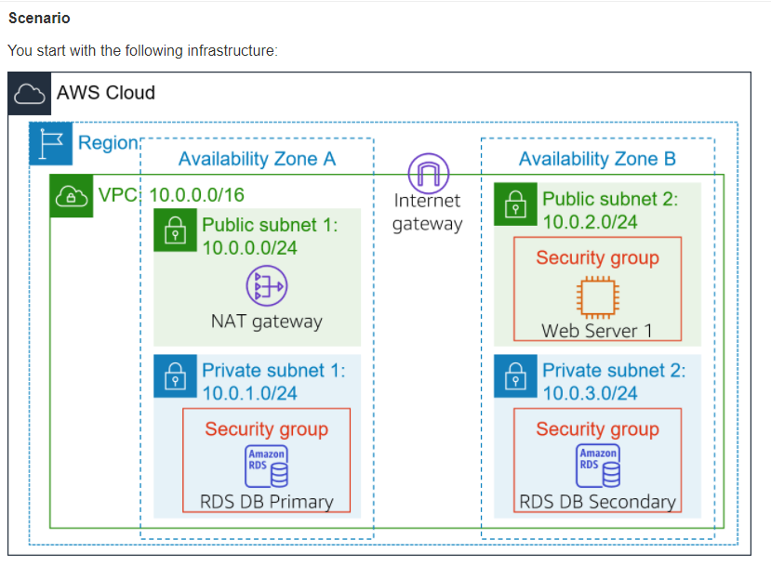

Figure 1Copyright AWS Cloud Foundation v2 – copied under S113P

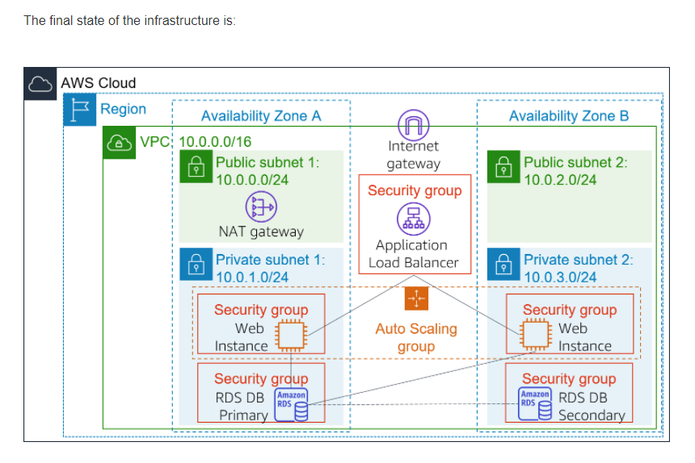

Figure 2 Copyright AWS Cloud Foundation v2 – copied under S113P

| Task # | Task/Activity performed | S | U/S | | Assessor comments (Describe the student’s ability in demonstrating the required skills and knowledge) |
| --- | --- | --- | --- | --- | --- |
| 6.1 | **Create an AMI for Auto Scaling**  Create an AMI from the existing Gelos *Web Server 1*. This will save the contents of the boot disk so that new instances can be launched with identical content.  Use the following configuration:   * + **Image name:** WebServer AMI   + **Image description:** Lab AMI for Web Server |  | |  |  |
| 6.2 | **Create an Application Load Balancer  Load Balancer for the Gelos Cloud**  Create and Application Load Balancer with the following configuration settings:   * + **Name:** LabELB   + **VPC:** Lab VPC (In the **Availability Zones** section   + **Availability Zones:** Select both to see the available subnets.   + Select **Public Subnet 1** and **Public Subnet 2** |  | |  |  |
| 6.3 | **Create a Launch Configuration and an Auto Scaling Group**  Create a *launch configuration* for the Gelos cloud. This will be used when as a template when creating EC2 Virtual Machines.  Use the following configuration settings for the launch configuration:   * + **Launch configuration name:** LabConfig   + **Amazon Machine Image (AMI):**     - Choose Web Server AMI   + **Instance type:**     - t3. micro   + **Additional configuration**     - **Monitoring:** Enable EC2 instance detailed monitoring within CloudWatch   + **Security groups**     - **Web Security Group**   + **Key pair**:     - **Existing key pair:** vockey |  | |  |  |
|  | * + **Auto Scaling group name:** Lab Auto Scaling Group   + **Network:** Lab VPC   + **Subnet:** Private Subnet 1 (10.0.1.0/24) **and** Private Subnet 2 (10.0.3.0/24)   + **Load balancing Attach to an existing load balancer**     - Lab Group   + **Additional settings - Enable group metrics collection within CloudWatch**   + **Group size**, configure:     - **Desired capacity:** 2     - **Minimum capacity:** 2     - **Maximum capacity:** 6   + **Scaling policies** -Target tracking scaling policy   + **Lab policy name:** LabScalingPolicy   + **Metric type:** Average CPU Utilization   + **Target value:** 60   Tags:   * + **Key:** Name **Value:** Lab Instance |  | |  |  |
| 6.4 | **Test and verify that Load Balancing is working on the Gelos Cloud**  Perform the following test to verify Load Balancer functionality:   * View Instances and check that 2 new instances have been launched by Autoscaling. * Click ‘Targets’ to test whether the load balancer can send traffic to the instance. - Status should show ‘healthy’ * Paste the DNS name of the Load balancer into a browser to verify that that application appears in the browsers. |  | |  |  |
| 6.5 | **Test Auto Scaling**  Perform tests to ensure that the error of workload estimate of 2 instances is fixed by your Auto Scaling configuration and ensuring that the number of instances increases from 2 and to 4, and stays within 6 instances)  In the CloudWatch **settings, check that t**wo alarms are displayed and showing the parameters set for autoscaling (automatically created for CPU load of 60% and limit instances between two and six.   * In the browser tab with the web application (from the tasks above) , click “**Load Test**“ * Check the **CloudWatch** console, to see the **Alarm High** chart indicating an increasing CPU percentage - as it crosses 60% for more than 3 minutes, it will trigger Auto Scaling, adding additional instances. * Check ‘**Instances’** to verify that more than two instances are running |  | |  |  |

## Assessment feedback

*NOTE: This section must have the Teacher/Assessor and student signature to complete the feedback. If you are submitting through the TAFE NSW online learning platform, your Teacher/Assessor will give you feedback via the platform.*

### Assessment outcome

Satisfactory

Unsatisfactory

**Assessor feedback**

Has the assessment declaration for this assessment event been signed and dated by the student?

Are you assured that the evidence presented for assessment is the student’s own work?

Was reasonable adjustment in place for this assessment event?

*If yes, ensure it is detailed on the assessment document.*

*Comments*:

### Assessor name, signature and date

### Student acknowledgement of assessment outcome

*Would you like to make any comments about this assessment?*

### Student name, signature and date