# Student Workbook Activities

## Criteria

### Unit code and name

Cluster | ICT Analysis

BSBCRT404 | Apply advanced critical thinking to work processes

ICTICT426 | Identify and evaluate emerging technologies and practices

ICTSAS432 | Identify and resolve client ICT problems

### Qualification/Course code and name

Select your Qualification/Course code and name from the dropdown.

ICT40120 | Certificate IV in Information Technology

Version: 20231120

Date created: 20 November 2023

© TAFE NSW 2023  
RTO Provider Number 90003 | CRICOS Provider Code: 00591E

This assessment can be found in the TAFE NSW [Learning Bank](https://share.tafensw.edu.au/share/logon.do?.page=searching.do?in%3DC1b145167-45e0-41ec-9f64-92af668e3e54%26q%3D%26type%3Dstandard%26sort%3Drank%26dr%3DAFTER%26page%3D1).

The content in this document is copyright © TAFE NSW 2023 and should not be reproduced without the permission of TAFE NSW. Information contained in this document is correct at time of printing: 09 February 2025. For current information please refer to our website or your teacher or assessor as appropriate.

# Instructions

Complete these learning activities as they will help you to gain the knowledge and skills you need to complete your assessments.

You may compete these activities individually or in a group.

## Activity 9: RED approach

### Scenario

You're considering purchasing a new software program for your computer. Use the RED critical thinking technique to assess the decision-making process.

Table 1 RED critical thinking technique

| **RED steps** | **Description** |
| --- | --- |
| **Recognise assumptions**  Identify any assumptions you might be making about the software before purchasing | It can improve or solve a specific problems  it is compatible with my system  I skills to use it effectively |
| **Evaluate arguments**  Assess the reasons and justifications you have for buying this specific software | I need it  its highly reviewed  has reliable customer support |
| **Draw conclusions**  Based on your analysis, conclude about whether purchasing the software is a sound decision | Maybe not, free alternatives available  maybe yes, meets my needs  yes, long term value is great |

## Activity 11: Decision making criteria in practice

### **Scenario:**

You are faced with the daily dilemma of deciding what to cook for dinner.

Table 2 Decision making criteria

| **List the criteria that your decision is based on e.g., gluten free** | **Determine 3 meal options that meet your criteria** |
| --- | --- |
| Low cost  quick and easy  high nutrients  filling or satiating | Pasta with cheese  noodles with vegetables  rice with eggs |
| Final decision based on analysis and evaluation: | Rice with eggs |

## Activity 12: Pros and cons

### Scenario

You're considering buying a new computer for your personal use. Your budget is limited, and you want to make the best decision. You can use the ‘pros and cons’ critical thinking method to weigh the options and make informed decisions based on your preferences and needs.

Table 3 Pros and cons

|  |  |
| --- | --- |
| **Desktop computer pros** | **Laptop computer pros** |
| Performance  longevity  versatility  ergonomics | Portability  ease of use  all in one device  energy efficiency |
| **Desktop computer cons** | **Laptop computer cons** |
| Not portable  power usage  time and effort to setup  dependency on power | Limited battery life  can be costlier than a computer  limited upgradability  limited performance  risk of theft |

#### Decision: Laptop

## Activity 14: 5-whys

### Scenario

Your office is facing a problem: the internet is not working at all. Let's use the ‘5 Whys’ critical thinking technique to identify the root cause of the issue and trouble shoot the internet issues.

Question 2 will flow from the answer to question 1 and so on.

Table 4: 5 whys

| **#** | **Question** | **Hypothetical response** |
| --- | --- | --- |
| 1 | Why did it work before but not now? | A recent change somewhere happened |
| 2 | Why was the internet slow the day it stopped working? | May have been a hardware or software issue |
| 3 | Why aren’t other people aware its down? | It might work for some people? |
| 4 | Why don’t we check the provider status? | We can check if its known its abnormal |
| 5 | Why is it working for other buildings? | It may just be a localised issue like a bad connection or unpaid bill. |

## Activity 15: Cause and effect diagram

### Task

Investigate the various factors that influence your budgeting and spending using a Cause and Effect (fishbone) diagram.

Here are some sources:

Canva, <https://www.canva.com/graphs/fishbone-diagrams/>

Smartdraw, <https://www.smartdraw.com/cause-and-effect/fishbone-diagram-maker.htm>

## Activity 16: SWOT analysis

### Scenario

You're contemplating whether to upgrade your current mobile phone. Let's use the SWOT analysis technique to help you evaluate the decision.

Table 5 SWOT

|  |  |
| --- | --- |
| **Strengths** | **Weaknesses** |
| is up to date with software  Longer battery life with brand new battery  can do everything I need it to  increased performance  enhanced features and updates | Higher upfront cost  potential learning curve with new OS  possible compatibility issues with old accessories |
| **Opportunities** | **Threats** |
| Abillity to leverage latest tech advancements  potential to improve productivity with faster and more capable hardware  possibility of trading in or selling old phone  access to newer apps or services | Rapid tech changes may make new phone outdated  security risk associated with tx data to new phone  environmental concerns related to waste from frequent upgrades |

## Activity 17: Mind mapping

### Task

You're excited about planning a weekend getaway and want to organise your thoughts using the Mind Mapping critical thinking technique. Create a simple mind map to outline the key elements and considerations for your weekend getaway.

Some of the decision points in the mind map may relate to the destination such as accommodation, activities, transport, budget, packing list.

Here are some sources:

* Miro, <https://miro.com/mind-map/>
* TemplateLAB, <https://templatelab.com/mind-map/>

## Activity: 6 Thinking Hats

### Scenario

Your IT team is facing system downtime, and you want to apply the "6 Hats critical thinking technique to approach the problem from different perspectives.

Look at the problem in 6 different ways using the Six Thinking Hats for decision-making.

Table 6: Six Thinking Hats

|  |  |
| --- | --- |
| **Your perspective** | **Critical thinking question/s** |
| Blue hat: Organising and planning | Are we making the most effective use of our time? |
| Green hat: Creative thinking | Its a great time to catch up and brainstorm |
| Red hat: Feelings and instinct | I don’t like wasting time, we need to fix it quick |
| Yellow hat: Benefits and values | This is a good opportunity to work on teamwork |
| Black hat: Risk assessment | We may miss the deadline during downtime |
| White hat: Information gathering | There are 18hrs left until BAU, only down for 24hrs |

## Activity 21: Evaluate collaborative tools

### Task 1

#### Scenario

At XYZ company, colleagues in the support team like to get together to map out issues and design solutions to problems using collaborative tools. There are three favourite tools, but no one can agree on which one to use. The tools the team uses are Miro, Lucidchart and Padlet.

1. Research and test each of the collaborative tools.
2. For each tool, identify and test the features and functionalities. If one is not present, write N for ‘No’. Add some notes about the test and your findings.
3. Rate the functionality for each feature from 1 – Low to 5 – High.
4. For each tool, include a weighting factor for each feature in the **Weighting factor column**. A weighting factor of 1 means it is not very important. A weighting factor of 3 means it is very important.

##### Tool 1:

Table 7 – Collaborative tool weighted decision matrix

| **Feature #** | **Feature description** | **Feature present** | **Research notes** | **Rating 1 to 5  (5 is the best)** | **Weighting factor  (1, 2 or 3)** | **Final weighted score** |
| --- | --- | --- | --- | --- | --- | --- |
| 1 | Standard template - variety |  |  |  |  |  |
| 2 | Standard template – design quality |  |  |  |  |  |
| 3 | Export to other formats (for example pdf, .csv) |  |  |  |  |  |
| 4 | Functionality – for example, can upload or create rich media, voice recording, video, map. |  |  |  |  |  |
| 5 | Stable when working together in real time |  |  |  |  |  |
| 6 | Accessibility WCAG specification (check the vendor notes on the web site for the level achieved) |  |  |  |  |  |
| 7 | User privacy – for example, login only |  |  |  |  |  |
| 8 | Special conditions in the fine print (think about the privacy and data implications) |  |  |  |  |  |

##### Tool 2:

Table 8 Collaborate tool 2

| **Feature #** | **Feature description** | **Feature present** | **Research notes** | **Rating 1 to 5  (5 is the best)** | **Weighting factor  (1, 2 or 3)** | **Final weighted score** |
| --- | --- | --- | --- | --- | --- | --- |
| 1 | Standard template - variety |  |  |  |  |  |
| 2 | Standard template – design quality |  |  |  |  |  |
| 3 | Export to other formats (for example pdf, .csv) |  |  |  |  |  |
| 4 | Functionality – for example, can upload or create rich media, voice recording, video, map. |  |  |  |  |  |
| 5 | Stable when working together in real time |  |  |  |  |  |
| 6 | Accessibility WCAG specification (check the vendor notes on the web site for the level achieved) |  |  |  |  |  |
| 7 | User privacy – for example, login only |  |  |  |  |  |
| 8 | Special conditions in the fine print (think about the privacy and data implications) |  |  |  |  |  |

##### Tool 3:

Table 9 Collaborative tool 3

| **Feature #** | **Feature description** | **Feature present** | **Research notes** | **Rating 1 to 5  (5 is the best)** | **Weighting factor  (1, 2 or 3)** | **Final weighted score** |
| --- | --- | --- | --- | --- | --- | --- |
| 1 | Standard template - variety |  |  |  |  |  |
| 2 | Standard template – design quality |  |  |  |  |  |
| 3 | Export to other formats (for example pdf, .csv) |  |  |  |  |  |
| 4 | Functionality – for example, can upload or create rich media, voice recording, video, map. |  |  |  |  |  |
| 5 | Stable when working together in real time |  |  |  |  |  |
| 6 | Accessibility WCAG specification (check the vendor notes on the web site for the level achieved) |  |  |  |  |  |
| 7 | User privacy – for example, login only |  |  |  |  |  |
| 8 | Special conditions in the fine print (think about the privacy and data implications) |  |  |  |  |  |

### Task 2

#### Scenario

After you have finished testing, documenting and scoring the tools, you are provided with new information about a user: one of team is vision impaired and uses a screen reader to interact with technologies.

Consider how this may affect your recommendation for a collaborative tool.

1. List the additional information you need to check if the tools will meet your new criteria.
2. How does this new information affect the choice of each tool?
3. What alternative tools or approaches would you explore to include the vision-impaired colleague? For example, think about how you could check your assumptions, and how you know that your recommendations will work for the user.

## Answers and feedback

Practice activity: Page:

Activity 9: RED approach 3

Question:

Use the RED critical thinking technique in decision-making process for buying new software.

Answer:

**Recognise assumptions:** Some of your assumptions may be that the new software would be easy to install, operate and integrate seamlessly with all other programs on your computer.

**Evaluate arguments:** Some of your reasons and justifications may be positive reviews and recommendations from friends. Did you also consider whether the software met your specific needs and requirements?

**Draw conclusions:** In this part you decide whether to buy the new software based on al logical critical thinking based decision-making process.

Feedback:

It's crucial to remain open to re-evaluation as technology evolves, and to regularly reassess the software's performance based on personal needs.

This exercise helps you apply the RED critical thinking technique in a simple context, allowing you to scrutinise assumptions, evaluate arguments, and draw conclusions before deciding.

Practice activity: Page:

Activity 11: Decision making criteria in practice 4

Question:

Decide what to prepare for dinner based on criteria.

Answer:

**List the criteria:** Even a simple decision has many criteria such as time to prepare, available ingredients, nutrition, level of effort, allergies, food preferences.

**Determine 3 options:** You now have 3 options that meet all or some of your criteria.

**Make a decision:** You will prioritise one option based on your evaluation e.g., bolognaise.

Feedback:

Some criteria may be more important than others such as allergens. Weighting the criteria improves decision making. The more people impacted by your decision, the more criteria.

Practice activity: Page:

Activity 12: Pros and cons 4

Question:

Use the ‘pros and cons’ critical thinking method to weigh the options and make informed decisions based on your preferences and needs for buying a personal computer.

Answer:

Responses will vary, depending on your personal context and preferences. For example,

**Desktop pros:** Typically, more powerful than laptops for the price, easier to upgrade individual components (e.g., memory, storage), larger screen for better visibility.

**Desktop cons:** Not portable – stays in one place, takes up more space in the room.

**Laptop pros:** Portable – can be used anywhere, takes up a small amount of space, integrated display, keyboard, and trackpad for convenience.

**Laptop cons:** Generally, more expensive than desktops for similar performance, limited upgrade options compared to desktops.

Feedback:

This simple exercise helps you apply the "pros and cons" technique to make informed decisions based on your preferences and needs.

Practice activity: Page:

Activity 14: 5-whys 6

Question:

Use the 5-Whys technique to identify the root cause of an issue.

Answer:

Responses will vary. Your response will look like this example:

Table 10: 5-whys

| **#** | **Question** | **Hypothetical response** |
| --- | --- | --- |
| **1** | Why is the internet not working? | The router is not functioning. |
| **2** | Why is the router not functioning? | The power to the router is off. |
| **3** | Why is the power off to the router? | There was a power outage. |
| **4** | Why was there a power outage? | The power company had scheduled maintenance. |
| **5** | Why was maintenance scheduled without notice? | The maintenance was an emergency fix due to a sudden equipment failure. |

Feedback:

Explore the root cause by repeatedly asking ‘Why?’ to uncover deeper layers of the issue.

Record each question and its response to visually represent the cause-and-effect chain.

Once the root cause is identified, discuss possible solutions to address the issue effectively.

Consider implementing preventive measures to avoid similar issues in the future.

Practice activity: Page:

Activity 15: Cause and effect diagram 7

Question:

Investigate the various factors that influence your budgeting and spending using a Cause and Effect (fishbone) diagram.

Answer:

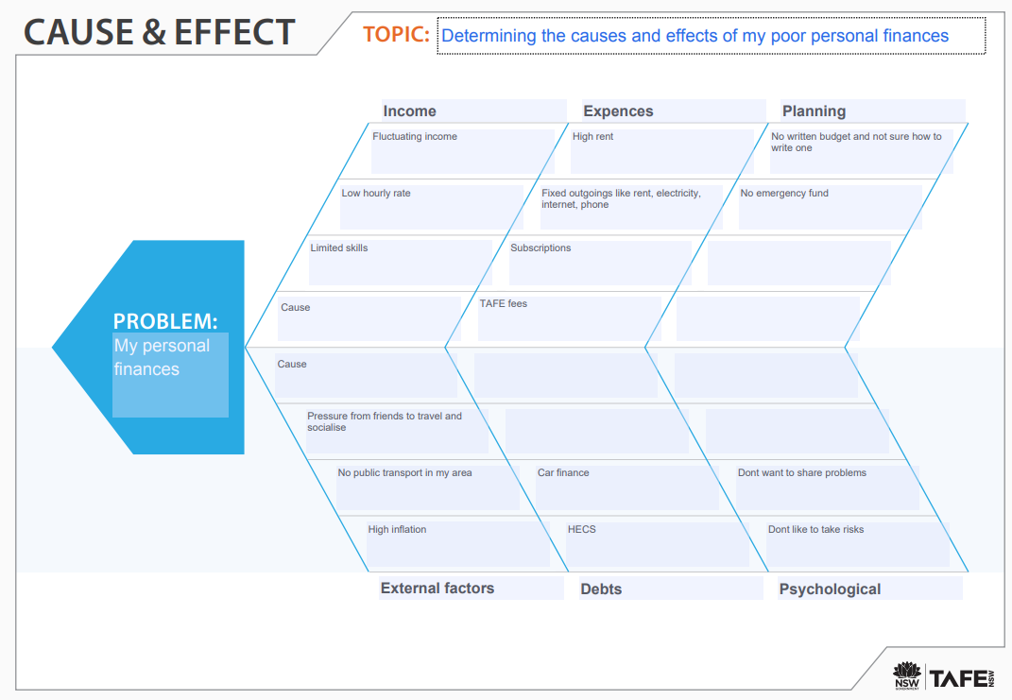

Figure 1 Cause and effect diagram © TAFE NSW 2023

Feedback:

Using an online cause and effect (fishbone) diagram lets you organise information in visual representation of your problem.

By analysing the potential causes in each category, you can pinpoint specific areas to address. For example, if impulse purchases are a significant factor, focusing on strategies to curb impulsive buying could help improve your budgeting.

Practice activity: Page:

Activity 16: SWOT analysis 7

Question:

Use SWOT analysis to analyse and evaluate whether to upgrade a mobile phone.

Answer:

Your answer may include these points:

**Strengths:**

• Access to the latest technology and features.

• Improved performance for faster operation.

• Potential for a better camera and enhanced user experience.

**Weaknesses:**

• Cost of purchasing a new phone.

• Learning curve to adapt to new features.

• Potential environmental impact of discarding the old phone.

**Opportunities:**

• Regular software updates for security and new features.

• Trade-in programs or discounts for upgrading.

• Potential for increased efficiency in daily tasks.

**Threats:**

• Rapid advancements in technology making new models quickly outdated.

• Potential dissatisfaction with the new phone's performance.

• Economic considerations and budget constraints.

Feedback:

Consider your priorities and needs:

If staying up to date with the latest technology and features is crucial, upgrading may provide significant benefits.

If budget constraints or satisfaction with your current phone's performance are higher priorities, sticking with your current phone might be a reasonable choice.

Applying the SWOT analysis technique to make an informed decision about whether to upgrade your mobile phone.

Practice activity: Page:

Activity 17: Mind mapping 8

Question:

Create a simple mind map to outline the key elements and considerations for a weekend getaway.

Answer:

Your mind map may look like this:

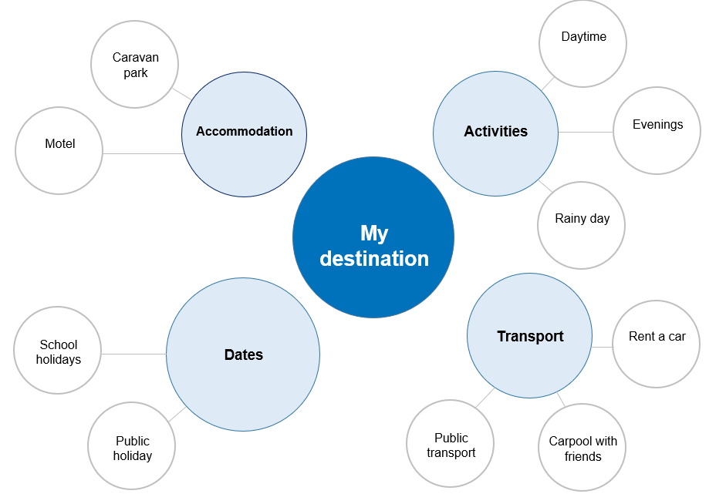

Figure 2 Mind map © TAFE NSW 2023

Feedback:

You can add more branches to your mind map to connect related ideas and add items.

Practice activity: Page:

Activity: 6 Thinking Hats 8Question:

A coffee shop is getting a growing number of complaints from customers as they are having to wait too long for their coffee. Look at the problem in 6 different ways using the Six Thinking Hats for decision-making.

Answer:

Use your critical thinking skills to develop open-ended questions.

**Blue hat:** Focus on organising the team's efforts. Discuss the steps to be taken, assign responsibilities, and outline a timeline for resolution.

**Green hat:** Brainstorm creative solutions to resolve the downtime quickly. Consider alternative approaches and new technologies that could prevent future issues.

**Red hat:** Consider how users and team members feel about the downtime. Acknowledge frustration and stress caused by the interruption.

**Yellow hat:** Identify any positive aspects or opportunities in the situation, such as the chance to implement system improvements during the downtime.

**Black hat:** Evaluate potential risks and challenges associated with the downtime, such as data loss, impact on productivity, or security concerns.

**White hat:** Gather data on when the downtime started, which systems are affected, and the number of users impacted.

Feedback:

By ‘wearing’ each of the Six Thinking Hats in turn, you can gain a rich understanding of the issues you face – and the best ways forward. Using this approach in a group encourages everyone to be fully involved in the decision-making process.

Practice activity: Page:

Activity 21: Evaluate collaborative tools 1

Question:

Research, test and recommend collaborative tools.

Answer:

Using systematic processes, you have gathered and analysed the information required to make a workplace decision.

Feedback:

You can now use various sources of information to provide answers to your research questions about technologies in the ICT sector; document your key findings and identify each technology’s advantages and disadvantages.