# Program Algorithm – Pseudocode

# Component 2 -  
# checking a username and password (logging in).  
# This component takes an existing username and password (for a previously registered user)  
# and checks if they match a valid entry in the file (accounts.txt).  
# assumes login is stored in the plaintext format "username,password"  
  
# Get the current username and password  
username = input("input username: ")  
password = input("input password: ")  
  
# combine username and password into one string  
login = username +","+ password  
  
# set flag to show login state  
valid_entry = False  
  
# open the accounts.txt file  
file = open("accounts.txt", "r")  
  
# check if the file is opened in read only mode  
if file.mode == 'r':  
  
 # read the entire file and return it as a list of strings  
 # where each string represents a line from the file  
 list = file.readlines()  
  
 # iterate through each line using for loop  
 for eachLine in list:  
  
 # selection using equality operator  
 if eachLine.strip() == login:  
  
 # set flag for valid entry to true  
 valid_entry = True  
  
 # exit the loop  
 break  
 # show the result to the user  
 print("login for", username, "is", valid_entry)  
  
# close file  
file.close()

# Program Algorithm – Flowchart

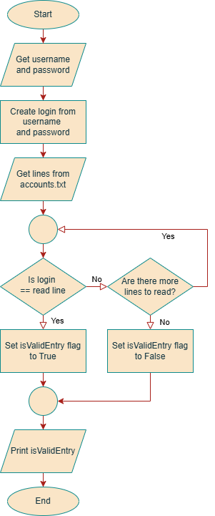

# Algorithm Feedback

|  |
| --- |
| **Supervisor Feedback** |
|  |