Short integer grid appears not to be read in properly.
This is an issue with the development version 5.4.0 in branch vscode-macos-dev-setup
This issue occurs with aread8 but likely is more pervasive. The following command results in incorrect output.
mpiexec -np 4 aread8 -p p.tif -ad8 ssa1.tif -wg weights.tif -nc
The output file ssa1.tif is incorrect. It has not accumulated the inputs from weights.tif
weights.tif is a short (16 bit) integer file with values 0 or 1.
I used ArcGIS raster calculator to produce weights1.tif that is equivalent to weights.tif but is a 32 bit floating point file
mpiexec -np 4 aread8 -p p.tif -ad8 ssa.tif -wg weights1.tif -nc
The output ssa.tif is correct.

When I do the above with the older (5.3.7) version of TauDEM the short integer (16 bit) file weights.tif is read correctly and the result is correct.

Note that I had to coerce weights.tif which is short
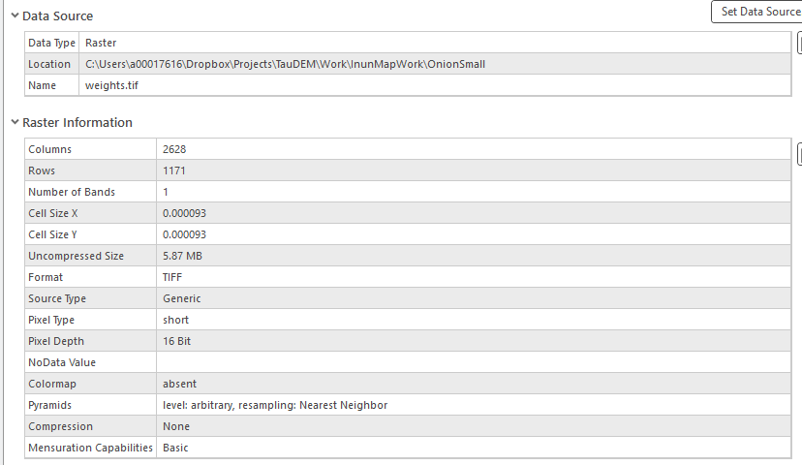
to floating point (weights1.tif)
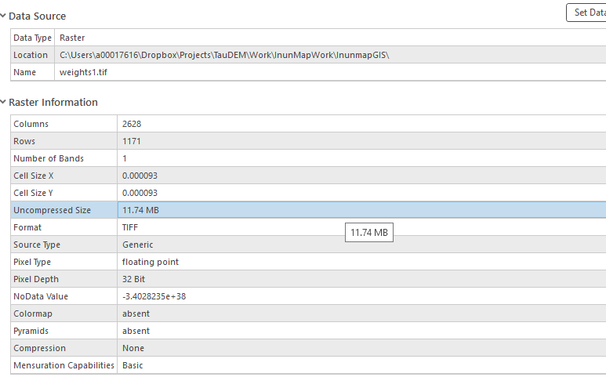
With weights.tif aread8 does not work.
mpiexec -np 4 aread8 -p p.tif -ad8 ssa1.tif -wg weights.tif -nc
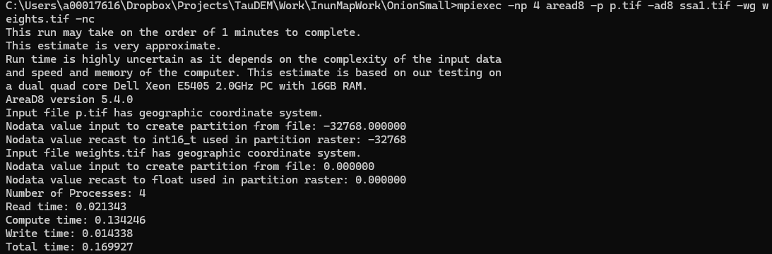
I am suspecting an issue with the no data value being cast as 0. Note that no data value appears to be blank/missing in weights.tif.

