Description of Bug in Move Outlets.
Version 5.4.0 TauDEM development code

Running moveoutletstostreams with a single processor results in the correct result
mpiexec -n 1 moveoutletstostreams -p p.tif -src src.tif -o outlets2_geo.shp -om outlets1_align.shp -md 3000
but using 8 processors gives an incorrect answer
mpiexec -n 8 moveoutletstostreams -p p.tif -src src.tif -o outlets2_geo.shp -om outlets8_align.shp -md 3000

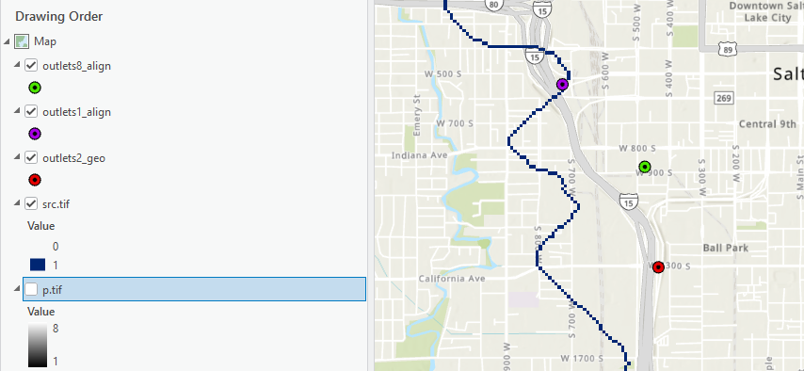
Single processor moves from red to purple, the correct result
8 processors moves from red to green, incorrect result.

Fixed with Issue #272

