# Advance preparation for the CSDMS TauDEM Clinic

David G. Tarboton, dtarb@usu.edu

Utah State University

The CSDMS TauDEM clinic will include presentations on the theory and methods used in TauDEM as well as "hands on" work to learn how to use TauDEM. Time will be split roughly evenly between theory and hands on work. You do not have to participate in this clinic "hands on". A significant part of the clinic will be used to present the theory, general data structures, and algorithms from a conceptual perspective not requiring you to be hands on. However if you are hands on it is much easier to experiment, reinforcing the concepts and developing the knowledge needed to use TauDEM beyond the clinic.

This note gives details on getting TauDEM set up on your computer so you can be ready for the hands on work if you want to do it, so that we can limit the time spent in the clinic resolving installation issues. So as to limit the time spent in the clinic resolving installation issues, I would like to encourage participants who want to use TauDEM "hands on" to install (following the above steps) and run the first TauDEM function.

TauDEM is primarily a set of tools for DEM based hydrologic computations. It does not come with its own visualization capability, rather it relies on standard geographic information system (GIS) raster and shape data formats and other software for visualization. TauDEM uses standard GeoTIFF files for its raster inputs and outputs and ESRI shapefiles for GIS feature inputs and outputs. These may be visualized in many software programs. TauDEM has primarily been configured and documented to be used on a PC with ArcGIS 9.3. However the basic tool functionality has been developed to be platform independent and has been tested on PC's, one mac, and some Linux clusters. In this clinic I will strive to accommodate platform variability among the attendees. For each tool used the general functionality of TauDEM will be described and specific examples of how to execute TauDEM from within different environments will be given. I will show how to use both ArcGIS and R to visualize results, and will show how to run the tools from the command line (all platforms) and from ArcGIS tools and using R system calls.

To participate in the hands-on parts of this clinic you will need to have one of the following setups on your computer.

1. Microsoft Windows PC with ArcGIS 9.3

2. Microsoft Windows PC with ArcGIS 10.0

3. Microsoft Windows PC with R

4. Mac with R

5. PC or Mac with other visualization software

6. Network access to CSDMS Beach

These are ranked from easiest to hardest. I will show how to visualize the output data in ArcGIS and R. If you have other software that can visualize and work with GeoTIFF and GIS shapefiles, e.g. Matlab, QGIS, you are welcome to use it (option 5) but I may not be able to help with it.

Following I give a brief overview of the functionality of TauDEM followed by details of software you need to install to use TauDEM. If you are going to use TauDEM "hands on" I would like to encourage you to do as much of the installation described as possible and get to the point where you can run the first TauDEM function so that in the clinic we can focus on what the functions do.

## Overview

TauDEM (Terrain analysis using Digital Elevation Models) is a set of Digital Elevation Model (DEM) analysis tools targeted at extraction of information useful for hydrologic modeling and analysis from DEMs.

TauDEM Tools provides the following capability:

* Pit removal by flooding to ensure hydraulic connectivity within the watershed.
* Computation of flow directions and slopes using single and multiple flow direction methods.
* Computation of contributing area using single and multiple flow direction methods.
* Multiple methods for the delineation of channel networks including geomorphology-based methods sensitive to spatially variable drainage density.
* Objective methods for determination of the channel network delineation threshold based on stream drop analysis.
* Delineation of watersheds and subwatersheds draining to each stream segment and association between watershed and segment attributes for setting up hydrologic models.
* Specialized functions for terrain analysis, including:
  + Slope over specific catchment area ratio which is the inverse of the wetness index.
  + Distances down to streams and up to ridges along flow directions measured horizontally, vertically, in a straight line, or following the topographic profile.
  + Upslope dependence function to map the locations upslope where activities have an effect on a downslope location.
  + Decaying accumulation that evaluates upslope contribution subject to decay or attenuation.
  + Concentration limited accumulation.
  + Transport limited accumulation.
  + Reverse accumulation.
  + Avalanche runout.
  + Average slope.

TauDEM is distributed from the website <http://hydrology.usu.edu/taudem>. This website contains links to the software, installation instructions, research papers and printed and video learning resources.

## Computer and Software Requirements

The following describes what you need to do to set up the software to run TauDEM.

#### MPICH2

The current version of TauDEM has been implemented using the MPICH2 library from Argonne National Laboratory so as to take advantage of multi-core and parallel computation capability. MPICH2 will need to be installed on whatever computer you use to run TauDEM. MPICH2 should be obtained from <http://www.mcs.anl.gov/research/projects/mpich2/>.

**On a PC** follow step 3 of the installation instructions at <http://hydrology.usu.edu/taudem/taudem5.0/downloads.html> to install MPICH2. It is important that MPICH2 be installed using THE ADMINISTRATOR ACCOUNT either logged in as administrator or by running from a command prompt that has been opened using "Run as Administrator". Also be sure to follow the instruction to set the path to MPICH2 executables.

**On a Mac** or other system you will need to download and compile the package appropriate for your system, or compile from source following the guidance at <http://www.mcs.anl.gov/research/projects/mpich2/downloads/index.php?s=downloads>.

#### TauDEM

**On a PC** follow step 4 of the installation instructions at <http://hydrology.usu.edu/taudem/taudem5.0/downloads.html> to install the TauDEM version appropriate for your computer (32 or 64 bit). Do this no matter whether you plan to use ArcGIS or R or something else for visualization.

**On a Mac or Unix system** download the TauDEM source from <http://hydrology.usu.edu/taudem/taudem5.0/downloads.html> and compile and build it for your system.

#### ArcGIS

Follow the instructions here if you plan to use ArcGIS to visualize TauDEM output.

**On a PC if you have ArcGIS 9.3** follow steps 5 and 6 of the installation instructions at <http://hydrology.usu.edu/taudem/taudem5.0/downloads.html> to activate the ArcToolbox interface

**On a PC if you have If you have ArcGIS10.0**. Obtain the in development (alpha) python tools from <http://hydrology.usu.edu/taudem/taudem5.0/TauDEMPythonTools.zip> (linked at the bottom of <http://hydrology.usu.edu/taudem/taudem5.0/downloads.html>). Unzip these into a convenient location (e.g. c:\program files\taudem\pyfiles). Copy the compiled help file C:\Program Files\ArcGIS\help\TauDEM_Tools.chm that should have been installed when you installed TauDEM into C:\Program Files\ArcGIS\Desktop10.0\help.

To add the TauDEM Python tools interface, open ArcMap and the ArcToolbox Window. Right click on ArcToolbox at the top of the window and select Add Toolbox... Then browse to the folder where you unzipped the python tools (e.g. c:\program files\taudem\pyfiles) and select the TauDEM_Python_Tools.tbx file.

We have not yet converted all tools to Python so in the TauDEM Python Tools toolbox you will not find all functions. The tools that are there can serve as an example for programming others if you need them before we get to them.

#### R

R provides alternative free visualization capability for those who do not have ArcGIS. R is also available for multiple platforms. If you plan to use R, it is helpful to have it already installed and know the basics.

Download and install R from <http://www.r-project.org/> and teach yourself how to use its basic functionality. Following are some web resources for getting started with R

* <http://cran.r-project.org/doc/manuals/R-intro.html#A-sample-session>. Working through about half of this session should give you the bare essentials needed to use R in this clinic.
* <http://www.nceas.ucsb.edu/files/scicomp/Dloads/RProgramming/BestFirstRTutorial.pdf>
* <http://cran.r-project.org/doc/contrib/Short-refcard.pdf>
* <http://cran.r-project.org/doc/manuals/R-intro.pdf>

#### Other visualization software.

TauDEM can be run from the command line and results visualized in any software that can work with GeoTIFF and shapefiles. If you want to use the full functionality of TauDEM you also need to be able to create and edit shapefiles. If you plan to use other visualization software, I suggest that you work out how to do this using the example data in <http://hydrology.usu.edu/taudem/taudem5.0/LoganDemo.zip>, prior to the clinic. You will need to be able to visualize a file like **logan.ti**f in this zip file. You will also need to be able to create a shapefile such as **LoganOutlet.shp** if you want to be able to run for anything other than the default outlet and data I have provided.

#### CSDMS Beach

If you plan to use the CSDMS Beach supercomputer to run TauDEM, you will need an account. You need to work with CSDMS staff to obtain an account. You will need to be familiar with the job submittal process used on Beach. You will need to have your own computer where you can download and visualize the output created on Beach. Use of Beach is really only recommended for jobs that are too big to run conveniently on a PC or Mac. The tutorial examples used in the clinic will be sufficiently small that they can run on a PC or Mac, but will also be demonstrated on Beach to show the process.

## Running your first TauDEM function

This section gives instructions for running a single TauDEM function intended to get you over the through the initial setup steps to where you can run a TauDEM function, so that in the clinic we can focus on what the functions do.

Download the Logan River example data zip file from <http://hydrology.usu.edu/taudem/taudem5.0/documentation.html>. Extract all files from the zip file. I used the folder C:\Users\dtarb\LoganDemo\Logan. The unzipped contents of LoganDemo.zip are illustrated below:

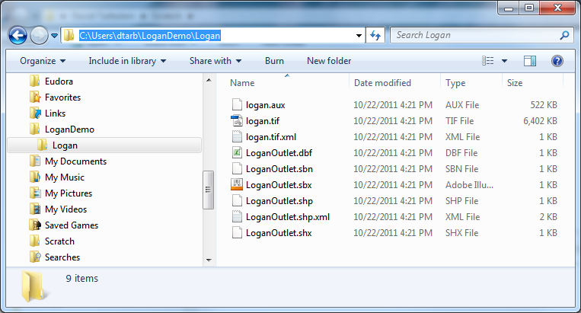

**In ArcMap**

Add logan.tif into a blank ArcMap document. Adjust the ArcMap symbology. The Logan River DEM is illustrated below.

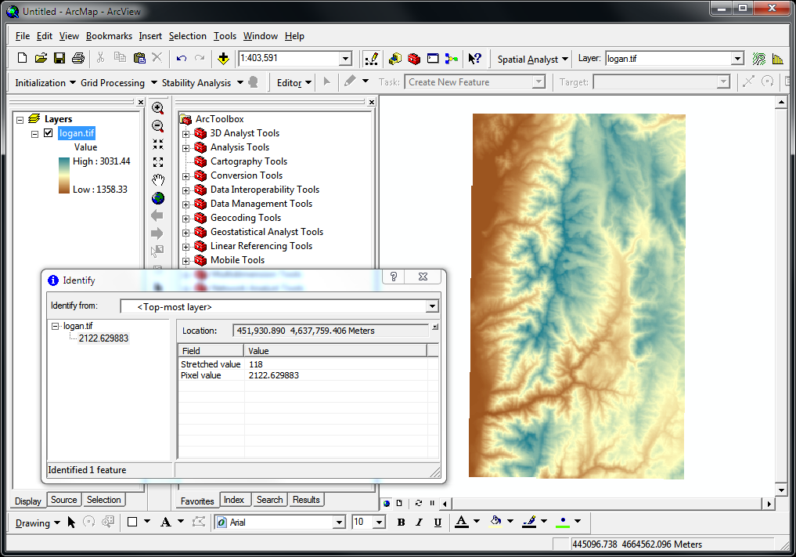

This display also shows the output from the ArcMap identify tool used to click on and examine individual grid cell values.

Open the TauDEM Tools[1] -> Basic Grid Analysis -> Pit Remove Tool. Select the *logan.tif* grid DEM as input and set the number of processes to 4. Click OK.

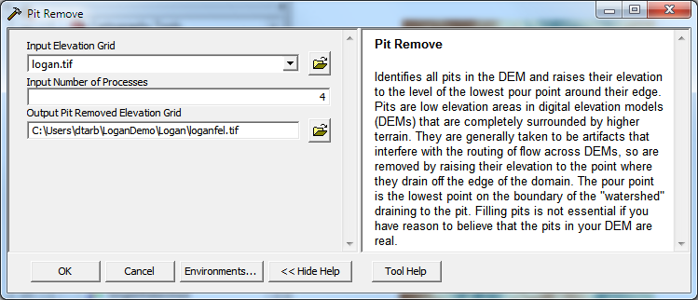

Note how when the Input elevation grid is selected the software automatically fills in output fields using TauDEM's file naming convention. This saves on some of the work involved in running these tools.

The result is a new layer *loganfel* that has been added to the map. The tool dialog box gives timing information and details of the shell command that was executed in the background while completing this task. This information is useful for debugging if something goes wrong.

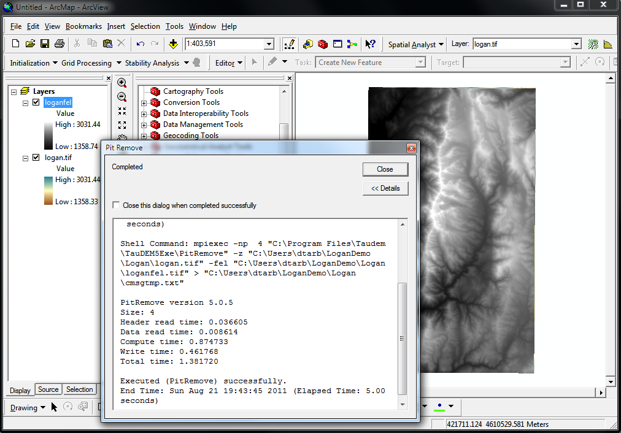

Congratulations, you have run your first TauDEM function.

**From the Command Line**

Open a command prompt. Select **Start -> All Programs -> Accessories -> Command Prompt**

Change directory to the folder where you are working. Type the equivalent on your computer to

cd C:\Users\dtarb\Scratch\Logan

Then type (or cut and paste from here) into the command prompt

mpiexec -n 4 pitremove -z logan.tif -fel loganfel.tif

The result should be as follows

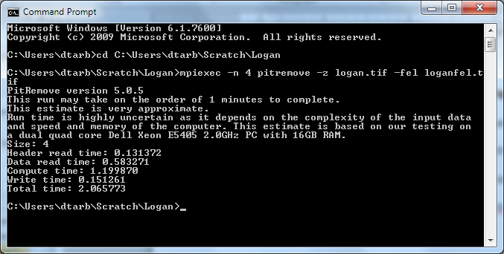

Congratulations, you have run your first TauDEM function from the command line. Now you need to visualize the output file loganfel.tif that was written.

You can learn more about running TauDEM from the command line at: <http://hydrology.usu.edu/taudem/taudem5.0/TauDEM5CommandLineGuide.pdf>

**From R**

Open R and Open a new R script (top left menu)

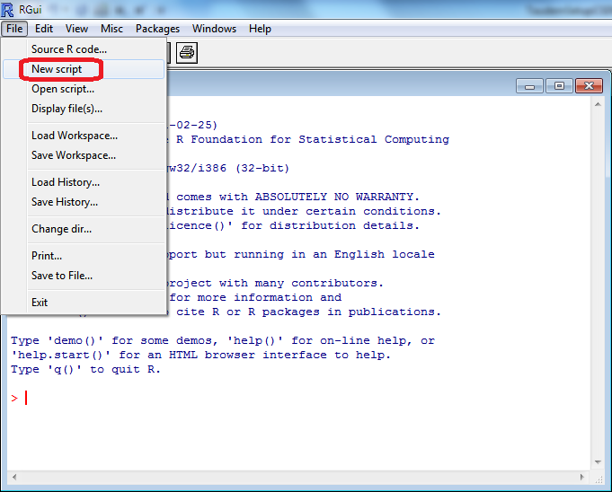

Type (or cut and paste from this document) the following text into the script and run it in steps (by selecting text and using Cntrl R). When prompted during the installation of libraries select an appropriate nearby R mirror

# R script to run TauDEM

# Obtain and install some libraries we use

# install rgdal

# install raster

# install shapefiles

install.packages("rgdal")

install.packages("raster")

install.packages("shapefiles")

library(raster)

library(shapefiles)

# Set working directory to your location

setwd("C:/Users/dtarb/Scratch/Logan")

z=raster("logan.tif")

plot(z)

Following is the display you should get

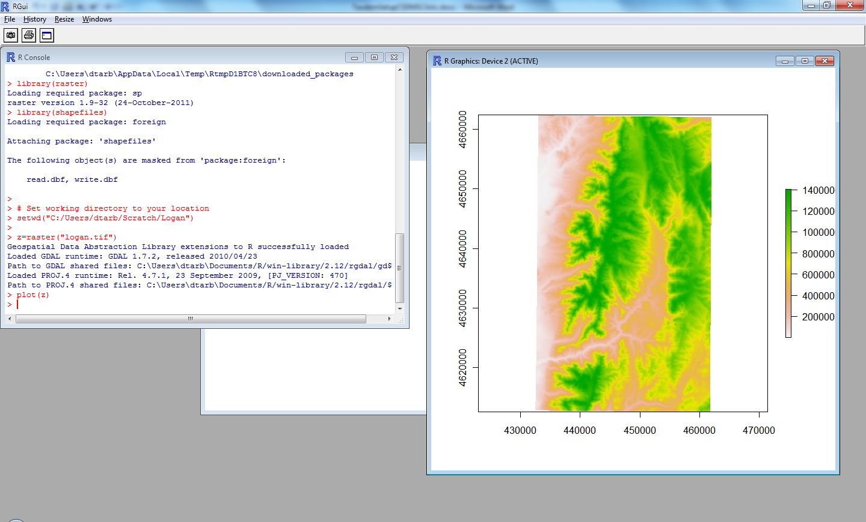

# Pitremove

system("mpiexec -n 8 pitremove -z logan.tif -fel loganfel.tif")

fel=raster("loganfel.tif")

plot(fel)

Following is the result

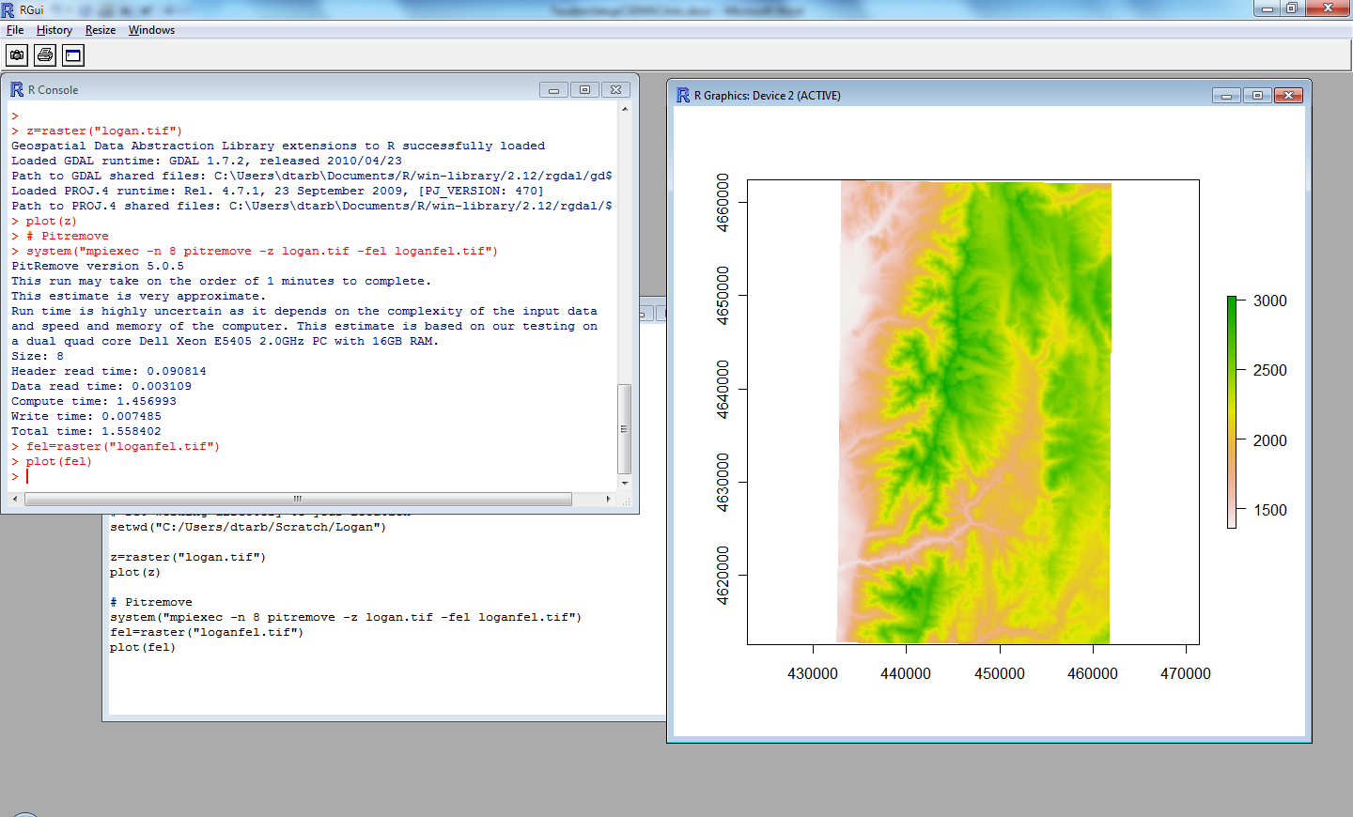

Congratulations, you have run your first TauDEM function from R.

## Links

* TauDEM software <http://hydrology.usu.edu/taudem/>.
* Compiled help file giving extensive documentation on each function <http://hydrology.usu.edu/taudem/taudem5.0/TauDEM_Tools.chm>. To activate the file: After downloading to your local disk, right click on the file and select Properties. At the bottom of the General Tab, click on the Unblock button.
* Quick start guide to using the TauDEM ArcGIS Toolbox <http://hydrology.usu.edu/taudem/taudem5.0/TauDEM5GettingStartedGuide.pdf>
* Guide to using the TauDEM Command Line Functions <http://hydrology.usu.edu/taudem/taudem5.0/TauDEM5CommandLineGuide.pdf>
* Watershed Delineation Using TauDEM Video and Tutorial <http://hydrology.usu.edu/taudem/taudem5.0/documentation.html>.
* Example data
  + Cub River <http://hydrology.usu.edu/taudem/taudem5.0/CubDemo.zip> (referenced in ArcGIS Toolbox quick start guide)
  + Logan River <http://hydrology.usu.edu/taudem/taudem5.0/LoganDemo.zip> (referenced in Command Line Functions guide and Watershed Delineation tutorial)
* MPICH2 is available from <http://www.mcs.anl.gov/research/projects/mpich2/>.
* R software is available from <http://www.r-project.org/>.
* ArcGIS is available from [www.esri.com](http://www.esri.com).

1. In the ArcGIS 10 alpha implementation these are in a toolbox named TauDEM Python Tools.