## Information on using Mercurial to work with UEB Bitbucket Repository

Obtain TortoiseHg from <http://tortoisehg.bitbucket.org/>

Double click on the msi file you obtained (e.g. tortoisehg-2.5.0-hg-2.3.1-x86.msi) and click through the install steps (I accepted all the defaults)

Open a command prompt and cd to the folder where you want the ueb repository to be saved

cd C:\Users\dtarb\

Type the command

hg clone <https://bitbucket.org/dtarb/ueb>

Once this has completed you should see a folder with the contents of the UEB project

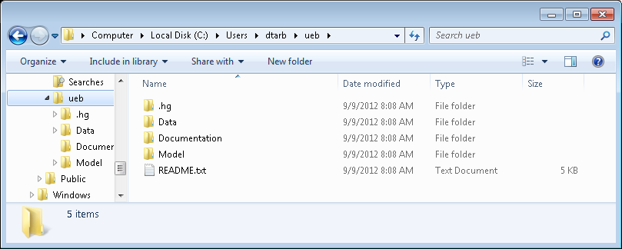

To make any changes to the model you will need to have a Visual Studio (Version 2008 or later recommended) with the Intel Fortran Compiler (I used Intel Fortran XE 2011). Then use Visual Studio to open the Model Solution File ..\ueb\Model\UEBGrid\UEBGrid.sln.

You can right click in the repository folder to open HgWorkbench



Hg Workbench provides capability to exchange information between your local repository and the bitbucket web repository. In general the procedure is as follows. (Caveat, I wrote this with somewhat limited experience with Mercurial. I found that this works for me, but as others find better ways, please let me know).

1. Pull to retrieve incoming changes from the web repository



2. Right click on the code set retrieved and either click Update or Merge with Local. Update replaces the local working set with what was just retrieved. Merge with Local merges the set retrieved with any local changes you may have made.

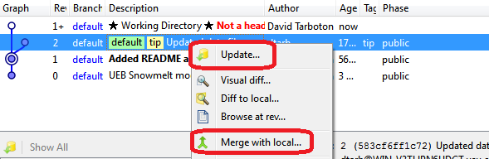

3. Do work. Make changes and improvements

4. Once your work is ready to share do another Pull/Merge to reconcile with changes others may have posted in the intervening time.

5. Then add a description to the change set and commit.

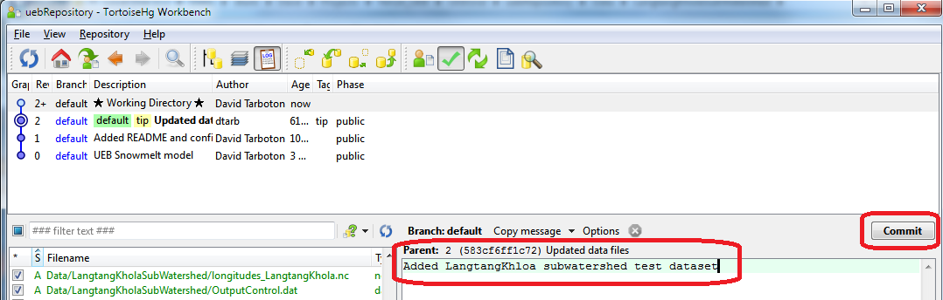

This commits the new changes to the local repository

6. Push the changes to the online repository

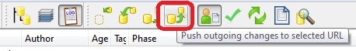

### To just use the model

1. Download netCDF from <ftp://ftp.unidata.ucar.edu/pub/netcdf/contrib/win32/netcdf-ifort-3.6.1.zip>

2. Add the folder ..\netcdf3.6.1\lib to the system path.

3. Add the folder ..\ueb\model\uebgrid\release to the system path

4. Change directory to the folder ..\ueb\data\TWDEF and run the command

uebgrid overallcontrol.dat

You should see new output created in the folder outputs

### To add a path variable

Select Start->Computer and right click to get Properties

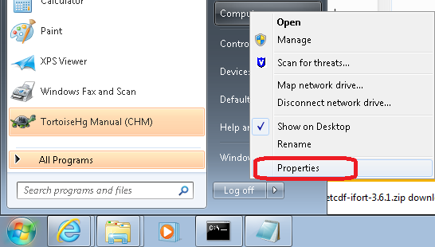

Click Advanced System Settings

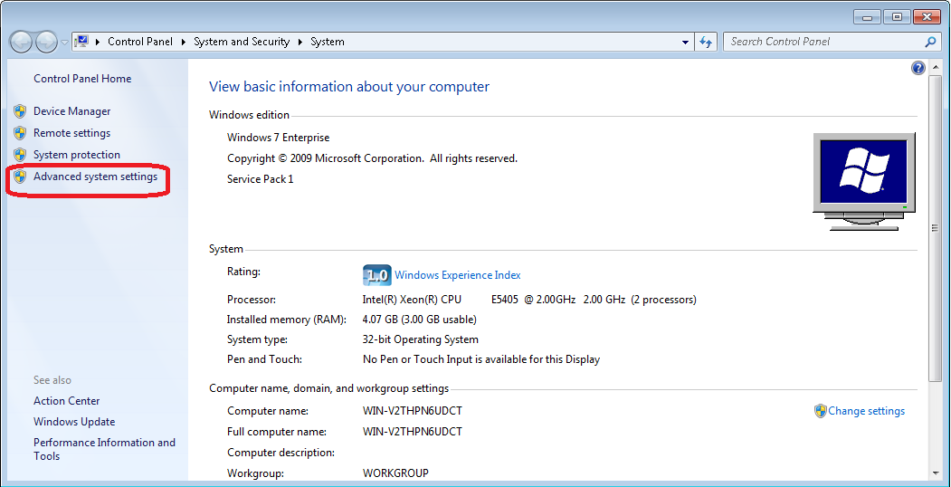

Click Environment Variables

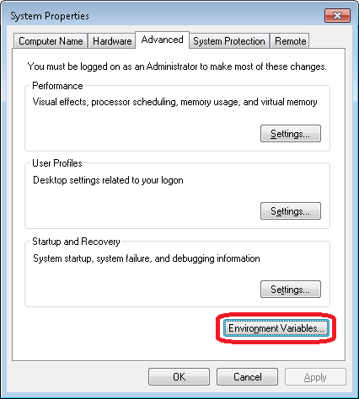

Locate Path in System Variables and Click Edit

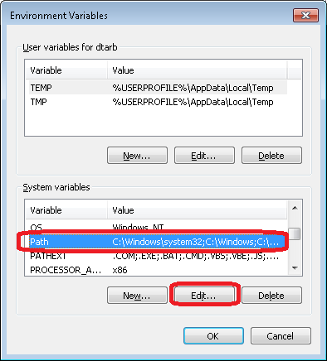

Add the new path entries to the Variable Value box. Entries may be separated by a semicolon ;. Be careful not to include any spaces that are not part of the file names.

