David Tarvin

July 16, 2019

WEB425 Exercise 2.2

Before click:

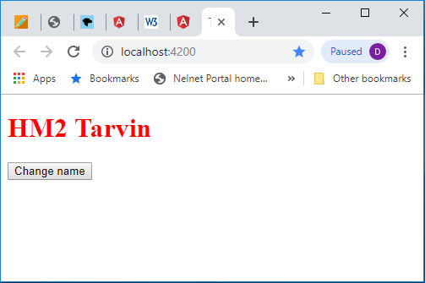

After click:

