David Tarvin

July 17, 2019

WEB425 Exercise 2.3

Before name added:

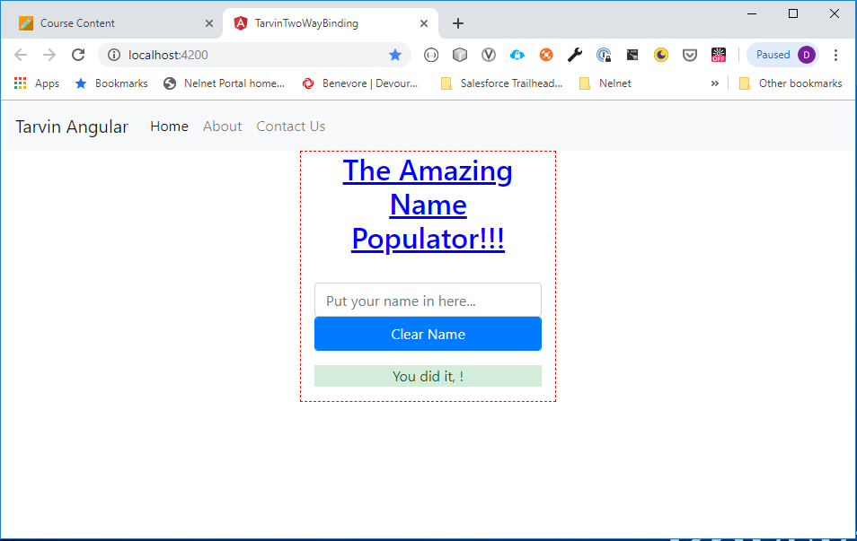

After name added:

