SPF5189Z Design Notes
Daniel H. Tatum
Revision 0
08/02/20
Table of Contents
Introduction 2
Matching Network Design 2
Stability Circles 3
Input Network 4
Output Network 6

Introduction
The Qorvo SPF5189Z [1] meets frequency and gain requirements while delivering excellent linearity with an OIP3 of 39.5dBm. The output power of +22.5dBm at the 1dB compression point makes the amplifier an ideal driver for a 4W-8W power amplifier.Integration requires a +5V power supply at 90mA of current, band-limiting matching networks, and DC blocking capacitors at both the input and output terminals. The SOT-89-3 package is simple to install in a home lab with a board heater and quality soldering iron.

Matching Network Design
Discrete matching networks are designed in the Quite Universal Circuit Simulator using manufacturer provided scattering parameter data and built-in microstrip models.

Stability Circles
A check of the Rollett stability factor indicates that a stable match on both the input (red) and output (blue) networks can be made anywhere on the Smith Chart as in Figure 1.
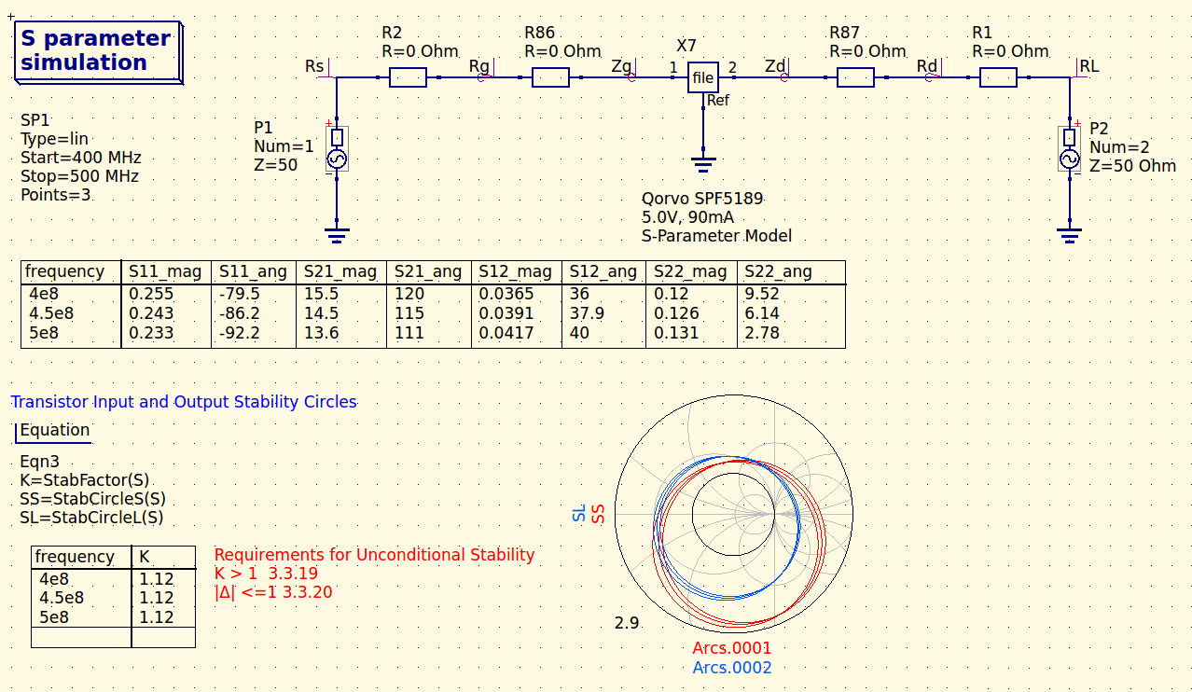Figure 1. Qucs Simulation deck for Rollett stability factor.

Input Network
A simulation has been configured in Qucs to automate the calculation of the required simultaneous conjugate matching coefficients to achieve maximum power output from the amplifier. The design process has been borrowed from [2] with the resulting coefficients in Figure 2.
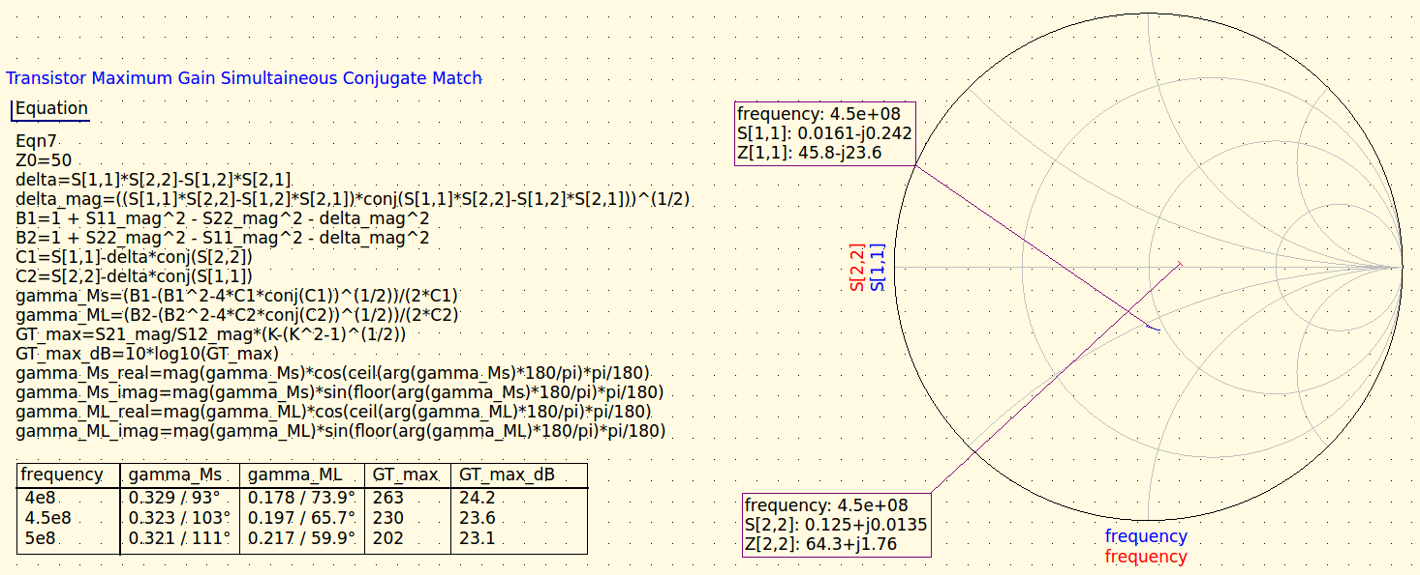Figure 2. Simultaneous conjugate matching reflection coefficients for the source (gamma_Ms) and load (gamma_ML) ports calculated using S-parameter data. The input reflection coefficient, S[1,1] (blue), and output reflection coefficient, S[2,2] (red), presented on the Smith chart represent the the reflection coefficients seen by the ports with characteristic impedance of 50Ω.
The required input impedance is then calculated and presented rectangular form in Figure 2 to subsequently determine required component values.
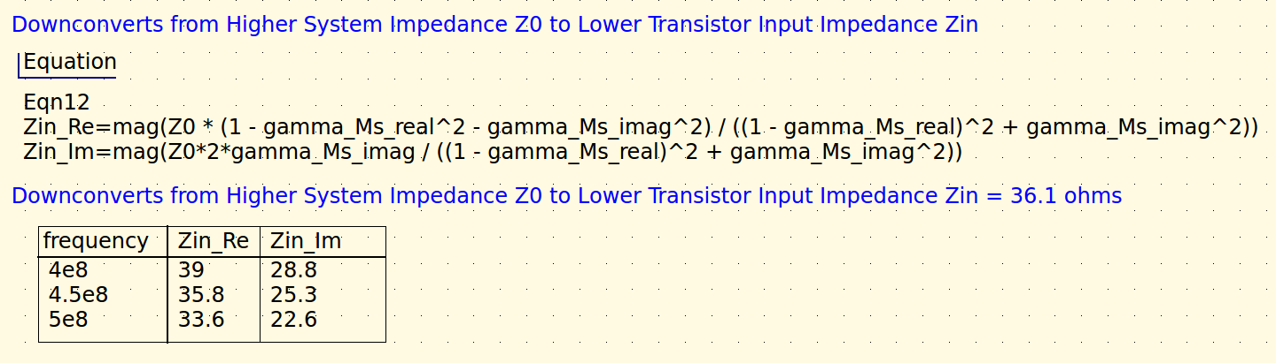Figure 3. Transistor input impedance calculation in Qucs for simultaneous conjugate match. The mag() operator is used to reduce complex floating point numeric error in the result.
The input network topology is a 2nd order Chebyshev bandpass matching network which converts from the system characteristic impedance to the lower gate input impedance while simultaneously band limiting the input signal.

Output Network
The output network is a 3rd order Chebyshev bandpass matching network with converts from the drain output impedance to the lower system characteristic impedance.
References
[1] Qorvo, Inc., SPF5189Z, https://www.qorvo.com/products/p/SPF5189Z
[2] G. Gonzalez, Microwave Transistor Amplfiers, 1997

