

linux.conf.au

Speaker
Information Pack
LCA By the Bay – Geelong, Australia
1 – 5 February 2016

Version 2.8 | 27 Jan 2016 |
speakers@lcabythebay.org.au

Table of contents

linux.conf.au 1
Speaker Information Pack 1
Table of contents 2
Introduction 3
Mailing list for Speakers 3
Wiki 3
Speakers' dinner 4
Social media 4
Visa and immigration information 4
Accommodation 4
Speaker checklist 5
Time allocated for presentations 6
Dress code 6
Presentation material 6
Speaker pre-conference briefing 6
Rooms, capacity and equipment 7
Audiovisual (AV) equipment 8
Your presentation 8
Filming of presentations 8
AV assistance and available connections 8
Questions 9
Arriving with plenty of time to spare before your talk is scheduled to begin 9
Internet access 9
Presentation template 9
Tips for a great presentation 10
Example videos from previous years' linux.conf.au 10
http://mirror.linux.org.au/linux.conf.au 10
Audience demographics 11
Campus Map 12
Map of Geelong and surrounding areas Attribution: Open Street Map 13

Introduction
Welcome!
Congratulations on being chosen as a Speaker for linux.conf.au 2016. This is a significant achievement - only a third of submissions were accepted to the conference.
In order to maximise the impact and quality of your presentation, and to ensure you and your audience have the most positive conference experience possible, this pack contains a significant amount of information including;
- Tips on what makes a great presentation;
- Information on the rooms being used for the conference and the audiovisual (AV) facilities they have;
- Maps of the conference venue and surrounding Geelong region
If you are receiving this pack, we have assumed that you have already confirmed your registration. If you have not, please take a moment to do so at:
http://linux.conf.au/register
(Use the ticket type 'Speaker')

Mailing list for Speakers
When you confirmed registration, we added you to a mailing list (speakers@lists.lcabythebay.org.au) which only has Speakers on it. Any announcements specifically for Speakers will come through to this list, so please make sure if doesn't get filtered into your spam folder. You can also use this mailing list for sharing thoughts, ideas etc with other Speakers. You will need to post to the list from the email address you registered at http://linux.conf.au.
You can also email the Speaker Liaison with questions, concerns and queries at any time on speakers@lcabythebay.org.au

Wiki
We're putting together a Wiki page full of helpful information, including this Speaker Information pack. You can find it here: http://linux.conf.au/wiki

Speakers' dinner
It is linux.conf.au tradition that a Speakers' Dinner is held each year, to provide an opportunity for all Speakers to get to know each other better, and for us to thank you for your efforts. 2016's conference will be no exception, and we have an exciting and entertaining night lined up for you at a stunning yet intimate venue.

Social media
linux.conf.au will use a variety of social media, including;
- linux.conf.au on Facebook
- linux.conf.au on LinkedIn
- linux.conf.au on Lanyrd
- linuxconfau on Twitter for updates
We'll be using #lca2016 as the tag for the conference. This tag will be used before, during and after the conference so please tag anything you post with #lca2016.

Visa and immigration information
(For Speakers non-resident in Australia, domestic Speakers may safely ignore)
Under Australia's universal visa system, all visitors to Australia must have a valid visa to travel to and enter Australia (other than New Zealand passport holders who will normally be granted a Special Category visa on arrival, provided they meet health and character requirements; and permanent residents of Norfolk Island who may be granted a Permanent Resident of Norfolk Island visa on arrival).
There are many visa options available to people wishing to visit Australia. Your Speaker Liaison has further information on visa options and can provide fact sheets and guidance. Should you require a Letter of Invitation for your visa application, your Speaker Liaison will also be able to assist.

Accommodation
If you indicated a need for single, student-style accommodation, your Acceptance email will have indicated whether this has been provided. If not, you will need to arrange your own accommodation.

Speaker checklist
October 2015 | - Ensure you have completed your registration at http://linux.conf.au/register. You should choose the 'Speaker' ticket type when registering.  - If you requested travel and were approved for travel as part of your conference submission, please let the conference organisers know your travel arrangements.  - If you requested accommodation and were approved for accommodation as part of your conference submission, you do not need to select accommodation at registration – we've already got you noted down!  - You should begin to prepare your presentation – see the presentation tips later on in the Speaker Info Pack.
November-December 2015 | - Your presentation should now be well prepared, and you may wish to consider rehearsing, preferably in front of other people.  - You may wish to refine the timing of your presentation, ensuring it fits within the time guidelines.
January 2016 | - Your presentation should now be well refined and well rehearsed.  - Confirm your travel arrangements.
Sunday 31st January 2016 (afternoon) | - Arrive in Geelong for conference.  - Become familiar with the conference venue and settle in.  - Speaker preparation and familiarisation session so that you can become more comfortable with the rooms being used and the audiovisual equipment available.
On the day of your presentation  1-5 February 2016 | - Prepare yourself mentally for your presentation, such as positive self talk and visualisation.  - Meet with the AV crew and Room Monitors so that you understand the audiovisual setup in the room.  - A Room Monitor will introduce you – ensure that they know correct pronunciation of your name.  - Start strongly and confidently.

Time allocated for presentations
Each presentation slot is 50 minutes, except tutorials which have a double slot of one hour and 40 minutes. It is expected that your talk will go for approximately 40 minutes, with 10 minutes for questions, unless you prefer to take questions during your presentation. For tutorials, it is assumed that questions will be asked during the tutorial rather than at the end.
Room monitors will be stationed in each conference room and will help guide you with timing and identifying questions from the audience. You will need to have practiced beforehand however to ensure that you don't go significantly over or under time.
NOTE: When answering questions, we request that you repeat the question for the benefit of the recording and for the audience.

Dress code
The dress code for the conference is 'neat casual'. Jeans, t-shirts, skirts, dresses. shorts etc are predominant. Footwear must be worn at all times.
Speakers and Delegates generally choose to wear 'business casual' or more formal attire for the Speakers' Dinner, Penguin Dinner and Professional Delegates' Networking Session.
We request that for the comfort of yourself and others at the conference that high standards of hygiene are maintained at all times. The Australian summer can be very warm, and you may find that you perspire more than usual.

Presentation material
Your presentation format is entirely up to you.
We expect that you'll be presenting from your own laptop, but if this is an issue please get in touch with your Speaker Liaison and we can make alternate arrangements. We usually ask for presentation material after the conference so that it can be made available.

Speaker pre-conference briefing
There will be a session on the Sunday afternoon especially for Speakers to allow familiarisation with rooms and audiovisual equipment. This is highly recommended for all Speakers. Time and location will be announced via the Speakers mailing list.

Rooms, capacity and equipment
The five main rooms that will be used for presentations, and they equipment they contain, is listed below;
 | Costa Hall  D2 | Costa Theatre  D4.303 | D2.193 Percy Baxter Lecture Theatre | D2.211 flat floor classroom | National Wool Museum Theatrette
Capacity | 700 seat performance theatre | 324 seat lecture theatre | 150 seat lecture theatre | 60 seat flat floor classroom | 200 person theatrette
Features | Projector  Overhead screen  Lapel microphone | Lectern  Projector x 2  Overhead  Screen x 2  Lapel microphone | Projector x 2  Lectern  Lapel microphone | Lecture Theatre  Lectern  Projector  Overhead  Screen
Other notes | 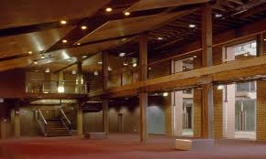  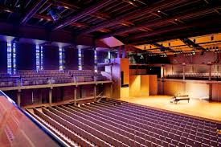  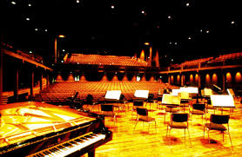 | 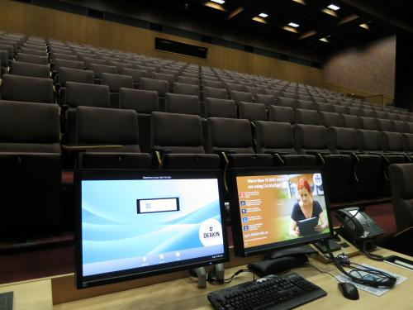  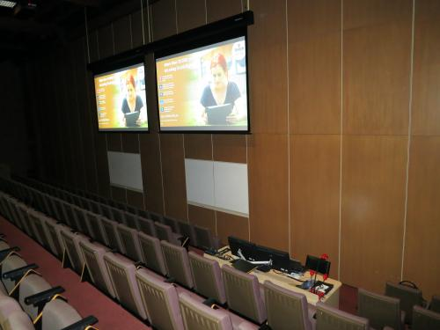 | 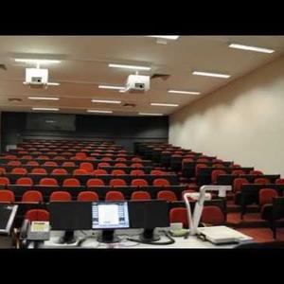 | 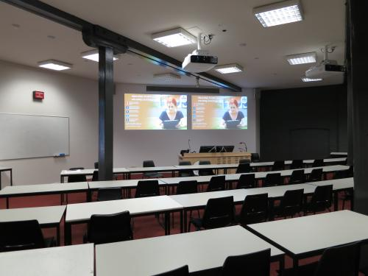  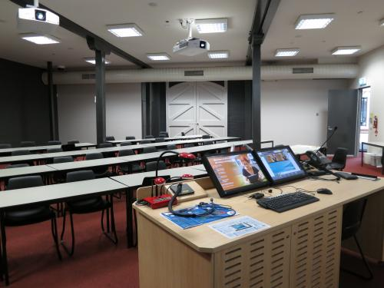 | No image available
Building on campus map | Building D  (Hay Building)  Level 2 | Building D  (Hay Building)  Level 4  (ground level is Level 2) | Building D  (Hay Building)  Level 2 | Building D  (Hay Building)  Level 2

Audiovisual (AV) equipment

Your presentation
Due to the large range of distributions, presentation software and other tools and utilities which are likely to be utilised at linux.conf.au, conference organisers will not pre-load presentations on computers/laptops. This means you will need to bring your laptop with you, or contact the organisers so we can arrange alternate methods for displaying your presentation.

Filming of presentations
Unless you have specifically withheld your permission, all talks given at linux.conf.au will be filmed and digitally distributed to share with the community.
NOTE: As per the terms and conditions of the conference, we cannot guarantee the timing at which recordings will be available, nor the quality of any recordings.

Video Connections – Updated 27th Jan
The video resolution will be 720p (1280x720). Please ensure your presentation is formatted in 16:9 ratio.
All rooms will only have HDMI connectors. If you need an adapter to output HDMI, please bring it with you. (If you forget your HDMI adapter, the A/V team might have one you can use - but there are no guarantees!)
Note: Previously information had reported that Wool Museum was VGA only, this has turned out not to be the case.
Please contact the speaker liaison if you must use VGA (or other) output. We do have a limited number of VGA to HDMI converters, but they frequently cause issues.

Audio & Microphones
Each room at the venue will be staffed by a small AV team who will provide you with a lapel microphone and perform a quick sound check before you begin, to ensure everyone in the room can hear you clearly. Positioning of the lapel microphone will involve a microphone being clipped to your clothing – such as a collar or t-shirt band – and a wire being run under your shirt, to connect with a battery pack which clips on to the belt of your pants.
NOTE: If you are wearing clothing without a belt or waistband, for instance Speakers who may prefer to wear a dress, please be aware that this may make it difficult to clip on the microphone battery pack. It's easier if there's something to clip it on to – such as the waist band or belt of slacks, trousers, jeans or a skirt.
We will try to have a 3.5mm stero audio connection for your laptop avaliable but this might not be possible.

Power Connections
Power will be available for you to plug your laptop into, please use only the power board indicated as others may have critical conference equipment plugged into them!
NOTE: that Australian standard electrical outlets provide 240V, 50Hz and use an AS3112 type outlet (http://en.wikipedia.org/wiki/Australian_power_connector).
If you are travelling to the conference from overseas, please don't forget your travel adapter and to check your power adapter is capable of dealing with 240V!

Internet access
Although organisers will endeavour to have reliable, high-speed internet access available for all conference talks, you need to be aware that it may be suboptimal – low speed, intermittent availability etc. Please keep this in mind if your presentation is heavily reliant on internet access.

Questions
The last 10 minutes of your talk slot is generally devoted to any questions that people may have, for this section a microphone will be handed around the room by one of the conference staff for people to ask questions through. If for some reason you need to address a question which was not asked through the mic, we ask that you please repeat the question first, so that later viewers of your talk will have some context around the answer!

Arriving with plenty of time to spare before your talk is scheduled to begin
Please try to arrive well before your talk is scheduled to start so that there is sufficient time to set up your microphone and laptop.

Presentation template
Along with this Speaker Information Pack you would have received a Presentation Template. Using this template is NOT compulsory. It is provided only as a courtesy in case you don't have a suitable presentation template handy.

Tips for a great presentation
A great presentation takes preparation, planning, practice and panache.
Generally, the more you prepare, the better the presentation you will be able to deliver. To help you get started, we've collated a list of links and resources which will assist.

- Dunlap, Joanna C., and Patrick R. Lowenthal. “Situational Qualities Exhibited by Exceptional Presenters.” (Research Bulletin). Boulder, CO: EDUCAUSE Center for Applied Research, October 18, 2011, available from http://www.educause.edu/Resources/SituationalQualitiesExhibitedb/238961
This great document walks the reader through a number of outstanding presentations and dissects what makes them so appealling – qualities such as immediacy, malleability, compellingness, resonance and coherence.
- Veen, J "7 Steps to Better Presentations"
http://veen.com/jeff/archives/000483.html
- Spencer, D "10 effective conference presentation tips"
http://www.docstoc.com/docs/6048121/10-effective-conference-presentation-tips-by-Donna-Spencer
- Reynolds, G "Presentation Zen"
http://www.presentationzen.com/
This website is dedicated to professional speaking and presentation tips and advice – well worth a read!

Example videos from previous years' linux.conf.au
To see examples of previous year's presentations, so that you can get a better idea of what works and what doesn't, you can view recordings at;

http://mirror.linux.org.au/linux.conf.au

Audience demographics
To help you better gauge the audience and pitch your presentation appropriately, we've included some basic audience demographics below.

Language | All presentations are expected to be given in English, and all conference information will be available in English only. All attendees are expected to have a high level of proficiency in written and spoken English.
Nationality | The majority of attendees – approximately 80% will be Australian, with a significant New Zealander contingent (10-15%). The remainder of attendees are from countries such as the United States, Canada and the United Kingdom, with a very small number of attendees from Europe.
Gender | Linux.conf.au endeavours to provide a safe and supportive environment for Delegates of all genders. Approximately 80% of attendees identify as male, however the number of female-identifying attendees has risen steadily over the years. Just under 20% of Speakers at this year's conference identify as female.
Technical competency | It is reasonable to assume a VERY HIGH level of technical competence amongst conference attendees. Many work in highly skilled occupations such as systems administration, network administration, software development and infrastructure management. Other attendees have at least a general understanding of computing, Linux, systems administration and are likely to work in affiliated professions such as technical writing or technology management.
Age | The vast majority of attendees are over 18.
Organisational affiliation | Attendees are associated with a wide range of organisations – such as Universities and scientific research organisations, private technology companies and government departments. Many attendees have no organisational affiliation and fund their own conference attendance as 'Hobbyists'.

Campus Map

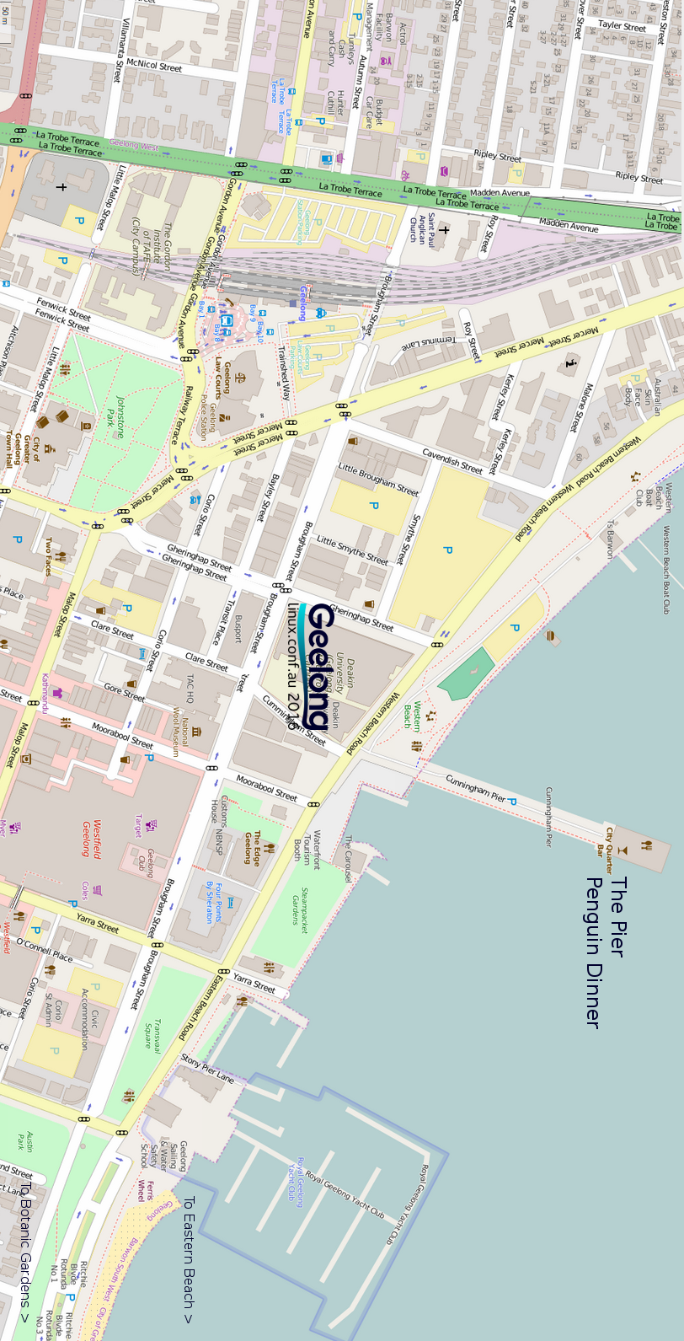
Map of Geelong and surrounding areas
Attribution: Open Street Map

